**Problem 1**

function [ DFT_vector ] = DFT( y )

one = ones(size(y))';

y_2D = (one*y)';

N = length(y);

n = 0:N-1;

k = n';

% The result is a 2D array such that

% the columns vary as k varies and rows vary as n varies

e = exp(-1i*k*n*2*pi/N);

% Multiply each element in y_2D by each element in e

Y = y_2D .* e;

DFT_vector = sum(Y);

end

y = 0:1000;

tic;

profile on;

our_function = DFT(y);

profile viewer

toc;

tic;

fft_function = fft(y);

toc;

Elapsed time is 0.602245 seconds.

Elapsed time is 0.010012 seconds.

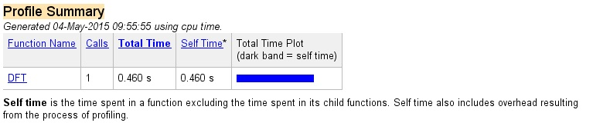

**Problem 2**

fs = 8000;

>> To = 0.004;

>> Ts = 1/fs;

>> N=2^nextpow2(To/Ts);

>> k = -N/2:N/2;

>> k = k * Ts;

>> z = (k<=.002) & (k>=0);

>> Y =fftshift( fft(z));

>> x=linspace(-To/2, To/2, N+1);

>> stem(x,z);

>> title('Rectangular signal - time domain');

>> xlabel('t/s');

>> ylabel('x(t)');

>> xlim([-.003, .003]);

>> ylim([0,2]);

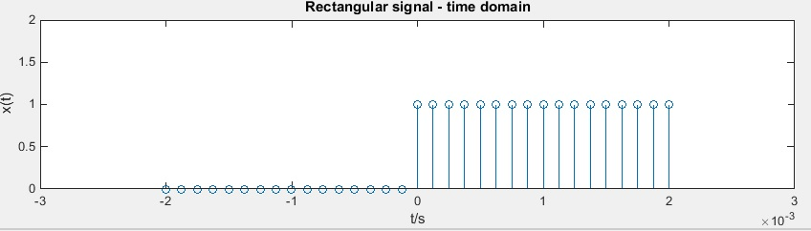

stem(x,abs(Y));

>> title('Amplitude spectrum');

>> xlabel('w');

>> ylabel('|X(jw)|');

>> xlim([-.003, .003]);

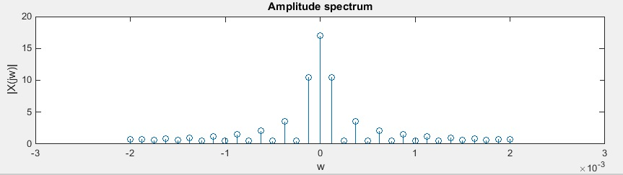

**We increase the sampling frequency to 80 kHz.**

fs = 80000;

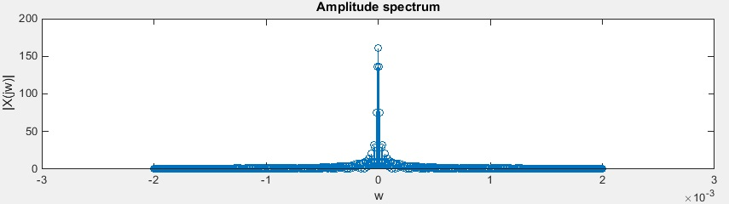

**With increasing the sampling frequency fs the resolution and the spectrum increase too.**

**Problem 3**

>> file = 'C:\Users\Mihail\Desktop\SS2_Labs\touchtone1.wav';

>> [y,Fs]=audioread(file);

>> soundsc(y,Fs);

C)

>> Ts = 1/Fs;

>> N = length(y) - 1;

>> To = N*Ts;

>> n = 0:Ts:To;

>> n = n.*Ts;

>> plot(n,y);

>> title('Time domain');

>> xlabel('time');

>> ylabel('|Y|');

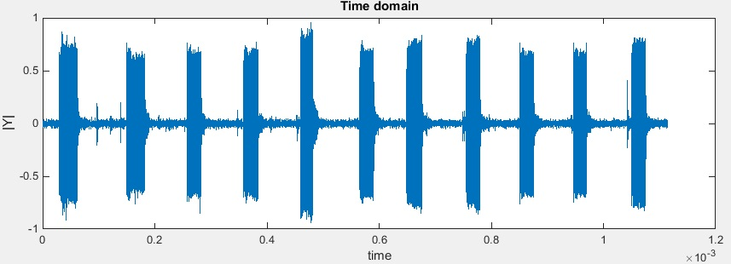

D)

>> fo = 1/To;

>> X = 0:fo:Fs;

>> subplot(2,1,1);

>> plot(X,abs(fft(y)));

>> title('frequency domain');

>> xlabel('w');

>> ylabel('|Y|');

>> subplot(2,1,2);

>> plot(X,abs(fft(y)));

>> xlim([0,4096]);

>> title('frequency domain');

>> xlabel('w');

>> ylabel('|Y|');

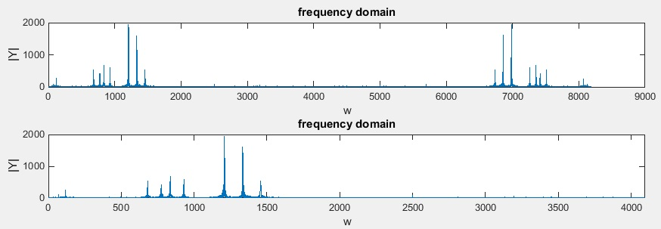

E)

function [tone] = generate_tones( key )

Fs = 8000;

t = 0:1/Fs:(1/2-1/Fs);

num=length(key);

for k=1:num;

value =key(k);

switch value

case{1,2,3}

row = 697;

case{4,5,6}

row = 770;

case{7,8,9}

row = 852;

otherwise

row = 942;

end

switch value

case{1,4,7}

column = 1209;

case{2,3,8,0}

column = 1336;

otherwise

column = 1477;

end

tone = 0.5*(sin(2*pi*row*t)+sin(2*pi*column*t));

sound(tone,Fs);

end

end

F)

function [ tones ] = dial_tones()

Fs=8000;

key = input('Please Dial your number:');

key = num2str(key)

num = length(key);

tones = zeros(1,num*Fs);

time = 0: 1/Fs:(num -1/Fs);

for x = 1:num

tones((1+Fs*(x-1)):(Fs/2 +Fs*(x-1))) = generate_tones(str2num(key(x)));

end

sound(tones,Fs);

%plot(time,tones);

plot(time(1:500),tones(1:500));

title('Dual Signal');

xlabel('Time(sec)');

ylabel('Magnitude');

end

