LAB 4: Prep sheet
- Pls. upload to EMIL before the lab session by every team member and in PDF format only (otherwise no grading),
and in addition
- give a hardcopy to the Prof/Lab Assistant at the beginning of the lab session

Team | if not a joint solution: tick corresponding author
Participant 1 | Name:
Participant 2 | Name:
Participant 3 | Name:

PREP TASK 1.1: Draw the block diagram with all port signals of the traffic light controller.

Block Diagram:

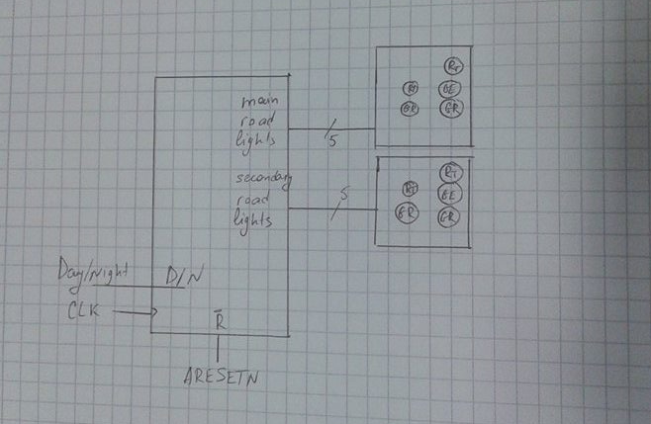

PREP TASK 1.2:
- Draw the complete state diagram (FSM) for the traffic light controller (including day and night operation) with states, transitions and output signals.
- Why is Mealy behaviour not required for this task?

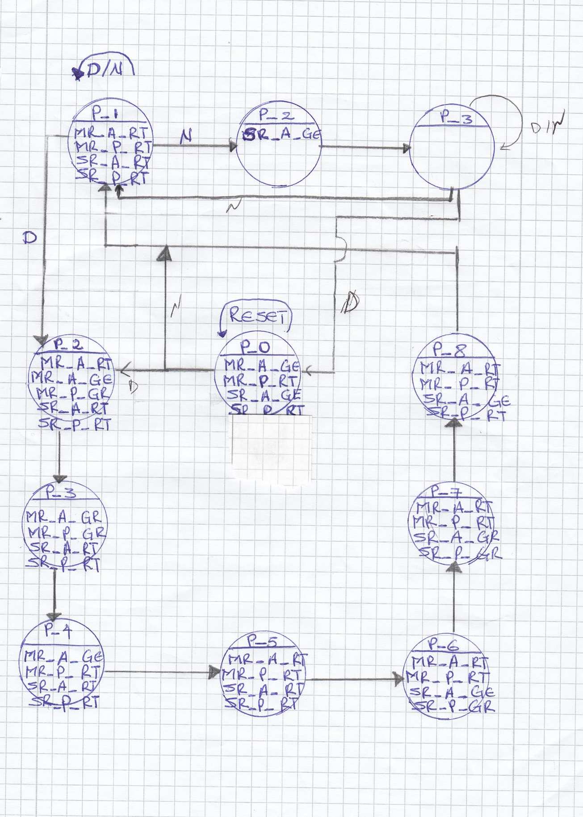
State Diagram:

Why is Mealy behaviour not required?

PREP TASK 1.3:
- Write a VHDL model with symbolic states and verify it by simulation (give the do file and simulation result).

VHDL code:
entity TrafficLight is
port(RESETN, CLK: in bit;
D_N: in bit;
MR_A : out bit_vector (2 downto 0);
MR_P : out bit_vector (1 downto 0);
SR_A : out bit_vector (2 downto 0);
SR_P : out bit_vector (1 downto 0)
);
end TrafficLight;

architecture MOORE of TrafficLight is
type STATES is (R, P_1, P_D2, P_D3, P_D4, P_D5, P_D6, P_D7, P_D8, P_N2, P_N3);
signal Z, ZPLUS : STATES;
begin

ZREG: process (CLK, RESETN)
begin
--asynchronous active-low reset
if RESETN='0' then
Z<=R; -- after 5 ns;
elsif CLK='1' and CLK'event then
--create register to keep current state vector
Z<=ZPLUS after 5 ns;
end if;
end process ZREG;

COMBIN: process (D_N, Z)
begin

--default values for outputs and next statues ZPLUS
MR_A<="000"; MR_P<="00";
SR_A<="000"; SR_P<="00";
ZPLUS<=Z;

case Z is

when R=> MR_A<="010"; MR_P<="01"; SR_A<="010"; SR_P<="01";
ZPLUS<=P_1;

when P_1=> MR_A<="001"; MR_P<="01"; SR_A<="001"; SR_P<="01";
if D_N='1' then ZPLUS<=P_D2;
else ZPLUS<=P_N2;
end if;

--day time
when P_D2=> MR_A<="011"; MR_P<="10"; SR_A<="001"; SR_P<="01";
ZPLUS<=P_D3;

when P_D3=> MR_A<="100"; MR_P<="10"; SR_A<="001"; SR_P<="01";
ZPLUS<=P_D4;

when P_D4=> MR_A<="010"; MR_P<="01"; SR_A<="001"; SR_P<="01";
ZPLUS<=P_D5;

when P_D5=> MR_A<="001"; MR_P<="01"; SR_A<="001"; SR_P<="01";
ZPLUS<=P_D6;

when P_D6=> MR_A<="001"; MR_P<="01"; SR_A<="011"; SR_P<="10";
ZPLUS<=P_D7;

when P_D7=> MR_A<="001"; MR_P<="01"; SR_A<="100"; SR_P<="10";
ZPLUS<=P_D8;

when P_D8=> MR_A<="001"; MR_P<="01"; SR_A<="010"; SR_P<="01";
ZPLUS<=P_1;

--night time
when P_N2=> MR_A<="000"; MR_P<="00"; SR_A<="010"; SR_P<="00";
ZPLUS<=P_N3;

when P_N3=> MR_A<="000"; MR_P<="00"; SR_A<="000"; SR_P<="00";
if D_N='1' then ZPLUS<=R;
else ZPLUS<=P_1;
end if;

end case;

end process COMBIN;
end;
Simulation result (waveforms):

Case 1
# compile project TrafficLight
vlib work
vcom -93 -work work TrafficLight.vhd
# simulate TrafficLight
vsim TrafficLight
view wave
radix hex

# show input signals
add wave -divider -height 32 Inputs
add wave -height 30 -radix default CLK
add wave -height 30 -radix default D_N
add wave -height 30 -radix default RESETN

# display output waves
add wave -divider -height 32 Outputs
add wave -height 32 -radix default MR_A
add wave -height 32 -radix default MR_P
add wave -height 32 -radix default SR_A
add wave -height 32 -radix default SR_P

force RESETN 0 0ns, 1 100ns, 0 200ns, 1 300ns, 0 400ns, 1 500ns
force CLK 1 0ns, 0 50ns, 1 150ns, 0 250ns, 1 350ns, 0 450ns
force D_N 1 0ns, 0 100ns, 1 250ns, 0 350ns, 1 490ns
run 500ns
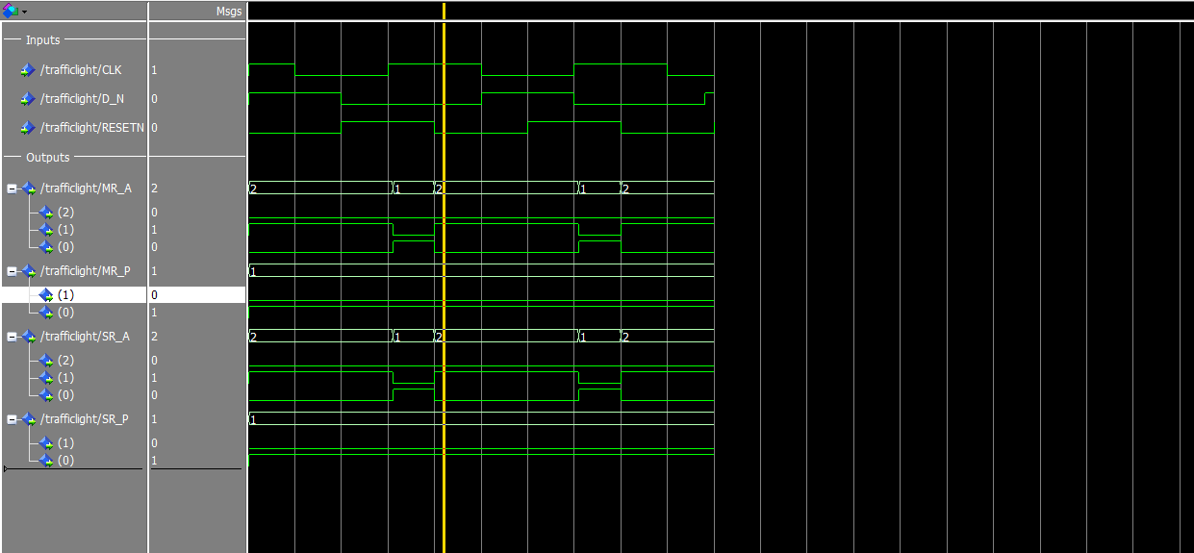
Case 2

# compile project TrafficLight
vlib work
vcom -93 -work work TrafficLight.vhd
# simulate TrafficLight
vsim TrafficLight
view wave
radix hex

# show input signals
add wave -divider -height 32 Inputs
add wave -height 30 -radix default CLK
add wave -height 30 -radix default D_N
add wave -height 30 -radix default RESETN

# display output waves
add wave -divider -height 32 Outputs
add wave -height 32 -radix default MR_A
add wave -height 32 -radix default MR_P
add wave -height 32 -radix default SR_A
add wave -height 32 -radix default SR_P

force RESETN 0 0ns, 1 50ns, 0 250ns, 1 350ns, 0 490ns
force CLK 1 0ns, 0 50ns, 1 100ns, 0 200ns, 1 250ns, 0 350ns, 1 500ns
force D_N 1 0ns, 0 150ns, 1 250ns, 0 400ns, 1 490ns
run 500ns

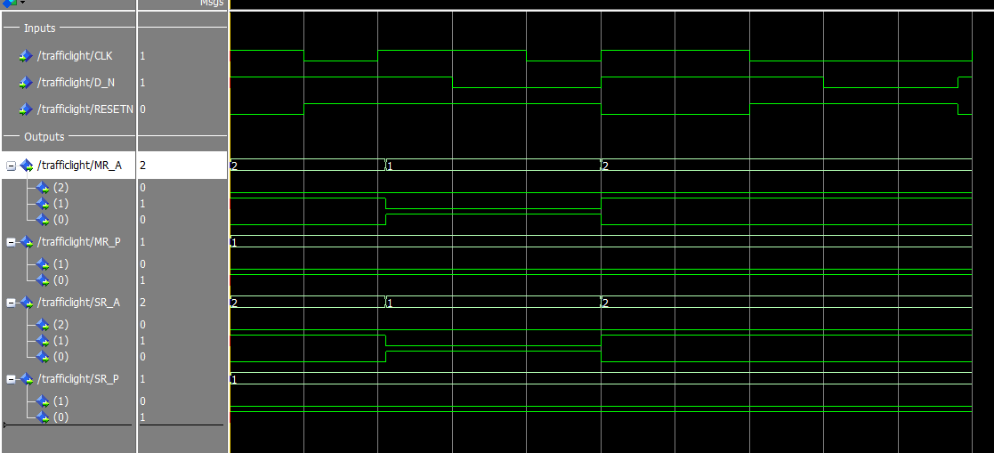

PREP TASK 2.1:
Let the counter be specified as follows:
- The counter is a modulo-n counter that counts upwards to a maximum value (which has to be determined). The maximum value shall be defined as a generic value in the entity declaration.
- The counter can be synchronously cleared by a CLRN input.
- The counter has an asynchronous active-low reset and a clock input.
- The counter shall be designed as an entity that is later instantiated as a component.
Develop a VHDL model for the counter specified above with clear input.
Hint: use the counter with preload value from Lab Session 3 as a template and modify it to your needs.
It is left to you to decide whether you use the counter for option (1) (FSM clears counter with every state transition) or option (2) (FSM clears counter once per entire traffic light cycle).
- Which value do you chose for n (the maximum number of count values) and why? What is the width of the output signal CNT?
- Draw the state diagram for the FSM with duration modelling.
- Write the VHDL model of the counter and verify it by simulation.

Which value do you chose for n (the maximum number of count values) and why?

We chose 8, because maximum duration of one of the phases (Phase 3) is 8 ticks.

What is the width of the output signal CNT?
4

■
Draw the state diagram for the FSM with duration modelling.
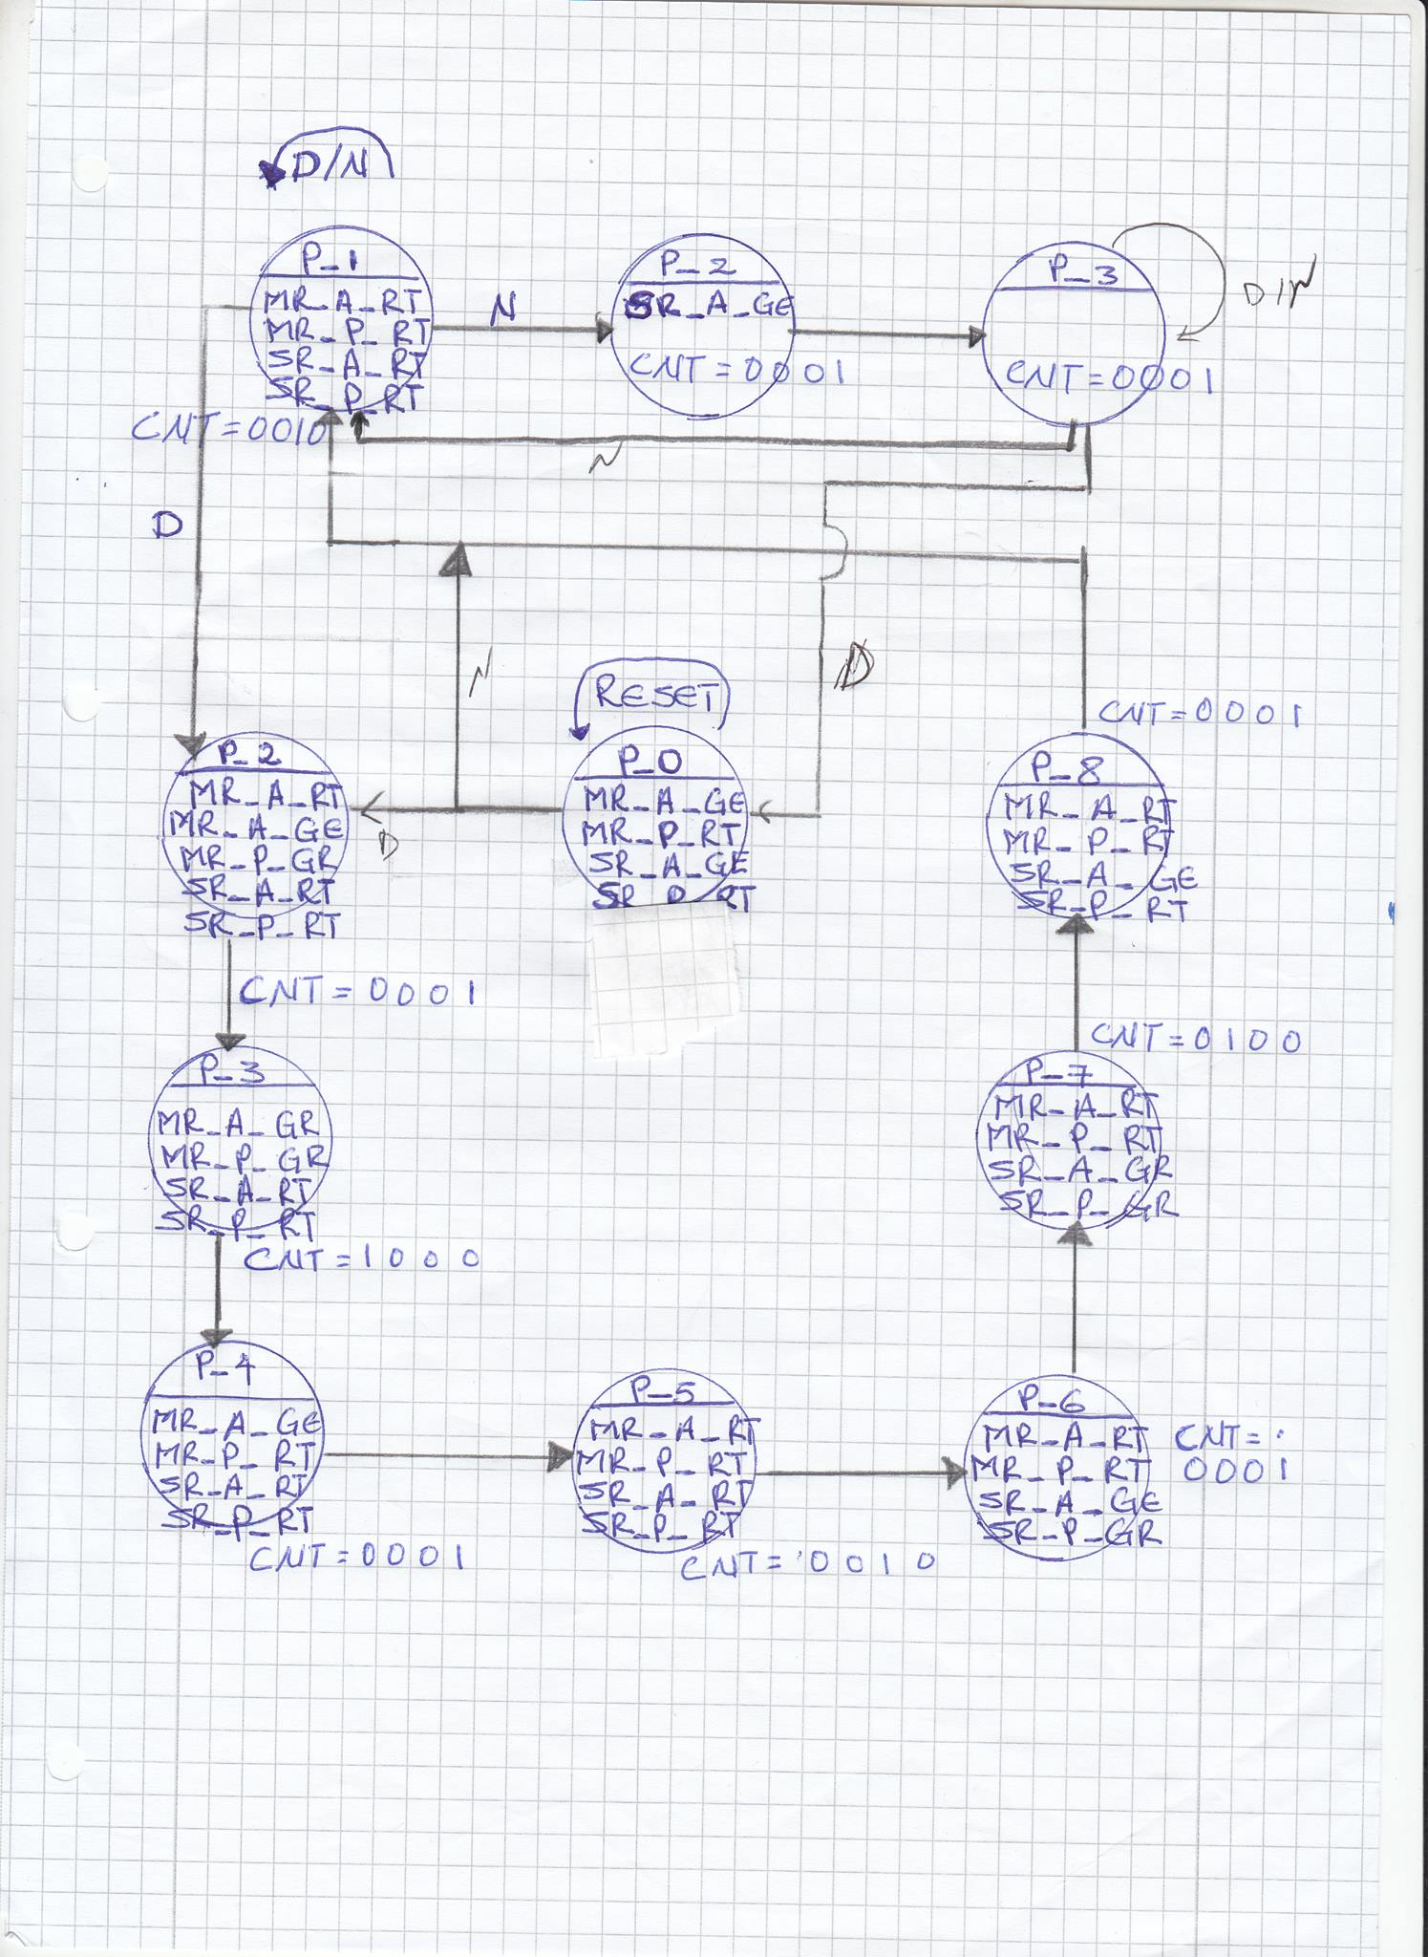

VHDL code of the counter

library ieee;
use ieee.std_logic_1164.all;
use ieee.numeric_std.all;

entity SUB_ENTITY is
port ( ARESETN, CLK, DIR, CNTEN, LOAD, TCEN : in bit;
PRE : in unsigned (3 downto 0);
CNT : out bit_vector (3 downto 0);
TC : out bit);
end entity SUB_ENTITY;

architecture BEHAVIORAL of MOD16_UD_CNT is
signal S : unsigned(3 downto 0);

begin

P_SYNC : process (ARESETN, CLK)
begin
if ARESETN = '0' then S <= "0000" after 5 ns;
elsif LOAD = '1' then
if CLK'event and CLK='1' then S <= PRE after 5 ns;
end if;
else
if CLK'event and CLK='1' then
if CNTEN='0' then
if DIR = '0' then
S <= S - 1 after 5 ns;
else
S <= S + 1 after 5 ns;
end if;
end if;
end if;
end if;
end process P_SYNC;

P_OUT : process (S,DIR,TCEN)
begin
TC <= '0' after 5 ns;
if TCEN = '0' then
if (DIR = '0' and S = 0) or (DIR = '1' and S = 15) then
TC <= '1' after 5 ns;
end if;
end if;
CNT <= to_bitvector(std_logic_vector(S));

end process P_OUT;

end architecture BEHAVIORAL;

Simulation results (waveforms)

We changed our TrafficLight.vhd as well, and faced with some problems in simulation results.

entity TrafficLight is
generic (N : integer :=8);
port(RESETN, CLK_S: in bit;
D_N : in bit;
CLRN : in bit;
DIR_S: in bit;
LOAD_S: in bit;
TCEN_S: in bit;
DUR : in bit_vector(3 downto 0);
MR_A : out bit_vector (2 downto 0);
MR_P : out bit_vector (1 downto 0);
SR_A : out bit_vector (2 downto 0);
SR_P : out bit_vector (1 downto 0);

CNT_S : in bit_vector (3 downto 0)

);
end TrafficLight;

architecture MOORE of TrafficLight is
type STATES is (R, P_1, P_D2, P_D3, P_D4, P_D5, P_D6, P_D7, P_D8, P_N2, P_N3);
signal Z, ZPLUS : STATES;

--component declaration
component SUB_ENTITY
port ( ARESETN, CLK, DIR, CNTEN, LOAD, TCEN : in bit;
CNT : out bit_vector (3 downto 0);
TC : out bit);
end component SUB_ENTITY;

begin

--instantiation of component
INST : SUB_ENTITY
port map (RESETN, CLK_S, DIR_S, CLRN, LOAD_S, TCEN_S, CNT_S);

ZREG: process (CLK_S, RESETN)
begin
--asynchronous active-low reset
if RESETN='0' then
Z<=R; -- after 5 ns;
elsif CLK_S='1' and CLK_S'event then
--create register to keep current state vector
Z<=ZPLUS after 5 ns;
end if;
end process ZREG;

COMBIN: process (D_N, Z)
begin

--default values for outputs and next statues ZPLUS
MR_A<="000"; MR_P<="00";
SR_A<="000"; SR_P<="00";
-- DUR<="0000";
ZPLUS<=Z;

case Z is

when R=> MR_A<="010"; MR_P<="01"; SR_A<="010"; SR_P<="01"; -- DUR<="0010";
if DUR=CNT_S then ZPLUS<=P_1;
else CLRN<='0';
end if;

when P_1=> MR_A<="001"; MR_P<="01"; SR_A<="001"; SR_P<="01"; -- DUR<="0010";
if DUR = CNT_S then
if D_N='1' then
ZPLUS<=P_D2;
else
ZPLUS<=P_N2;
end if;

else CLRN<='0';
end if;

--day time
when P_D2=> MR_A<="011"; MR_P<="10"; SR_A<="001"; SR_P<="01"; -- DUR<="0001";
if CNT_S = DUR then ZPLUS<=P_D3;
else CLRN<='0';
end if;

when P_D3=> MR_A<="100"; MR_P<="10"; SR_A<="001"; SR_P<="01"; -- DUR<="1000";
if CNT_S = DUR then ZPLUS<=P_D4;
else CLRN<='0';
end if;

when P_D4=> MR_A<="010"; MR_P<="01"; SR_A<="001"; SR_P<="01"; -- DUR<="0001";
if CNT_S = DUR then ZPLUS<=P_D5;
else CLRN<='0';
end if;

when P_D5=> MR_A<="001"; MR_P<="01"; SR_A<="001"; SR_P<="01"; -- DUR<="0010";
if CNT_S = DUR then ZPLUS<=P_D6;
else CLRN<='0';
end if;

when P_D6=> MR_A<="001"; MR_P<="01"; SR_A<="011"; SR_P<="10"; -- DUR<="0001";
if CNT_S = DUR then ZPLUS<=P_D7;
else CLRN<='0';
end if;

when P_D7=> MR_A<="001"; MR_P<="01"; SR_A<="100"; SR_P<="10"; -- DUR<="0100";
if CNT_S = DUR then ZPLUS<=P_D8;
else CLRN<='0';
end if;

when P_D8=> MR_A<="001"; MR_P<="01"; SR_A<="010"; SR_P<="01"; -- DUR<="0001";
if CNT_S = DUR then ZPLUS<=P_1;
else CLRN<='0';
end if;

--night time
when P_N2=> MR_A<="000"; MR_P<="00"; SR_A<="010"; SR_P<="00"; -- DUR<="0001";
if CNT_S = DUR then ZPLUS<=P_N3;
else CLRN<='0';
end if;

when P_N3=> MR_A<="000"; MR_P<="00"; SR_A<="000"; SR_P<="00"; -- DUR<="0001";
if CNT_S = DUR then
if D_N='1' then
ZPLUS<=R;
else
ZPLUS<=P_1;
end if;
else CLRN<='0';
end if;

end case;
end process COMBIN;
end;

