LAB 2: Prep sheet
- Pls. upload to EMIL before the lab session by every team member and in PDF format only (otherwise no grading),
and in addition
- give a hardcopy to the Prof/Lab Assistant at the beginning of the lab session

Team | if not a joint solution: tick corresponding author
Participant 1 | Name: Nikolay Stoitsov
Participant 2 | Name: Plamen Iliev
Participant 3 | Name: Ali Sahin

PREP TASK 1.1: Verify that the equations above and the truth table are equivalent.

Explanation: sn = (an←|→bn) ←|→cn

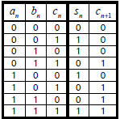

c_{n+1}=(a_{n^}b_{n})v(c_{n^}(a_{n}vb_{n}))
an | bn | cn | an←|→bn | sn
0 | 0 | 0 | 0 | 0
0 | 0 | 1 | 0 | 1
0 | 1 | 0 | 1 | 1
0 | 1 | 1 | 1 | 0
1 | 0 | 0 | 1 | 1
1 | 0 | 1 | 1 | 0
1 | 1 | 0 | 0 | 0
1 | 1 | 1 | 0 | 1

These are truth tables of the 2 equations describing the 1-bit full adder with carry-in. It comes clear that the result for Sn and Cn+1 is the same.
an | bn | cn | an^bn | anVbn | cn^(anVbn) | cn+1
0 | 0 | 0 | 0 | 0 | 0 | 0
0 | 0 | 1 | 0 | 0 | 0 | 0
0 | 1 | 0 | 0 | 1 | 0 | 0
0 | 1 | 1 | 0 | 1 | 1 | 1
1 | 0 | 0 | 0 | 1 | 0 | 0
1 | 0 | 1 | 0 | 1 | 1 | 1
1 | 1 | 0 | 1 | 1 | 0 | 1
1 | 1 | 1 | 1 | 1 | 1 | 1

PREP TASK 1.2: Simulate the 1-bit full adder. Does the simulation agree with the truth table in Error: Reference source not found? Insert the waveforms in the prep sheet.

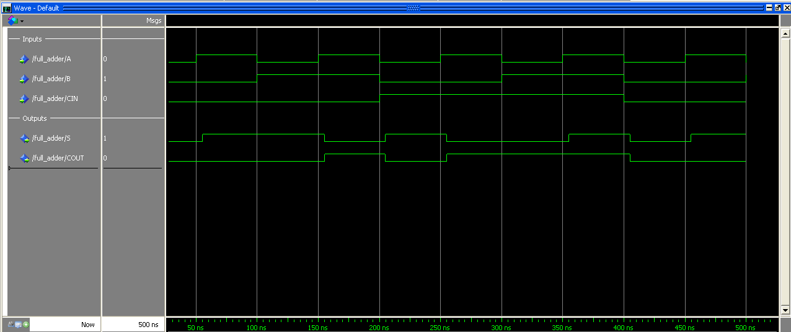
As we can see the results fit.

PREP TASK 1.2: Let N=3. Draw the 3-bit adder and label all signals according to the VHDL model in Error: Reference source not found. Use the following symbol of a 1-bit full adder in your sketch.
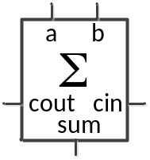

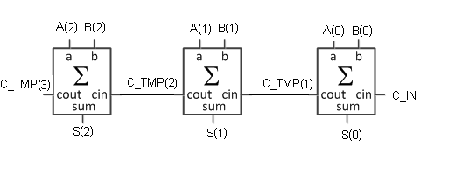

PREP TASK 1.3: Write a test bench for the n-bit adder after reading again the text above about good test benches and test cases.

Write down first at least 5 test cases (here: input stimuli to the n-bit adder) and explain why you have chosen those. In the lab, you will later have to measure the maximum propagation delay that the Ripple-Carry Adder can have. Therefore, your test bench should include a test case in which the maximum propagation delay occurs.

Extend the .do-file provided in EMIL with your test cases and simulate your VHDL model. Insert your .do-file and the simulated waveform in the prep sheet.

Test cases:
input A: 00 FF FF AA AA FF
input B: 00 FF AA AA 55 01

# --- compilation
vlib work
vcom -93 -work work NBITADDER.vhd
vsim NBITADDER
# --- simulation
# view signal wave forms
view wave
# number format is hex
radix hex

# show input signals
add wave -divider -height 32 Inputs
add wave -height 30 -radix default A
add wave -height 30 -radix default B
add wave -height 30 -radix default C_IN

# show internal signals
add wave -divider -height 32 Internal
add wave -height 30 -radix default C_TMP

# show output signals
add wave -divider -height 32 Outputs
add wave -height 30 -radix default S

# generate input stimuli
# use hexadecimal notation to assign values to bit_vectors
# force SIG 00 0ns, FF 100ns, 3A 150ns etc.
force A 00 0ns, FF 100ns, AA 300ns, FF 500ns
force B 00 0ns, FF 100ns, AA 200ns, AA 300ns, 55 400ns, 01 500ns
force C_IN 0 0ns, 1 300ns, 0 400ns

run 600ns
Simulation results:
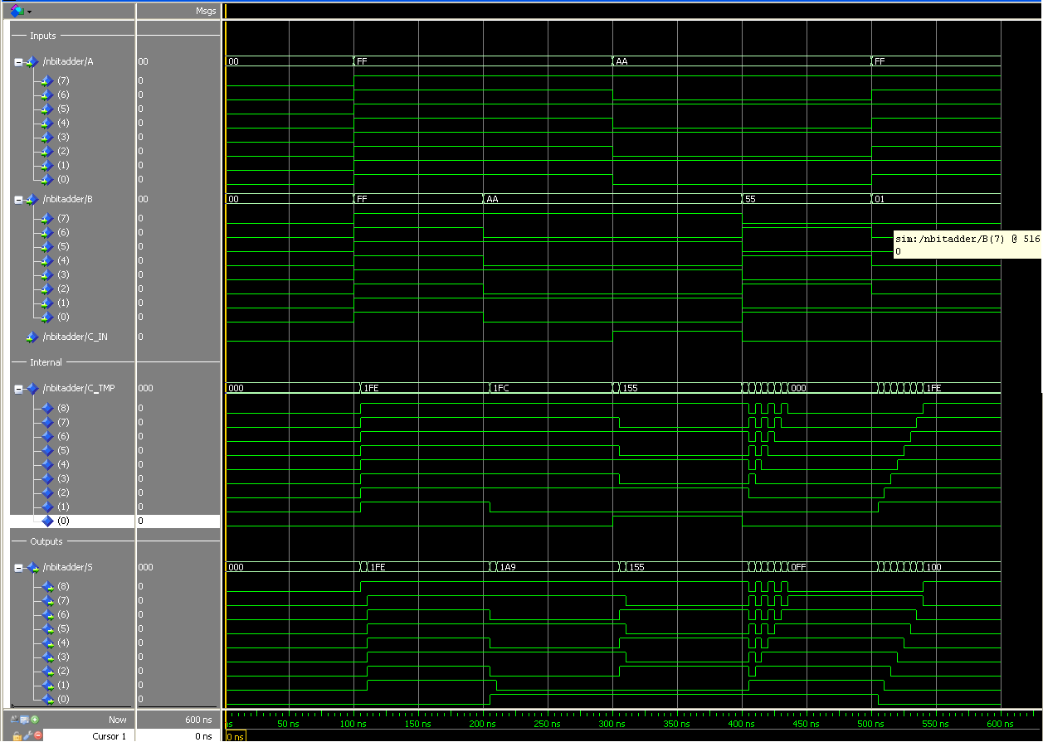

PREP TASK 3.1: Use the same test bench as in PREP TASK 1.3 (minor modifications are required since file and entity name have changed) to simulate the arithmetic adder. Compare the results of 1.3 and 3.1 and insert the waveforms in the prep sheet.

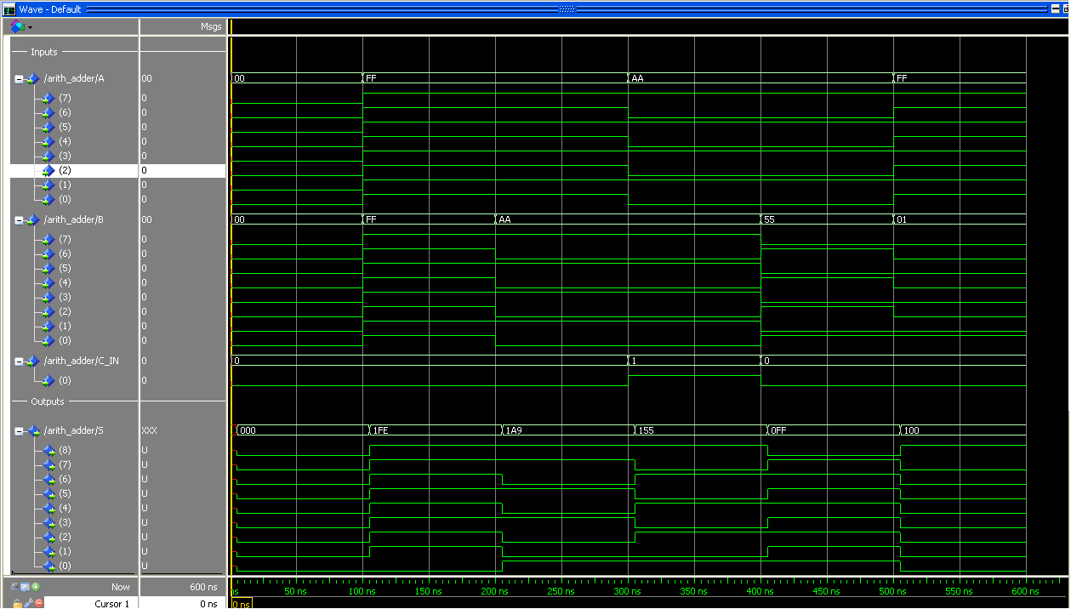

The propagation delay in the result is less since the intermediate part with C_TMP is skipped. There are no oscillations since the for loop is skipped and in general the output signal is more stable and correct.

Case 1:
A = 0: 0000 0000
B = 0: 0000 0000
C_IN: 0
S = 0: 0 0000 0000

Case 2:
A = FF 1111 1111
B = FF 1111 1111
C_IN: 0
S = 1FE: 1 1111 1110

Case 3:
A = FF 1111 1111
B = AA 1010 1010
C_IN: 0
S = 1A9 1 1010 1001

Case 4:
A = AA: 1010 1010
B = AA: 1010 1010
C_IN: 1
S = 155 1 0101 0101

Case 5:
A = AA: 1010 1010
B = 55: 0101 0101
C_IN: 0
S = 0FF 0 1111 1111

Case 6:
A = FF: 1111 1111
B: = 01 0000 0001
C_IN: 0
S = 100 1 0000 0000

