LAB 3: Prep sheet
- Pls. upload to EMIL before the lab session by every team member and in PDF format only (otherwise no grading),
and in addition
- give a hardcopy to the Prof/Lab Assistant at the beginning of the lab session

Team | if not a joint solution: tick corresponding author
Participant 1 | Name: Nikolay Stoitsov
Participant 2 | Name: Plamen Iliev
Participant 3 | Name: Ali Sahin

PREP TASK 1.1: Simulate the counter in Error: Reference source not found with relevant test cases. Highlight the different timing behaviour of Mealy and Moore outputs in the simulated waveforms.

Test cases (textual description):
- in: ARESETN=0; CLK=x(don’t care); DIR=0 (count downwards); CNTEN=0 (counter is enabled)
out: TCUP=0; TCDN=1; CNT=0
When ARESETN is 0, the output CNT is 0 regardless of the values of the other inputs
When DIR and CNT are 0, output TCDN is 1 and TCUP is 0 by default
- in: ARESETN=1; CLK=0; DIR=0; CNTEN=0
out: TCUP=0; TCDN=1; CNT=0
Here ARESETN changes from 0 to 1 but until a rising edge of the clock occurs, the outputs are not changed.
- in: ARESETN=1; CLK=1; DIR=0; CNTEN=0
out: TCUP=0; TCDN=0 (after 10ns); CNT=F
When a rising edge of the clock occurs (and counter is enabled CNTEN=0 and counting direction is downwards DIR=0) the counter CNT changes from 0 to F (15) so the output TCDN will become a 0. With every rising edge of the clock the counter CNT will decrement by 1 until some other changes in the inputs occur or it reaches 0 and starts again from F.
- in: ARESETN=1; CLK=x; DIR=0 (or 1); CNTEN=1
out: TCUP=0; TCDN=0; CNT= C
When CNTEN is 1, the counting is disabled and the counter output CNT will stay unchanged with the value it had before this change.
- in: ARESETN=1; CLK=1; DIR=1; CNTEN=0
out: TCUP=0; TCDN=0; CNT=D
The counting is enabled (CNTEN=0) and the direction is reversed to upwards counting (DIR=1) so with the next rising edge of the clock (CLK=1) the counter will get the next upcoming value (which in our case is D(13)). With every next rising edge of the clock the output will get the next upcoming value until it comes to F (the condition DIR=1 and CNT=F leads to TCUP=1) and then it starts again from 0.

Simulation results (waveforms incl. Mealy behaviour highlighted)

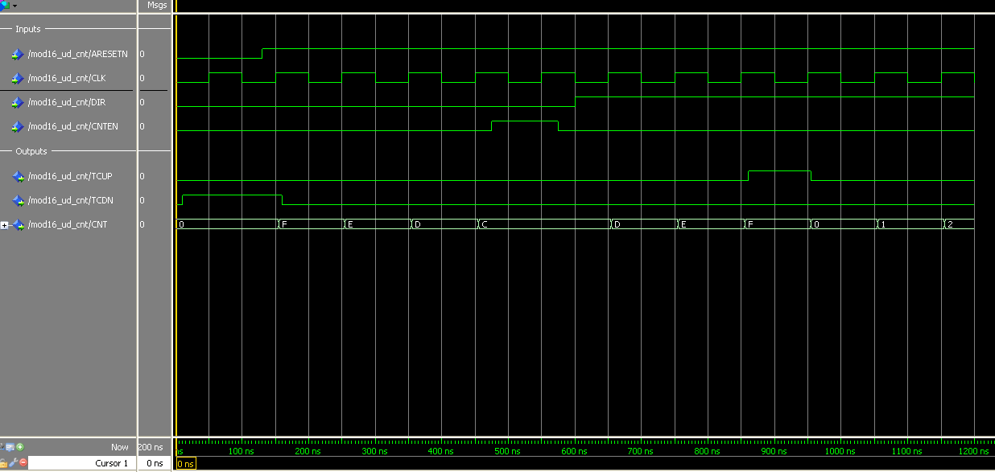
Fig1: Simulation Results

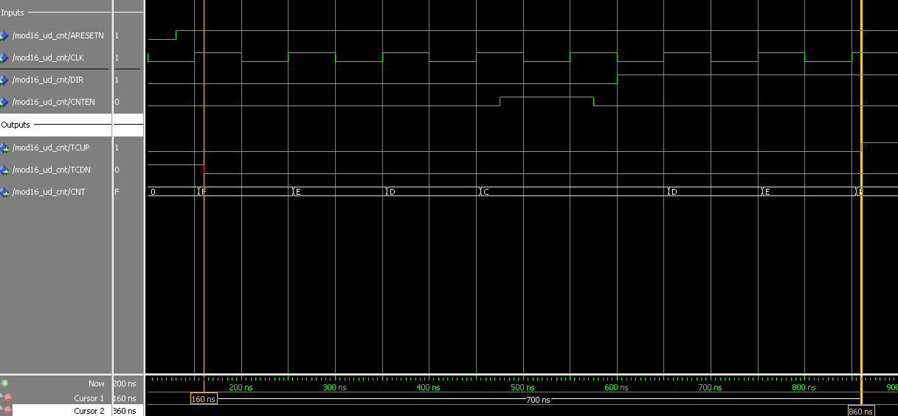

Fig2: Changes in the Mealy outputs TCUP and TCDN are highlighted with cursors. As seen they change with rising edge of the clock.

PREP TASK 2.1: Assume the counter shall count upwards and the TC signal shall be enabled. Give the required signal configuration (high, low, rising edge, value, don’t care):
LOAD | DIR | TCEN | CNTEN | CLK | PRE(3..0)
0/L | 1/H | 0/L | 0/L | _/ RE | X
The counter shall be loaded with value 11 and TC shall be enabled. Give the required signal configuration (high, low, rising edge, value, don’t care):
LOAD | DIR | TCEN | CNTEN | CLK | PRE(3..0)
1/H | X | 0/L | X | _/ RE | 1011/11

PREP TASK 2.2: Modify the above flowcharts P_SYNC and P_OUT (Error: Reference source not found and Error: Reference source not found) that the counter meets the specification above.

Modified flowchart P_SYNC
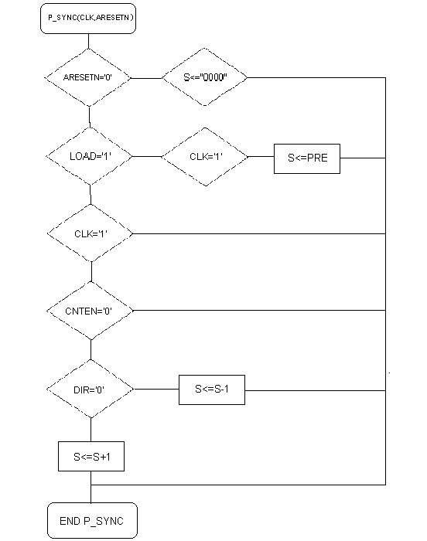

Modified flowchart P_OUT
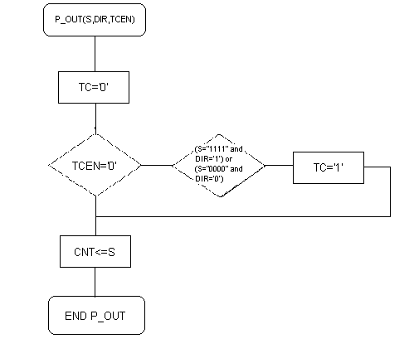

PREP TASK 2.3: Adapt the VHDL code in Error: Reference source not found acc. to the modified flowcharts in PREP TASK 2.2 and simulate it with relevant test cases. Make sure that the Mealy behaviour of the output TC is visible in your waveforms.

Modified VHDL code
library ieee;
use ieee.std_logic_1164.all;
use ieee.numeric_std.all;

entity MOD16_UD_CNT is
port ( ARESETN, CLK, DIR, CNTEN, LOAD, TCEN : in bit;
PRE : in unsigned (3 downto 0);
CNT : out bit_vector (3 downto 0);
TC : out bit);
end entity MOD16_UD_CNT;

architecture BEHAVIORAL of MOD16_UD_CNT is
signal S : unsigned(3 downto 0);

begin

P_SYNC : process (ARESETN, CLK)
begin
if ARESETN = '0' then S <= "0000" after 5 ns;
elsif LOAD = '1' then
if CLK'event and CLK='1' then S <= PRE after 5 ns;
end if;
else
if CLK'event and CLK='1' then
if CNTEN='0' then
if DIR = '0' then
S <= S - 1 after 5 ns;
else
S <= S + 1 after 5 ns;
end if;
end if;
end if;
end if;
end process P_SYNC;

P_OUT : process (S,DIR,TCEN)
begin
TC <= '0' after 5 ns;
if TCEN = '0' then
if (DIR = '0' and S = 0) or (DIR = '1' and S = 15) then
TC <= '1' after 5 ns;
end if;
end if;
CNT <= to_bitvector(std_logic_vector(S));

end process P_OUT;

end architecture BEHAVIORAL;

Simulation results (waveforms) incl. test scenarios that prove the Mealy behaviour
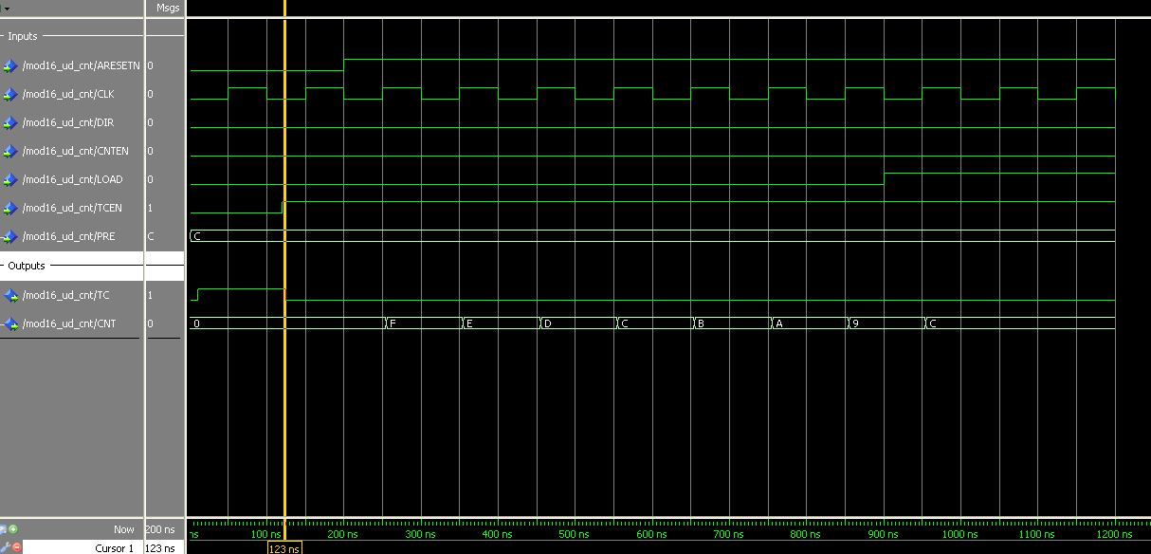
Fig3: The Mealy output TC depends only on the eneble TCEN and not on the clock, hence it is asynchronous.

