LAB 4: Prep sheet
- Pls. upload to EMIL before the lab session by every team member and in PDF format only (otherwise no grading),
and in addition
- give a hardcopy to the Prof/Lab Assistant at the beginning of the lab session

Team | if not a joint solution: tick corresponding author
Participant 1 | Name: Nikolay Stoitsov
Participant 2 | Name: Plamen Iliev
Participant 3 | Name: Ali Sahin

PREP TASK 1.1: Draw the block diagram with all port signals of the traffic light controller.

Block Diagram:
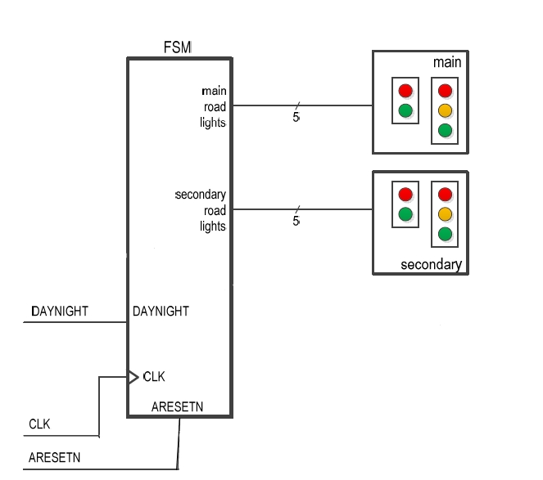

PREP TASK 1.2:
- Draw the complete state diagram (FSM) for the traffic light controller (including day and night operation) with states, transitions and output signals.
- Why is Mealy behaviour not required for this task?

State Diagram:
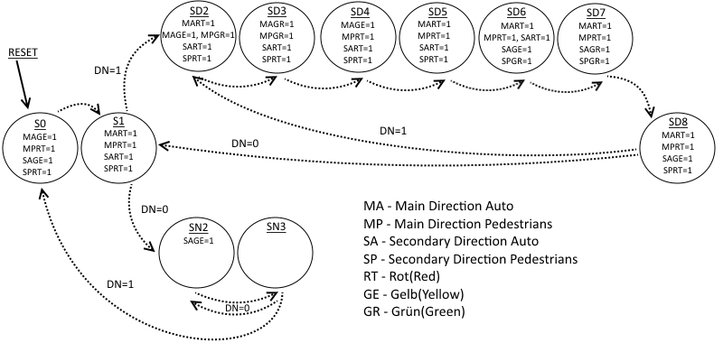

Why is Mealy behaviour not required?

Because the output is dependent on the state not directly on the input. In other words if we change the input, it will still reach the end state before changing the state order and it will not directly affect the output.

PREP TASK 1.3:
- Write a VHDL model with symbolic states and verify it by simulation (give the do file and simulation result).

VHDL code:

entity Traffic_light is
port(RESET, CLK, DN : in bit;
MART, MAGE, MAGR, MPRT, MPGR, SART, SAGE, SAGR, SPRT, SPGR : out bit);
end Traffic_light;

architecture CONTROLLER of Traffic_light is
type STATES is ( S0, S1, SD2, SD3, SD4, SD5, SD6, SD7, SD8, SN2, SN3);
signal Z, ZPLUS : STATES;

begin
P1: process(CLK, RESET)
begin
if RESET = '0' then Z <= S0 after 5 ns;
elsif CLK = '1' and CLK' event then Z <= ZPLUS after 5 ns;
end if;
end process P1;

P2: process(DN, Z)
begin
MART <= '0' after 5 ns; MAGE <= '0' after 5 ns; MAGR <= '0' after 5 ns; MPRT <= '0' after 5 ns; MPGR <= '0' after 5 ns; SART <= '0' after 5 ns;
SAGE <= '0' after 5 ns; SAGR <= '0' after 5 ns; SPRT <= '0' after 5 ns; SPGR <= '0' after 5 ns; ZPLUS <= Z after 5 ns;

case Z is
when S0 => ZPLUS <= S1 after 5 ns; MAGE <= '1' after 5 ns; MPRT <= '1' after 5 ns; SAGE <= '1' after 5 ns; SPRT <= '1' after 5 ns;
when S1 => MART <= '1' after 5 ns; MPRT <= '1' after 5 ns; SART <= '1' after 5 ns; SPRT <= '1' after 5 ns;
if DN = '1' then ZPLUS <= SD2 after 5 ns;
else ZPLUS <= SN2 after 5 ns;
end if;
when SD2 => MART <= '1' after 5 ns; MAGE <= '1' after 5 ns; MPGR <= '1' after 5 ns; SART <= '1' after 5 ns; SPRT <= '1' after 5 ns;
ZPLUS <= SD3 after 5 ns;
when SD3 => MAGR <= '1' after 5 ns; MPGR <= '1' after 5 ns; SART <= '1' after 5 ns; SPRT <= '1' after 5 ns;
ZPLUS <= SD4 after 5 ns;
when SD4 => MAGE <= '1' after 5 ns; MPRT <= '1' after 5 ns; SART <= '1' after 5 ns; SPRT <= '1' after 5 ns;
ZPLUS <= SD5 after 5 ns;
when SD5 => MART <= '1' after 5 ns; MPRT <= '1' after 5 ns; SART <= '1' after 5 ns; SPRT <= '1' after 5 ns;
ZPLUS <= SD6 after 5 ns;
when SD6 => MART <= '1' after 5 ns; MPRT <= '1' after 5 ns; SART <= '1' after 5 ns; SAGE <= '1' after 5 ns; SPGR <= '1' after 5 ns;
ZPLUS <= SD7 after 5 ns;
when SD7 => MART <= '1' after 5 ns; MPRT <= '1' after 5 ns; SAGR <= '1' after 5 ns; SPGR <= '1' after 5 ns;
ZPLUS <= SD8 after 5 ns;
when SD8 => MART <= '1' after 5 ns; MPRT <= '1' after 5 ns; SAGE <= '1' after 5 ns; SPRT <= '1' after 5 ns;
if DN = '1' then ZPLUS <= SD2 after 5 ns;
else ZPLUS <= S1 after 5 ns;
end if;
when SN2 => SAGE <= '1' after 5 ns; ZPLUS <= SN3 after 5 ns;
when SN3 => if DN = '1' then ZPLUS <= S0 after 5 ns;
else ZPLUS <= SN2 after 5 ns;
end if;
end case;
end process P2;
end CONTROLLER;

DO File:

# --- compilation
vlib work
vcom -93 -work work Traffic_light.vhd
vsim Traffic_light
# view signal wave forms
view wave
# number format is hex
radix hex
# show input signals
add wave -divider -height 32 Inputs
add wave -height 30 -radix default RESET
add wave -height 30 -radix default CLK
add wave -height 30 -radix default DN
# show output signals
add wave -divider -height 32 Outputs
add wave -height 30 -radix default MART
add wave -height 30 -radix default MAGE
add wave -height 30 -radix default MAGR
add wave -height 30 -radix default MPRT
add wave -height 30 -radix default MPGR
add wave -height 30 -radix default SART
add wave -height 30 -radix default SAGE
add wave -height 30 -radix default SAGR
add wave -height 30 -radix default SPRT
add wave -height 30 -radix default SPGR
# generate input stimuli
force CLK 0 0ns, 1 25ns -r 50ns
force RESET 0 0ns, 1 20ns, 0 265ns, 1 280ns, 0 980ns, 1 1000ns
force DN 1 0ns, 0 580ns
run 1300ns

Simulation result (waveforms):
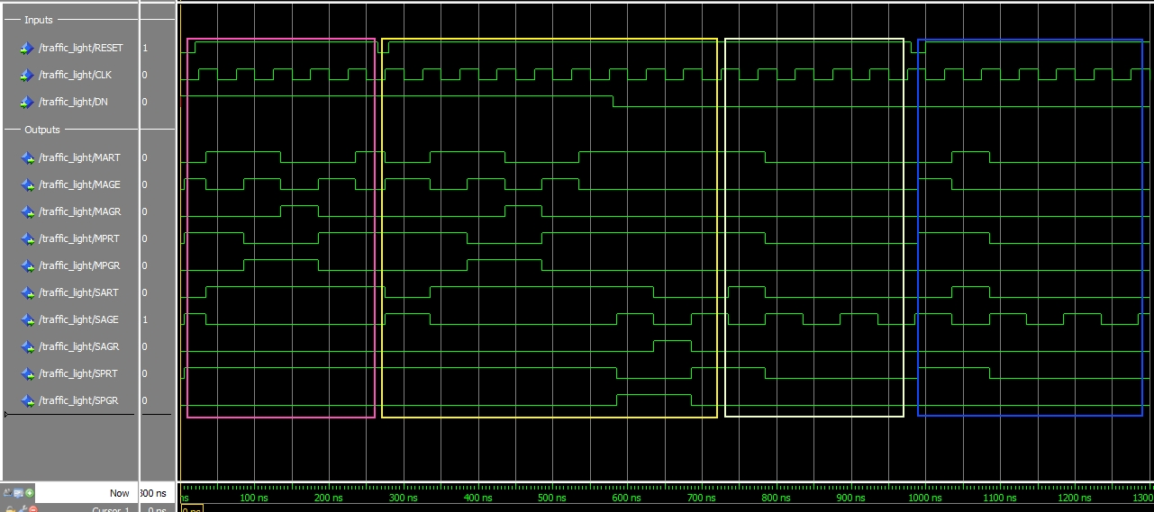

Pink: We run from state 0 until the RESET gets a value of 1 and then it starts over
Yellow: Once it re-starts we change at 580 ns DN (Day-Night) to 0 (Night) and we note that it first finishes to state 8 before going to state 1 and then to SN2 and SN3
White: Showing Night states
Blue: We reset at night state to check if it will continue running only the night states 0,1,2,3.

PREP TASK 2.1:
Let the counter be specified as follows:
- The counter is a modulo-n counter that counts upwards to a maximum value (which has to be determined). The maximum value shall be defined as a generic value in the entity declaration.
- The counter can be synchronously cleared by a CLRN input.
- The counter has an asynchronous active-low reset and a clock input.
- The counter shall be designed as an entity that is later instantiated as a component.
Develop a VHDL model for the counter specified above with clear input.
Hint: use the counter with preload value from Lab Session 3 as a template and modify it to your needs.
It is left to you to decide whether you use the counter for option (1) (FSM clears counter with every state transition) or option (2) (FSM clears counter once per entire traffic light cycle).
- Which value do you chose for n (the maximum number of count values) and why? What is the width of the output signal CNT?
- Draw the state diagram for the FSM with duration modelling.
- Write the VHDL model of the counter and verify it by simulation.

Which value do you chose for n (the maximum number of count values) and why?

What is the width of the output signal CNT?

■
Draw the state diagram for the FSM with duration modelling.

VHDL code of the counter

Simulation results (waveforms)

