Hochschule für Angewandte Wissenschaften Hamburg
Hamburg University of Applied Sciences

Fakultät Technik und Informatik

Studiendepartment Informations- und Elektrotechnik
LAB_1 | Databases
Semester / Group  SS13 / 1 |  |  |  |  | Record editor  Liliia Kolchenko
Date:  02.05.2013 |  |  |  |  | Participant  Yanling Liu
Professor

Prof. S.Utcke

Approvals

Assignment 1: Non – Relational Database

Mongo DB – Non Relational Database:
Mongo-DB is an open source, high performance, schema-free, document oriented database which is written in C++. The document oriented characteristic gives a possibility to manage collection of JSON (Java Script Object Notation). Thus, many applications can model data in a more natural way, as data can be nested in complex hierarchies and still be query able and index able.
Features:

- Consistent UTF-8 encoding. Non UTF-8 data can be saved, queried and retrieved with a special binary data type
- Binaries available for Windows, Linux, Solaris
- Supports range queries, regular expression searches and other special type of queries

Data in MongoDB has a flexible schema. Collections do not enforce document structure. This means that:
- documents in the same collection do not need to have the same set of fields or structure, and
- common fields in a collection’s documents may hold different types of data.
Each document only needs to contain relevant fields to the entity or object that the document represents. In practice, most documents in a collection share a similar structure. Schema flexibility means that you can model your documents in MongoDB so that they can closely resemble and reflect application-level objects.
As in all data modeling, when developing data models (i.e. schema designs) for MongoDB, you must consider the inherent properties and requirements of the application objects and the relationships between application objects. MongoDB data models must also reflect:
- how data will grow and change over time, and
- the kinds of queries your application will perform.
These considerations and requirements force developers to make a number of multi-factored decisions when modeling data, including normalization and de-normalization (these decisions reflect the degree to which the data model should store related pieces of data in a single document. Fully normalized data models describe relationships using references between documents, while de-normalized models may store redundant information across related models). Although a number of data models may be functionally equivalent for a given application, different data models may have significant impacts on MongoDB and applications performance.

Operational Considerations
In addition to normalization and normalization concerns, a number of other operational factors help shape data modeling decisions in MongoDB. These factors include:
- data lifecycle management,
- number of collections and
- indexing requirements,
- managing document growth.
These factors implications for database and application performance as well as future maintenance and development costs.

Large Number of Collections
In certain situations, you might choose to store information in several collections rather than in a single collection.
Consider a sample collection „logs“ that stores log documents for various environment and applications. The „logs“ collection contains documents of the following form:

{ log: "dev", ts: ..., info: ... }
{ log: "debug", ts: ..., info: ...}

If the total number of documents is low you may group documents into collection by type. For logs, consider maintaining distinct log collections, such as „logs.dev“ and „logs.debug“. The „logs.dev“ collection would contain only the documents related to the dev environment.
Generally, having large number of collections has no significant performance penalty and results in very good performance. Distinct collections are very important for high-throughput batch processing.

Indexes
Create indexes to support common queries. Generally, indexes and index use in MongoDB correspond to indexes and index use in relational database: build indexes on fields that appear often in queries and for all operations that return sorted results. MongoDB automatically creates a unique index on the _id_field.

Document Growth
Certain updates to documents can increase the document size, such as pushing elements to an array and adding new fields. If the document size exceeds the allocated space for that document, MongoDB relocates the document on disk. This internal relocation can be both time and resource consuming.

Assignment 2: Bank Database

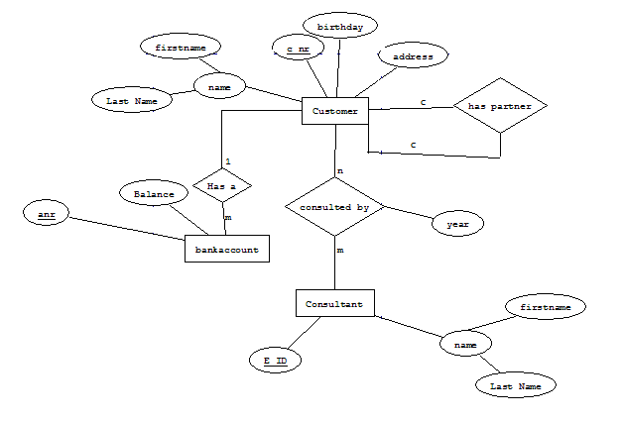

Assignment 3: Movies Database
A MOVIES database confirms to the constraints shown in the following ERM diagram (Actor is used as a generic term and includes actress).

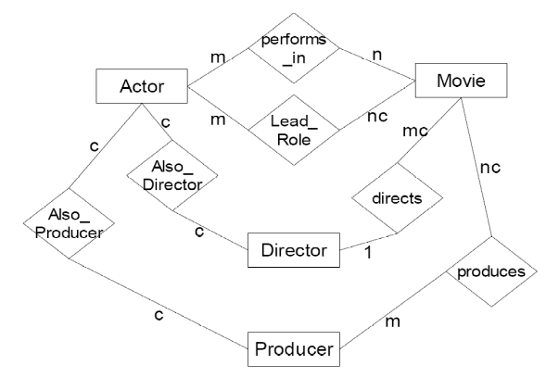

Assignment 3.1:
The task was to assume that the MOVIES database is populated with data confirming to the constraints. Given this ERM with constraints in MC notation, respond to the following statements with TRUE, FALSE or MAYBE (MAYBE is used for statements which cannot be shown as TRUE or FALSE from the constraints given in the ERM. The actual data is not known).

- FALSE, m to n relationship
- MAYBE, it might be correct (not precise)
- TRUE, m to n
- FALSE , nc to m
- MAYBE, it might be correct (not precise)
- MAYBE, it might be correct (some might be, some might be not)
- MAYBE, it might be correct (some might be, some might be not)
- FALSE (Producer can be an actor, and an actor can perform in many movies)
- MAYBE, it might be correct (not precise)
- MAYBE (one or many producers, but only one director)
- TRUE, mc to 1
- TRUE, nc to m
- FALSE, mc to 1
- MAYBE, it might be correct (not precise)
- MAYBE, if they are actors at the same time
- MAYBE, it might be correct (not precise)
- MAYBE, it might be correct (not precise)

Assignment 3.2: Relation Schema

Actor (A_id, name, date_of_birth)
Director (D_id, A_id(FK) unique, name, oscar_won, company)
Producer (P_id, A_id(FK) unique, name, company)
Movie (M_id, D_id(FK), title, year, budget, country_of_production, genre)
---------------------------------------------------------------------------------
Performs_in (M_id(FK), A_id(FK))
Lead_Role (A_id(FK), M_id(FK))
Produces (M_id(FK), P_id(FK))

In the RS we do not have the relationships “Also_Director”, “Also_Producer”, “directs”, because they are already included into “Director” and “Producer”:

Director (D_id, A_id(FK) unique …);
Producer (P_id, A_id(FK) unique …);
Movie (M_id, D_id(FK) …) -- according to the mc to 1 relationship every movie has exactly one director.

The following keys could be a candidate key, but for relations “Actor”, “Director” and “Producer” these keys can be duplicated, so the best choice is artificial keys, not the candidate ones:

Name can be a candidate key for Relation: Actor
Name, oscar_won can be a candidate key for Relation: Director
Name, company can be a candidate key for Relation: Producer
Title, year can be a candidate key for Relation: Movie

