Hochschule für Angewandte Wissenschaften Hamburg
Hamburg University of Applied Sciences

Fakultät Technik und Informatik

Studiendepartment Informations- und Elektrotechnik
LAB_2 | Databases
Semester / Group  SS13 / 1 |  |  |  |  | Record editor  Yanling Liu
Date:  16.05.2013 |  |  |  |  | Participant  Liliia Kolchenko
Professor

Prof. S.Utcke

Approvals

Assignment 4:
The SQL script for movie database is as follows:

CREATE TABLE Actor(A_id int CONSTRAINT a_pk PRIMARY KEY,
A_name varchar(20) not null,
DateofBirth char(10) not null);

CREATE TABLE Director (D_id int CONSTRAINT d_pk PRIMARY KEY,
a_id_fk int constraint fk_2_a references Actor not null unique,
D_name varchar (20) not null,
Oscar_won int,
Company varchar (50));

CREATE TABLE Producer (P_id int CONSTRAINT prod_pk PRIMARY KEY,
prod_name varchar (20) not null,
Company varchar (50),
a_id_fk int constraint fk_p_2_a references Actor not null unique);

CREATE TABLE Movie(M_id int CONSTRAINT m_pk PRIMARY KEY,
D_id_fk int constraint fk_2_d references Director not null unique,
title varchar(20) not null unique,
movie_year char(4) not null,
budget numeric(20,2),
country_of_production varchar(20) not null,
movie_genre varchar(20) not null);

CREATE TABLE performs_in(a_id_fk int constraint fk_perf_2_a references Actor not null,
M_id_fk int constraint fk_perf_2_m references movie not null);

CREATE TABLE lead_Role(a_id_fk int constraint fk_ld_2_a references Actor not null,
M_id_fk int constraint fk_ld_2_m references movie not null);

CREATE TABLE Produces(p_id_fk int constraint fk_produces_2_producer references producer not null,
M_id_fk int constraint fk_produces_2_m references movie not null);

The output after creating the table:

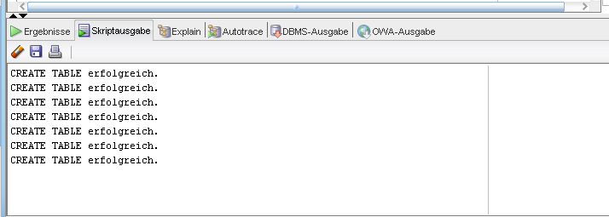

SQL script for deleting the tables:

drop table Produces;
drop table lead_Role;
drop table performs_in;
drop table Movie;
drop table Director;
drop table Producer;
drop table Actor;

The output after deleting the table:

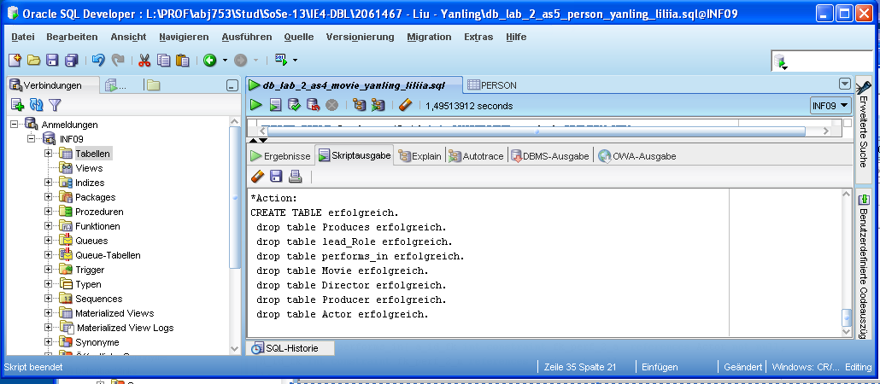

Assignment 5:

- Relational Schema for task 5:

Person (name, birthday, dayOfDeath, Father(FK), Mother(FK)).

In this relational schema there is one primary key (PK), namely name. And we have two foreign keys (FK), for father and mother respectively as they belong to the same Person entity.

- Oracle Script and output for assignment 5:

drop table person;

create table Person(P_name varchar(20) primary key,
birthday date not null,
dayOfDeath date,
Father varchar(20) constraint father_2_person references Person,
Mother varchar(20) constraint mother_2_person references Person); --creates table person

insert into Person values('Walt', TO_DATE('10-apr-1930', 'DD-MON-YYYY'),
TO_DATE('20-dez-2007', 'DD-MON-YYYY'),
null,null); --insert values in table person

insert into Person values('Ellen', TO_DATE('9-sep-1930', 'DD-MON-YYYY'),
null,null,null); --insert values in table person

insert into Person values('Rich', TO_DATE('19-apr-1935', 'DD-MON-YYYY'),
null,null,null); --insert values in table person

insert into Person values('Sue', TO_DATE('13-mai-1940', 'DD-MON-YYYY'),
TO_DATE('28-mai-2002', 'DD-MON-YYYY'),
null,null); --insert values in table person

insert into Person values('Bob', TO_DATE('11-nov-1965', 'DD-MON-YYYY'),
null,'Walt','Ellen'); --insert values in table person

insert into Person values('Susan', TO_DATE('8-aug-1966', 'DD-MON-YYYY'),
null,'Rich','Sue'); --insert values in table person

insert into Person values('Jane', TO_DATE('1-jan-2006', 'DD-MON-YYYY'),
null,'Bob','Susan'); --insert values in table person

insert into Person values('Joe', TO_DATE('2-feb-2007', 'DD-MON-YYYY'),
null,'Bob','Susan'); --insert values in table person
commit;

The Screen Output after creating the table and inserting the values:

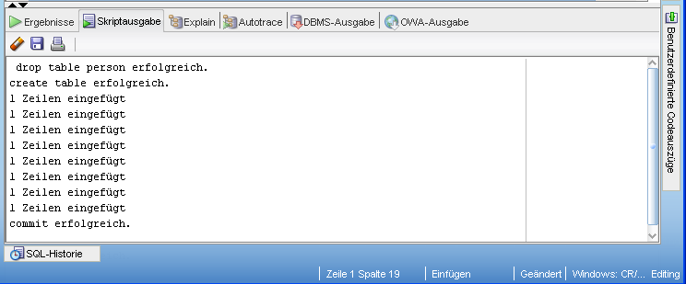

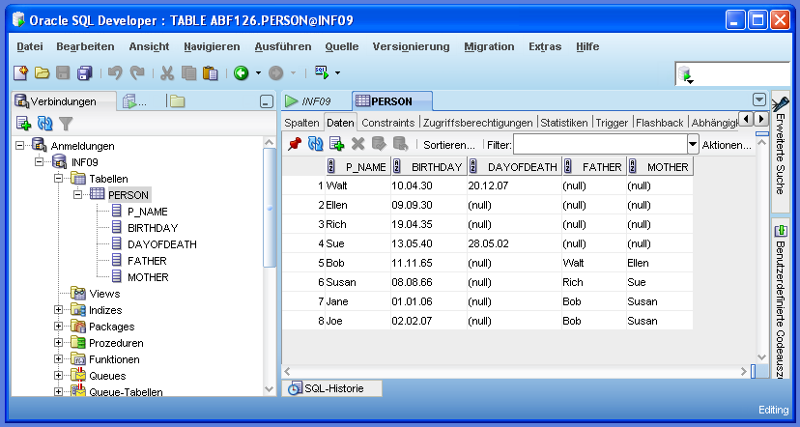

In our code we have changed all names of months to German names, because the Oracle version was in German and it showed errors in the English names of months.

- Name column should be not null, every person has a name;
Birthday column should be not null, every person has a birthday;
DayOfDeath column should be nullable, every person is not dead;
Father(FK) and Mother(FK) columns should be nullable, we don’t have the information for Grandparents’ father and mother.

- First we enter the data for Grandparents, then parents and then children. The reason is the presence of foreign keys father and mother. These foreign keys contain the name of the person already present. So a parent should be present before we enter child’s data.

Assignment 6:

a) Full functional dependencies:

Prof_id -> prof_name
note_id -> price
note_id -> lect_id
lect_id -> lec_name
prof_id, note_id -> quantity

b) Primary keys: prof_id, note_id

Lect_id | Lec_name | Prof_id | Prof_name | Note_id | Price | Quantity
24 | DB | 47 | Miller | 5 | 32 | 12
24 | DB | 272 | Adams | 1 | 35 | 15
24 | DB | 251 | Meyer | 5 | 32 | 12
25 | Java | 47 | Miller | 3 | 22 | 19

c) 2NF:

Profs:
Prof_id | Prof_name
47 | Miller
272 | Adams
251 | Meyer

Course:
Note_id | Lect_id | Lec_name | Price
5 | 24 | DB | 32
1 | 24 | DB | 35
5 | 24 | DB | 32
3 | 25 | Java | 22

Note:
Prof_id (FK) | Note_id (FK) | Quantity
47 | 5 | 12
272 | 1 | 15
251 | 5 | 12
47 | 3 | 19

d) 3NF:

Table course can break as follows:
Note_id | Price | Lec_id (FK)
5 | 32 | 24
1 | 35 | 24
5 | 32 | 24
3 | 22 | 25

Lect_id | Lec_name
24 | DB
25 | Java

e) ER diagram of 3NF:
