Hochschule für Angewandte Wissenschaften Hamburg
Hamburg University of Applied Sciences

Fakultät Technik und Informatik

Studiendepartment Informations- und Elektrotechnik
LAB_3 | Databases
Semester / Group  SS13 / 1 |  |  |  |  | Record editor  Liliia Kolchenko
Date:  30.05.2013 |  |  |  |  | Participant  Yanling Liu
Professor

Prof. S.Utcke

Approvals

Assignment 7:

insert into Person values('Alice', TO_DATE( '2-feb-1955', 'DD-MON-YYYY' ), null, null, null);
insert into Person values('Albert', TO_DATE( '3-mai-1956', 'DD-MON-YYYY' ), null, null, null);
insert into Person values('Trent', TO_DATE('4-jul-1986', 'DD-MON-YYYY' ), null, 'Alice', 'Albert');
update Person set Father = 'Trent' where P_name = 'Jane' or P_name = 'Joe' ;
delete from Person where P_name = 'Walt' or P_name = 'Ellen' or P_name = 'Bob';

Output of the Oracle:

1 Zeilen eingefügt
1 Zeilen eingefügt
1 Zeilen eingefügt
2 Zeilen aktualisiert
3 Zeilen gelöscht

Assignment 8:

8. A:
Entity Relationship diagram

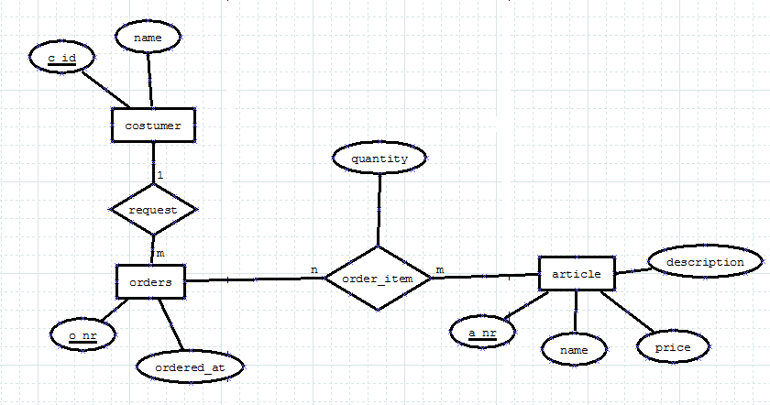

8. B:
--8.1 display all articles
select *from article;

Output of the Oracle:
A_NR NAME PRICE DESCRIPTION
---------------------- ------------------------------ ---------------------- ----------------------------------------
1 Apple 0,99 An apple a day keeps the doctor away
2 Melon 2,99 Water Melon
3 Tomato 0,49
4 Chili 1,49 Very hot
5 Pear 0,99
6 Lemon 1,03 Very healthy
7 Grapefruit 1,99
8 Kiwi 0,79 Also healthy
9 Banana 0,49
10 Cabbage 1,35
10 rows selected

--8.2
select * from article where price = 0.99;

Output of the Oracle:
A_NR NAME PRICE DESCRIPTION
---------------------- ------------------------------ ---------------------- ----------------------------------------
1 Apple 0,99 An apple a day keeps the doctor away
5 Pear 0,99
2 rows selected

--8.3
select price from article where name = 'Apple';
Output of the Oracle:
PRICE
----------------------
0,99
1 rows selected

--8.4
select name, price from article where description is NULL;
Output of the Oracle:
NAME PRICE
------------------------------ ----------------------
Tomato 0,49
Pear 0,99
Grapefruit 1,99
Banana 0,49
Cabbage 1,35
5 rows selected

--8.5
select name, price from article order by name ASC;
Output of the Oracle:
NAME PRICE
------------------------------ ----------------------
Apple 0,99
Banana 0,49
Cabbage 1,35
Chili 1,49
Grapefruit 1,99
Kiwi 0,79
Lemon 1,03
Melon 2,99
Pear 0,99
Tomato 0,49
10 rows selected

--8.6
select name, price from article order by price DESC;
Output of the Oracle:
NAME PRICE
------------------------------ ----------------------
Melon 2,99
Grapefruit 1,99
Chili 1,49
Cabbage 1,35
Lemon 1,03
Apple 0,99
Pear 0,99
Kiwi 0,79
Banana 0,49
Tomato 0,49
10 rows selected

--8.7
select avg(price) from article;
Output of the Oracle:
AVG(PRICE)
----------------------
1,26
1 rows selected

--8.8
select max(price) from article;
Output of the Oracle:
MAX(PRICE)
----------------------
2,99
1 rows selected

--8.9
select min(price) from article;
Output of the Oracle:
MIN(PRICE)
----------------------
0,49
1 rows selected

--8.10
--select o_nr from customer, orders where customer.name = 'Ringo' and customer.c_id = orders.c_id;
select orders.o_nr from customer inner join orders ON customer.name = 'Ringo' and customer.c_id = orders.c_id;
Output of the Oracle:

O_NR
----------------------
3
4
5
3 rows selected

--8.11
select customer.name, orders.o_nr from customer inner join orders ON customer.c_id=orders.c_id;
Output of the Oracle:
NAME O_NR
------------------------------ ----------------------
Paul 1
Paul 2
Ringo 3
Ringo 4
Ringo 5
5 rows selected

--8.12
select customer.name, orders.o_nr from customer full outer join orders ON customer.c_id=orders.c_id;
Output of the Oracle:
NAME O_NR
------------------------------ ----------------------
Paul 1
Paul 2
Ringo 3
Ringo 4
Ringo 5
George
John
7 rows selected

--8.13
select distinct customer.name, article.name from customer, article, order_item, orders where customer.c_id = orders.c_id and orders.o_nr = order_item.o_nr and article.a_nr = order_item.a_nr order by customer.name, article.name asc;
Output of the Oracle:
NAME NAME
------------------------------ ------------------------------
Paul Apple
Paul Chili
Paul Melon
Ringo Apple
Ringo Banana
Ringo Chili
Ringo Kiwi
Ringo Lemon
Ringo Melon
9 rows selected

--8.14
select distinct article.name, article.price, order_item.quantity , order_item.quantity * article.price FROM order_item, article WHERE order_item.o_nr=5 AND order_item.a_nr = article.a_nr ORDER BY article.name ASC;
Output of the Oracle:

NAME PRICE QUANTITY ORDER_ITEM.QUANTITY*ARTICLE.PRICE
------------------------------ ---------------------- ---------------------- ---------------------------------
Apple 0,99 15 14,85
Banana 0,49 4 1,96
Chili 1,49 100 149
Kiwi 0,79 5 3,95
Lemon 1,03 3 3,09
5 rows selected

--8.15
select sum(order_item.quantity*article.price) FROM order_item, article WHERE order_item.o_nr=5 AND order_item.a_nr = article.a_nr;
Output of the Oracle:
SUM(ORDER_ITEM.QUANTITY*ARTICLE.PRICE)
--------------------------------------
172,85
1 rows selected

--8.16
select order_item.o_nr, sum(order_item.quantity*article.price) FROM order_item, article, orders WHERE order_item.o_nr = orders.o_nr and order_item.a_nr = article.a_nr group by order_item.o_nr;
Output of the Oracle:
O_NR SUM(ORDER_ITEM.QUANTITY*ARTICLE.PRICE)
---------------------- --------------------------------------
1 22,84
2 14,9
4 25,78
5 172,85
3 9,9
5 rows selected

--8.17
select order_item.o_nr, customer.name, sum(order_item.quantity*article.price) FROM order_item, article, orders, customer WHERE order_item.o_nr = orders.o_nr and order_item.a_nr = article.a_nr and customer.c_id = orders.c_id group by order_item.o_nr, customer.name;
Output of the Oracle:
O_NR NAME SUM(ORDER_ITEM.QUANTITY*ARTICLE.PRICE)
---------------------- ------------------------------ --------------------------------------
4 Ringo 25,78
3 Ringo 9,9
5 Ringo 172,85
1 Paul 22,84
2 Paul 14,9
5 rows selected

Output of the Oracle:
DROP TABLE order_item erfolgreich.
DROP TABLE article erfolgreich.
DROP TABLE orders erfolgreich.
DROP TABLE customer erfolgreich.
CREATE TABLE erfolgreich.
CREATE TABLE erfolgreich.
CREATE TABLE erfolgreich.
CREATE TABLE erfolgreich.
1 Zeilen eingefügt
1 Zeilen eingefügt
1 Zeilen eingefügt
1 Zeilen eingefügt
1 Zeilen eingefügt
1 Zeilen eingefügt
1 Zeilen eingefügt
1 Zeilen eingefügt
1 Zeilen eingefügt
1 Zeilen eingefügt
1 Zeilen eingefügt
1 Zeilen eingefügt
1 Zeilen eingefügt
1 Zeilen eingefügt
1 Zeilen eingefügt
1 Zeilen eingefügt
1 Zeilen eingefügt
1 Zeilen eingefügt
1 Zeilen eingefügt
1 Zeilen eingefügt
1 Zeilen eingefügt
1 Zeilen eingefügt
1 Zeilen eingefügt
1 Zeilen eingefügt
1 Zeilen eingefügt
1 Zeilen eingefügt
1 Zeilen eingefügt
1 Zeilen eingefügt
1 Zeilen eingefügt
1 Zeilen eingefügt
1 Zeilen eingefügt
COMMIT erfolgreich.

