LAB :1
Group:2

Lab Team:
1)Hasan Hasanli
2)Mohammad Abu Barza

Assignment 1: Webshop

- Number of sections (e.g. electronics, parfume and e.t.c.).
- Who has access to database (who can modify, edit or delete)?
- User view Do users or applications have a specific view data sets?
- Which columns are accessible (posibly all)?
- Does database has control of consistency (correctness checking)?
- Does synchronization is needed?

Assignment 2: Bank Database for customers

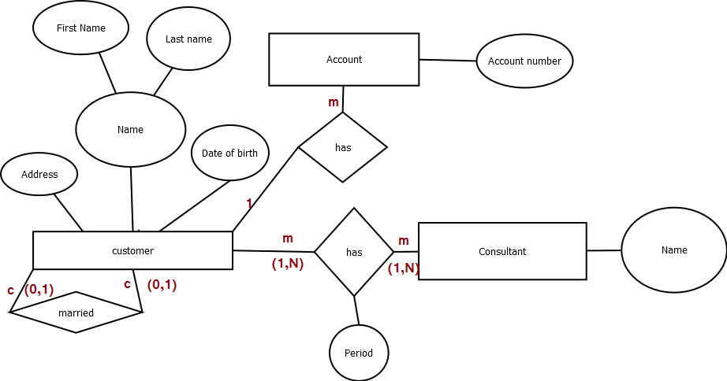

a) A customer which is a primary entity has name (first name , last name) addresses, date of birth
birthdate, partner, etc.
b) In the case of a married couple, both persons get an individual customer record. Therefore, we use recursive to link with customer
c) Every customer has a bank consultant, who is responsible for this customer in a specified
Period in time. For legal reasons, a track of the history “which consultant was responsible for
Which customer at which time” has to be stored. A customer can have different
Consultants at different points in time. Therefore they have M to M relation.
d) A bank account is identified by its account number and bank account itself is an entity.
e) A customer can have several accounts. Every account belongs to exactly one customer.

Assignment 3: Movies Database

 |  | T | F | M
1 | There are actors in this database that have been performing in no movies. |  | x
2 | There are some actors who have acted in more than ten movies. |  |  | x
3 | Every actor performs in at least one movie. | x
4 | A movie can have only a maximum of two lead actors. |  | x
5 | Some actors have done a lead role in multiple movies. |  |  | x
6 | Every director has been an actor in some movie. |  |  | x
7 | No producer has ever been an actor. |  |  | x
8 | A producer cannot be an actor in some other movie. |  | x
9 | There are movies with more than ten actors. |  |  | x
10 | Most movies have one director and one producer. |  |  | x
11 | Every movie has one director. | x
12 | Every movie has at least one producer. | x
13 | Some movies have two directors. |  | x
14 | Some movies have one director but several producers. |  |  | x
15 | Some producers have been a director as well. |  |  | x
16 | There are some actors that have done a lead role, directed a movie and produced some movie. |  |  | x
17 | No movie has a director that also acted in that movie. |  |  | x

1. Each actor has been performing in at least one movie.
2. We don't know exact number of movies in which actor has acted.
3. Every actor performs in at least one movie.
4. We every movie can have at least one lead role actor, and there is no upper boundary of lead roles.
5. There is no limit for number of lead roles.
6. Director can be an actor in max one movie.
7. Producer can be an actor.
8. Because producer can perform in only one movie.
9. We can't tell it for sure, because we don't know precise limit of actors.
10. Movies have exactly one director, but movie may have more than one producer.
11. Every movie has exactly one director.
12. Minimum number of producers of movie is 1.
13. Movie can not have more than 1 director.
14. Movie can have exactly one director and one or several producers.
15. It is not shown in diagram.
16. Actor can be director, producer and perform in movie.
17. Director can be an actor in his movie.

3.2 Transform the ERM to a Relation Schema:

Entity:

Actor | Actor ID (PK) | Director ID (FK) | Producer ID (FK)

Actor ID is primary key because foreign keys Director ID and Producer ID can be null, but primary key cannot be null.

Performs | Actor ID (PK and FK) | Movie (PK and FK)

Each actor can play in 1 or many movies. All actors can play in 1 or many movies. There can be just one actor in movie or many actors. All movies can have just one actor or many actors.

Produces | Movie ID (PK and FK) | Producer ID (PK and FK)

Producer can be producer in many movies or no movie. All producers can produce many movies or no movie. Also all movies can be produced by one producer or many producer. And also there can be no movie produced by producer.

Directs | Movie (PK and FK) | Director ID (FK)

Director directs no movie or many movies. And no movie or many movies are directed by 1 director.

Lead Role | Actor ID (PK and FK) | Movie ID (PK and FK)

Actor can be in lead role in no movie or in many movies. Also all actors can have no movie or many movies. All movies can have lead role played by one actor or many actors. There is no movie where actor can have lead role.

Producer | Producer ID (PK)

Director | Director ID (PK)

Movie | Movie ID (PK) | Name of Movies

