Hochschule für Angewandte Wissenschaften Hamburg
Hamburg University of Applied Sciences

Fakultät Technik und Informatik

Studiendepartment Informations- und Elektrotechnik
4 | Databases
Semester / Group  SS13 / 1 |  |  |  |  | Record editor  Liu Yanling
Date:  20.06.2013 |  |  |  |  | Participant  Liliia Kolchenko
Professor

Dr.Sven Utcke

Approvals

Assignment 9: JDBC
Main.java:
package de.haw.ie4lab4;

import java.io.IOException;
import java.sql.SQLException;

public class Main {

// TODO: provide the correct class name of the driver!
static final String driverName = "oracle.jdbc.driver.OracleDriver";
// TODO: provide the correct JDBC-URL for the HAW database!
static final String url = "jdbc:oracle:thin:@oracle:1521:INF09";

static final String user = MyDBUserPassword.user;
static final String password = MyDBUserPassword.password;

/**
* @param args
* @throws IOException
*/
public static void main(String[] args) throws IOException {
DbHandler db = new DbHandler();

try {
db.connectDB(driverName, url, user, password);

db.printOrderNumbers("Ringo");
db.printOrderNumbers("John");
db.printOrderNumbers("O'Hara");

int orderNumber = 5;
db.printInvoiceForOrder(orderNumber);

db.insertNewCustomer(5, "Whoever");

db.changeArticlePrice("Apple", 1.23);

} catch (SQLException e) {

// TODO: print stack trace!
e.printStackTrace();
// TODO: Print nice error message using System.err.println() and db.getSql()!
System.err.println(db.getSql());
} finally {
// TODO: close connection
db.close();
}
}
}

DbHandler.java:
package de.haw.ie4lab4;

import java.sql.Connection;
import java.sql.DatabaseMetaData;
import java.sql.DriverManager;
import java.sql.PreparedStatement;
import java.sql.ResultSet;
import java.sql.SQLException;
import java.sql.Statement;

public class DbHandler {
/**
* Database connection
*/
private Connection conn;

/**
* The current SQL statement
*/
private String sql;

/**
* Getter for the current SQL statement
* @return the SQL statement
*/
public String getSql() {
return sql;
}

/**
* Connect to the database.
* @param driverName - name of JDBC driver class
* @param url - JDBC URL
* @param user - DB user name
* @param password - DB password
* @throws SQLException
*/

public void connectDB(String driverName, String url, String user, String password) throws SQLException {
System.out.println("Trying to connect to " + url);

// TODO: connect to the DB!
try {
Class.forName(driverName);
} catch (ClassNotFoundException e) {
// TODO Auto-generated catch block
e.printStackTrace();
}
conn = DriverManager.getConnection(url, user, password);

// TODO: disable autoCommit!

//
// Print success message and some meta data:
//
DatabaseMetaData metaData = conn.getMetaData();
System.out.println("Connected to DB " + metaData.getURL() + " as user " + metaData.getUserName());
System.out.println(metaData.getDatabaseProductName() + " " + metaData.getDatabaseMajorVersion() + "." + metaData.getDatabaseMinorVersion());
}

/**
* Close the connection
*/
public void close() {
/* TODO: rollback the transaction
* (in real life, you'd want to commit
* -> but then you cannot call insertNewCustomer() twice.)
*/

// TODO: close the connection (if it has been initialized)
try {
conn.rollback();
conn.close();
} catch (SQLException e) {
// TODO Auto-generated catch block
e.printStackTrace();
}
}

/**
* Print the list of order numbers for the given customer
* @param customer - Name of customer
* @throws SQLException
*/
public void printOrderNumbers(String customer) throws SQLException {
System.out.println(customer + "'s orders:");

// TODO: SQL see assignment 8b-10
Statement st = conn.createStatement();
sql= "SELECT o_nr FROM customer c, orders o WHERE c.name = ? and c.c_id = o.c_id";
PreparedStatement pst =conn.prepareStatement(sql);
pst.setString(1, customer);
ResultSet cursor = pst.executeQuery();
while (cursor.next()) {
int i = cursor.getInt(1);
System.out.print(i+" ");
}
cursor.close();
st.close();
sql = "";
}

/**
* Print an invoice for the given order.
* The invoice shall contain every single order item and the total price.
* @param orderNumber - value for o_nr
* @throws SQLException
*/
public void printInvoiceForOrder(int orderNumber) throws SQLException {
System.out.println("Invoice for order number " + orderNumber);

// Optional: You could print customer information here!

/*
* TODO: For every order item, print the article name, the article's price per unit, the
* quantity, and the price of the order item.
* SQL see assignment 8b-14
*/
Statement st = conn.createStatement();
sql= "select name,price , quantity , price * quantity from orders o, order_item ort inner join article art on ort.a_nr=art.a_nr where o.o_nr=? and ort.o_nr=? order by name ASC";
PreparedStatement pst =conn.prepareStatement(sql);
pst.setInt(1, orderNumber);
pst.setInt(2, orderNumber);
int n = pst.executeUpdate();
ResultSet cursor = pst.executeQuery();
double d3=0;
while (cursor.next()) {
// position in cursor starts at 1!
String s1 = cursor.getString(1);
double d1 = cursor.getDouble(2);
int i1 = cursor.getInt(3);
double d2 = cursor.getDouble(4);

d3+=d2;
//int i2 = cursor.getInt(2);
System.out.println(s1+" "+d1+" "+i1+" "+d2+" ");
//System.out.println(i2);
}
cursor.close();
st.close();
System.out.println("-----------------------");
/*
* TODO: Print the total price of the order.
* You can calculate the sum via SQL (see assignment 8b-15),
* or in Java.
*/
System.out.println("Order's total price: "+d3);
sql = "";

}

/**
* Insert a new customer
* @param id - customer ID
* @param name - customer name
* @throws SQLException
*/
public void insertNewCustomer(int id, String name) throws SQLException {
System.out.println("Trying to insert new customer. id="+id+ ", name="+name);

// TODO: insert a new customer with the given values
Statement st = conn.createStatement();
sql = "INSERT INTO customer VALUES (?, ?)";
PreparedStatement pst =conn.prepareStatement(sql);
pst.setInt(1, id);
pst.setString(2, name);
pst.execute();
st.close();
sql = "";
}

/**
* Change the article's price
* @param articleName - identifies the article
* @param price - the new price
* @throws SQLException
*/
public void changeArticlePrice(String articleName, double price) throws SQLException {
System.out.println("Trying to set the price of " + articleName + " to " + price);
sql = "";
int n = 0;

// TODO: change the article's price
sql = "UPDATE article SET price = ? WHERE name=?";
PreparedStatement pst =
conn.prepareStatement(sql);
pst.setDouble(1, price);
pst.setString(2, articleName);
n = pst.executeUpdate();
sql = "";
System.out.println("Number of rows affected: " + n);
}
}

Screen output:
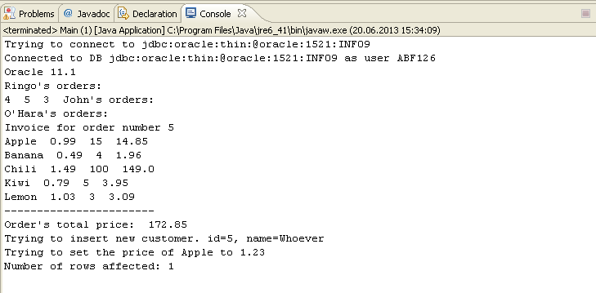

Assignment 10: Sub selects
- select * from article where price in (select Min (price) from article) or price in (select Max (price) from article);
output:
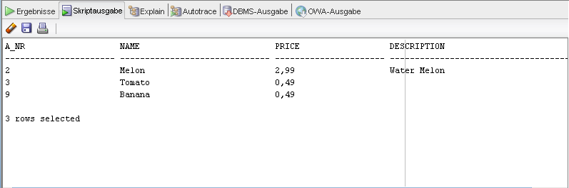

delete from person where p_name = (select father from person where p_name = 'bob') or p_name = 'bob';

Assignment 11: Transactions

CREATE TABLE tab10(id integer CONSTRAINT pk_tab10
PRIMARY KEY, n integer);
- The table is visible in session 2 both before and after committing in session 1.

INSERT INTO TAB10 Values (1,1);
INSERT INTO TAB10 Values (2,2);
INSERT INTO TAB10 Values (3,3);
- Before commit the changes in session 1 no changes in session 2 would be visible.
- After commit the changes would be updated and can be accessible in session 2 as well.
Output of session 2 before commit in session 1:
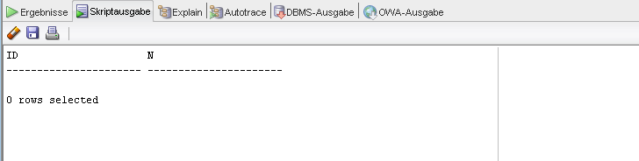
Output of session 2 after commit in session 1:
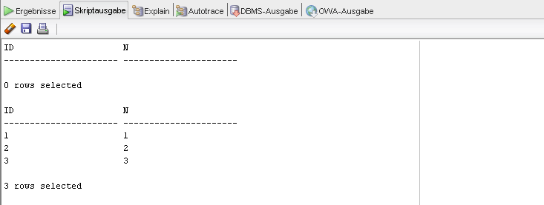
- UPDATE TAB10 SET N=33 WHERE id=3;
- Before rollback in session 1
Output:
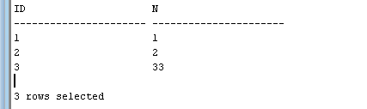
- After rollback in session 1
output:
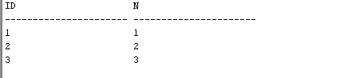
- Before rollback in session 2 (сессия даже не видит 33, так как мы не делали коммит)
- output:
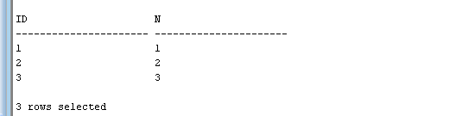
- After rollback in session 2
output:
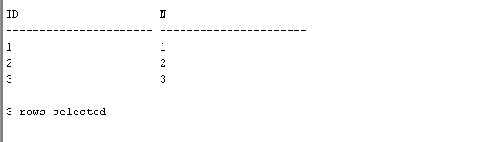
Because in session 1 no commit were happened therefore the value won’t be change by update neither after rollback.

- UPDATE TAB10 SET N=(N*2) WHERE id=1;
- Output in session 1:
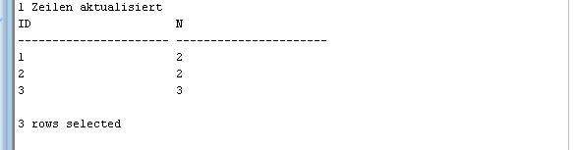
- Output in session 2:
UPDATE TAB10 SET N=(N*3) WHERE id=1;
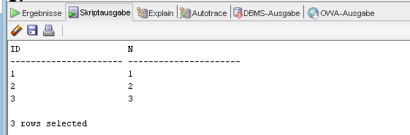

- Because the first session still has locked update the data is not possible and this transaction has to be waiting.
- After committing the transaction in session 1 the lock will be released and update command from session 2 can be executed.
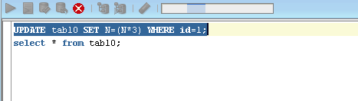

- Output in session 1 after commit in session 1:
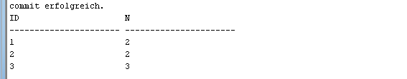

- Output in session 2 after commit in session 1:

- Output in session 1 after commit in session 2:
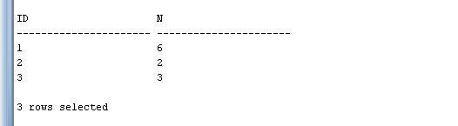
- Output in session 2 after commit in session 2:
- The value of n for the tuple with id =1 in both session is 6!

