IE3-CO Lab Session #3: Preparation sheet
Surname, First Name | Group:
This preparation sheet must be filled and uploaded to EMIL by every student before the lab session. Cooperation within the lab team (of 2-3 students) is possible (same solution). However, no cooperation across lab teams.

Question 1:
Develop the flow chart (NSD) for the main program required for task 2.1.3. Make use of following items (add more if necessary or modify them).
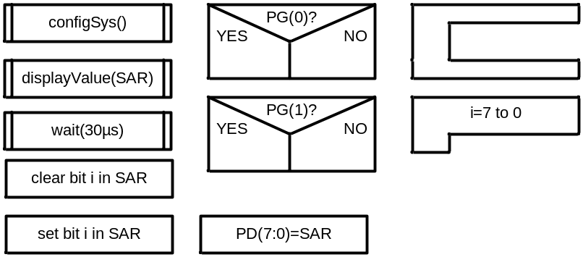

Question 2:
Develop the function configSys() which configures the ports (and timer if you want to realize the time delay by a timer):

Question 3:
Develop the function displayValue() that receives the successive approximations register value and calculates the voltage in mV. (Full range is 5V, the resolution 10 bit, see assignment sheet for details). Use integer (fix point) operations instead of floating point. Afterwards the function outputs the value in mV on the 7-segment display. For this, the voltage value (mV) has to be decomposed into decimal digits. Write the function in C (incl . conversion to mV and output to display).

Question 4:
Write the program for task 2.2.1 which includes the configuration of the ADC and the sampling of channel PE(7).

