IE4-MC Lab Session #1: Preparation sheet
Surname, First Name | Group Team
1.  2.  3. | 1 ◻ A B C D E F  2 ◻  3 ◻
This preparation sheet must be filled and uploaded to EMIL by every student before the lab session. Cooperation within the lab team (of 2-3 students) is possible (same solution). However, no cooperation across lab teams.

Question 1 (3 POINTS)
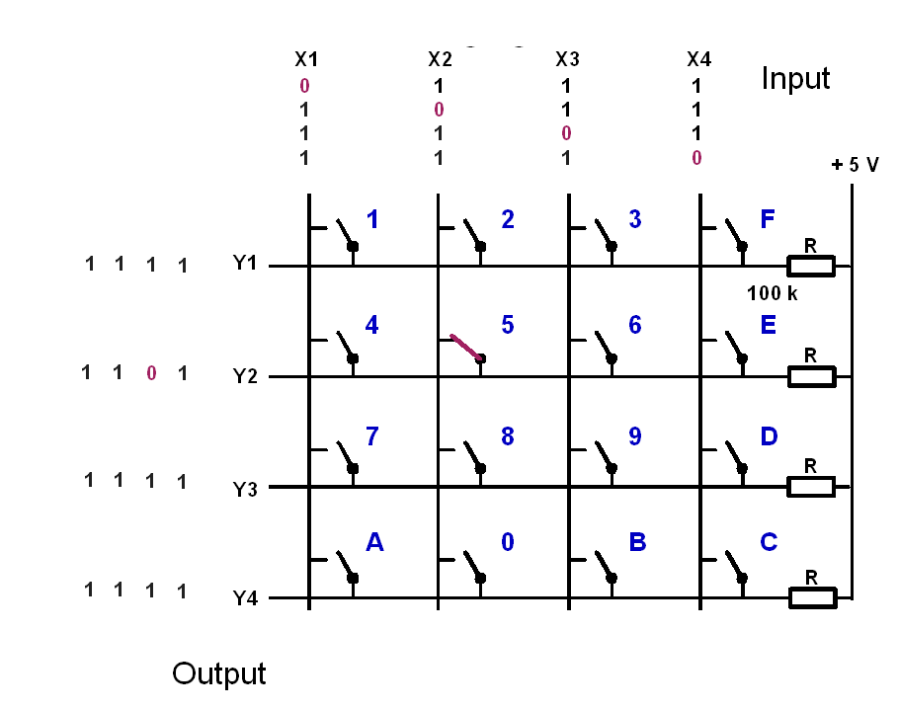
Let the input signals to the keyboard be (X1,X2,X3,X4)=(1,0,1,1). Give the output signals (Y1,Y2,Y3,Y4), if the following keys are pressed:
key | y1 | y2 | y3 | y4
1 pressed | 1 | 1 | 1 | 1
5 pressed | 1 | 0 | 1 | 1
9 pressed | 1 | 1 | 1 | 1
C pressed | 1 | 1 | 1 | 1
0 pressed | 1 | 1 | 1 | 0
0 and 5 pressed | 1 | 0 | 1 | 0

Question 2 (5 POINTS)
The basic operation of the keyboard decoder is as follows:
- Apply a voltage pattern at the inputs of the keyboard (X1,X2,X3,X4) that sets one column 0 (low) and the others 1 (high).
- Wait to compensate for propagation delays.
- Read the output pattern (Y1,Y2,Y3,Y4) and decide based on (Y1,Y2,Y3,Y4) and the knowledge which column has been set 0 (low), which key has been pressed and print the key.
- Cycle the column with the zero and continue with 1.
- The function shall be non-blocking, so it must not wait if no key is pressed but leave the function and reenter it to check again.
- Solutions with more than 50 instructions are not accepted (number of semicolons or pairs of curly braces)
Draw the Nassi-Shneiderman-Diagram of the program (with structurizer tool: http://structorizer.fisch.lu/ ):
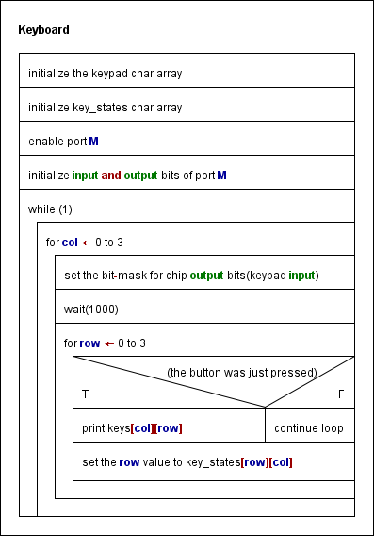

Source code:

#include "tm4c1294ncpdt.h"
#include <stdio.h>
#define AR_SIZE 4

int main()
{
int i = 0;
char keys[AR_SIZE][AR_SIZE] = { {'1' ,'2' ,'3' ,'F'},
{'4' ,'5' ,'6' ,'E'},
{'7' ,'8' ,'9' ,'D'},
{'A' ,'0' ,'B' ,'C'}};

char key_states[AR_SIZE][AR_SIZE]; //make all zeros

SYSCTL_RCGCGRIO_R |= (1<<12); //check if this M port

while(!(SYSCTL_RCGCGRIO_R & 0x0800));
GRIO_PORTM_DEN_R = 0xFF; //M(7 : 0) port enable
GRIO_PORTM_DIR_R = 0x0F; //(7:4) - output from the keyboard, (3:0) - input for keyboard

while(1)
{
for(int col = 0; col < AR_SIZE; col++)
{
GPIO_PORTM_DATA_R = (GPIO_PORTM_DATA_R | 0x0F) ^ (0x01 << col);

while(i++ < 1000); //wait for propagation path delay

for(int row = 0; row < AR_SIZE; row++)
{
char isPressed = !(GPIO_PORTM_DATA_R & (0x10 << row));

if(isPressed && !key_states[row][col])
{
printf("Button %c is pressed! \n", keys[row][col]);
}
key_states[row][col] = isPressed;
}
}
}

}

Question 3 (3 points)
Write the source code in C (shall be syntax error free (tested!), further tests with real-time constraints can be done in the lab session):

