IE3-CO Lab Session #3: Preparation sheet
Surname, First Name | Group:
This preparation sheet must be filled and uploaded to EMIL by every student before the lab session. Cooperation within the lab team (of 2-3 students) is possible (same solution). However, no cooperation across lab teams.

Question 1:
Develop the flow chart (NSD) for the main program required for task 2.1.3. Make use of following items (add more if necessary or modify them).
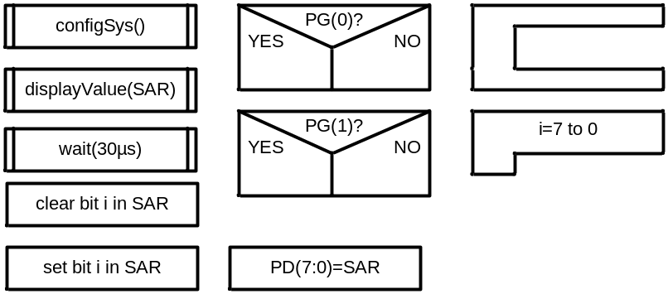

Question 2:
Develop the function configSys() which configures the ports (and timer if you want to realize the time delay by a timer):
void wait(void){
int i =0;
for (i =0;i < 1000; i++)
{

}
}
void timerConfig(){
// configure Timer 0
SYSCTL_RCGC1_R |= (1<<16);
TIMER0_CTL_R &= ~0x0001; // disable Timer 0
TIMER0_CFG_R = 0x04; // 2 x 16-bit mode
TIMER0_TAMR_R = 0x22; // periodic mode + match enable
TIMER0_TAPR_R = 3-1; // prescaler PR= ceil((10ms*fCPU)/2^16)

}
void timerWait(unsigned short Usec){
TIMER0_TAILR_R = ((16*Usec)/3)-1; // ((16Mhz*Usec)/PR)-1 Here Usec should be 30Usec

TIMER0_CTL_R |= 0x0001; //Enable the Timer
while((TIMER0_RIS_R & (1<<0))==0)
{ // wait until the flag set

}
TIMER0_ICR_R |= (1<<0); //clear the interrupt flag
TIMER0_CTL_R &= ~0x0001; //Disable the Timer
}

void ConfigSys(void){
// activate main oscillator at 16 MHz w/ external XTAL
SYSCTL_RCC_R = ((SYSCTL_RCC_R | 0x00000540) & ~0x000002B1);
SYSCTL_RCGC2_R |= (1<<3)| (1<<6)| (1<<8)| (1<<4); // Ports Activation respective PD-PG-PJ-PE
wait();

// Port D as out put
GPIO_PORTD_DEN_R |= 0xFF; // PD(0) enable (7:0)
GPIO_PORTD_DIR_R |= 0xFF; // PD(0) output (7:0)

// Port E as Output
GPIO_PORTE_DEN_R |= 0x07; // PE(0) enable (pin 3:0)
GPIO_PORTE_DIR_R |= 0x07; // PE(0) output (pin 3:0)

// Port G as input
GPIO_PORTG_DEN_R = 0x03; // PG(0) enable (pin 1:0)
GPIO_PORTG_DIR_R = 0x00; // PG(0) Input (pin 1:0) Comparator Input

// Port J as input
GPIO_PORTJ_DEN_R = 0xFF; // PJ(0) enable (7:0)
GPIO_PORTJ_DIR_R = 0xFF; // PJ(0) output (7:0)

timerConfig();
}

Question 3:
Develop the function displayValue() that receives the successive approximations register value and calculates the voltage in mV. (Full range is 5V, the resolution 10 bit, see assignment sheet for details). Use integer (fix point) operations instead of floating point. Afterwards the function outputs the value in mV on the 7-segment display. For this, the voltage value (mV) has to be decomposed into decimal digits. Write the function in C (incl . conversion to mV and output to display).
void Display(){

int i = 8,j=0,temp=0;
float Ulsb = 5/256;
int Uout = 0;
int SuccDigiInput = 0;

GPIO_PORTD_DATA_R = 1<<8;

while((GPIO_PORTG_DATA_R & 0x02)== 0x02 ){}

if((GPIO_PORTG_DATA_R & 0x01)==0){//Uout greater than Ue

}
if((GPIO_PORTG_DATA_R & 0x01)==1){//Ue greater than Uout

}

Uout = (int)(SuccDigiInput * Ulsb);

GPIO_PORTE_DATA_R= 0x01;

temp=Uout % 100;

GPIO_PORTJ_DATA_R= (int)(((temp/10)<<4)|(temp%10));

Uout/= 100;

GPIO_PORTE_DATA_R= 0x02;

GPIO_PORTJ_DATA_R= (int)(((Uout/10)<<4)|(Uout%10));

}

Question 4:
Write the program for task 2.2.1 which includes the configuration of the ADC and the sampling of channel PE(7).
//deactivate digital GPIO for analog use
GPIO_PORTE_DEN_R = 0xFF;//enable PortE bits 0 to 7
GPIO_PORTE_AFSEL_R = 0x80;//configure bit 7 to alternate function
GPIO_PORTE_DEN_R &= ~0xF8;//disables pin 7-3,rest remain enable
//GPIO_PORTD activate analog input fuunction
GPIO_PORTE_AMSEL_R |= 0x80;//activate bit 7 as analog function
GPIO_PORTE_DIR_R = 0x03;//set pin 0 and 1 to output,pin 2 in input
// ADC0_SS0 configuration
ADC0_ACTSS_R &= ~0x0F; // disable all 4 sequencers of ADC0
ADC0_SSMUX0_R |= 0x0000000; // sequencer 0, channel AIN0,in sequence,defines
the sequence,analog channel to be sampled
ADC0_SSCTL0_R |= 0x0000002; // END2 set, sequence length = 1,defines the end of
the sequence
ADC0_ACTSS_R |= 0x01; // enable sequencer 0 ADC0,activates the Sample
Sequencers
while(1) {
ADC0_PSSI_R |= 0x01; // start ADC0_SS0,start ADC conversion
while ((ADC0_SSFSTAT0_R & (1<<8))==1) // wait for FIFO non-empty
;
// read ADC value from FIFO, convert in mV and display
ulData=(unsigned long) ADC0_SSFIFO0_R*5000UL/1023;

}
}

