IE4-MC Lab Session #1: Preparation sheet
Surname, First Name | Group Team
1.  2.  3. | 1 ◻ A B C D E F  2 ◻  3 ◻
This preparation sheet must be filled and uploaded to EMIL by every student before the lab session. Cooperation within the lab team (of 2-3 students) is possible (same solution). However, no cooperation across lab teams.

Question 1 (3 POINTS)
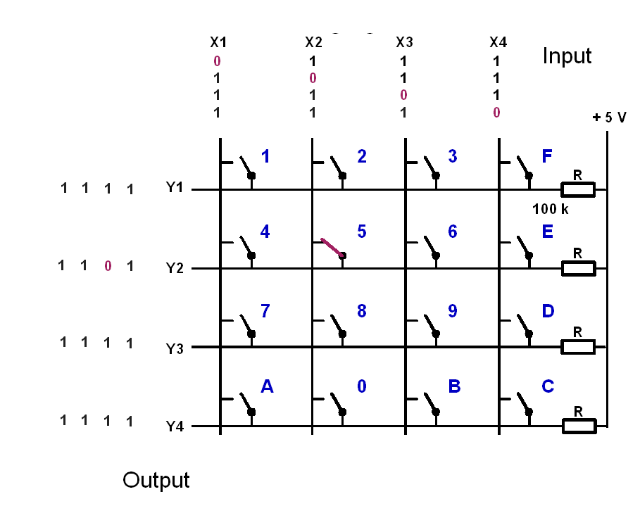
Let the input signals to the keyboard be (X1,X2,X3,X4)=(1,0,1,1). Give the output signals (Y1,Y2,Y3,Y4), if the following keys are pressed:
key | y1 | y2 | y3 | y4
1 pressed | 1 | 1 | 1 | 1
5 pressed | 1 | 0 | 1 | 1
9 pressed | 1 | 1 | 1 | 1
C pressed | 1 | 1 | 1 | 1
0 pressed | 1 | 1 | 1 | 0
0 and 5 pressed | 1 | 0 | 1 | 0

Question 2 (5 POINTS)
The basic operation of the keyboard decoder is as follows:
- Apply a voltage pattern at the inputs of the keyboard (X1,X2,X3,X4) that sets one column 0 (low) and the others 1 (high).
- Wait to compensate for propagation delays.
- Read the output pattern (Y1,Y2,Y3,Y4) and decide based on (Y1,Y2,Y3,Y4) and the knowledge which column has been set 0 (low), which key has been pressed and print the key.
- Cycle the column with the zero and continue with 1.
- The function shall be non-blocking, so it must not wait if no key is pressed but leave the function and reenter it to check again.
- Solutions with more than 50 instructions are not accepted (number of semicolons or pairs of curly braces)
Draw the Nassi-Shneiderman-Diagram of the program (with structurizer tool: http://structorizer.fisch.lu/ ):
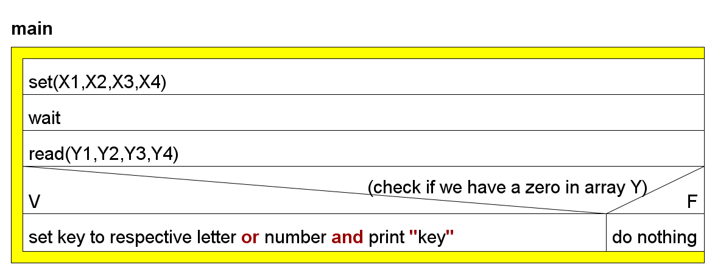

Question 3 (3 points)
Write the source code in C (shall be syntax error free (tested!), further tests with real-time constraints can be done in the lab session):
#include<Windows.h>
#include<stdio.h>
#include<stdlib.h>

// Main function
void main() {
int row, col,Y=7,X;
char value;
char key[4][4] = {
{ '1', '2', '3', 'F' },
{ '4', '5', '6', 'E' },
{ '7', '8', '9', 'D' },
{ 'A', '0', 'B', 'C' } };
printf("Press one of the keys :\n");//we entered it by Y
while (1) {
for (col = 0; col < 4; col++) { // iterating col
X = 0x0F ^ (0x01 << col);// toggle 0's and 1's to find the X array
Sleep(500); // delay
for (row = 0; row < 4; row++) {
if (!(Y & (0x01 << row)))
printf("you pressed: %c\n", key[row][col]);
}
}
}
}

