IE4-MC Lab Session #1: Preparation sheet
Surname, First Name | Group Team
1.  2.  3. | 1 ◻ A B C D E F  2 ◻  3 ◻
This preparation sheet must be filled and uploaded to EMIL by every student before the lab session. Cooperation within the lab team (of 2-3 students) is possible (same solution). However, no cooperation across lab teams.

Question 1 (3 POINTS)
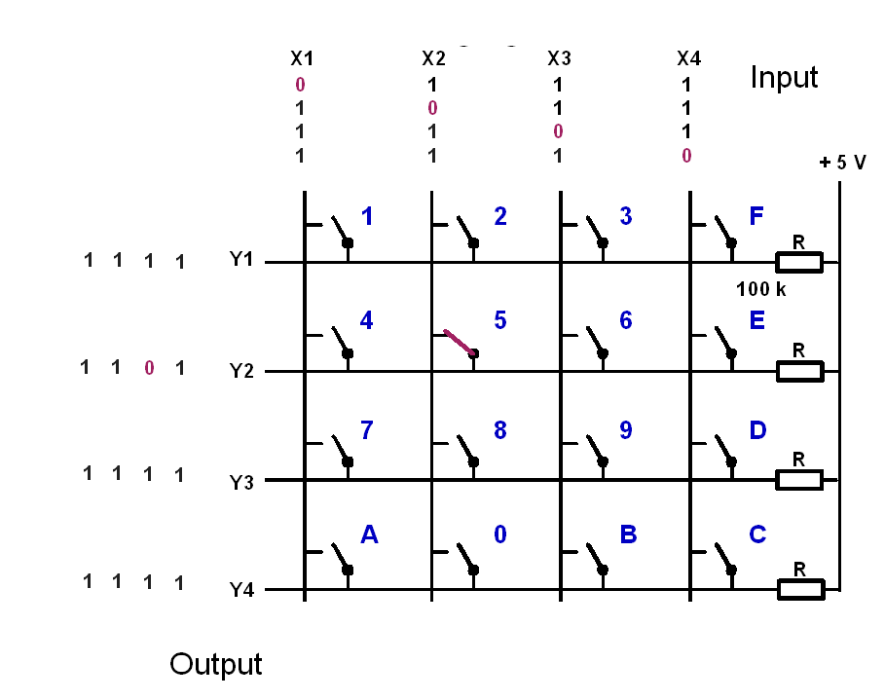
Let the input signals to the keyboard be (X1,X2,X3,X4)=(1,0,1,1). Give the output signals (Y1,Y2,Y3,Y4), if the following keys are pressed:
key | y1 | y2 | y3 | y4
1 pressed
5 pressed
9 pressed
C pressed
0 pressed
0 and 5 pressed

Question 2 (5 POINTS)
The basic operation of the keyboard decoder is as follows:
- Apply a voltage pattern at the inputs of the keyboard (X1,X2,X3,X4) that sets one column 0 (low) and the others 1 (high).
- Wait to compensate for propagation delays.
- Read the output pattern (Y1,Y2,Y3,Y4) and decide based on (Y1,Y2,Y3,Y4) and the knowledge which column has been set 0 (low), which key has been pressed and print the key.
- Cycle the column with the zero and continue with 1.
- The function shall be non-blocking, so it must not wait if no key is pressed but leave the function and reenter it to check again.
- Solutions with more than 50 instructions are not accepted (number of semicolons or pairs of curly braces)
Draw the Nassi-Shneiderman-Diagram of the program (with structurizer tool: http://structorizer.fisch.lu/ ):

Question 3 (3 points)
Write the source code in C (shall be syntax error free (tested!), further tests with real-time constraints can be done in the lab session):

