

Software Engineering (IE4-SEL)
Laboratory Report

Lab number: <{2}>
Lab date: <25.04.2016>
Authors: <Carlos A. Sousa, Sammi Ullah, Ievgenii Nudga >

HAW Hamburg
Faculty of Engineering & Computer Science
Department of Information & Electrical Engineering

Use Case Diagram

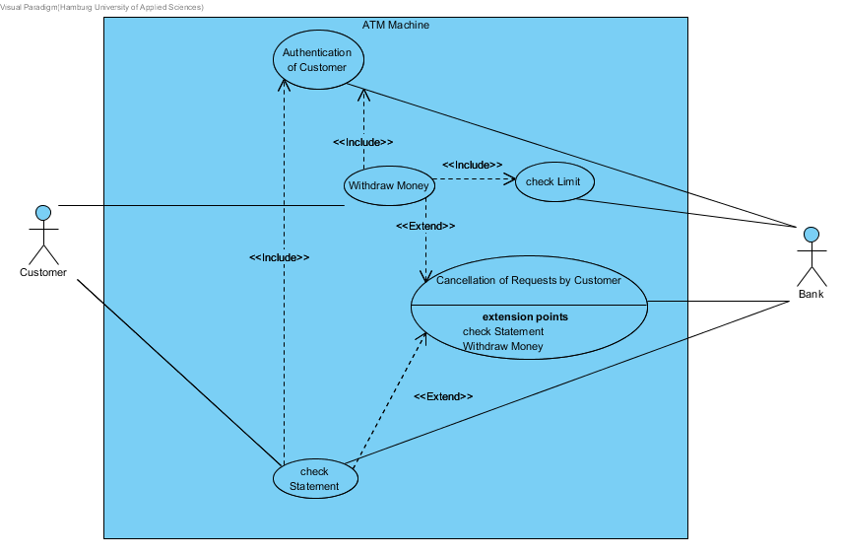

Activity Diagram

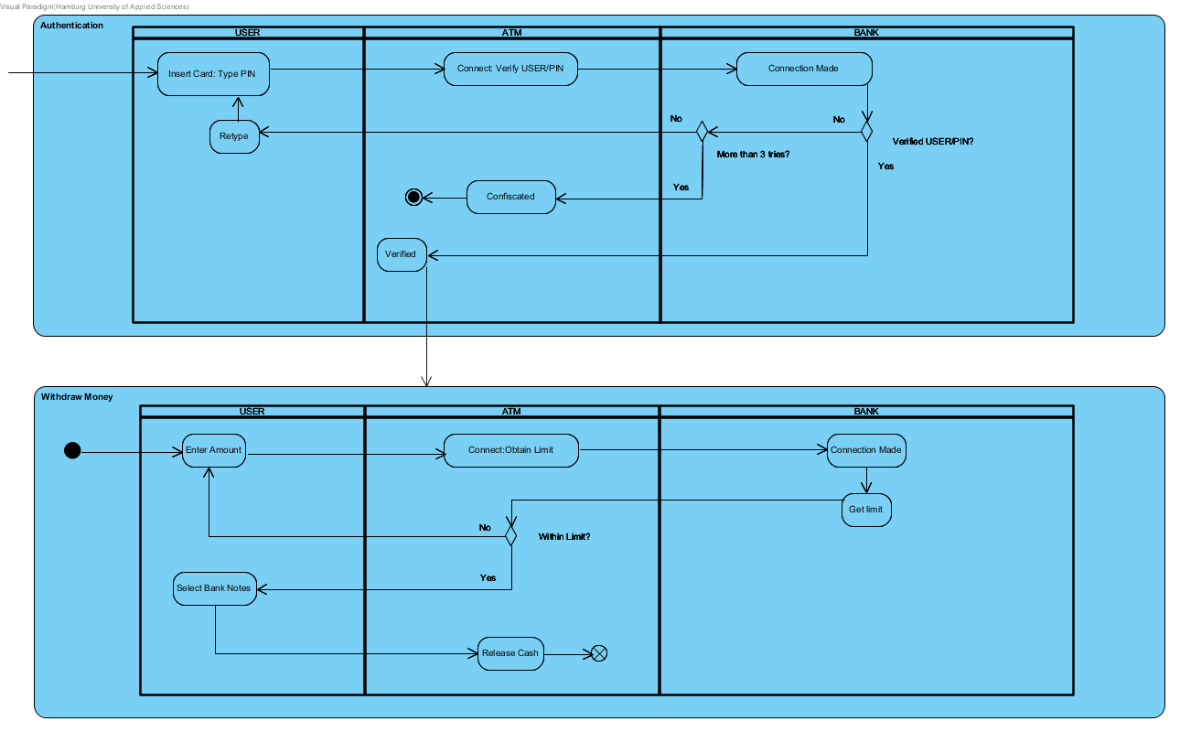
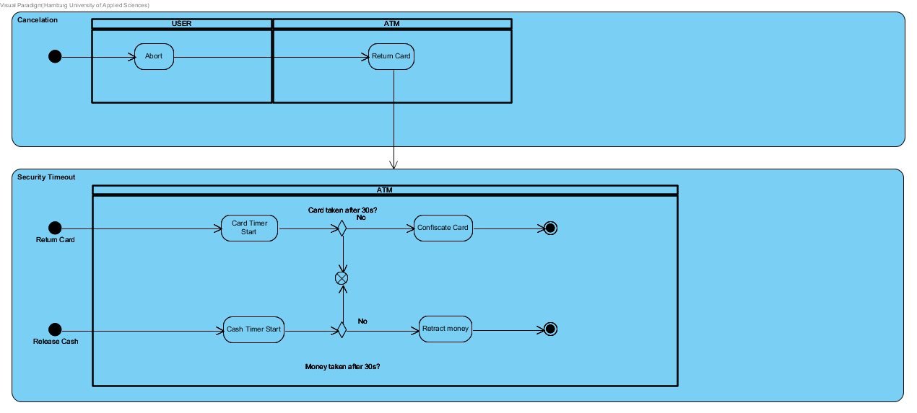

Class Diagram

The approach for the Class Diagram was to make a synthesis of the requirements described on the case study added to what was extracted from the Activity Diagram: The main actions correspond to the methods on each class, one related to the customer action (user) and another related to the atm itself.

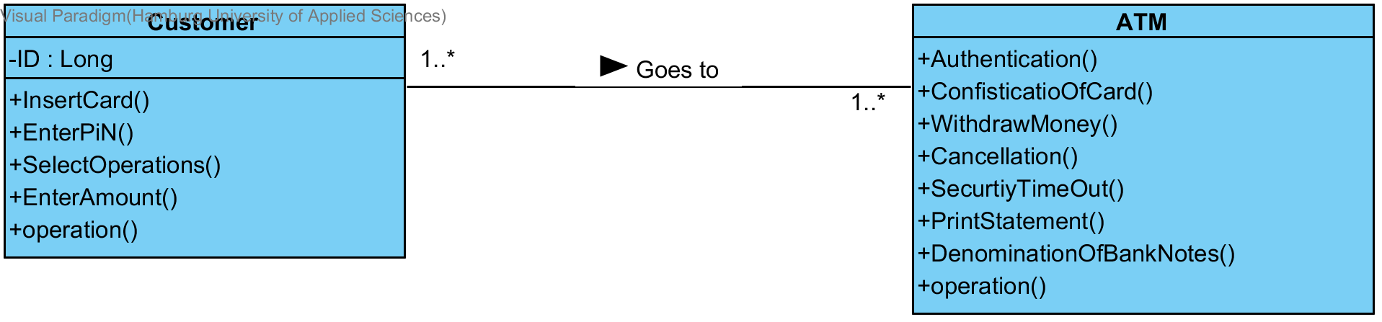

Date | Description of change / rework
<Date> | Initial version

— End of document —

