Problem1:

Command prompt:

For a=1/2 and R=3 case:
>> x=zeros(1,50)
>> x(1)=1
>> y=echo(x,1/2,3)
>> plot(abs(fftshift(fft(y))).^2)
>> plot(angle(fftshift(fft(y))))

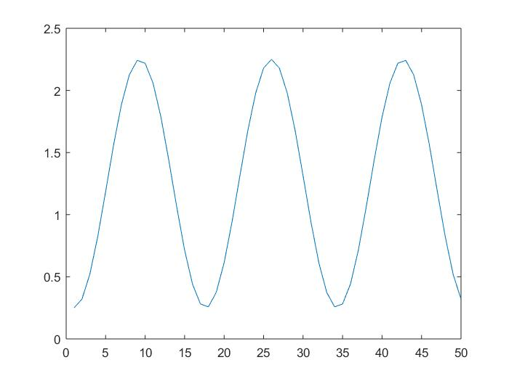
Fig: Magnitude
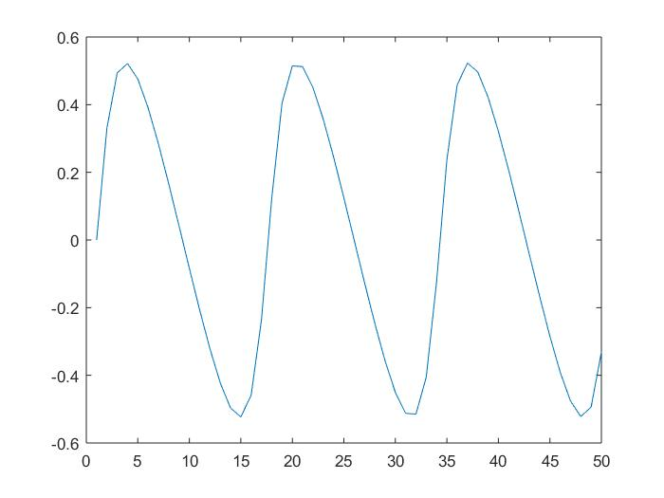
Fig: phase

When a=1
>> x=zeros(1,50)
>> x(1)=1
>> y=echo(x,1,3)
>> plot(abs(fftshift(fft(y))).^2)
>> plot(angle(fftshift(fft(y))))

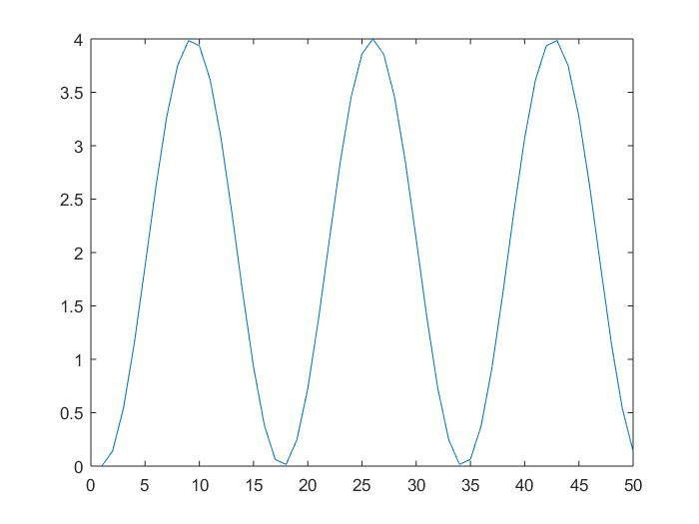
Fig: magnitude
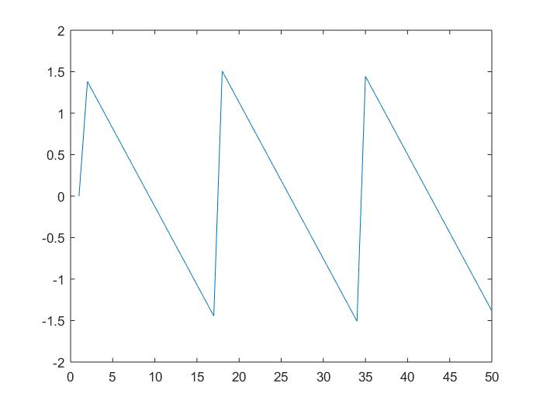
Fig: phase

Problem2:

N=6;
a=1/2;
R=3;
h_num=zeros(1,R*(N+1)+1);
h_num(1)=1;
h_num(length(h_num))=a^(N+1);
h_den=zeros(1,R+1);
h_den=1;
h_den(R+1)=a;
zplane(h_num,h_den);

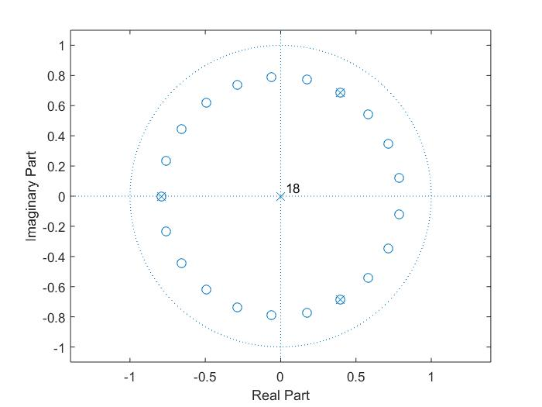
Fig: pole-zero for a=1/2

When a=1.5

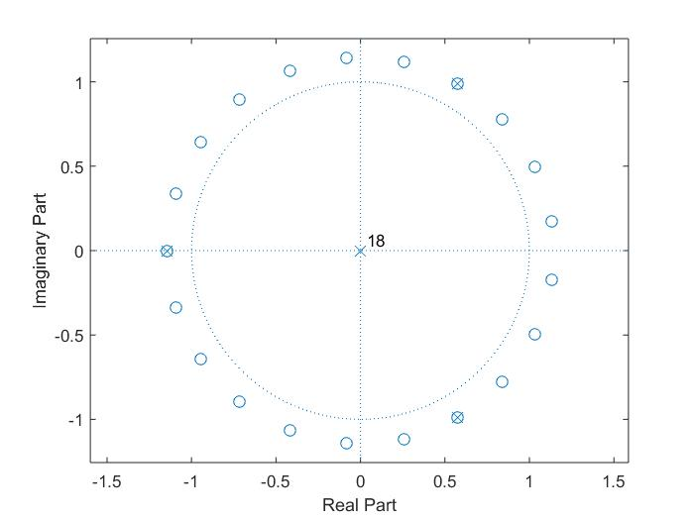
Fig: pole-zero for a=1.5

