4. Return the first name, last name and city of all customers who live in Canada. Order the results first by the last then by the first name.

**Ans.**

**Query:** SELECT first_name,last_name, city, country

FROM customer cust

join address as a on cust.address_id = a.address_id

join city as c on a.city_id = c.city_id

join country as cou on c.country_id = cou.country_id

WHERE cou.country='Canada'

ORDER BY cust.last_name ,cust.first_name;

**Result.**

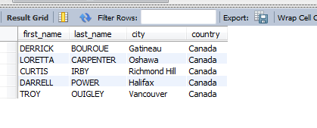

5. How many customers are from Brazil?

**Ans.**

**Query:** select count(first_name)

from customer as cust

join address as a on cust.address_id = a.address_id

join city as c on a.city_id = c.city_id

join country as cou on c.country_id = cou.country_id

where cou.country = 'brazil';

**Result .**



6. Return the "popular countries"? (that is, the ones with more than 20 customer). For each

such country, return its name and its correspond number of customers. Order the result by the

number of customers (descending).

**Ans.**

**Query:** select country AS Popular_countries ,COUNT(*) AS No_of_customers

from customer as cust

join address as a on cust.address_id = a.address_id

join city as c on a.city_id = c.city_id

join country as cou on c.country_id = cou.country_id

GROUP BY cou.country

HAVING COUNT(*)>20

ORDER BY COUNT(*) DESC;

**Result .**

