* ODE45 was used in solving the suspension model problem because it is quite versatile and any problem output could be tested using ODE45. The output turned out to be correct, so there was no need of changing the solver.
* The system for which the output was tested:

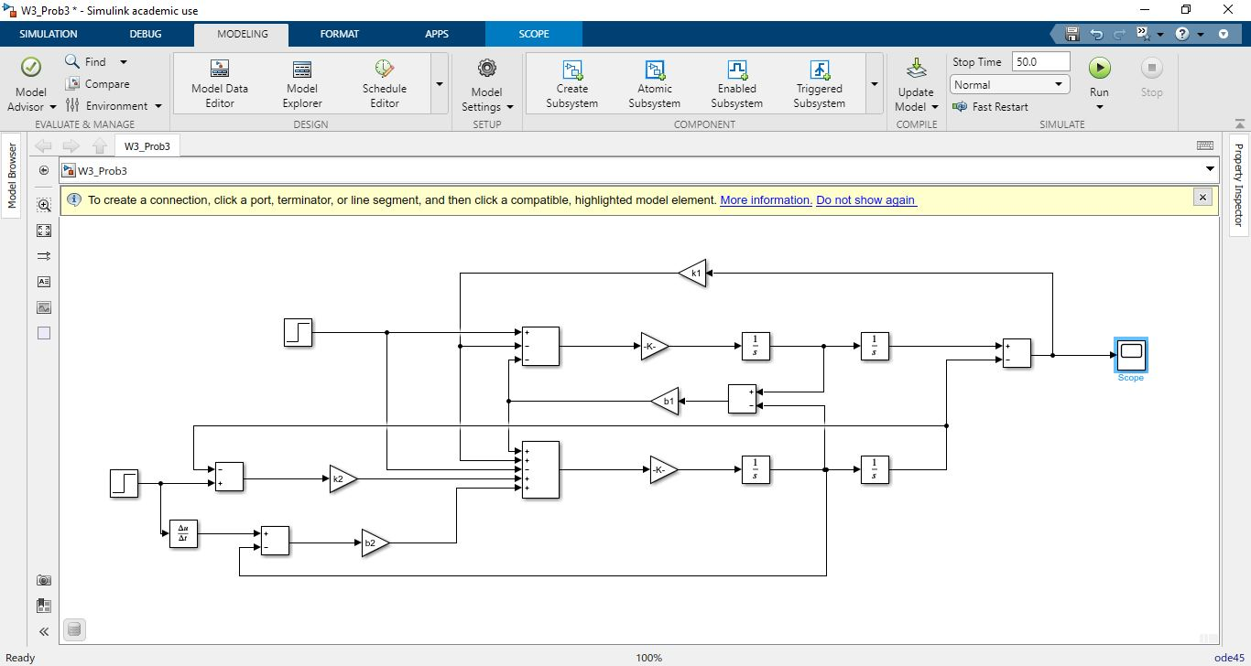

* The output of the system:

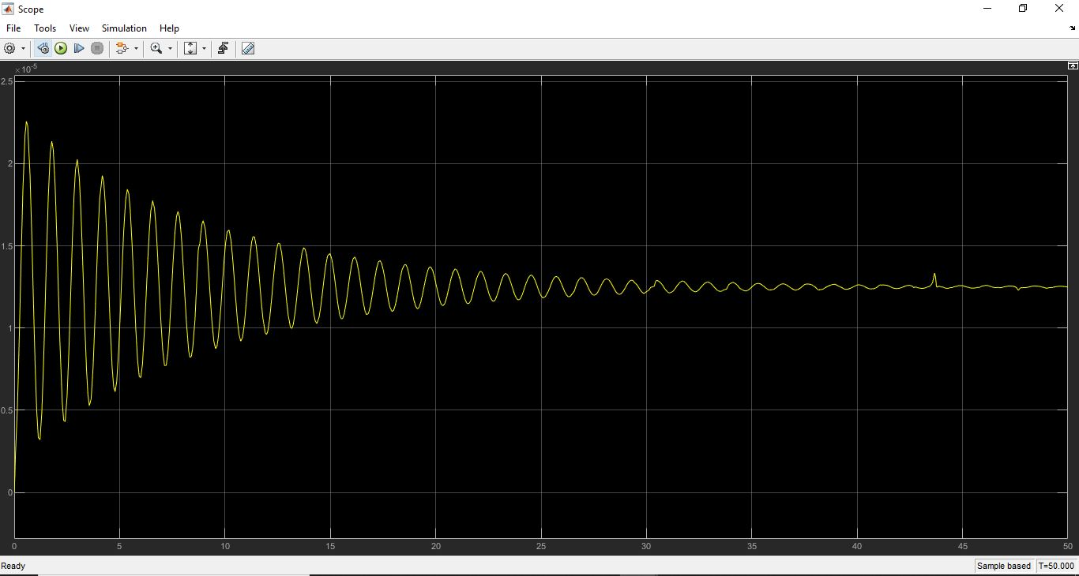

* The two outputs given to the system were

1. For flat road, with the final value of the step input to be ‘0’.
2. For pot-hole filled road, the step input final value was set at ‘-1’, to indicate a hole, whose depth would be around 10 cm.

* Data inspector has two outputs, one for flat road and other for hole filled road.

The oscillations in the hole filled road, were exponentially damped, leading to smooth and comfortable experience for the passenger.