[shounakkhulape007@gmail.com](mailto:shounakkhulape007@gmail.com)

**LetsUpgrade Assignment/Project Day 4**

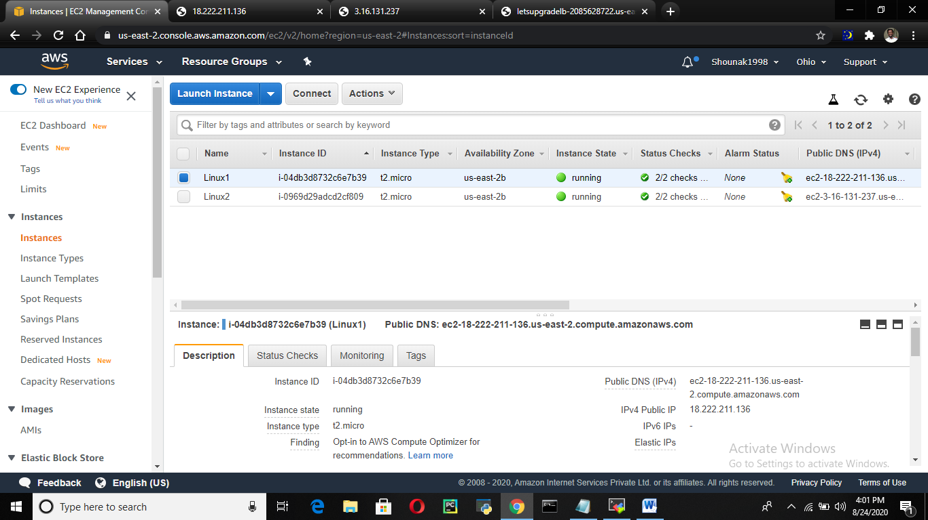

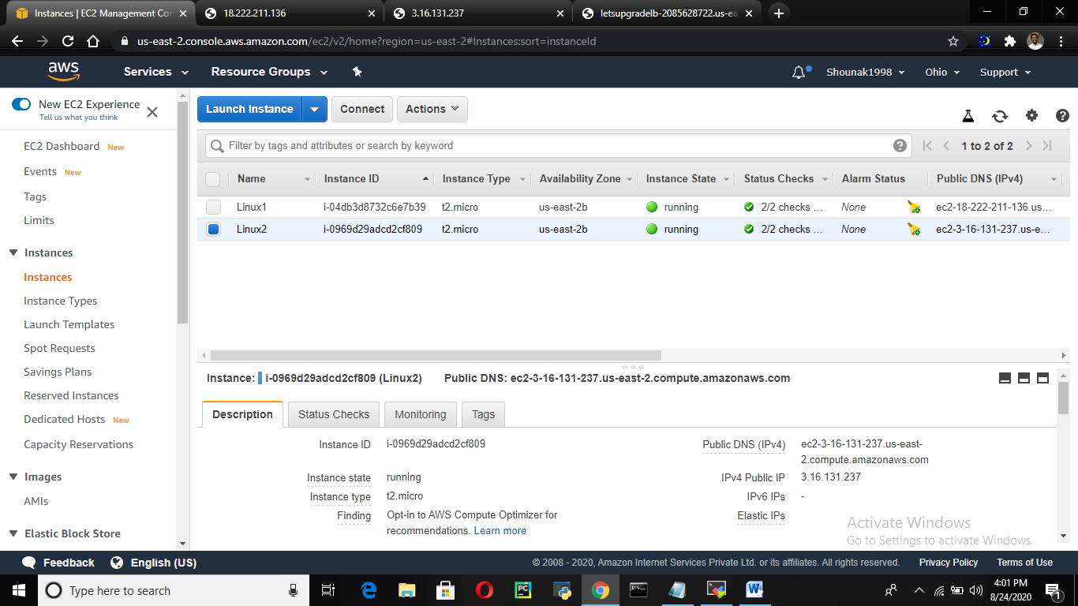

[shounakkhulape007@gmail.com](mailto:shounakkhulape007@gmail.com)

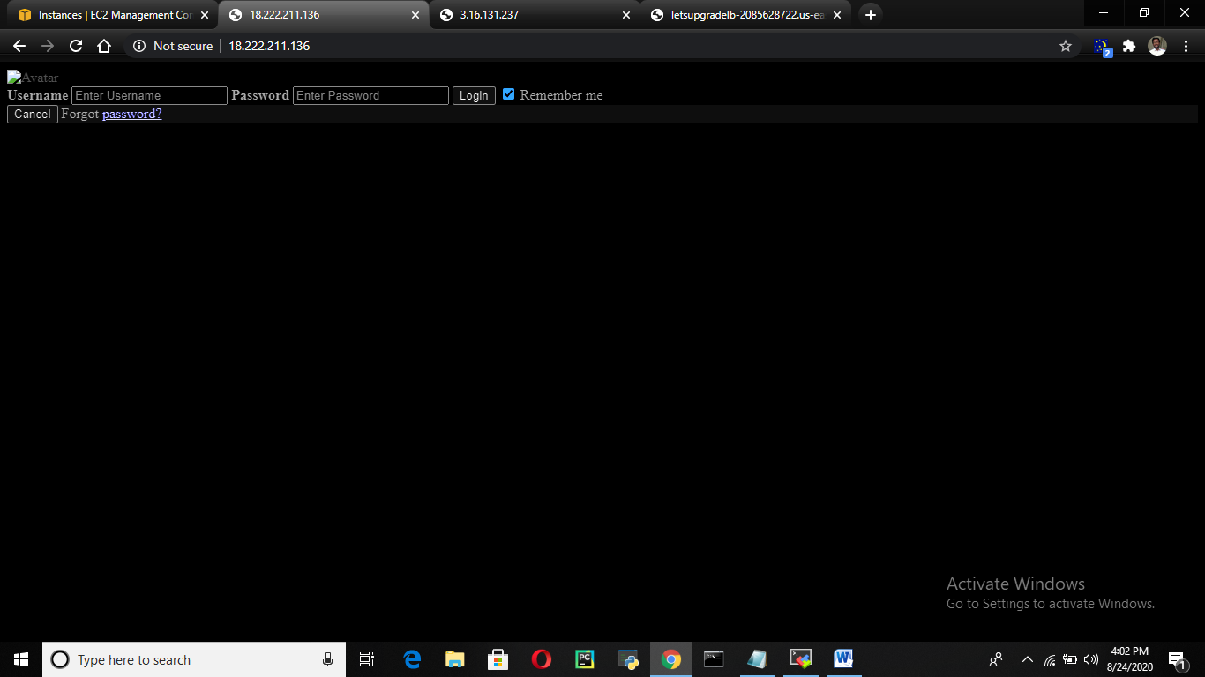

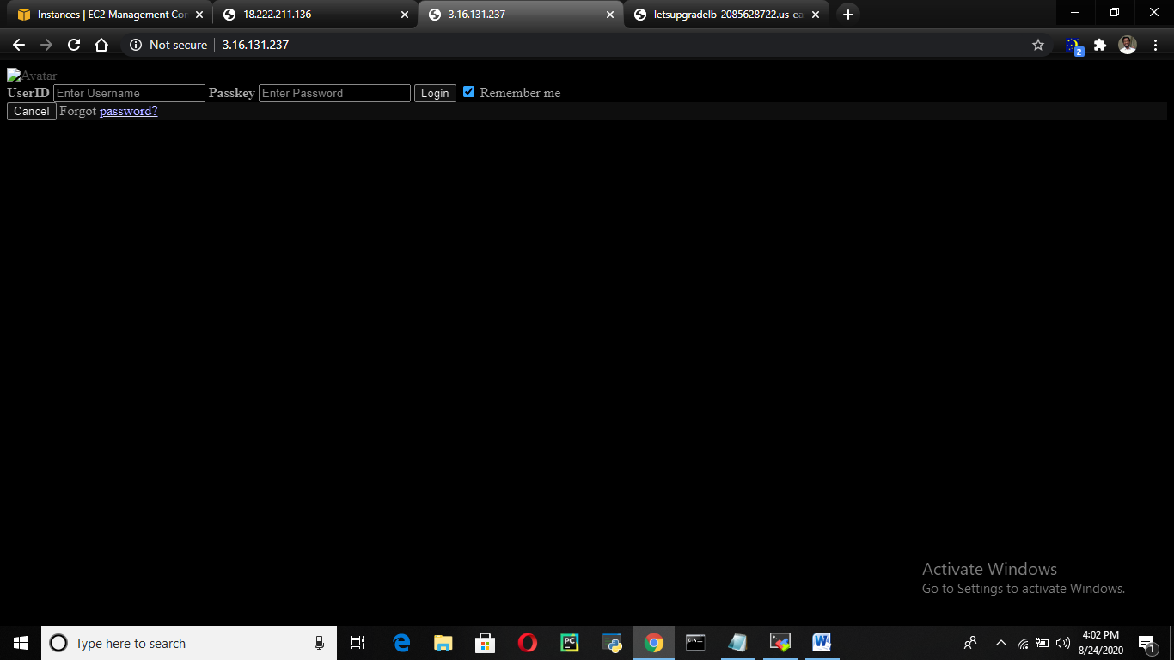

[shounakkhulape007@gmail.com](mailto:shounakkhulape007@gmail.com)

