
DEPARTMENT OF COMPUTER SCIENCE AND ENGINEERING
Course: CSE391
Section: 1
Name: Shourav Saha
ID: 24341151
Email:
Project Title: ReserveUrTime
ReserveUrTime is a multi-restaurant website where users can find restaurants, reserve tables, order food and manage their account.
Project Features:
By the end of this course, I implemented these features:
a) I made separate login systems for Customer, Platform Admin and Restaurant Admin.
b) I added restaurant browsing and search so users can find restaurants easily.
c) I added table reservation with table availability checking and payment support.
d) I added customer favourites, cart, orders, profile and reservation history.
e) I made Restaurant Admin tools for menu, tables, reservations, orders, gallery and profile.
f) I made Platform Admin tools to manage restaurants, Restaurant Admin accounts and homepage content.
g) I added reviews, contact messages and notifications.
h) I added 3D food visuals and animated sections to make the website more interactive.
Screenshots:
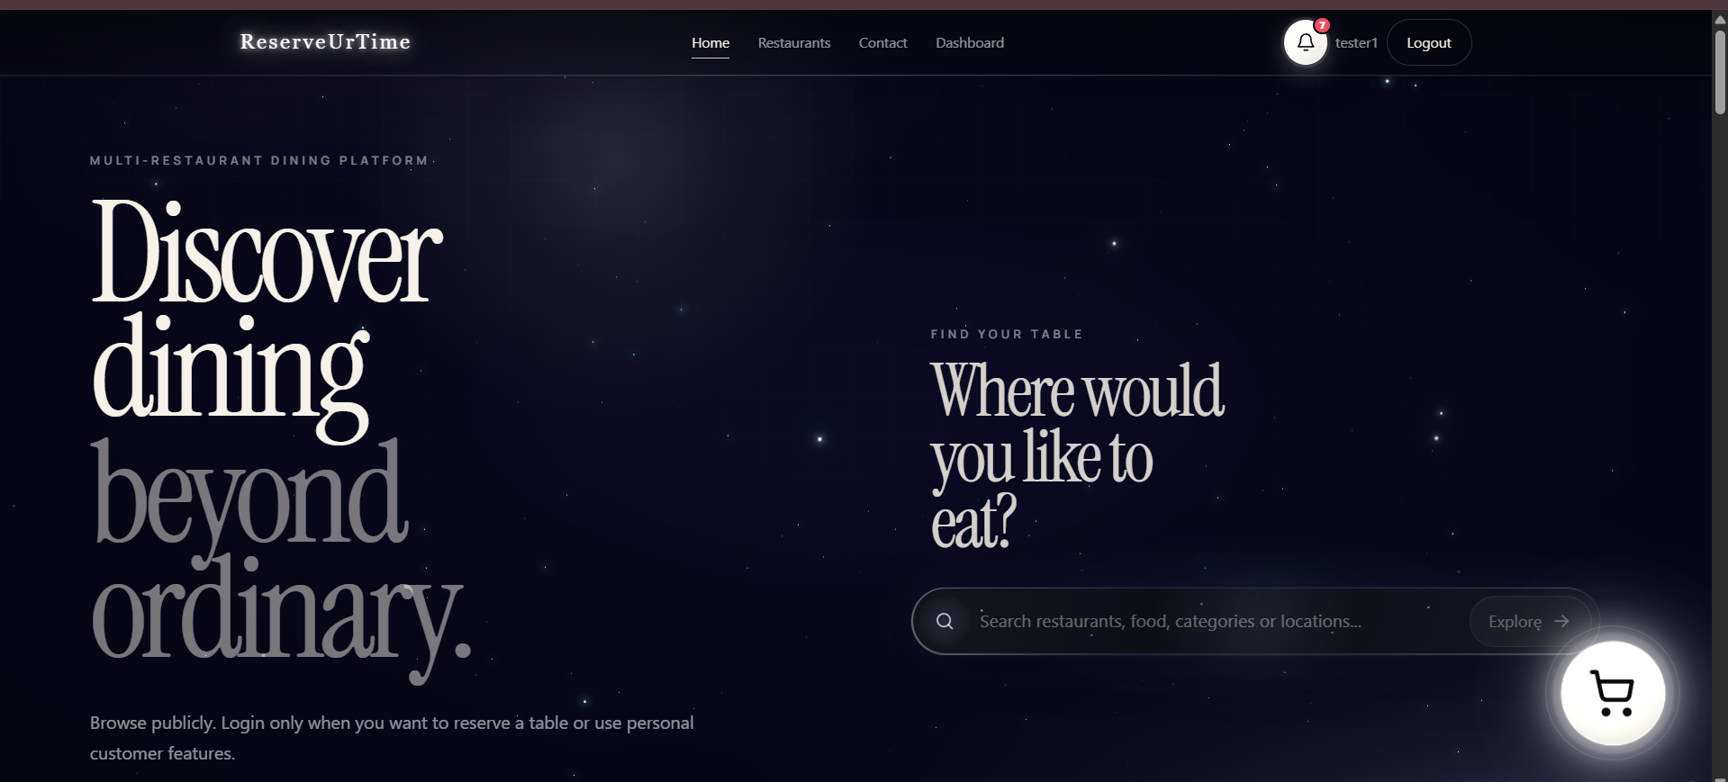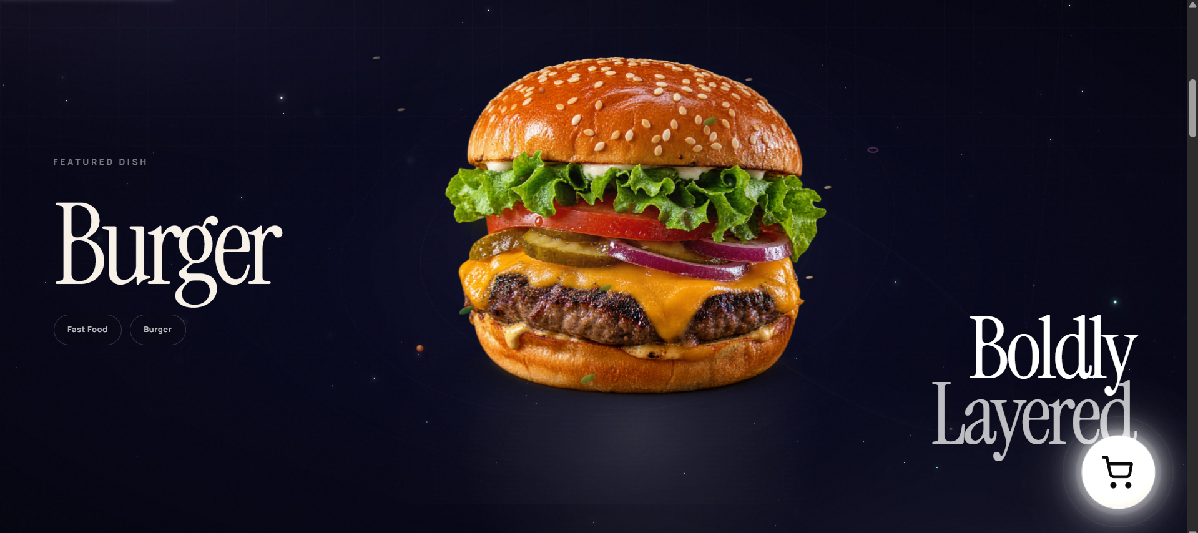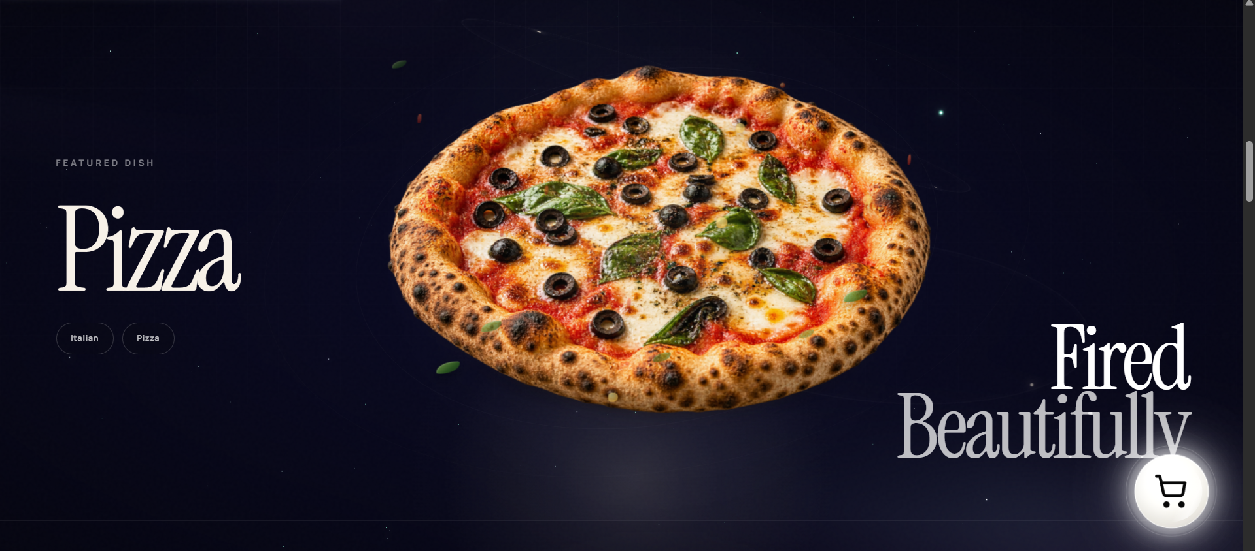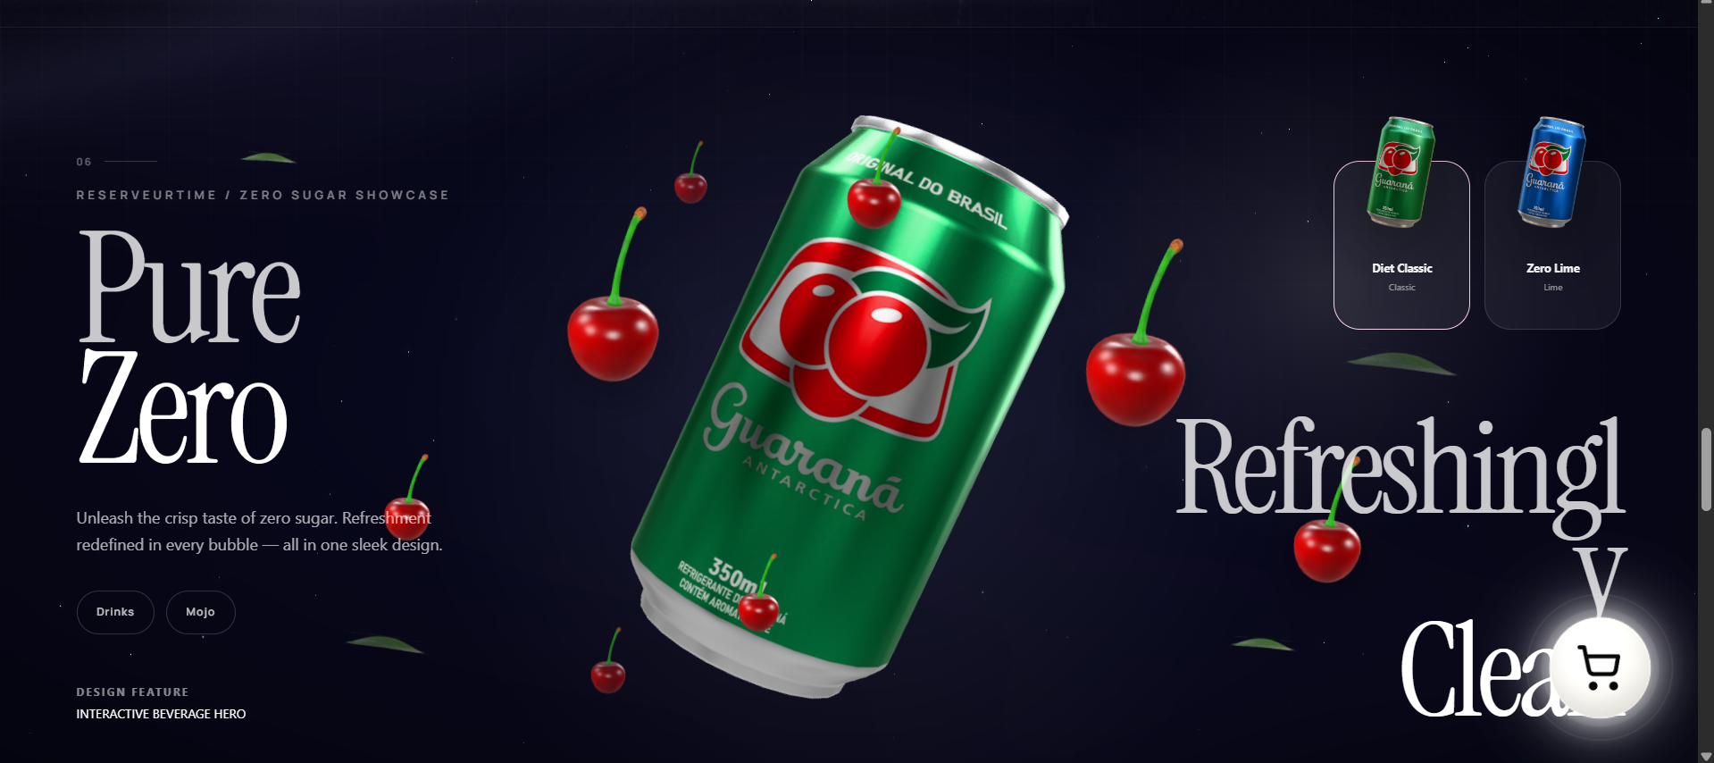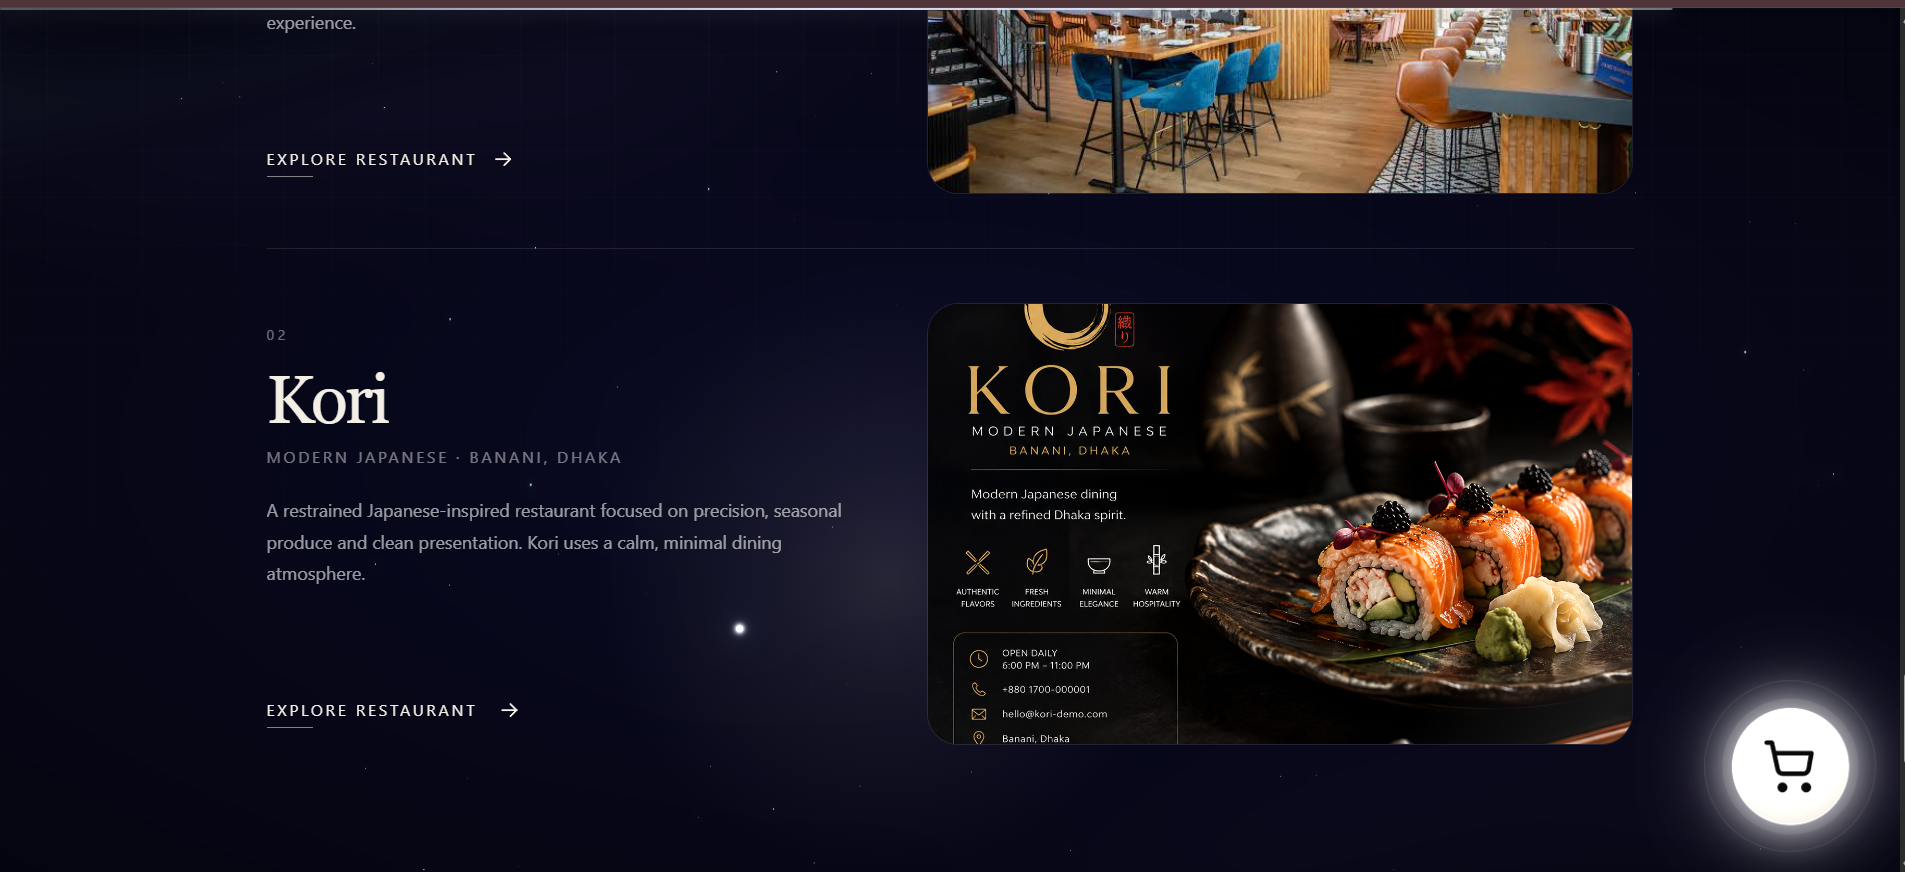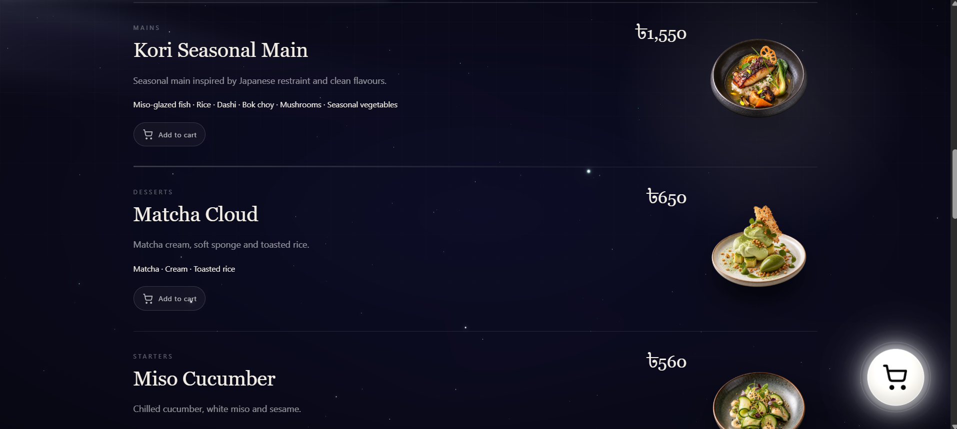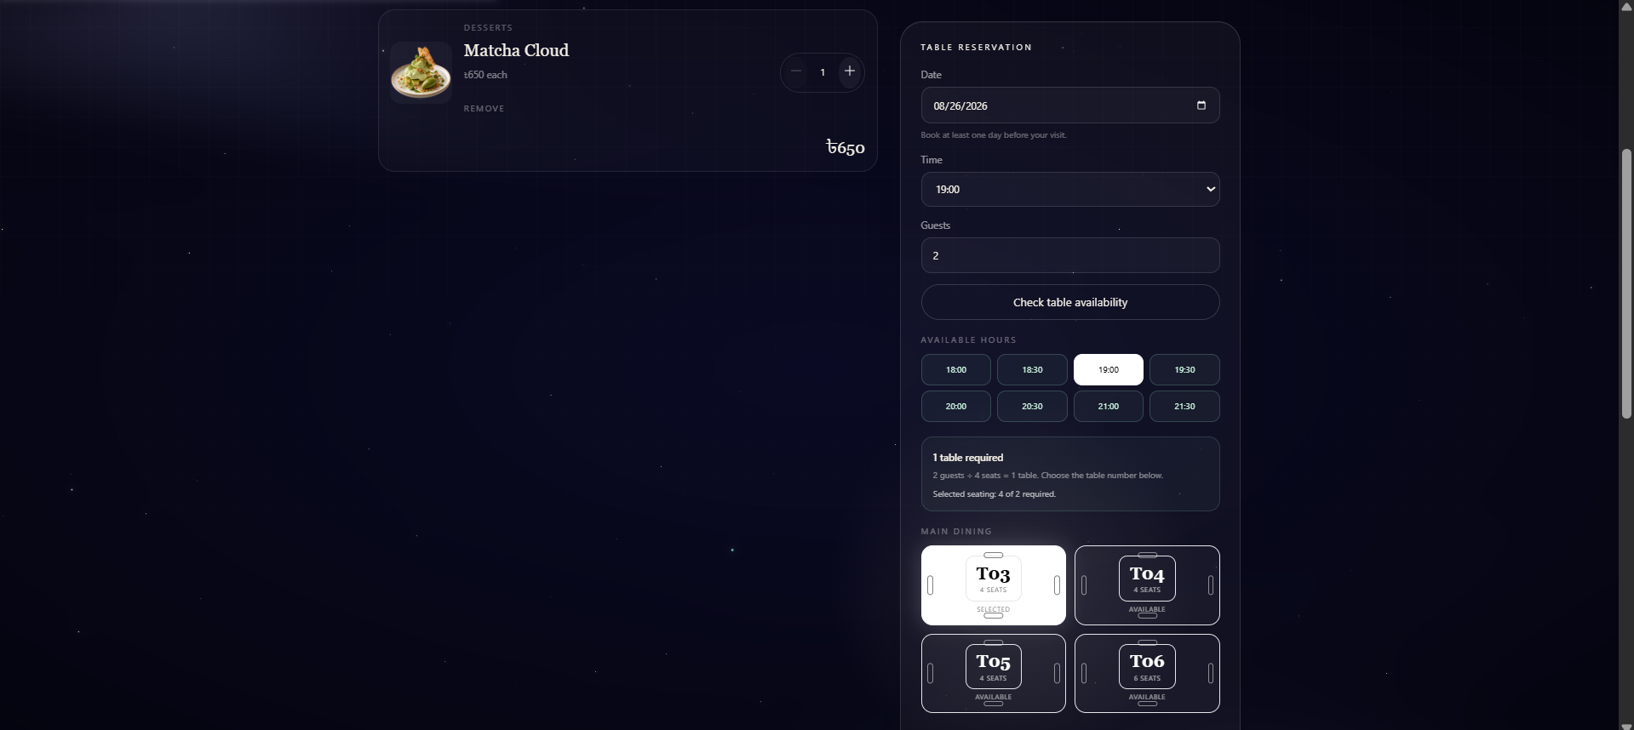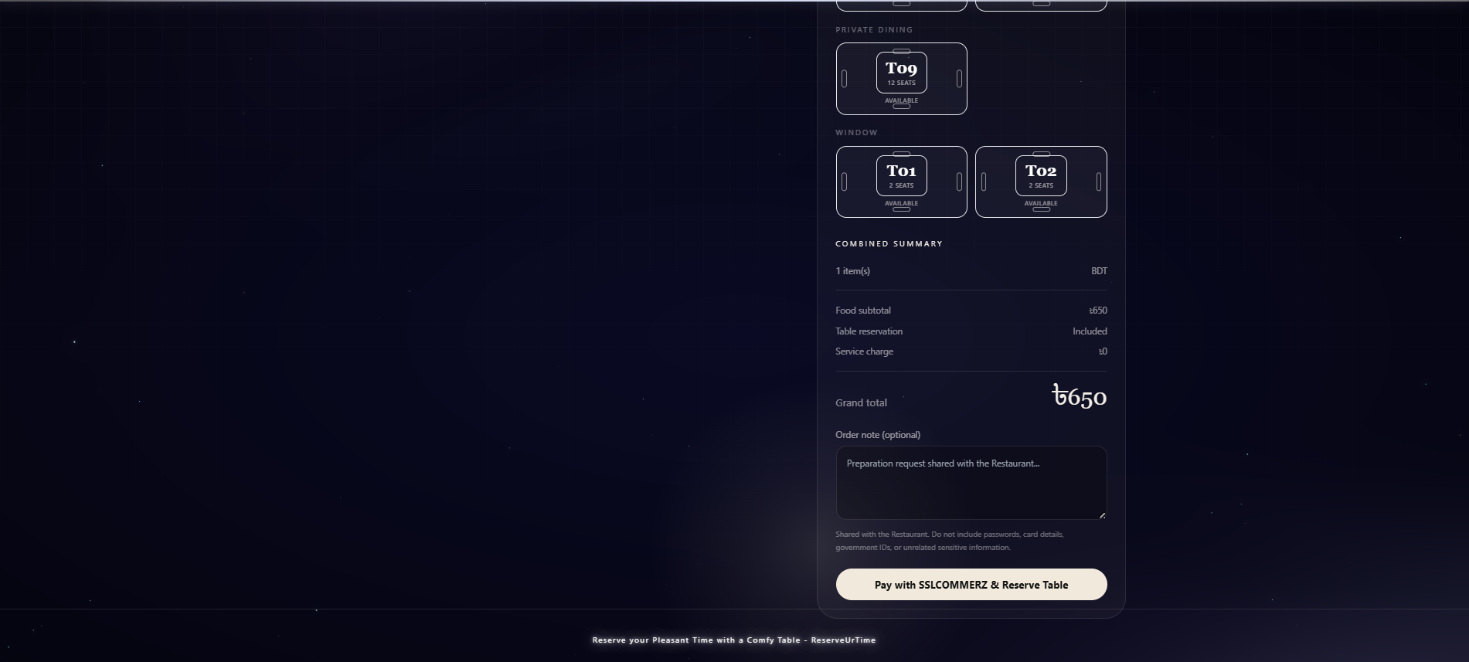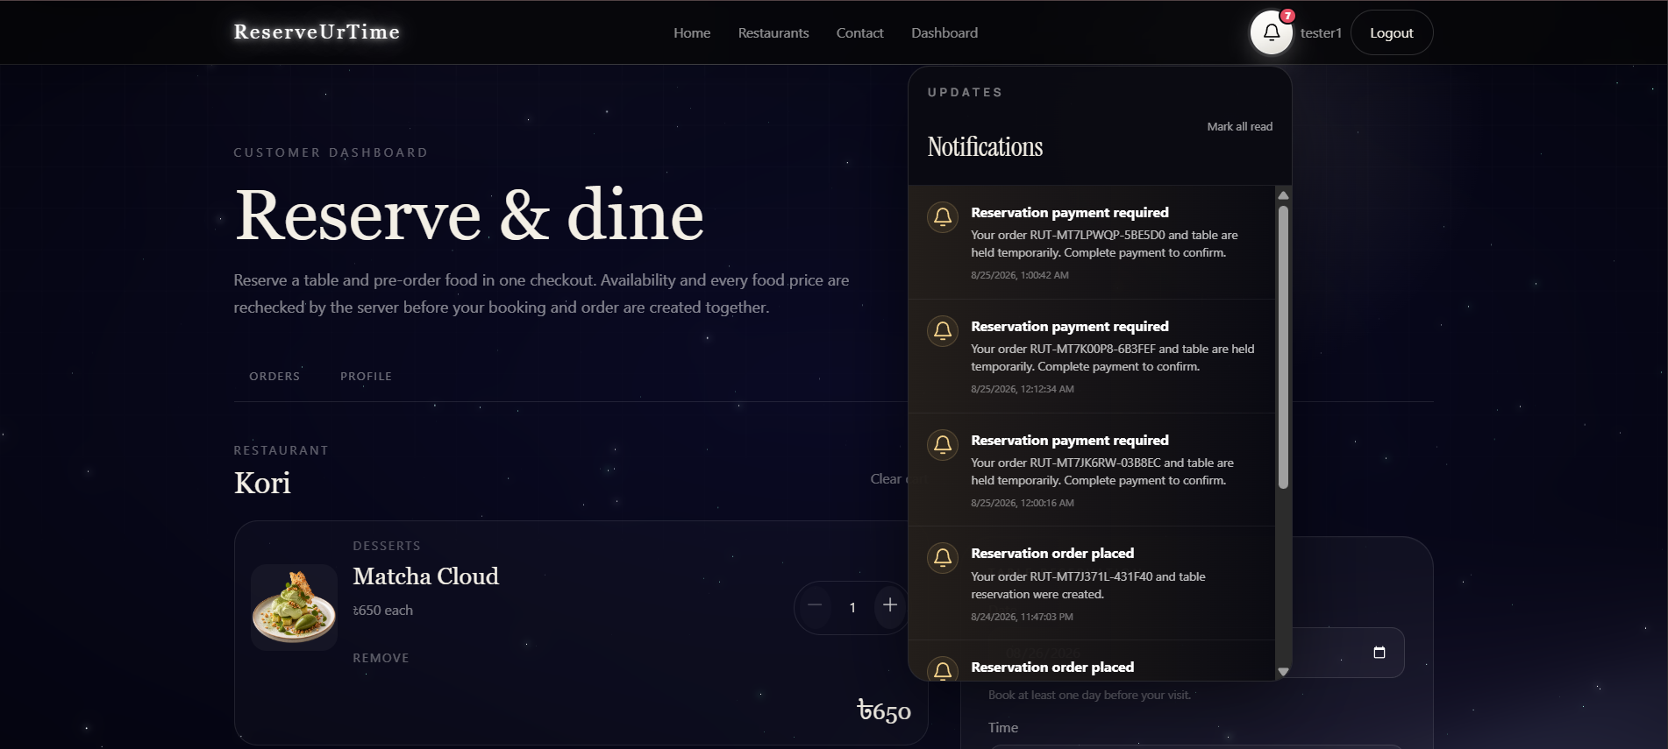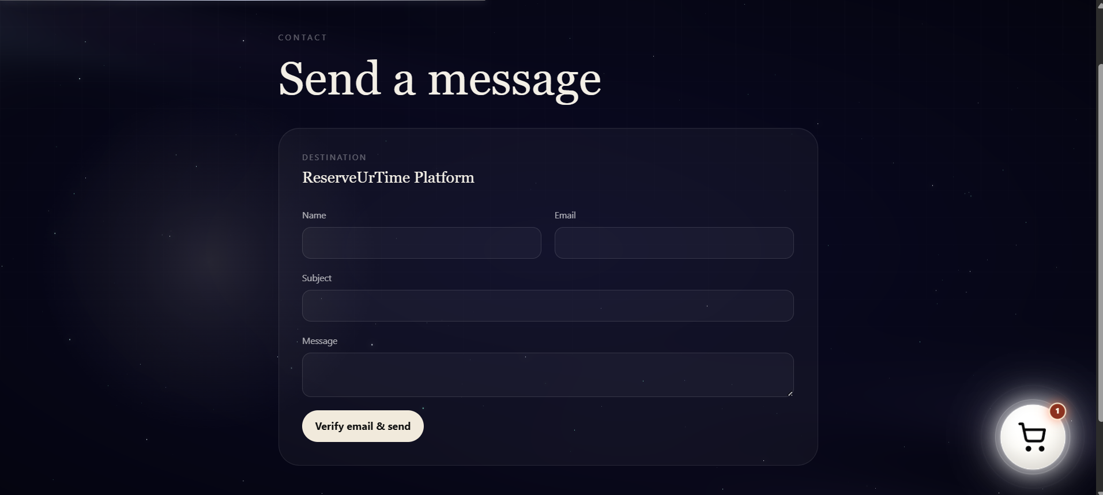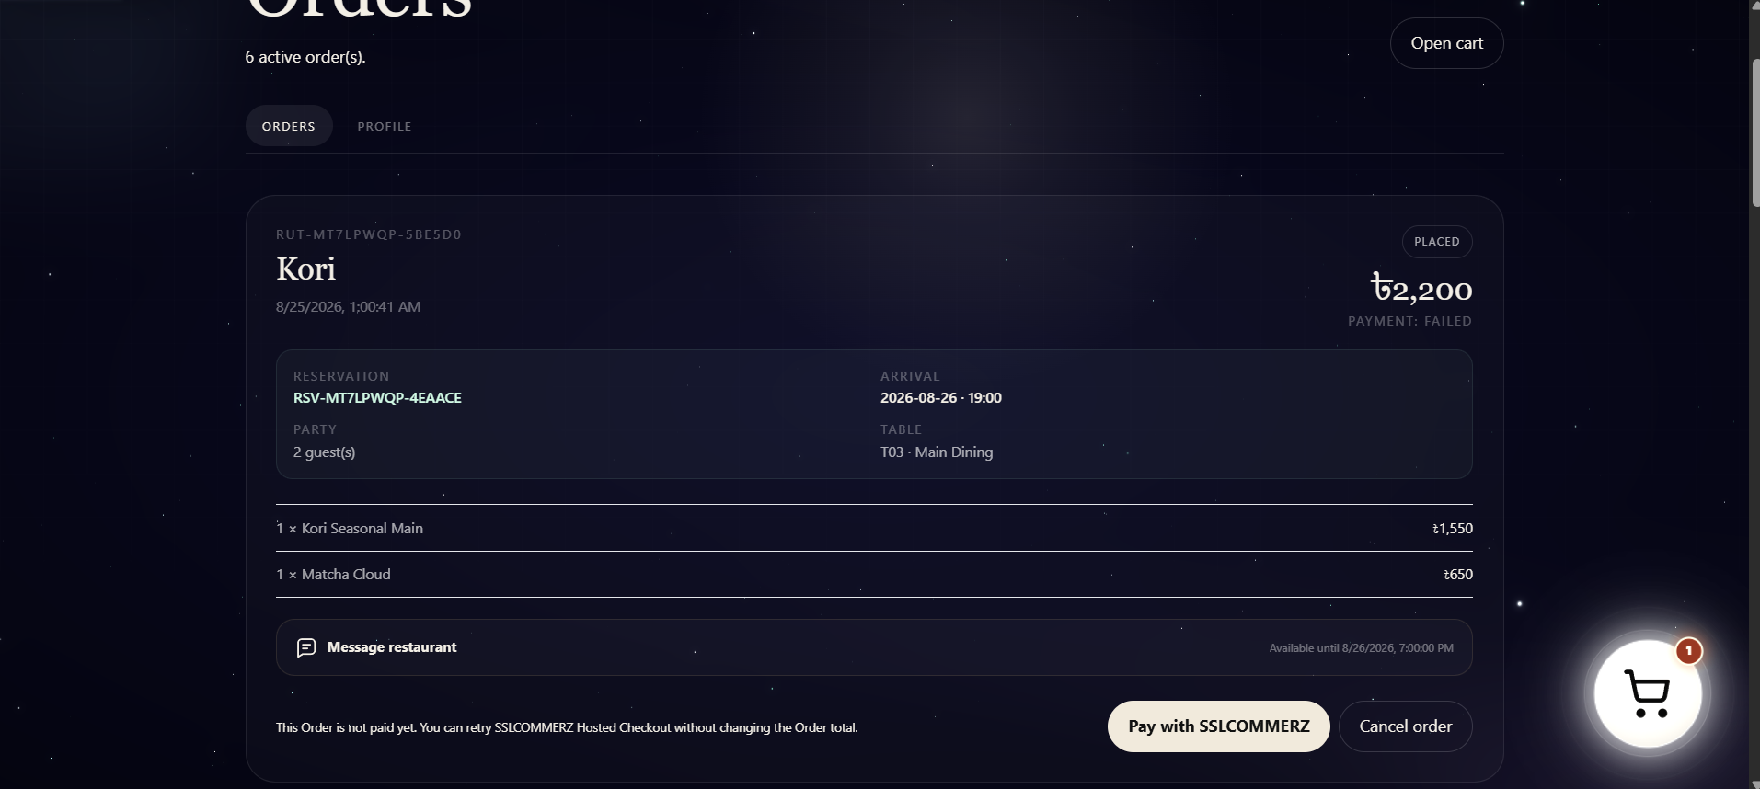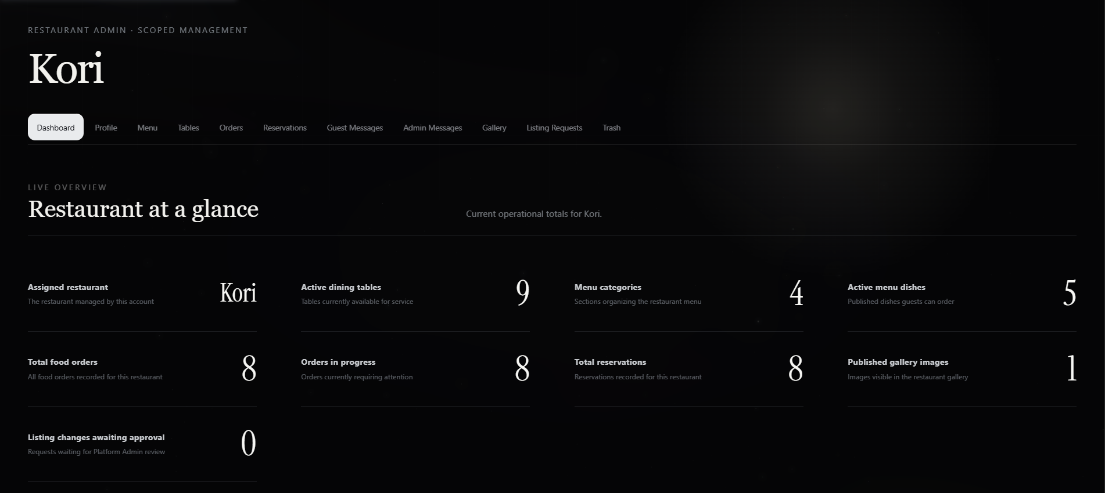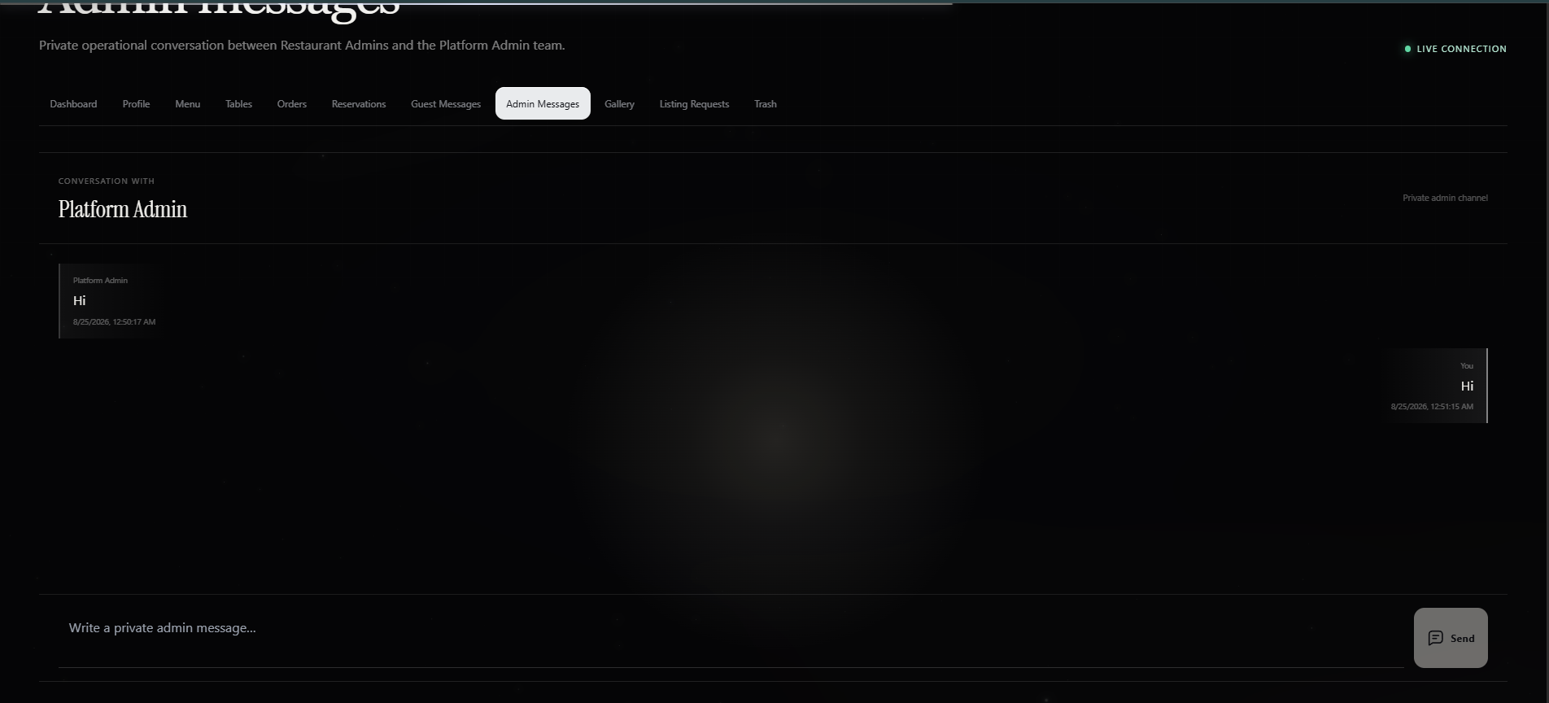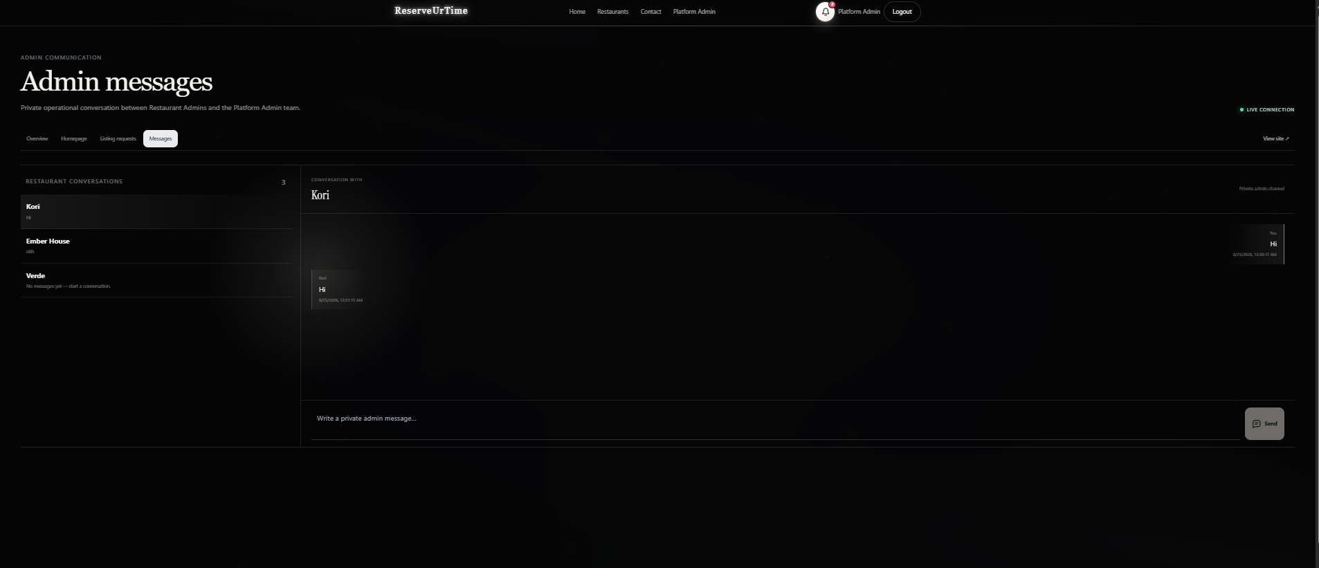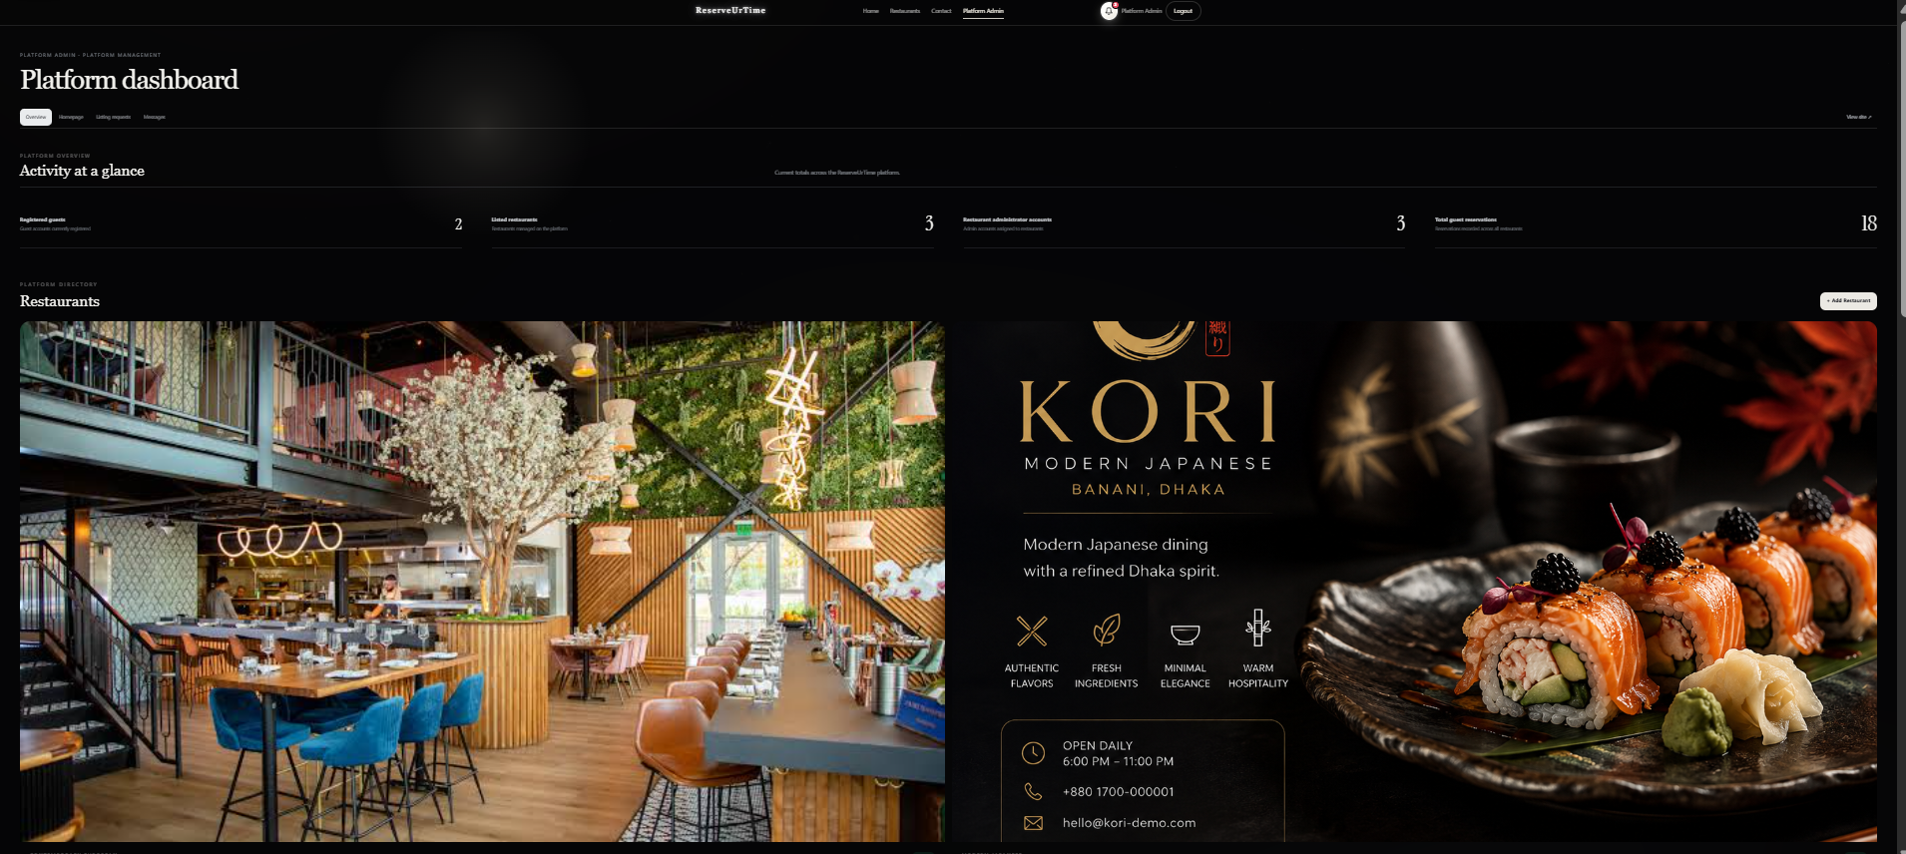
Online Resources used:
a) getlayers.com – I used it as a reference for layer-based visual and animation ideas.
b) lottiefiles.com – I used it for Lottie animation resources and animation ideas.
Future Enhancements:
The following improvements can be added to the current system:
a) Add more restaurants and locations.
b) Improve mobile performance and loading speed.
c) Add more online payment methods.
d) Add a live table layout so users can choose a table visually.
e) Add better restaurant and food suggestions based on user activity.

