**Lab 1:Introduction to Python**

Shourov kabiraj

ID: IT-17045

**Exercise 4.1.1:** Create a python project, click in **File > New > PyDev Project.** Provide a name for the project (SDN_LAB_1 for the fits lab), then select the version of python to be used and select to add the project to working set as shown below:

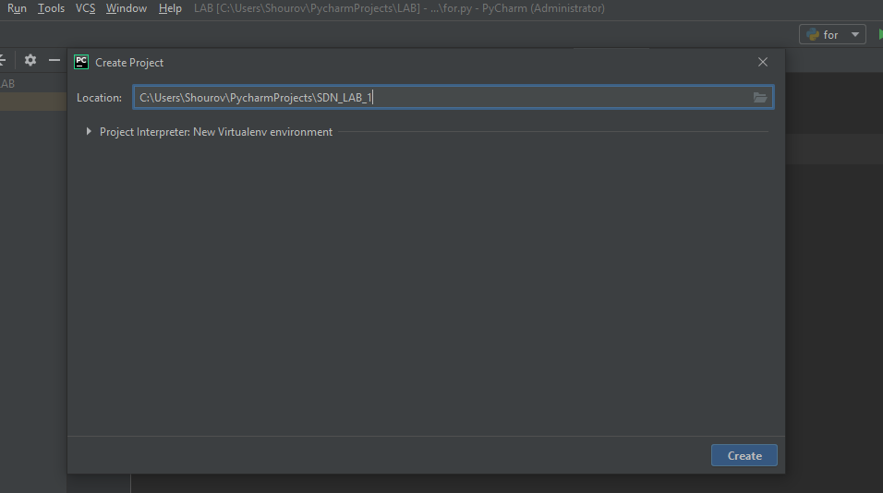

**Exercise 4.1.2:** Write a Hello World program Almost all books about programming languages start with a very simple program that prints the text Hello, World! to the screen. Make such a program in Python. (save as hello_world.py).

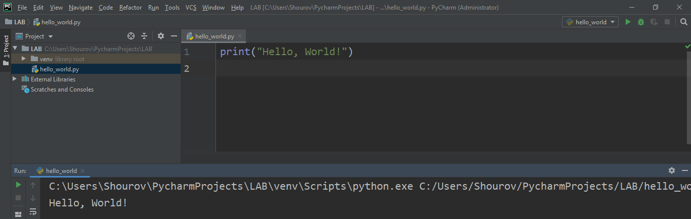

**Exercise 4.1.3:** Compute 1+1

The first exercise concerns some very basic mathematics and programming: assign the result of 1+1 to a variable and print the value of that variable (save as 1plus1.py).

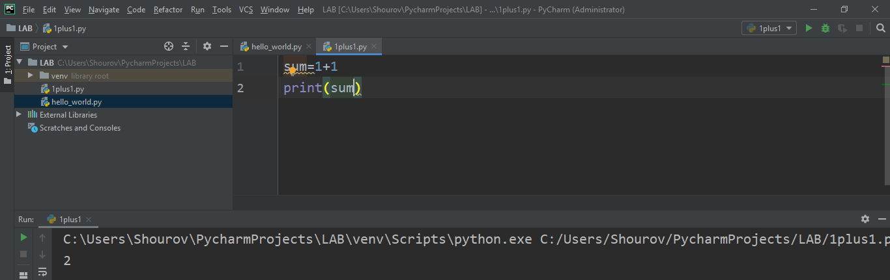

**Exercise 4.1.4:** Type in program text

|  |
| --- |
| Type the following program in your editor and execute it. If your program does not work, check that you have copied the code correctly and debug it (save as formulas_shapes.py).  h = 5.0 # height  r = 1.5 # radius  b = 3.5  if __name__ == *'__main__'*:  area_parallelogram = h*b  print (*'The area of the parallelogram is %.3f'* % area_parallelogram)  area_square = b**2  print (*'The area of the square is %g'* % area_square)  area_circle = pi*r**2  print (*'The area of the circle is %.3f'* % area_circle)  volume_cone = 1.0/3*pi*r**2*h  print (*'The volume of the cone is %.3f'* % volume_cone) |

**Exercise 4.2.2:** The if statement: Create a program for taking a number from the user and check if it is the number that you have saved in the code (TIP: use input command). Save the file as if.py

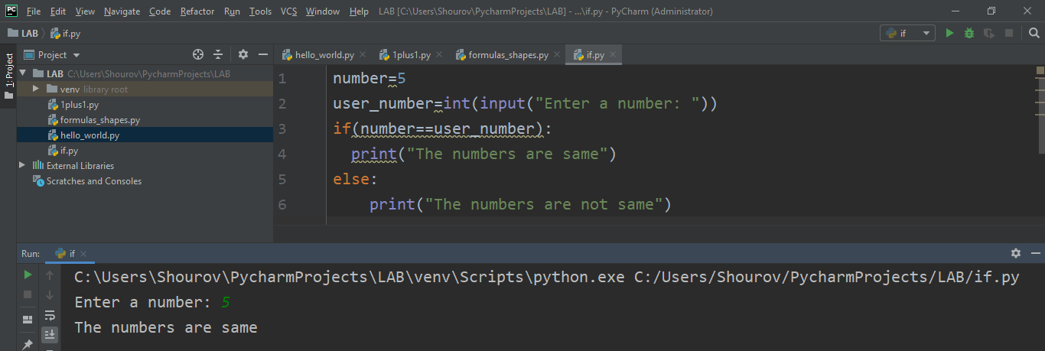

**Exercise 4.2.3:** The while Statement :Create a program for taking a number from the user and check if it is the number that you have saved in the code. The program run until the user will guess the number. Save the file as while.py

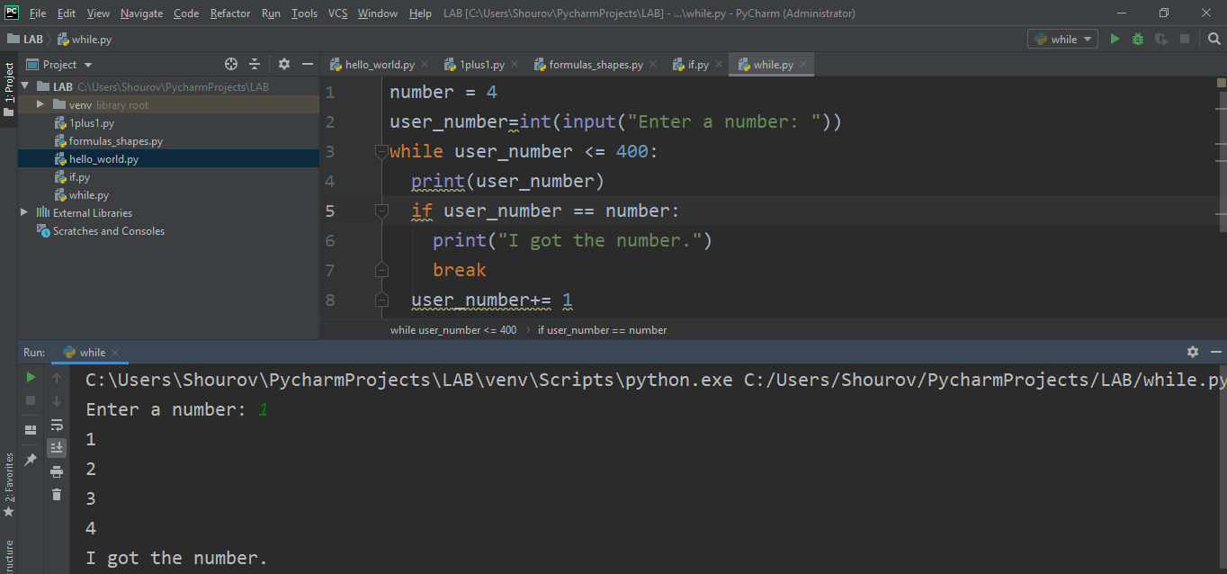

**Exercise 4.2.4:** The for Statement : Create a program for printing a sequence of numbers. Save the file as for.py

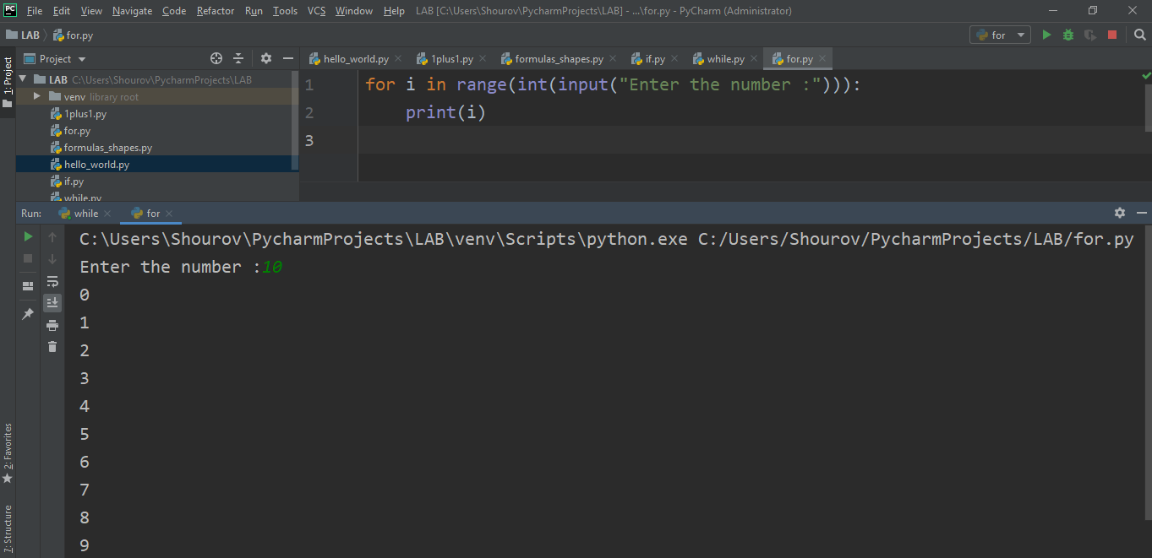

Question 5.1: Explain what is eclipse? And why we use it for programing on python?

Ans

Eclipse is an [integrated development environment](https://en.wikipedia.org/wiki/Integrated_development_environment) (IDE) used in [computer programming](https://en.wikipedia.org/wiki/Computer_programming).[[6]](https://en.wikipedia.org/wiki/Eclipse_(software)#cite_note-6) It contains a base [workspace](https://en.wikipedia.org/wiki/Workspace) and an extensible [plug-in](https://en.wikipedia.org/wiki/Plug-in_(computing)) system for customizing the environment. Eclipse is written mostly in [Java](https://en.wikipedia.org/wiki/Java_(programming_language)) and its primary use is for developing Java applications, but it may also be used to develop applications in other [programming languages](https://en.wikipedia.org/wiki/Programming_language) via plug-ins, including [Ada](https://en.wikipedia.org/wiki/Ada_(programming_language)), [ABAP](https://en.wikipedia.org/wiki/ABAP), [C](https://en.wikipedia.org/wiki/C_(programming_language)), [C++](https://en.wikipedia.org/wiki/C%2B%2B), [C#](https://en.wikipedia.org/wiki/C_Sharp_(programming_language)), [Clojure](https://en.wikipedia.org/wiki/Clojure), [COBOL](https://en.wikipedia.org/wiki/COBOL), [D](https://en.wikipedia.org/wiki/D_(programming_language)), [Erlang](https://en.wikipedia.org/wiki/Erlang_(programming_language)), [Fortran](https://en.wikipedia.org/wiki/Fortran), [Groovy](https://en.wikipedia.org/wiki/Groovy_(programming_language)), [Haskell](https://en.wikipedia.org/wiki/Haskell_(programming_language)), [JavaScript](https://en.wikipedia.org/wiki/JavaScript), [Julia](https://en.wikipedia.org/wiki/Julia_(programming_language)),[[7]](https://en.wikipedia.org/wiki/Eclipse_(software)#cite_note-7) [Lasso](https://en.wikipedia.org/wiki/Lasso_(programming_language)), [Lua](https://en.wikipedia.org/wiki/Lua_(programming_language)), [NATURAL](https://en.wikipedia.org/wiki/Software_AG), [Perl](https://en.wikipedia.org/wiki/Perl), [PHP](https://en.wikipedia.org/wiki/PHP), [Prolog](https://en.wikipedia.org/wiki/Prolog), [Python](https://en.wikipedia.org/wiki/Python_(programming_language)), [R](https://en.wikipedia.org/wiki/R_(programming_language)), [Ruby](https://en.wikipedia.org/wiki/Ruby_(programming_language)) (including [Ruby on Rails](https://en.wikipedia.org/wiki/Ruby_on_Rails) framework), [Rust](https://en.wikipedia.org/wiki/Rust_(programming_language)), [Scala](https://en.wikipedia.org/wiki/Scala_(programming_language)), and [Scheme](https://en.wikipedia.org/wiki/Scheme_(programming_language)). It can also be used to develop documents with [LaTeX](https://en.wikipedia.org/wiki/LaTeX) and packages for the software [Mathematica](https://en.wikipedia.org/wiki/Mathematica). Development environments include the Eclipse Java development tools (JDT) for Java and Scala, Eclipse CDT for C/C++, and Eclipse PDT for PHP, among others.

**PyDev is one of the commonly used Python IDE** and is a natural choice of many Python developers coming from Java background. It is the 5th most popular Eclipse plugin by its all-time usage count. Also, it is meaningless to say that you won’t need to spare a penny to land it in your service. PyDev brings some promising features for Python programmers that are more than enough to make them choose it as the best Python IDE. Its top features are Django integration, Just-In-Time Python debugging, auto code completion, code inspection, Go to the definition, and refactoring. It supports GIT integration for source code control, also enables code coverage, UML views, and allows editing.

**Question 5.2:** Explain three main characteristics of python that you test in the lab?

Ans

Three main characteristics of python that I test in the lab are given.

1.Object-Oriented Language: Python supports object-oriented language and concepts of classes and objects come into existence. It supports inheritance, polymorphism, and encapsulation, etc. The object-oriented procedure helps to programmer to write reusable code and develop applications in less code.

### 2. GUI Programming Support: Graphical User Interface is used for the developing Desktop application. PyQT5, Tkinter, Kivy are the libraries which are used for developing the web application.

### 3.Dynamic Memory Allocation: In Python, we don't need to specify the data-type of the variable. When we assign some value to the variable, it automatically allocates the memory to the variable at run time. Suppose we are assigned integer value 15 to **x,** then we don't need to write **int x = 15.** Just write x = 15.

**Question 5.3:** Which is the difference between empty module and main module when creating a python script?

Ans

**Question 5.4:** Find error(s) in a program Suppose somebody has written a simple one-line program for computing sin(1):



Create this program and try to run it. What is the problem? Which is the correct code?

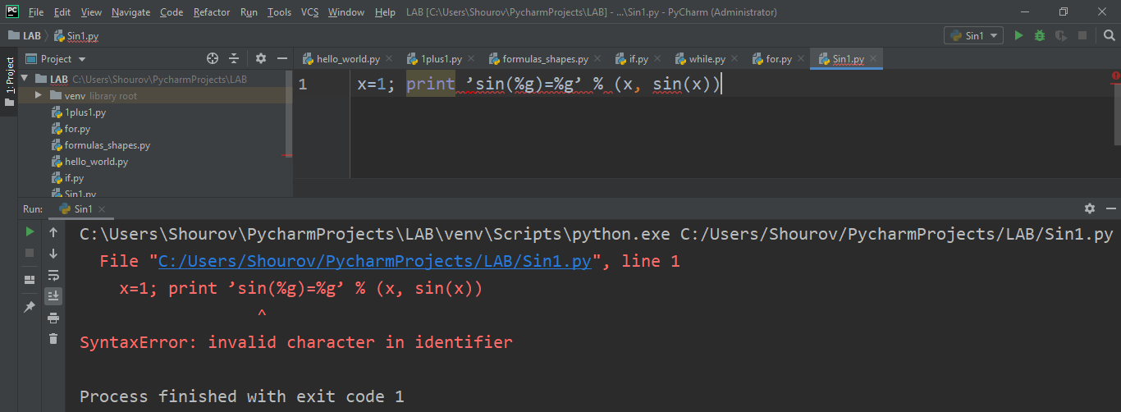

Here we can see invalid character in identifier error and here not included math library function.

Correct code is

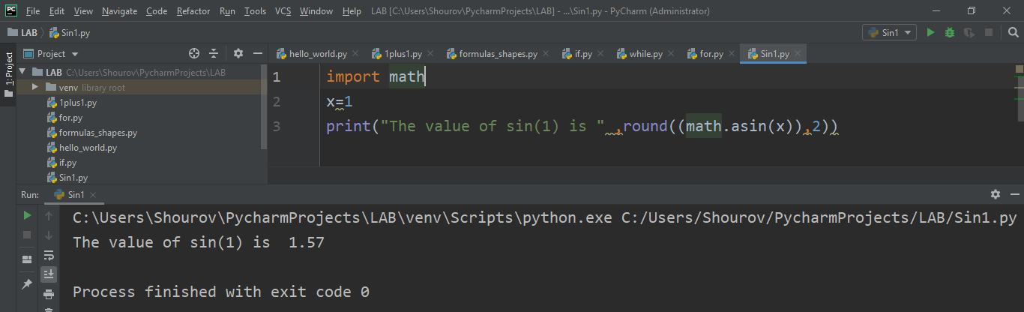

**Question 5.5**: Create a python program that combines at least 4 operators and one statement (if, while or for)

