Lab Report No: 05

Name of the lab report : Connecting a database (MySQL) with Linux

Name: Shourov kabiraj

ID: IT-17045

Objective: This Lab is about how we install mysql in Linux OS and after installation some execution of Query like create, insert, delete etc.

Installation process of Mysql:

1.Install the MySQL server by using the Ubuntu package manager:

sudo apt-get install mysql-server

2.Run the security script.

sudo mysql_secure_installation

3.And then

sudo mysql -u root -p

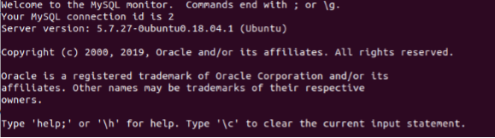

Create database:

In MySQL, we can create a database using the **CREATE DATABASE** statement. But, if database already exits, it throws an error.

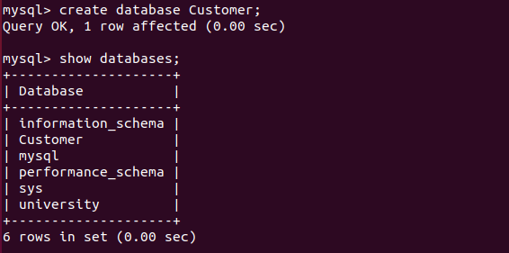

Show tables:

Use the database with the name sample and have some tables. First, we will show all tables after that we will apply to sort on the table name. 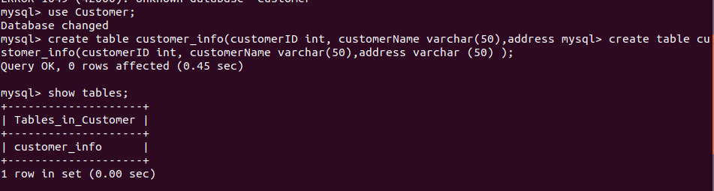

Describe table:

To show the table information , we use this command.

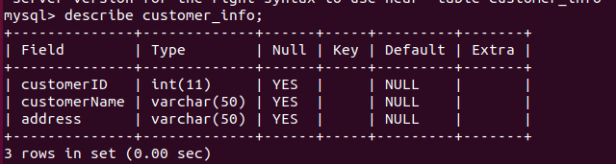

Insert data:

SQL has the INSERT command that is used to store data into a table. The **INSERT command creates a new row**in the table to store data. 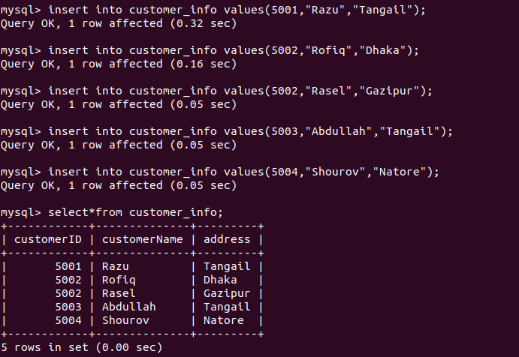

Show information :

select *(all) from Table name;

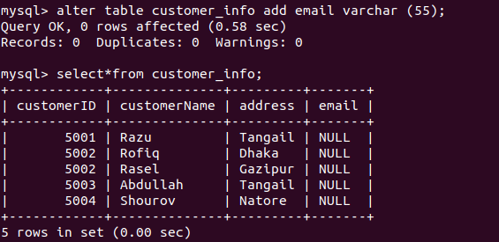

Update table:

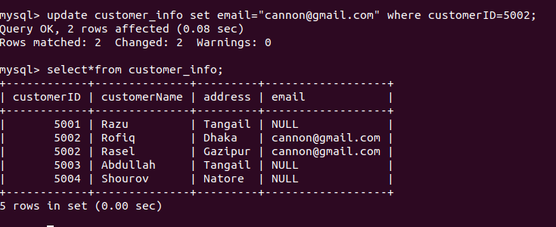

Alter table:

The ALTER TABLE statement is used to add, delete, or modify columns in an existing table

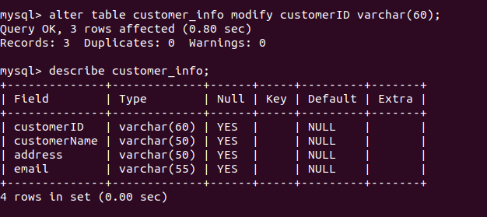

Use of ‘where’ key word:

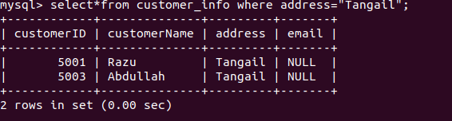

Delete from table:

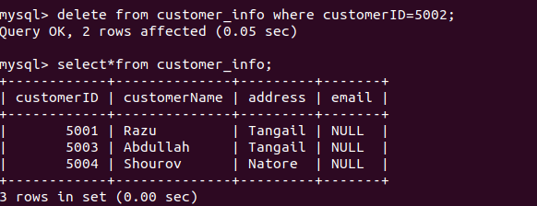

Drop data of table:

The DROP TABLE statement is used to drop an existing table in a database.



Conclusion : MySQL is the world's most popular open-source database. Despite its powerful features, MySQL is simple to set up and easy to use. And from this lab I have learnt how to connect database with linux and how to execution some query.