Game Design Document

Fill up the following document

1. Write the title of your project.

Breakout Burst

1. What is the goal of the game?

To hit the bircks and clearing them using a ball

1. Write a brief story of your game.

Open ended story depends on the user what they can think of the story.

1. Which are the playing characters of this game?

* Playing characters are the ones who respond to the user based on the input from the user.
* Cars, monkeys, dinos, wizards, etc., are the playing characters in the game.

|  |  |  |
| --- | --- | --- |
| Number | Character Name | What can this character do? |
| 1 | Bar(paddle) | Move right to left and allow the ball to bounce of it. |
| 2 | ball | Hitting bricks causing them to vanish |
| 3 |  |  |
| 4 |  |  |
| 5 |  |  |
| 6 |  |  |
| 7 |  |  |
| 8 |  |  |

1. Which are the Non-Playing Characters of this game?

* Non-Playing characters are the ones that don't have an action or behavior when the user interacts with the game.
* Hurdles, stones, bananas, coins, etc., are non-playing characters in the game.

|  |  |  |
| --- | --- | --- |
| Number | Character Name | What can this character do? |
| 1 | Bricks | On hitting them with the ball player gains points |
| 2 |  |  |
| 3 |  |  |
| 4 |  |  |
| 5 |  |  |
| 6 |  |  |
| 7 |  |  |
| 8 |  |  |

Draw your imagination of this game. What does this game look like?

* Draw the game either on your computer or on paper.
* Add images of the game scenes to show each of the playing and non-playing characters at least once.

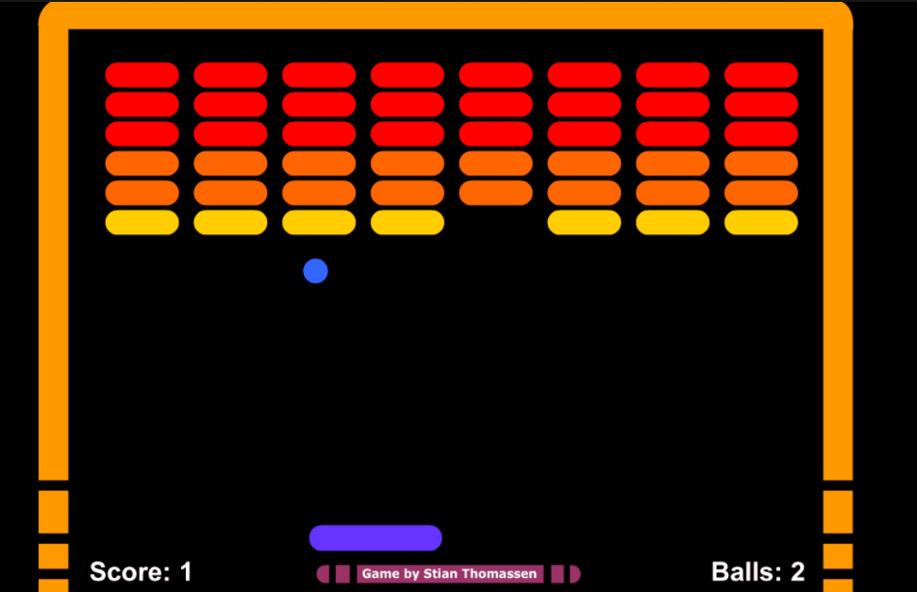

How do you plan to make your game engaging?

By adding different levels to the game each level compsing different design,structure of the bricks .s