Week 4 Task: Supervised Learning Model Implementation
Titanic Survival Prediction — Classification Model
Dataset: Titanic Cleaned Dataset (titanic_cleaned.csv), produced during Week 1 data cleaning and used consistently across Week 2 (EDA) and Week 3 (clustering).

1. Objective
The objective of this task is to design and implement a supervised learning model using Python to predict Titanic passenger survival. This is a binary classification problem, where the target variable, Survived, indicates whether a passenger survived (1) or did not survive (0) the disaster. The work builds directly on the cleaned and feature-engineered dataset produced in Week 1, and extends the exploratory insights from Week 2 and the unsupervised clustering patterns discovered in Week 3.

2. Problem Definition
Problem type: Classification (supervised learning).
Target variable: Survived (0 = Did not survive, 1 = Survived).
Business/analytical question: Given a passenger's demographic and travel details, can we accurately predict whether they survived the Titanic disaster? The class distribution is moderately imbalanced (about 61.6% did not survive vs. 38.4% survived), which was accounted for using stratified train/test splitting and stratified cross-validation.

3. Tools and Libraries
Python, Pandas, NumPy, Matplotlib, Seaborn, and Scikit-learn (LogisticRegression, RandomForestClassifier, train_test_split, StratifiedKFold, cross_val_score, GridSearchCV, StandardScaler, and the sklearn.metrics module).

4. Dataset and Feature Engineering
The dataset contains 891 rows and 20 columns after Week 1 cleaning, which included grouped-median imputation for Age, mode imputation for Embarked, IQR-based capping of Fare outliers, one-hot encoding of Embarked and Title, and engineered features such as FamilySize and IsAlone.
For this task, 16 features were selected as model inputs:
Pclass, Sex_encoded, Age, SibSp, Parch, Fare, FamilySize, IsAlone, Embarked_C, Embarked_Q, Embarked_S, Title_Master, Title_Miss, Title_Mr, Title_Mrs, Title_Rare.
Raw text columns (Sex, Name-derived Title strings) were excluded in favor of their already-encoded numeric counterparts produced in Week 1. Boolean one-hot columns were cast to integers (0/1) for compatibility with Scikit-learn estimators. No additional feature engineering was required at this stage, since Week 1 already produced a model-ready feature set; this task focuses on model selection, training, validation and evaluation.

5. Data Splitting and Preprocessing
The dataset was split into an 80% training set (712 rows) and a 20% held-out test set (179 rows) using stratified sampling on the target variable, preserving the survival class ratio in both sets. Features were standardized using StandardScaler for the Logistic Regression model, which is sensitive to feature scale; the Random Forest model was trained on the original (unscaled) features, since tree-based models are scale-invariant.

6. Model Selection and Rationale
Two complementary algorithms were implemented and compared:
- Logistic Regression — chosen as an interpretable baseline. Its coefficients directly indicate the direction and relative strength of each feature's effect on survival probability, which is valuable for explaining the model to non-technical stakeholders.
- Random Forest Classifier — chosen as a non-linear ensemble model capable of capturing feature interactions (e.g., between Sex, Pclass and Fare) that a linear model cannot. It also provides a built-in feature-importance ranking.
Both models were evaluated first with default/near-default settings, and the Random Forest was then tuned using GridSearchCV over n_estimators, max_depth and min_samples_leaf, with 5-fold stratified cross-validation optimizing accuracy.

7. Model Validation Strategy
In addition to the single train/test split, 5-fold Stratified K-Fold cross-validation was applied on the training set for both models to obtain a more robust estimate of generalization performance and to reduce the risk of overfitting to a single split:
- Logistic Regression — 5-Fold CV Accuracy: 0.8245 (± 0.0230)
- Random Forest (default) — 5-Fold CV Accuracy: 0.8245 (± 0.0152)
- Random Forest (tuned, via GridSearchCV) — Best CV Accuracy: 0.8329, with best parameters {max_depth: 4, min_samples_leaf: 4, n_estimators: 200}

8. Evaluation Metrics
All three model variants were evaluated on the held-out 20% test set using Accuracy, Precision, Recall, F1-score, and ROC-AUC, since accuracy alone can be misleading on an imbalanced target.
Model | Accuracy | Precision | Recall | F1-Score | ROC-AUC
Logistic Regression | 0.8492 | 0.8281 | 0.7681 | 0.7970 | 0.8781
Random Forest (default) | 0.8380 | 0.8448 | 0.7101 | 0.7717 | 0.8615
Random Forest (tuned) | 0.8212 | 0.7937 | 0.7246 | 0.7576 | 0.8582

Logistic Regression achieved the strongest overall test performance across every metric, including the highest ROC-AUC (0.878), indicating it separates the two classes most reliably on unseen data for this dataset size.

8.1 Model Performance Comparison
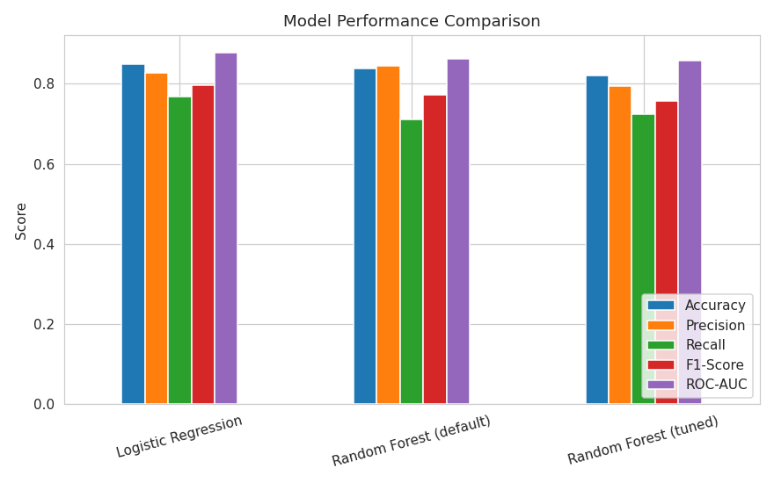
Figure 1: Accuracy, Precision, Recall, F1-Score and ROC-AUC across the three model variants.

8.2 ROC Curve Comparison
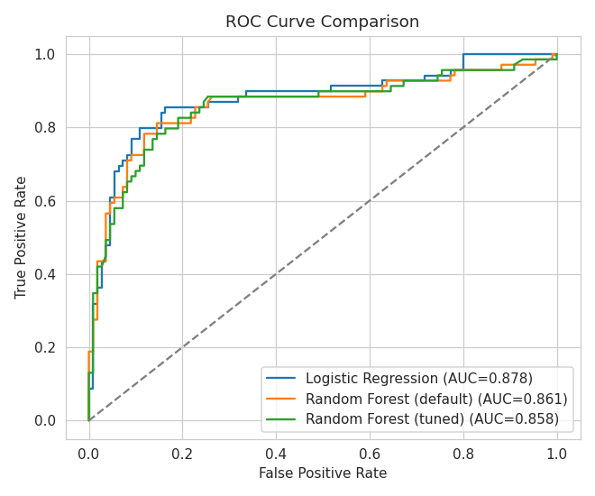
Figure 2: ROC curves for all three models. Logistic Regression has the largest area under the curve (AUC = 0.878).

8.3 Confusion Matrix (Tuned Random Forest)
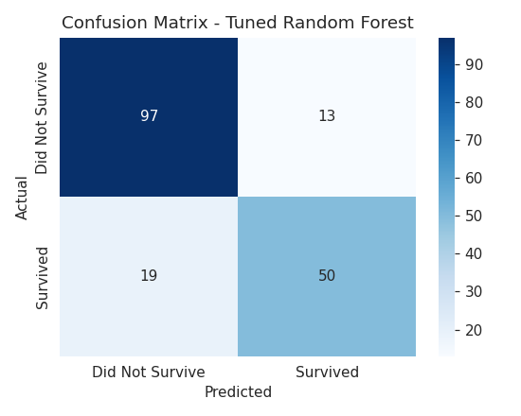
Figure 3: Confusion matrix on the test set for the tuned Random Forest model.
Of 179 test passengers, the model correctly identified the majority of non-survivors and survivors. Most errors were false negatives (predicting a passenger did not survive when they actually did), which is common in this dataset because survival depended on situational factors (e.g., lifeboat access) not fully captured by the available features.

9. Feature Importance and Interpretability
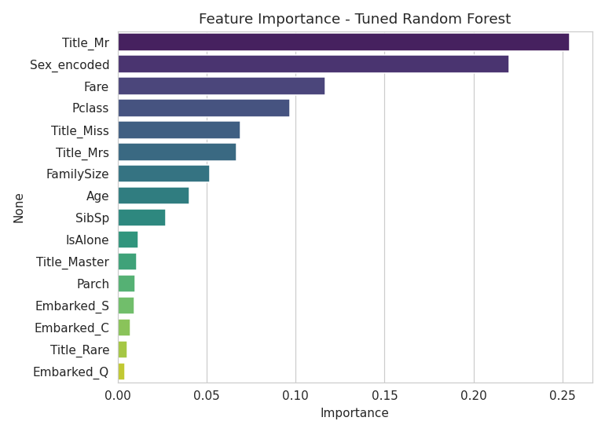
Figure 4: Random Forest feature importance ranking.
The Random Forest model identifies Title_Mr, Sex_encoded, Fare and Pclass as the most influential predictors, confirming the well-known Titanic pattern that gender, social title and passenger class strongly determined survival odds.
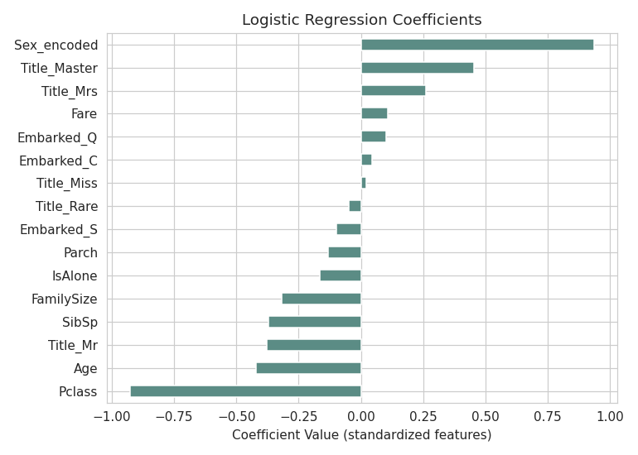
Figure 5: Logistic Regression standardized coefficients.
The Logistic Regression coefficients tell the same story from a linear perspective: being addressed as "Mr" (adult male) and traveling in a lower class carry strongly negative coefficients (reducing survival probability), while female-associated titles and higher fares carry positive coefficients (increasing survival probability). This aligns with the Week 2 EDA finding that women and first-class passengers survived at much higher rates, and with the Week 3 clustering result that passenger groups separated by age, fare and family size showed different survival tendencies.

10. Discussion: Strengths and Limitations

10.1 Strengths
- Both models achieve strong discrimination (ROC-AUC 0.86–0.88), well above a random baseline of 0.5.
- Cross-validation results are stable across folds (low standard deviation), suggesting the models generalize consistently rather than overfitting to one split.
- The Logistic Regression model offers clear interpretability, useful for explaining survival drivers to a non-technical audience.
- The Random Forest model surfaces non-linear feature interactions and provides a feature-importance ranking that corroborates domain knowledge.

10.2 Limitations
- The dataset is small (891 rows), which limits the achievable accuracy ceiling and makes performance estimates somewhat sensitive to the particular train/test split.
- Hyperparameter tuning of the Random Forest via GridSearchCV improved cross-validated training accuracy (0.8329) but produced a slightly lower held-out test score (0.8212) than the untuned model, illustrating the variance that can arise when tuning on a small training set — the untuned Random Forest and Logistic Regression generalized at least as well in this case.
- Some potentially predictive information (e.g., cabin location, exact lifeboat assignment) was dropped in Week 1 due to excessive missingness, which likely caps the maximum achievable performance.
- Age imputation (grouped median) and Fare capping, while reasonable, introduce some approximation that could bias the model slightly for extreme cases.

10.3 Possible Improvements
1. Try additional algorithms (e.g., Gradient Boosting, XGBoost, or Support Vector Machines) and compare against the current baselines.
2. Use a wider or randomized hyperparameter search (RandomizedSearchCV or Bayesian optimization) with a larger cross-validation fold count to reduce variance in the tuning step.
3. Engineer additional features, such as fare-per-family-member or ticket-group survival correlation, to capture more of the signal lost when Cabin and Ticket were dropped.
4. Apply class-imbalance techniques (e.g., class_weight='balanced' or SMOTE) and re-evaluate recall for the survived class, since correctly identifying survivors carries analytical value.
5. Use model explainability tools such as SHAP values for a more granular, per-passenger interpretation of predictions.

11. Conclusion
This task successfully implemented and validated a supervised classification pipeline for predicting Titanic passenger survival. Logistic Regression and Random Forest models were trained, cross-validated, and evaluated using Accuracy, Precision, Recall, F1-score and ROC-AUC, with the Logistic Regression model providing the best overall generalization on the held-out test set (Accuracy 0.849, ROC-AUC 0.878). Feature importance analysis confirmed that gender, title, passenger class and fare were the dominant predictors of survival, consistent with the findings from the Week 2 EDA and Week 3 clustering analyses. The exercise also highlighted practical lessons about the risk of overfitting during hyperparameter tuning on small datasets, and outlines concrete directions for further improving model performance.

