Week 6 Task: Integrative Capstone Project and Evaluation
Titanic Passenger Data Science Project — End-to-End Python Workflow
Integration of Weeks 1–5

1. Executive Summary
This capstone integrates the data-science techniques developed throughout the internship into one complete project using the Titanic passenger dataset. The workflow begins with the cleaned dataset produced during Week 1, continues through exploratory data analysis in Week 2, passenger segmentation with K-Means in Week 3, supervised survival prediction in Week 4, and deep learning with a feed-forward neural network in Week 5. The purpose is to demonstrate an independent, reproducible data-science pipeline from data preparation to evaluation and final recommendations.

2. Problem Statement and Opportunity
The analytical problem is to understand passenger survival patterns and build models that can predict the binary target Survived. A value of 0 indicates that the passenger did not survive and 1 indicates survival. The project also asks a broader descriptive question: what passenger characteristics form meaningful groups, and which features are most useful for explaining or predicting survival?

3. Methodological Approach
- Data acquisition and cleaning: use the public Titanic dataset and the cleaned model-ready version from Week 1.
- Preprocessing: missing-value handling, Fare outlier capping, categorical encoding, FamilySize/IsAlone engineering, and scaling where required.
- EDA: inspect survival distribution and relationships with sex, passenger class, age, fare, and family-related variables.
- Unsupervised learning: standardize Age, Fare, and FamilySize and apply K-Means with three clusters.
- Supervised learning: compare Logistic Regression and Random Forest using a stratified 80/20 split and standard evaluation metrics.
- Deep learning: use the Week 5 PyTorch multilayer perceptron with validation monitoring, dropout, weight decay, and early stopping.
- Evaluation: compare models, interpret clustering, identify limitations, and formulate recommendations.

4. Data Acquisition, Cleaning, and Preprocessing
Week 1 established the foundation for the entire capstone. The raw Titanic dataset contained 891 rows and 12 columns. Cabin had 687 missing values (77.10%), Age had 177 missing values (19.87%), and Embarked had two missing values. The cleaning process dropped Cabin, Ticket, and PassengerId; imputed Age using the median within Pclass × Sex groups; filled Embarked with its mode; normalized categorical text; and capped extreme Fare values at the 99th percentile. Feature engineering then created Title, FamilySize, IsAlone, encoded Sex, one-hot encoded Embarked and Title, and scaled Age/Fare. The resulting cleaned dataset is the common input to the later project stages.

5. Exploratory Data Analysis
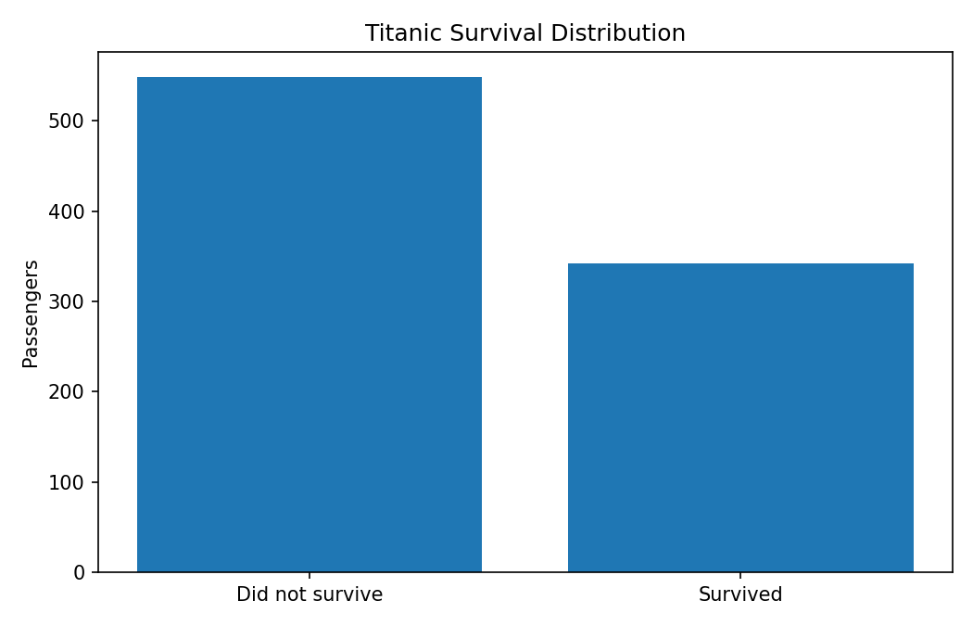
Figure 1. Distribution of the survival target.
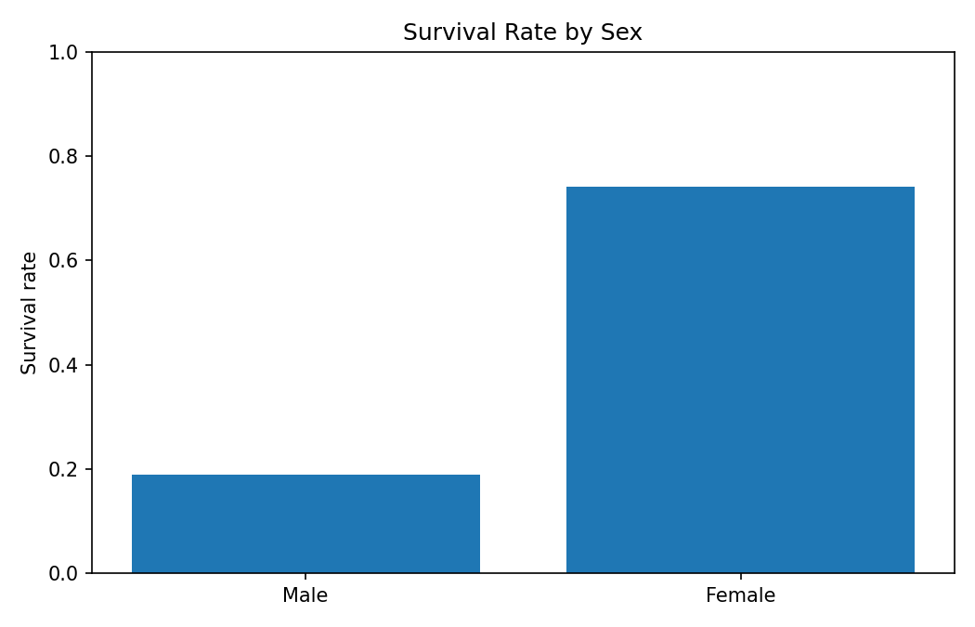
Figure 2. Survival rate by encoded sex.
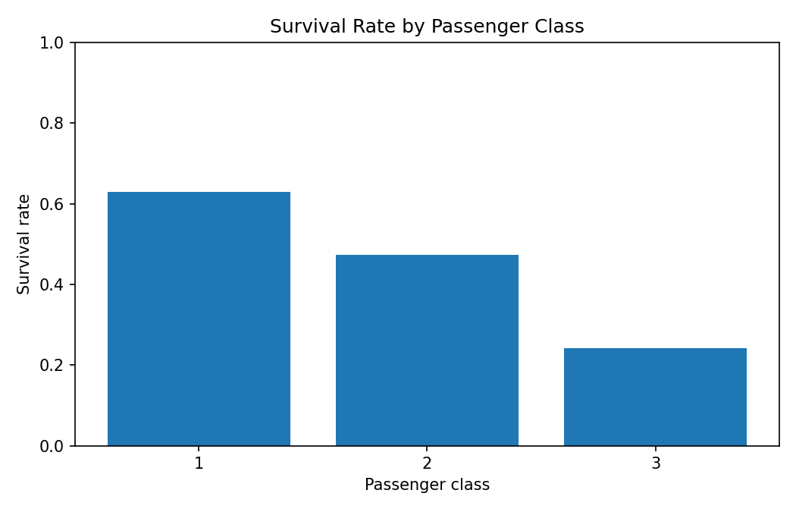
Figure 3. Survival rate by passenger class.
The overall survival rate in the cleaned dataset is 0.384. The EDA confirms the main patterns identified during Week 2: survival differs substantially by sex and passenger class. These findings are important because they provide both domain insight and a basis for the predictive modeling stage.

6. Unsupervised Learning — K-Means Segmentation
Week 3 applied K-Means to Age, Fare, and FamilySize after standardization. Three clusters were selected to create interpretable passenger segments. The project interpretation described Cluster 0 as medium-fare, average-age passengers; Cluster 1 as higher-fare, mostly premium-class passengers; and Cluster 2 as lower-fare, generally younger or third-class travellers. These segments are descriptive rather than survival predictions.
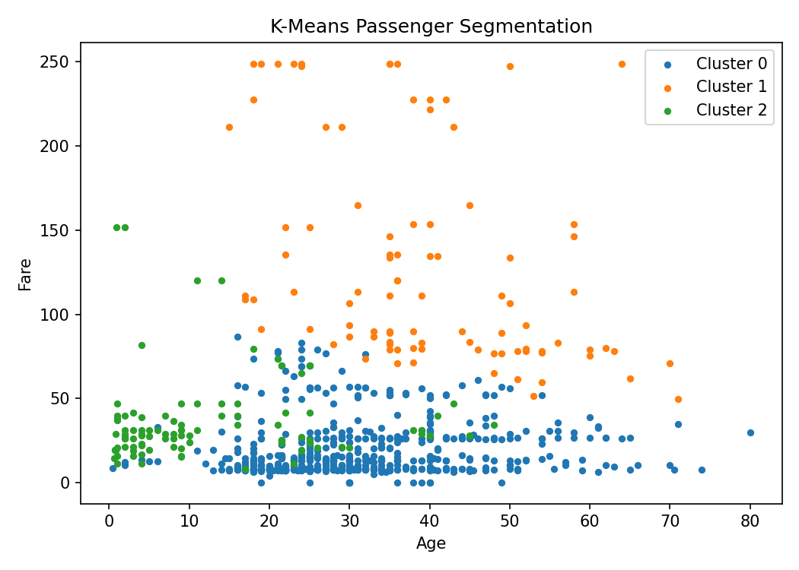
Figure 4. K-Means passenger segmentation using Age and Fare.
The reproduced three-cluster solution has a silhouette score of 0.502. Cluster sizes were: Cluster 0 = 696 passengers, Cluster 1 = 93 passengers, Cluster 2 = 102 passengers.
Cluster-level numerical summary:
Cluster | Age mean | Fare mean | FamilySize mean | Survival mean
0 | 30.03 | 17.34 | 1.36 | 0.332
1 | 39.45 | 128.65 | 2.27 | 0.731
2 | 13.44 | 37.15 | 5.29 | 0.422

7. Supervised Learning — Survival Prediction
Week 4 framed survival as a supervised binary classification problem. The same 16 model inputs were used: Pclass, Sex_encoded, Age, SibSp, Parch, Fare, FamilySize, IsAlone, Embarked_C, Embarked_Q, Embarked_S, Title_Master, Title_Miss, Title_Mr, Title_Mrs, and Title_Rare. Logistic Regression provided an interpretable linear baseline, while Random Forest provided a non-linear ensemble capable of modeling feature interactions.
The held-out test results from the integrated Weeks 4–5 work are shown below.
Model | Accuracy | Precision | Recall | F1-Score | ROC-AUC
Logistic Regression | 0.8492 | 0.8281 | 0.7681 | 0.7970 | 0.8781
Random Forest (default) | 0.8380 | 0.8448 | 0.7101 | 0.7717 | 0.8615
Random Forest (tuned) | 0.8212 | 0.7937 | 0.7246 | 0.7576 | 0.8582
Deep Learning MLP | 0.8380 | 0.8704 | 0.6812 | 0.7642 | 0.8704
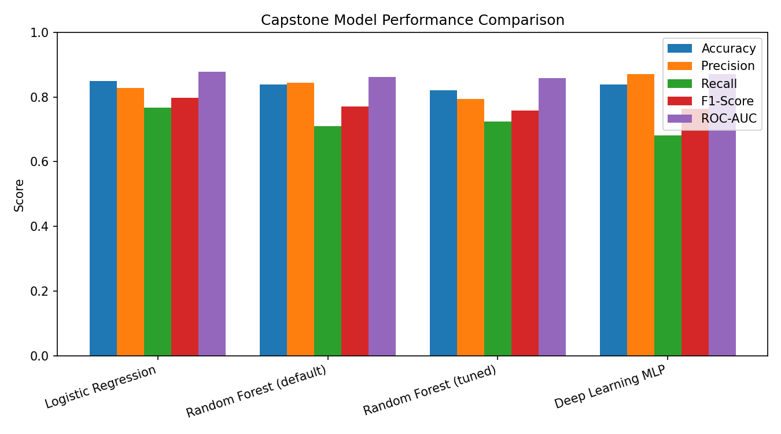
Figure 5. Comparison of supervised and deep-learning models.

8. Deep Learning Extension
Week 5 extended the supervised-learning stage with a feed-forward PyTorch neural network. The architecture used 16 input features, a 32-neuron dense layer, ReLU activation, dropout, a 16-neuron dense layer, another ReLU/dropout stage, and a single output logit converted to a survival probability. Adam, BCEWithLogitsLoss, standardized inputs, validation monitoring, weight decay, and early stopping were used. The held-out test performance was Accuracy 0.8380, Precision 0.8704, Recall 0.6812, F1-score 0.7642, and ROC-AUC 0.8704.
The deep-learning result is competitive but does not beat Logistic Regression, whose Week 4 held-out Accuracy was 0.8492 and ROC-AUC was 0.8781. This is an important capstone lesson: model complexity should be justified by data size and validation evidence rather than assumed to improve performance.

9. Integrated Findings and Insights
- Sex and passenger class are consistently important survival-related variables across EDA, supervised models, and the deep-learning interpretation.
- Passenger groups can be segmented using Age, Fare, and FamilySize, revealing meaningful differences in passenger profiles.
- Logistic Regression provides the strongest overall held-out benchmark among the implemented models, while remaining highly interpretable.
- Random Forest captures non-linear interactions and provides a useful complementary modeling perspective.
- The neural network demonstrates practical deep-learning skills, but the small 891-row tabular dataset limits the advantage of a higher-capacity model.
- The preprocessing choices made in Week 1 materially affect all later stages; a reliable modeling pipeline depends on consistent cleaning and feature preparation.

10. Challenges and How They Were Addressed
- High missingness in Cabin: the column was removed rather than aggressively imputed.
- Missing Age: grouped-median imputation by passenger class and sex preserved known structure better than a single global median.
- Fare outliers: 99th-percentile capping preserved legitimate high-fare observations while reducing extreme influence.
- Small sample size: stratified splitting, validation monitoring, dropout, weight decay, and early stopping were used for modeling.
- Model interpretability: Logistic Regression coefficients, Random Forest feature importance, and neural-network permutation importance were used as complementary interpretation methods.
- Tuning variability: Week 4 showed that tuning Random Forest improved cross-validated training performance but did not improve the held-out test result, demonstrating the sensitivity of small datasets.

11. Critical Evaluation of the Complete Pipeline
The capstone shows a coherent progression from raw data to actionable modeling insight. The main strength is methodological continuity: the same cleaned dataset and engineered features support EDA, clustering, classical supervised learning, and deep learning. This makes comparisons meaningful and reduces unnecessary changes between project phases. At the same time, the project has limitations. The dataset contains only 891 observations, and some potentially useful information was removed because of missingness or high cardinality. Therefore, performance estimates are sensitive to the train/test split and should not be treated as universal estimates of real-world predictive performance. The capstone also demonstrates that unsupervised clusters are descriptive segments and should not be interpreted as causal explanations of survival.

12. Recommendations and Further Analysis
- Use repeated stratified cross-validation to obtain more stable performance estimates.
- Experiment with Gradient Boosting, XGBoost, or SVM as additional benchmarks, as suggested in the supervised-learning analysis.
- Engineer carefully justified features such as fare per family member or ticket-group information if reliable source data are available.
- Investigate class-weighting or decision-threshold optimization if survivor recall is more important than overall accuracy.
- Apply SHAP or another explainability method for more detailed per-passenger prediction explanations.
- For deep learning, systematically tune network width, dropout, learning rate, batch size, and weight decay and compare a smaller network against the current architecture.
- If deploying the pipeline, add automated data-quality checks and model monitoring before accepting new data.

13. Conclusion
This integrative capstone demonstrates an end-to-end data-science workflow in Python using the Titanic dataset. The project acquired and cleaned public data, explored important survival patterns, segmented passengers using K-Means, built supervised classification models, extended the analysis with a neural network, and compared the resulting methods using appropriate evaluation metrics. The strongest overall held-out benchmark was Logistic Regression, while the neural network provided a successful deep-learning implementation and competitive discrimination. The most important practical conclusion is that good data preparation, thoughtful feature engineering, appropriate validation, and critical interpretation matter as much as model complexity. The final project package is reproducible and contains the report, integrated Python code, supporting tables, and visualizations.

14. Project Deliverables
- Week 6 Integrative Capstone Report (.docx)
- Integrated Python script covering the full workflow
- Deep-learning Python implementation from Week 5
- EDA and clustering visualizations
- Model comparison table and chart
- Cluster summary table
- Submission description (200+ words)

