Data Acquisition, Cleaning, and Preprocessing
Week 1 Task Report — AI & Data Science with Python
Dataset: Titanic Passenger Dataset (Public)

1. Objective
The objective of this task is to demonstrate the ability to acquire a publicly available dataset, perform systematic data cleaning, and preprocess it using Python. This report documents the complete process of handling missing values, outliers, and erroneous entries in order to prepare the dataset for further analysis, along with the challenges faced and how they were resolved.

2. Dataset Selection and Acquisition
The Titanic Passenger Dataset was selected as a relevant public dataset. It is widely used for data cleaning and predictive analysis practice because it naturally contains missing values, outliers, and inconsistent entries — making it an ideal candidate for this task.
- Source: Public GitHub repository (datasciencedojo/datasets), a well-known mirror of the classic Kaggle Titanic dataset.
- Size: 891 rows × 12 columns
- Content: Passenger demographic and travel information (age, sex, class, fare, family relations) along with survival outcome.
import pandas as pd
df = pd.read_csv('titanic_raw.csv')
print(df.shape) # (891, 12)
print(df.dtypes)
print(df.head())

3. Initial Data Exploration
Before cleaning, the structure and quality of the raw data were explored using .info(), .describe(), and a missing-value summary. This step helps understand data types, ranges, and the extent of data quality issues.
df.info()
print(df.describe(include='all'))
missing = df.isnull().sum().sort_values(ascending=False)
missing_pct = (df.isnull().sum() / len(df) * 100).round(2)
print(pd.DataFrame({'Missing Count': missing, 'Missing %': missing_pct}))
Column | Missing Count | Missing %
Cabin | 687 | 77.10%
Age | 177 | 19.87%
Embarked | 2 | 0.22%
All other columns | 0 | 0.00%
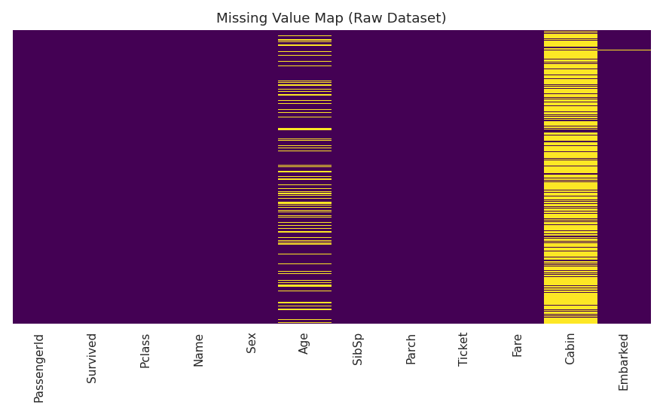
Figure 1: Missing value map of the raw dataset — yellow strips indicate gaps in Age and Cabin.
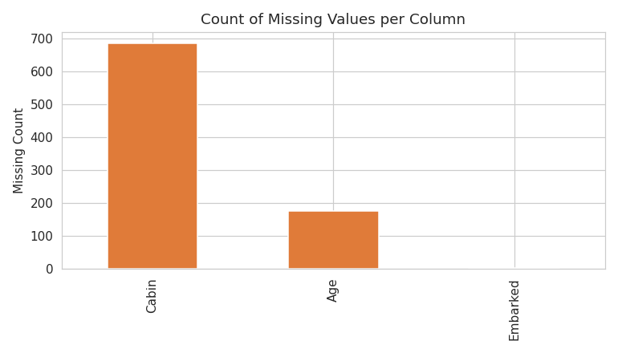
Figure 2: Count of missing values per column.

4. Identifying Data Quality Issues
Beyond missing values, the exploration phase also checked for duplicate records, inconsistent categorical entries, and statistical outliers.
- Duplicate rows found: 0
- Categorical consistency: Sex ('male'/'female') and Embarked ('S','C','Q') were consistent in spelling but Embarked had 2 missing entries.
- Outliers (IQR method): Fare had 116 values outside the 1.5×IQR range (bounds ≈ -26.72 to 65.63), driven by first-class fares as high as 512. Age had 11 outlier values.
- Erroneous entries: 15 rows had Fare = 0, which is inconsistent for paying passengers and was investigated separately (typically crew or complimentary tickets).
def iqr_outliers(series):
q1, q3 = series.quantile(0.25), series.quantile(0.75)
iqr = q3 - q1
lower, upper = q1 - 1.5*iqr, q3 + 1.5*iqr
return series[(series < lower) | (series > upper)]
fare_outliers = iqr_outliers(df['Fare'].dropna()) # 116 rows
age_outliers = iqr_outliers(df['Age'].dropna()) # 11 rows
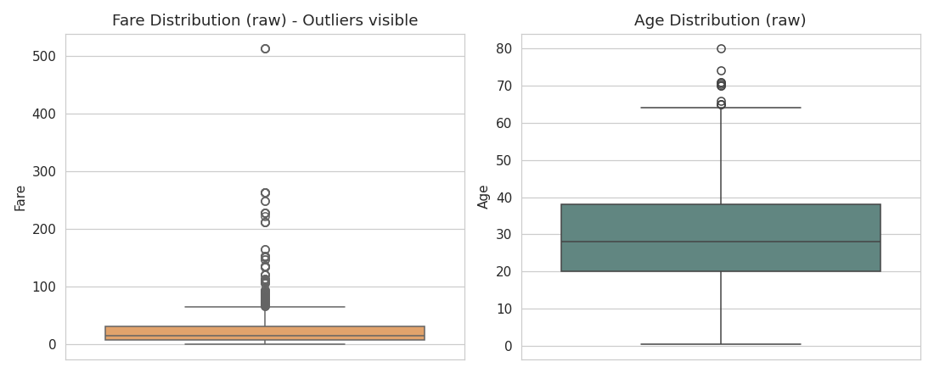
Figure 3: Boxplots of Fare and Age before cleaning, showing outliers as points beyond the whiskers.

5. Data Cleaning
The following cleaning steps were applied, each chosen based on the nature and extent of the issue identified above:

5.1 Dropping low-value columns
Cabin was dropped because 77% of its values were missing — imputing it would introduce more noise than signal. Ticket was dropped due to high cardinality with no clear predictive structure, and PassengerId was dropped as it is only a row identifier.
df_clean = df.copy()
df_clean.drop(columns=['Cabin', 'Ticket', 'PassengerId'], inplace=True)

5.2 Handling missing Age
Rather than a single global median (which would ignore known structure in the data), Age was imputed using the median Age within each Pclass × Sex group. This is more accurate because age distributions differ meaningfully across passenger class and sex (e.g., first-class passengers skewed older).
df_clean['Age'] = df_clean.groupby(['Pclass','Sex'])['Age']\
.transform(lambda x: x.fillna(x.median()))
# Missing Age after imputation: 0

5.3 Handling missing Embarked
Only 2 rows had a missing Embarked value, so mode imputation (filling with the most frequent port, 'S' — Southampton) was used since the impact on the overall distribution is negligible.
mode_embarked = df_clean['Embarked'].mode()[0] # 'S'
df_clean['Embarked'] = df_clean['Embarked'].fillna(mode_embarked)

5.4 Removing duplicates and fixing data types
No exact duplicate rows were found. Categorical columns (Survived, Pclass) were cast to category dtype, and text fields (Sex, Embarked) were normalized to consistent casing to prevent silent mismatches during grouping/encoding.
df_clean.drop_duplicates(inplace=True)
df_clean['Survived'] = df_clean['Survived'].astype('category')
df_clean['Pclass'] = df_clean['Pclass'].astype('category')
df_clean['Sex'] = df_clean['Sex'].str.lower().str.strip()
df_clean['Embarked'] = df_clean['Embarked'].str.upper().str.strip()

5.5 Treating Fare outliers
Instead of deleting outlier rows (which would discard legitimate high first-class fares and shrink the dataset), extreme Fare values were capped (winsorized) at the 99th percentile. This preserves sample size while limiting the influence of extreme values on downstream statistics and models.
fare_cap = df_clean['Fare'].quantile(0.99) # 249.01
df_clean['Fare'] = np.where(df_clean['Fare'] > fare_cap,
fare_cap, df_clean['Fare'])
# 9 extreme values capped
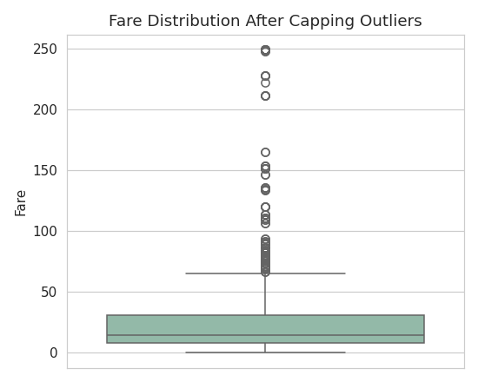
Figure 4: Fare distribution after capping — extreme values are bounded, distribution shape preserved.
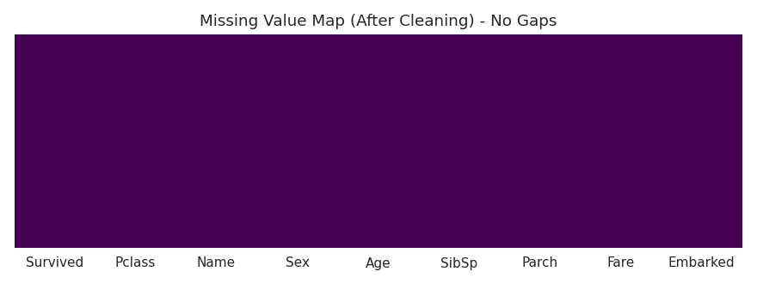
Figure 5: Missing value map after cleaning — no gaps remain in any column.

6. Preprocessing and Feature Engineering
With the dataset cleaned, several preprocessing steps were applied to make it analysis- and model-ready:
- Title extraction: Passenger titles (Mr, Mrs, Miss, Master, Rare) were extracted from the Name field as a new categorical feature, since titles often correlate with age, sex, and social status.
- Family size: FamilySize (SibSp + Parch + 1) and a binary IsAlone flag were engineered to capture the effect of traveling alone versus with family.
- Encoding: Sex was binary-mapped (male=0, female=1); Embarked and Title were one-hot encoded.
- Scaling: Age and Fare were min-max scaled to a 0–1 range (Age_scaled, Fare_scaled) for algorithms sensitive to feature magnitude, while the original columns were retained for interpretability.
df_clean['Title'] = df['Name'].str.extract(r',\s*([^\.]*)\.')
df_clean['Title'] = df_clean['Title'].replace(
['Lady','Countess','Capt','Col','Don','Dr','Major',
'Rev','Sir','Jonkheer','Dona'], 'Rare')
df_clean['FamilySize'] = df_clean['SibSp'] + df_clean['Parch'] + 1
df_clean['IsAlone'] = (df_clean['FamilySize'] == 1).astype(int)
df_clean['Sex_encoded'] = df_clean['Sex'].map({'male': 0, 'female': 1})
df_clean = pd.get_dummies(df_clean, columns=['Embarked','Title'])
df_clean['Age_scaled'] = (df_clean['Age'] - df_clean['Age'].min()) / \
(df_clean['Age'].max() - df_clean['Age'].min())
df_clean['Fare_scaled'] = (df_clean['Fare'] - df_clean['Fare'].min()) / \
(df_clean['Fare'].max() - df_clean['Fare'].min())
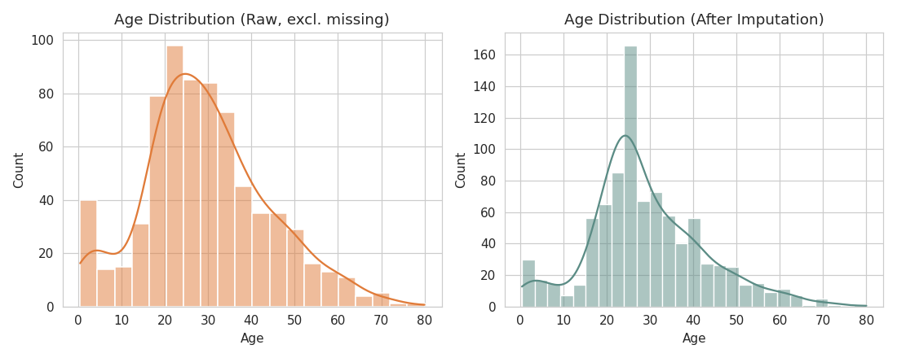
Figure 6: Age distribution before (raw, excluding missing) and after grouped-median imputation — overall shape is preserved.
The final preprocessed dataset has 891 rows and 21 columns, with zero missing values, normalized numeric ranges, and encoded categorical variables ready for exploratory or predictive analysis.
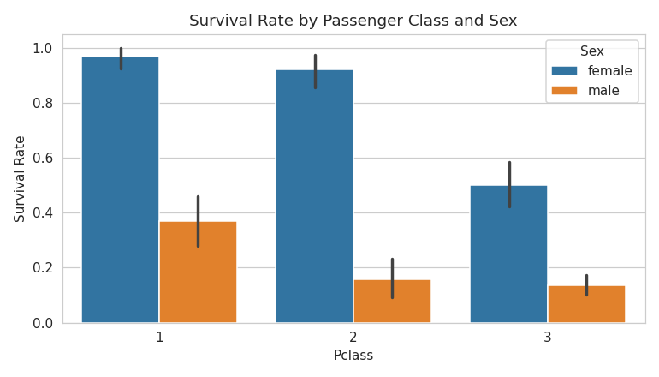
Figure 7: A downstream insight enabled by the cleaned data — survival rate by class and sex.

7. Challenges Faced and How They Were Overcome
- Choosing an imputation strategy for Age: A simple global median would have ignored real differences across class and sex. This was resolved by using grouped median imputation (Pclass × Sex), which better preserves the underlying data structure.
- Deciding how to treat Fare outliers: Deleting outlier rows risked losing legitimate high-value first-class fares and reducing sample size. Capping (winsorization) at the 99th percentile was chosen as a balance between reducing extreme influence and retaining all records.
- High-cardinality/high-missingness columns: Cabin (77% missing) and Ticket (near-unique values) offered little reliable signal, so they were dropped rather than force-imputed, which would have introduced misleading patterns.
- Extracting a usable feature from free text: The Name column itself is not directly usable, but parsing out the passenger Title turned unstructured text into a meaningful categorical feature.

8. Impact of Preprocessing on Subsequent Analysis
These preprocessing choices directly affect any downstream analysis or modeling. Grouped imputation of Age avoids biasing the age distribution toward a single global value and keeps class/sex-based patterns intact. Capping Fare outliers reduces the risk of a few extreme values dominating distance-based or regression-based models while still preserving all 891 records. One-hot encoding and scaling make the dataset directly usable by machine learning algorithms without further transformation. Overall, the cleaned dataset is more reliable, complete, and analysis-ready than the raw source data.

9. Conclusion
This task involved acquiring the public Titanic dataset, exploring its structure, identifying missing values, inconsistencies, and outliers, and applying targeted cleaning and preprocessing techniques. Each decision — from grouped imputation to outlier capping to feature engineering — was made with a clear rationale to preserve data integrity while improving usability. The final cleaned and preprocessed dataset (titanic_cleaned.csv) is complete, consistent, and ready for exploratory data analysis or machine learning tasks.

