Week 2 Internship Report – Exploratory Data Analysis (EDA) and Visualization on Titanic Dataset
Dataset: Titanic Cleaned Dataset (same dataset used in Week 1 for continuity).

Objective
Perform exploratory data analysis using Python libraries (Pandas and Matplotlib) to understand passenger survival patterns and visualize meaningful insights.

Tools and Libraries
Python, Pandas, Matplotlib, Jupyter/Google Colab.

Dataset Overview
Rows: 891
Columns: 20
Features: Survived, Pclass, Sex, Age, SibSp, Parch, Fare, FamilySize, IsAlone, Sex_encoded, Embarked_C, Embarked_Q, Embarked_S, Title_Master, Title_Miss, Title_Mr, Title_Mrs, Title_Rare, Age_scaled, Fare_scaled

EDA Process
1. Loaded cleaned Titanic dataset.
2. Checked dataset structure and statistics.
3. Explored missing values.
4. Generated visualizations for survival, age, gender and class.
5. Interpreted patterns and findings.

Basic Statistics
Survived Pclass Sex ... Title_Rare Age_scaled Fare_scaled
count 891.000000 891.000000 891 ... 891 891.000000 891.000000
unique NaN NaN 2 ... 2 NaN NaN
top NaN NaN male ... False NaN NaN
freq NaN NaN 577 ... 868 NaN NaN
mean 0.383838 2.308642 NaN ... NaN 0.360548 0.125398
[5 rows x 20 columns]

Visualizations and Interpretation

Figure 1: Passenger Survival Count
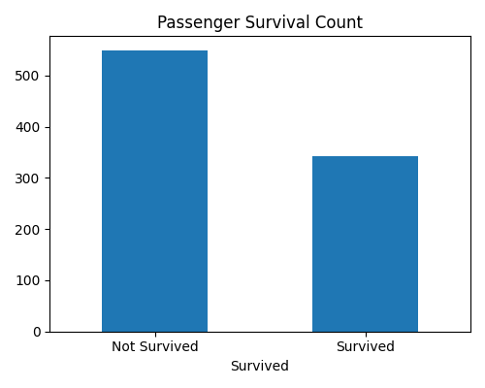
Most passengers did not survive, but a significant number survived, making survival prediction meaningful.

Figure 2: Survival by Gender
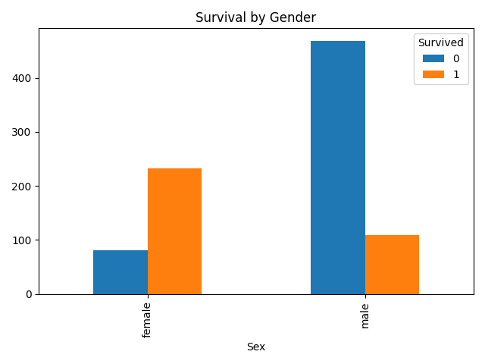
Female passengers had a much higher survival rate than male passengers.

Figure 3: Age Distribution
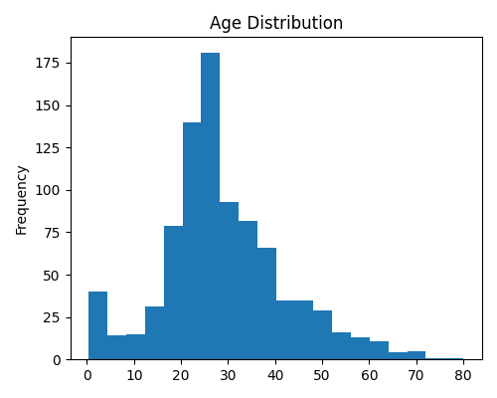
Most passengers were between 20 and 40 years old, with fewer elderly passengers.

Figure 4: Survival by Passenger Class
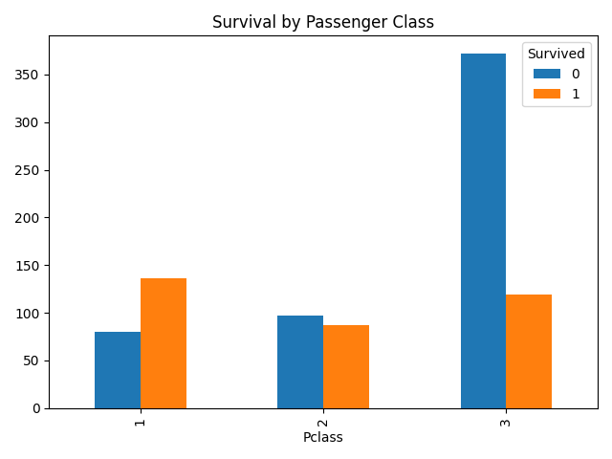
First-class passengers had better survival rates than second and third-class passengers.

Key Findings
- Female passengers survived more frequently than male passengers.
- First-class passengers had higher survival chances.
- Age distribution shows most passengers were adults between 20–40 years.
- The cleaned dataset was suitable for visualization because missing values had already been handled in Week 1.
- EDA helped identify important relationships between passenger features and survival.

Conclusion
This report continues the Week 1 Titanic data cleaning project by performing exploratory data analysis and visualization. The analysis successfully identified important survival trends based on gender, age, and passenger class. The visualizations provide clear insights into the dataset and demonstrate the complete EDA workflow.

