Week 5 Task: Deep Learning Application in Data Science
Titanic Passenger Survival Prediction — Neural Network Classification
Dataset: Titanic Cleaned Dataset (continuation of Weeks 1–4)

1. Objective
The objective of this task is to apply deep learning to a practical data-science problem using Python. Following the same Titanic dataset used for data cleaning in Week 1, exploratory analysis in Week 2, clustering in Week 3, and supervised learning in Week 4, a feed-forward neural network was designed, trained, validated, and evaluated for binary passenger-survival prediction.

2. Problem Statement
This is a binary classification problem. The target variable is Survived, where 0 represents a passenger who did not survive and 1 represents a passenger who survived. The analytical question is whether demographic, family, fare, passenger-class, embarkation, and title-related features can be used by a neural network to predict survival on unseen passengers.

3. Dataset and Connection to Previous Weeks
The Week 1 preprocessing pipeline produced a cleaned Titanic dataset. Missing Age values were filled using grouped medians based on passenger class and sex; missing Embarked values were filled with the mode; Fare extremes were capped at the 99th percentile; and low-value/high-missingness columns such as Cabin, Ticket, and PassengerId were removed. Title, FamilySize, IsAlone, Sex_encoded, and one-hot encoded Embarked/Title features were then created. The resulting dataset contains 891 rows and 20 columns in the supplied cleaned CSV.
Week 2 EDA showed that female passengers survived more often and that first-class passengers had higher survival rates. Week 3 K-Means clustering used Age, Fare, and FamilySize to segment passengers into three groups. Week 4 then used the same model-ready features for Logistic Regression and Random Forest classification. The Week 5 neural network therefore extends the existing workflow rather than introducing a new dataset.

4. Features Used
The neural network uses the same 16 model inputs selected in Week 4: Pclass, Sex_encoded, Age, SibSp, Parch, Fare, FamilySize, IsAlone, Embarked_C, Embarked_Q, Embarked_S, Title_Master, Title_Miss, Title_Mr, Title_Mrs, Title_Rare.

5. Neural Network Architecture
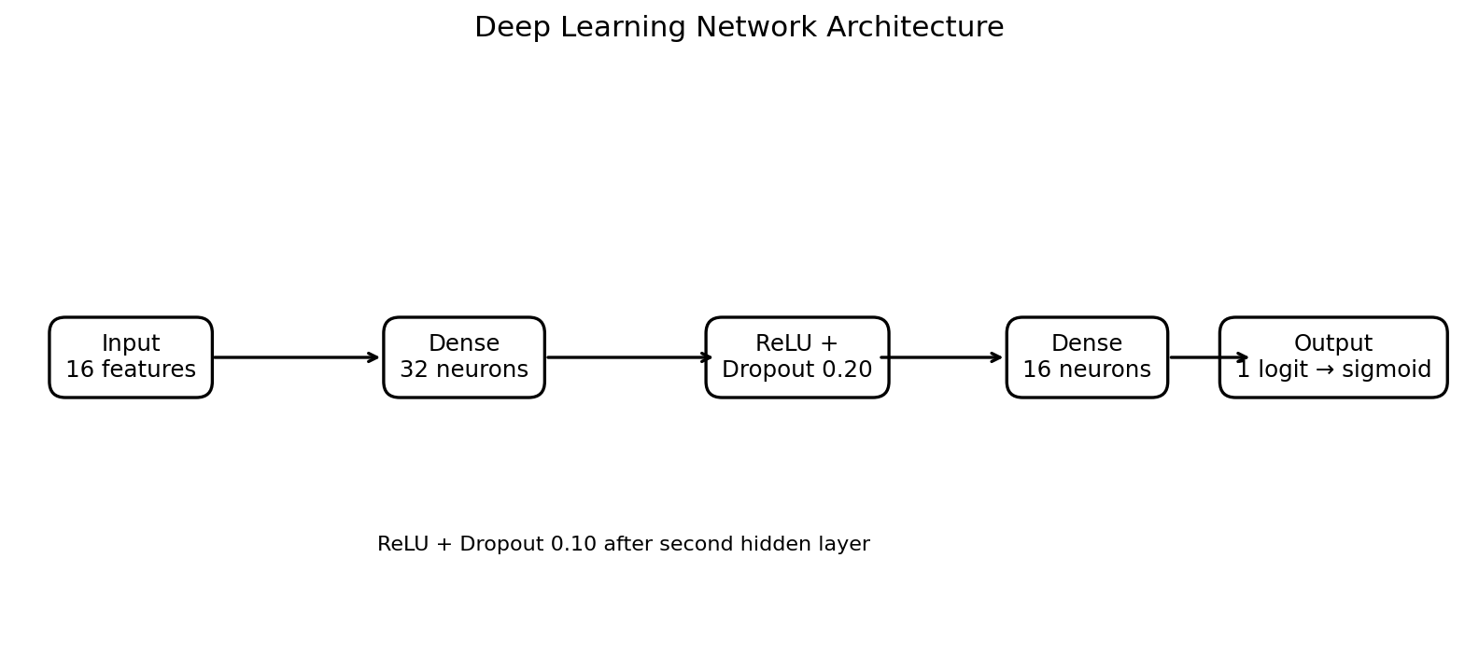
Figure 1. Feed-forward neural network architecture used for Titanic survival prediction.
Architecture: 16 input features → Dense(32) → ReLU → Dropout(0.20) → Dense(16) → ReLU → Dropout(0.10) → one output logit. Sigmoid is applied to the final logit when converting the prediction to a survival probability. The hidden layers allow the model to learn non-linear relationships and feature interactions that may not be represented by a purely linear classifier.

6. Training and Design Decisions
- Train/test split: 80% training and 20% held-out test set, stratified by Survived.
- Validation: 15% of the training portion was held out as an internal validation set, also stratified.
- Scaling: StandardScaler was fitted only on the training subset and then applied to validation and test data.
- Loss function: Binary Cross-Entropy with logits (BCEWithLogitsLoss).
- Optimizer: Adam with learning rate 0.001 and weight decay 0.0001.
- Batch size: 32.
- Regularization: Dropout of 0.20 and 0.10 in the two hidden stages.
- Training: maximum 300 epochs with early stopping based on validation loss (patience 25).
- Random seed: 42 for reproducibility.

7. Training Process
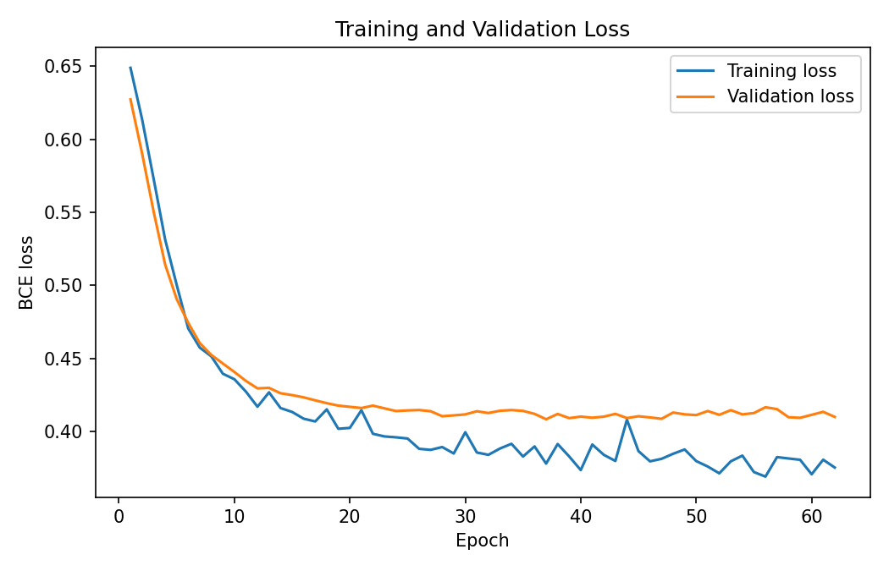
Figure 2. Training and validation loss across epochs.
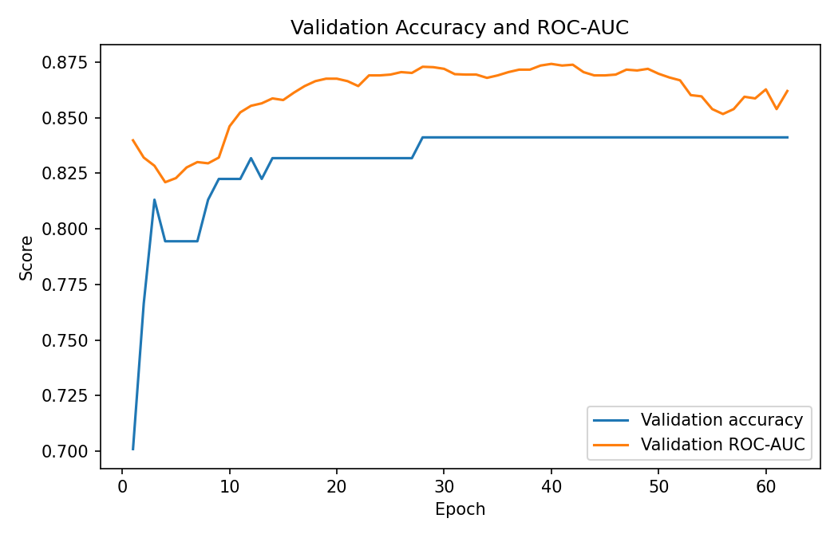
Figure 3. Validation accuracy and ROC-AUC during training.
Early stopping selected the model state from epoch 37. Training stopped after 62 epochs because the validation loss stopped improving sufficiently. This was used to reduce unnecessary training and limit overfitting on the relatively small Titanic dataset.

8. Evaluation Metrics and Results
Model | Accuracy | Precision | Recall | F1-Score | ROC-AUC
Logistic Regression | 0.8492 | 0.8281 | 0.7681 | 0.7970 | 0.8781
Random Forest (default) | 0.8380 | 0.8448 | 0.7101 | 0.7717 | 0.8615
Random Forest (tuned) | 0.8212 | 0.7937 | 0.7246 | 0.7576 | 0.8582
Deep Learning MLP | 0.8380 | 0.8704 | 0.6812 | 0.7642 | 0.8704
The Week 5 neural network achieved test accuracy of 0.8380, precision of 0.8704, recall of 0.6812, F1-score of 0.7642, and ROC-AUC of 0.8704. The ROC-AUC indicates good class-separation ability even though the neural network did not exceed the Week 4 Logistic Regression baseline on this small dataset.

9. ROC Curve and Confusion Matrix
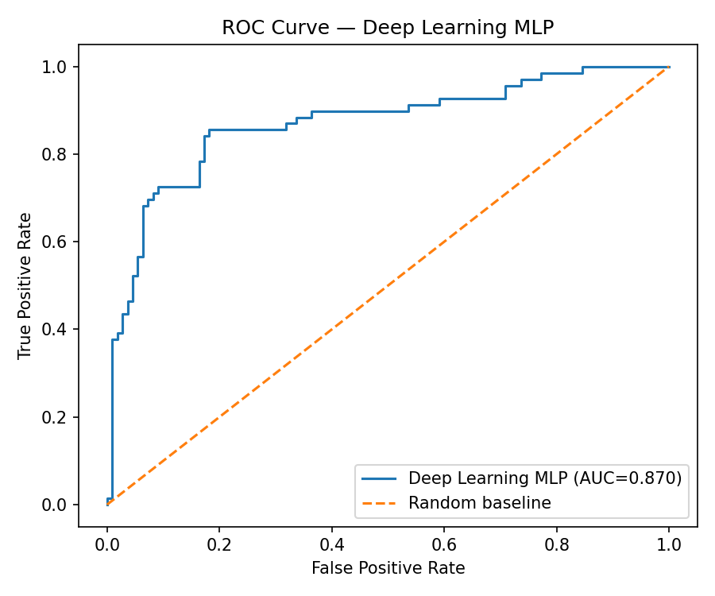
Figure 4. ROC curve for the Week 5 neural network.
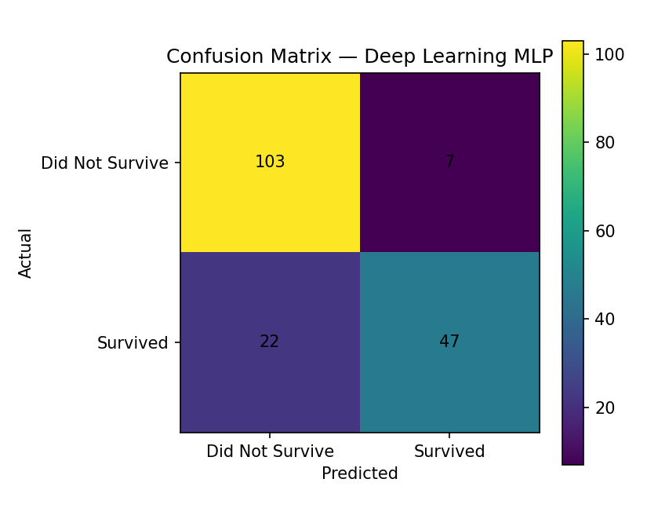
Figure 5. Confusion matrix for the Week 5 neural network.
On the 179-passenger test set, the confusion matrix contained 103 true negatives, 7 false positives, 22 false negatives, and 47 true positives. The model therefore correctly classified 150 of 179 test passengers.

10. Feature Importance and Interpretation
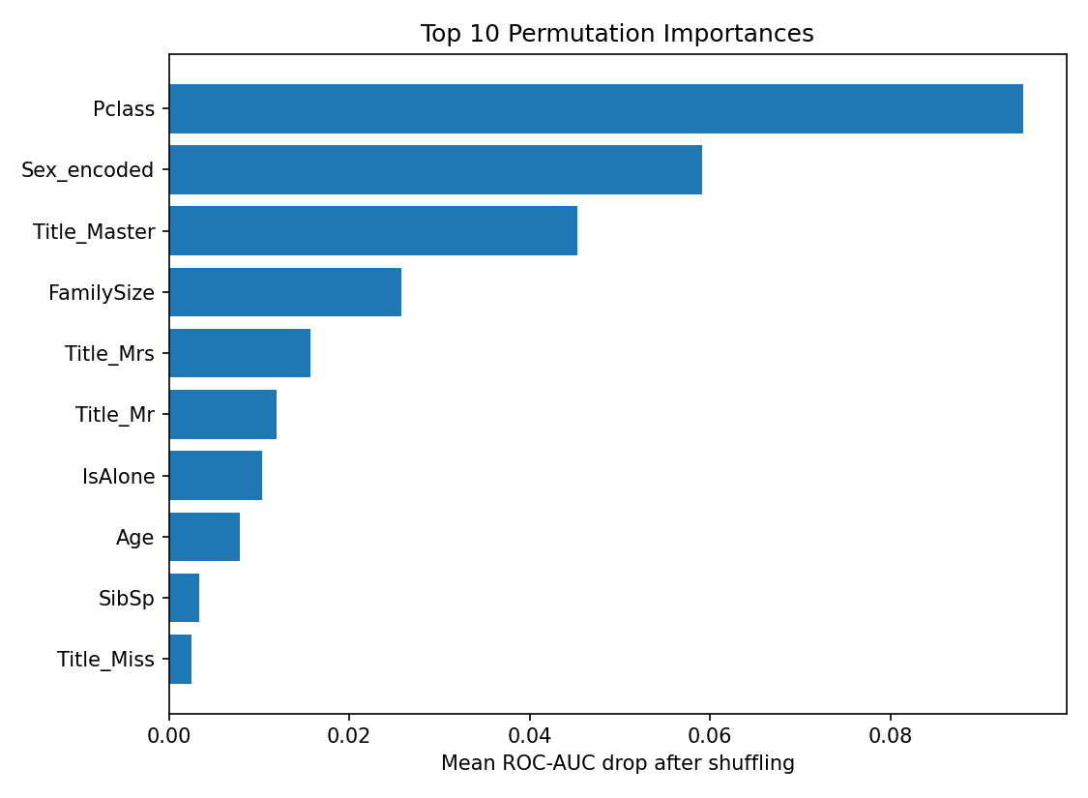
Figure 6. Top permutation importances measured by reduction in ROC-AUC after feature shuffling.
Because a neural network does not provide the same native feature-importance output as a Random Forest, permutation importance was used. Each feature was shuffled repeatedly in the test set and the average drop in ROC-AUC was recorded. Larger drops indicate that the model's predictions relied more strongly on that feature. The resulting ranking provides a model-specific interpretation while preserving the neural-network architecture.
Top five permutation-importance features:
- Pclass: mean ROC-AUC drop = 0.0948
- Sex_encoded: mean ROC-AUC drop = 0.0591
- Title_Master: mean ROC-AUC drop = 0.0453
- FamilySize: mean ROC-AUC drop = 0.0257
- Title_Mrs: mean ROC-AUC drop = 0.0157

11. Comparison with Week 4 Models
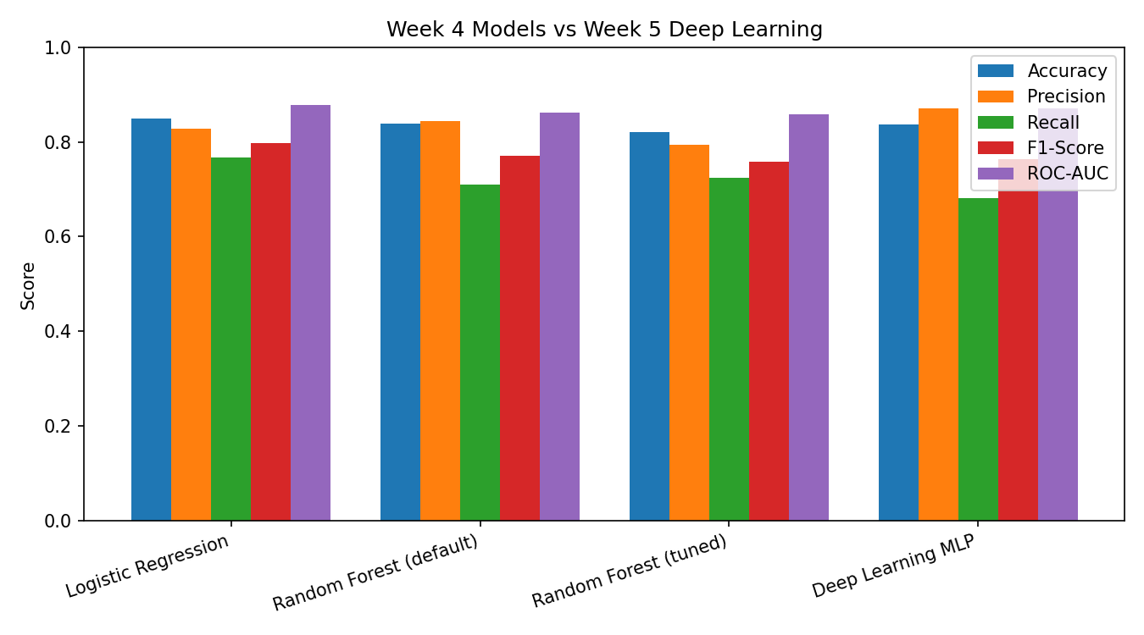
Figure 7. Comparison of Week 4 supervised models with the Week 5 deep learning model.
Logistic Regression from Week 4 remains the strongest overall test model for this dataset, with accuracy 0.8492 and ROC-AUC 0.8781. The Week 5 neural network reached ROC-AUC 0.8704, which is competitive but slightly lower. This result is useful rather than disappointing: the Titanic dataset has only 891 rows, so a more complex neural network does not automatically outperform a simpler, well-specified model. The neural network demonstrates the deep-learning workflow and captures non-linear relationships while also showing why model complexity should be justified by data size and performance.

12. Challenges Encountered and Solutions
- Small dataset: 891 observations limit the amount of information available for learning a high-capacity neural network.
- Overfitting risk: Dropout, weight decay, validation monitoring, and early stopping were used to control overfitting.
- Feature scale: Standardization was required so that features with different numeric ranges could be learned more consistently.
- Class distribution: Survival is moderately imbalanced, so stratified splitting was used to preserve the class ratio across subsets.
- Interpretability: Neural networks are less directly interpretable than Logistic Regression, so permutation importance was added.
- Model selection: The final neural network was retained as the Week 5 deep-learning model even though Week 4 Logistic Regression generalized better on the held-out test set.

13. Critical Analysis
The experiment demonstrates that deep learning can be applied successfully to structured tabular classification, but it also highlights an important practical lesson: more complex models are not always better. The neural network produced a strong ROC-AUC of 0.8704 and learned useful relationships from the engineered features, yet the simpler Logistic Regression model achieved the best overall test results in the previous week. This is plausible because the Titanic dataset is relatively small and many of its strongest signals—especially sex, passenger class, fare, and title—are already represented effectively by engineered tabular variables. The neural network is therefore valuable as a deep-learning implementation and as a foundation for future experiments, rather than being justified solely by winning the current benchmark.

14. Possible Improvements
- Perform repeated or nested cross-validation for a more stable estimate of neural-network generalization.
- Tune hidden-layer widths, dropout rates, learning rate, batch size, and weight decay systematically.
- Compare alternative architectures, including a smaller network to reduce variance on the small dataset.
- Experiment with class-weighted loss and threshold selection when recall for survivors is the priority.
- Add carefully justified engineered variables such as fare per family member or ticket-group information if reliable data is available.
- Use explainability tools such as SHAP, where appropriate, for per-passenger interpretation.

15. Conclusion
The Week 5 task successfully extended the Titanic data-science workflow into deep learning. A feed-forward neural network was designed using the same cleaned and feature-engineered dataset developed in Weeks 1–4. The model was trained with Adam, regularized with dropout and weight decay, monitored on a validation set, and stopped early to limit overfitting. On the held-out test set it achieved 0.838 accuracy and 0.870 ROC-AUC. The comparison with Week 4 confirms that the neural network is competitive but does not automatically outperform simpler models on a small tabular dataset. The main practical insight is that deep learning should be selected based on the problem, available data, validation evidence, and interpretability requirements rather than complexity alone.

16. Reproducibility and Deliverables
The accompanying Python script reproduces the complete Week 5 pipeline: data loading, stratified splitting, standardization, neural-network construction, training with early stopping, evaluation, permutation importance, and generation of the report figures and CSV outputs.

