DESIGN AN NIGHT LAMP

PUSH BUTTON:

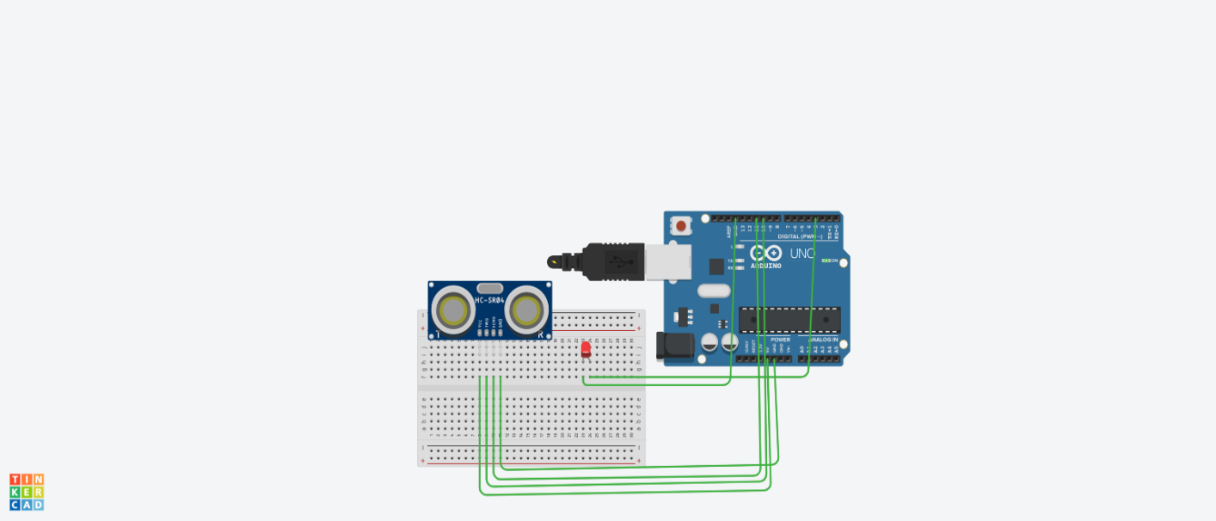

Theory:

CONCEPT USED:

➢ By using kirchoff’s voltage law &

➢ By using kirchoff’s current law

LEARNING AND OBSERVATIONS:

• Connections in Breadboard and wiring.

• How to control arduino and its coding. •

Use of multimeter for continuity.

OBSERVATION:

➢ When the object is near it measures the distance.

➢ Relation between software and hardware.

PROBLEMS & TROUBLESHOOTING:

o To select the right port and type of arduino

o To check the loose connections

o To check the connections according to the codes

o To check the continuity of the circuit

o To check the flow of current in the circuit

PRECAUTIONS:

o Handle tools carefully

o Wear gloves

o Do not connect arduino till the circuit is complete

OUTCOMES:

o Distance measurement when the object comes near to the ultrasonic sensor.

o Used in project works