The idea of our project:

TeleToAuto_ADY is a remote teleoperation system. An operator logs in through a web app and controls a distant humanoid robot with two inputs:
- Hand pose: a camera tracks both hands, and software converts them into arm joint angles using inverse kinematics.
- Head movement: the phone’s orientation sensor steers the robot’s head camera.
The robot copies these motions and streams its head-camera video back to the operator.
How it works
- The operator logs in. Our server checks credentials and ensures only one operator controls a robot at a time.
- The server sets up the connection (signaling), then WebRTC carries the live video and control data.
- The robot program checks each command for sanity and safety, then passes it to the simulator or arms.
- The robot’s camera video returns to the operator over the same WebRTC link
Main data Transfers that occurs:
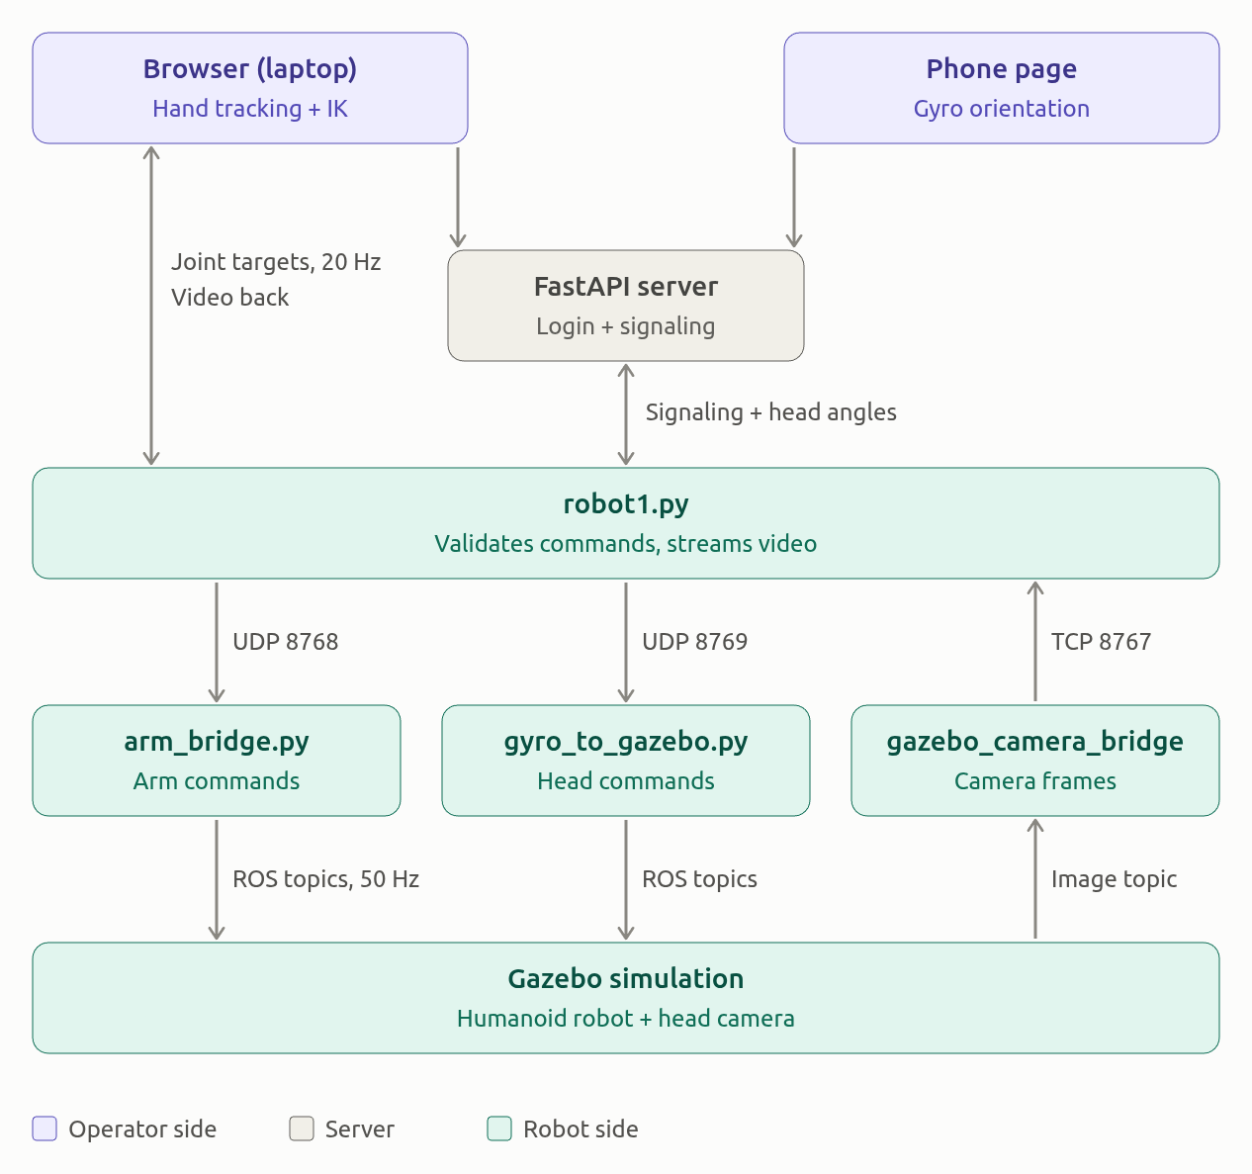

Topic | Type | Example data | Rate
/right_arm_position_controller/commands (and /left_...) | Float64MultiArray | [0.10, -0.35, 0.80, 0.20, 0.00, -0.60] — 5 joint angles plus gripper, in rad | 50 Hz
/camera_yaw_position_controller/commands (and /camera_pitch_...) | Float64MultiArray | [0.35] — one angle in rad | About 30 Hz, published on each phone packet
/joint_states | JointState | Joint names with measured positions, such as Revolute_23: 0.10 | Not set in the project; the controller manager runs at 100 Hz
/camera/sim_camera/image_raw | sensor_msgs/Image | 640×480 RGB frame | 30 Hz (the URDF sensor’s update_rate)

JSON data packet sent:
1. Joint data.

{
"type": "joint_targets",
"sequence": 1042,
"timestamp_ms": 1763020800123,
"units": "deg",
"arms": {
"left": { "shoulder_pan": 10.5, "shoulder_lift": -20.0, "elbow_flex": 45.0, "wrist_flex": 5.0, "wrist_roll": 0.0 },
"right": { "shoulder_pan": -8.0, "shoulder_lift": -15.5, "elbow_flex": 50.2, "wrist_flex": 3.1, "wrist_roll": 12.0 }
},
"gripper": { "left_percent": 0.0, "right_percent": 100.0 },
"arms_rad": {
"left": { "shoulder_pan": 0.1833, "shoulder_lift": -0.3491, "elbow_flex": 0.7854, "wrist_flex": 0.0873, "wrist_roll": 0.0 },
"right": { "shoulder_pan": -0.1396, "shoulder_lift": -0.2705, "elbow_flex": 0.8762, "wrist_flex": 0.0541, "wrist_roll": 0.2094 }
},
"gripper_rad": { "left": -1.5, "right": 0.0 },
"joint_units_rad": "rad",
"gripper_units_rad": "rad",
"received_at": 1763020800.131
}

2. Gyroscope data

{
"type": "mobile_imu_readout",
"gx": 20.05,
"gy": -6.88,
"units": "deg",
"source": "phone_device_orientation",
"timestamp_ms": 1763020800150
}

Detailed Wise topic/API data transmission in the project:

Folder wise Topic’s:

1. Client folder:

Topic / data | From → To | What it carries
Hand landmarks | hand-tracker.js → dual-hand-ik-controller.js (via app.js) | 21 points per hand, handedness and a quality score
joint_targets | dual-hand-ik-controller.js → app.js → robot-connection.js → WebRTC joint-control → robot1.py | Left and right arms: 5 joints each in degrees, plus gripper open/closed. 20 Hz
Joint UDP, port 8768 | robot1.py → arm_bridge.py | Same targets, converted to radians
Arm ROS topics | arm_bridge.py → /right_arm_position_controller/commands and /left_arm_position_controller/commands | 6 values per arm (5 joints + gripper), 50 Hz, speed-limited
head_orientation | mobile-gyro.js → server/websocket.py → robot1.py | Yaw, pitch, roll in radians, about 30 Hz
Head UDP, port 8769 | robot1.py → gyro_to_gazebo.py | Same orientation data
Camera ROS topics | gyro_to_gazebo.py → /camera_yaw_position_controller/commands and /camera_pitch_position_controller/commands | Head yaw and tilt
mobile_imu_readout | server/websocket.py → app.js | Phone gx/gy in degrees, shown as a readout only
Video frames (TCP 8767) | gazebo_camera_bridge.py → robot1.py | JPEG frames from /camera/sim_camera/image_raw, with a 4-byte length prefix
Video track | robot1.py → robot-connection.js → ui-controller.js (and the phone page) | Robot head-camera video over WebRTC
Signaling (offer / answer / candidate) | robot1.py ↔ server/websocket.py ↔ browser or phone | WebRTC session setup
Session events | server/websocket.py ↔ robot, browser, phone | browser_ready, mobile_ready, *_disconnected, robot_disconnected, error

2. Server Folder

Topic / data | From → To | What it carries
First message (auth) | Robot, browser or phone → websocket.py | Role, robot ID, and a robot token or user session token
authenticated | websocket.py → robot | Robot accepted
connected / mobile_gyro_connected | websocket.py → browser / phone | Slot reserved
browser_ready / mobile_ready | websocket.py → robot | A viewer is ready, so the robot starts a WebRTC session
offer, candidate | Robot → browser or phone (the viewer field picks which) | WebRTC session setup from the robot
answer, candidate | Browser or phone → robot | WebRTC reply. For phone messages the server adds viewer: mobile
head_orientation | Phone → websocket.py → robot | Yaw, pitch, roll in radians. Dropped if older than 1 s or outside ±π
mobile_imu_readout | websocket.py → browser | Phone gx/gy in degrees, for display only
robot_disconnected | robot_manager.py → browser and phone | The robot went offline
browser_disconnected / mobile_disconnected | robot_manager.py → robot | The viewer left, so the robot closes that session
error | websocket.py → client | Robot offline, not authorized or already in use
Users and robots data | users.json, robots.json → config.py → auth.py / robot_manager.py | Password hashes, robot tokens and each robot’s allowed users
Session tokens | auth.py (in-memory table) | Token to username map

3. Robot folder

Topic / data | From → To | What it carries
Authentication | robot1.py → websocket.py | role: robot, robot ID and token
authenticated | websocket.py → robot1.py | Robot accepted
browser_ready / mobile_ready | websocket.py → robot1.py | A viewer is ready, so the robot creates a WebRTC peer for it
offer, candidate | robot1.py → websocket.py → browser or phone | SDP offer. It is sent after ICE gathering finishes, with a 10 s timeout
answer | Browser or phone → websocket.py → robot1.py | SDP reply, matched to the right peer by the viewer field
browser_disconnected / mobile_disconnected | websocket.py → robot1.py | Close that viewer’s peer
joint_targets | Browser → robot1.py, on WebRTC joint-control | Arm angles in degrees, left and right, plus gripper
head_orientation | Phone → websocket.py → robot1.py | Yaw, pitch, roll in radians
head_orientation / head_gyro | Browser → robot1.py, on WebRTC imu-control | Channel is wired up on the robot side, but the current browser never sends on it
Joint UDP, port 8768 | robot1.py → arm_bridge.py | Degrees plus added radian fields, and a received_at time
Head UDP, port 8769 | robot1.py → gyro_to_gazebo.py | Orientation packets
Video frames (TCP 8767) | gazebo_camera_bridge.py → robot1.py | JPEG frames, each with a 4-byte length prefix
Video track | robot1.py → browser and phone | Latest Gazebo frame over WebRTC

4. static folder

Topic / data | From → To | What it carries
UDP 8768 | robot1.py → arm_bridge.py | joint_targets: degrees for 5 joints per arm, gripper percent, plus a received_at time
/right_arm_position_controller/commands | arm_bridge.py → Gazebo controller | 6 radian values: 5 joints and the gripper. 50 Hz
/left_arm_position_controller/commands | arm_bridge.py → Gazebo controller | Same, for the left arm
/joint_states | Gazebo → arm_bridge.py | Measured joint positions. Used as the starting pose so the arm doesn’t jump
UDP 8769 | robot1.py → gyro_to_gazebo.py | head_orientation in radians, or head_gyro in deg/s
/camera_yaw_position_controller/commands | gyro_to_gazebo.py → Gazebo controller | Camera yaw (Revolute_18)
/camera_pitch_position_controller/commands | gyro_to_gazebo.py → Gazebo controller | Camera vertical tilt (Revolute_19), driven by phone roll
/camera/sim_camera/image_raw | Gazebo camera → gazebo_camera_bridge.py | Raw simulated camera images
TCP 8767 | gazebo_camera_bridge.py → robot1.py | JPEG frames, each with a 4-byte length prefix

Folder wise API’s:

1. Client folder

Endpoint | Method | Called from → Handled by | Purpose / data
/ | GET | Browser → routes.py | Serves index.html
/mobile | GET | Phone → routes.py | Serves mobile-index.html
/app.js, /style.css, other .js modules | GET | Browser → routes.py | Serves the client files
/api/health | GET | Any → routes.py | Returns ok and the list of online robots
/api/login | POST | ui-controller.js → routes.py / auth.py | Sends username and password, returns a session token
/api/robots | GET | ui-controller.js → routes.py | Needs a token. Returns the robots the user may use, with online/busy status
/api/calibration | GET | Client → routes.py | Needs a token. Returns SO-101 leader calibration, or a default
/ws (role robot) | WebSocket | robot1.py → websocket.py | Authenticates with robot ID and token, then exchanges signaling
/ws (role browser) | WebSocket | robot-connection.js → websocket.py | Authenticates with session token and robot ID. Takes the single operator slot
/ws (role mobile_gyro) | WebSocket | mobile-gyro.js → websocket.py | Authenticates, takes the phone slot, sends head_orientation

2. Server folder

Endpoint | Method | Handled in | Purpose
/, /mobile | GET | routes.py | Serve index.html and mobile-index.html
Client files (/app.js, /style.css, other .js modules) | GET | routes.py | Serve the client files
/favicon.ico, /.well-known/appspecific/com.chrome.devtools.json | GET | routes.py | Inline icon, and an empty reply for Chrome’s probe
/api/health | GET | routes.py | Returns ok and the online robot IDs
/api/login | POST | routes.py → auth.py | Username and password in, session token out
/api/robots | GET | routes.py → robot_manager.py | Needs a Bearer token. Returns the user’s robots with online, busy and used-by status
/api/calibration | GET | routes.py | Needs a Bearer token. Returns leader calibration from lerobot’s cache, or the built-in default
/ws | WebSocket | websocket.py | Role is robot, browser or mobile_gyro

3. Robot folder

Interface | Direction | Purpose
/ws signaling WebSocket | Robot → server | Auth, session setup and viewer events
WebRTC joint-control | Browser → robot | Arm targets, 20 Hz
WebRTC imu-control | Browser → robot | Head orientation (unused by the current browser)
WebRTC video track | Robot → viewers | Head-camera video
UDP 8768 and 8769 | Robot → local ROS bridges | Arm and head commands
TCP 8767 | Local ROS bridge → robot | Camera frames

4. Static folder

Interface | Where | Purpose
UDP 8768 and 8769 | Listened to by arm_bridge.py and gyro_to_gazebo.py | Receive arm and head commands from robot1.py
TCP 8767 | gazebo_camera_bridge.py connects to robot1.py | Camera frames
ROS 2 topics | The topics in section 2 | Gazebo control and camera
Parameters | The ROS parameters on arm_bridge.py and gyro_to_gazebo.py | UDP host and port, topic names, speed limits, gripper open and closed angles and publish rate

