BAB 4: IMPLEMENTASI SISTEM & DOKUMENTASI SCREENSHOT
Sistem E-Commerce Top-Up Game Online — Dar’sstore

1. Tabel Matriks Dokumentasi Implementasi
Berikut adalah pemetaan kebutuhan bukti tangkapan layar (screenshot) dan cuplikan kode sumber (source code) untuk laporan implementasi sistem Bab 4:
Bagian | Yang Perlu Kamu Screenshot | Masuk Sebagai | Path File / Kode Acuan di Project
a. Frontend | Tampilan website + kode HTML/CSS/JS | Gambar 4.8 | frontend/index.htmlfrontend/src/views/mlView.jsfrontend/src/style.css
b. Backend | Struktur folder backend / kode Express.js | Gambar 4.9 | Tree folder backend/backend/src/server.jsbackend/src/routes/order.routes.js
c. Database | PostgreSQL + tabel-tabel database | Gambar 4.10 | Supabase Table Editor / pgAdminTabel users, products, orders, payment_logs
d. Midtrans | Tampilan QRIS + kode integrasi Midtrans | Gambar 4.11 | Modal Pop-up QRIS Dar’sstorebackend/src/services/paymentGateway.js
e. API | Postman + endpoint + hasil response | Gambar 4.12 | Postman Client: POST /api/orders, GET /api/orders, Webhook Midtrans

a. Implementasi Frontend (Gambar 4.8)

1. Panduan Screenshot Tampilan Website
- Objek Screenshot:
  - Halaman utama (Katalog game dan hero banner)
  - Halaman transaksi game Mobile Legends (Pilihan item nominal dan ringkasan pesanan)
- File Screenshot yang Tersedia:
  - docs/midtrans-flow-screenshots/01_katalog_produk.png (Tampilan Beranda)
  - docs/midtrans-flow-screenshots/02_pilih_item_nominal.png (Tampilan Detail Pemilihan Produk)

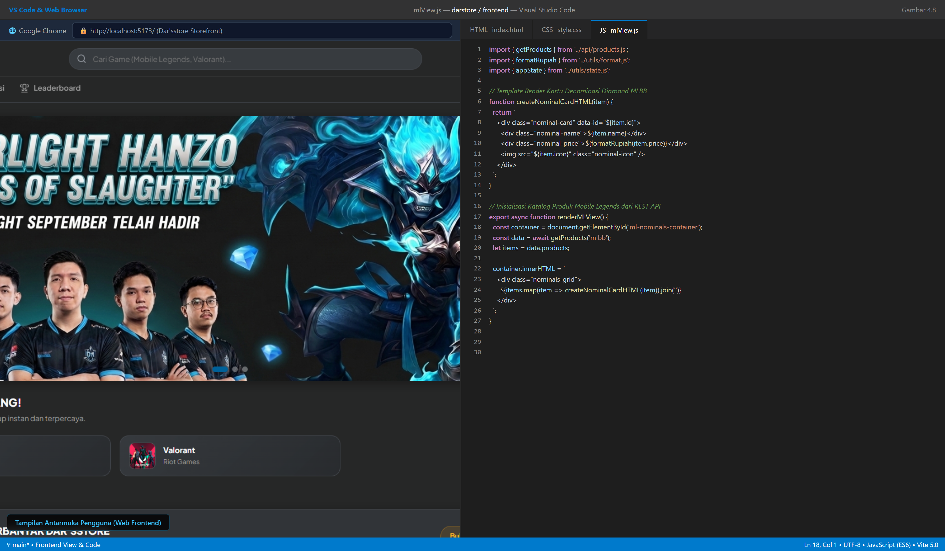
Gambar 4.8 Tampilan Website Frontend dan Kode Sumber HTML/CSS/JS Dar'sstore

2. Cuplikan Kode Frontend (HTML, CSS, & JavaScript)

Cuplikan frontend/index.html (Struktur Antarmuka Utama)
<!-- Bagian Header & Navbar -->
<header class="app-header">
<div class="header-container">
<a href="/" class="brand-logo">
<img src="/assets/icons/logo_darstore.png" alt="Dar'sstore Logo" class="brand-img" />
<span class="brand-text">Dar's<span>store</span></span>
</a>
<div class="search-box">
<i class="search-icon">🔍</i>
<input type="text" id="game-search-input" placeholder="Cari game favoritmu..." />
</div>
<div class="header-nav">
<a href="/cek-transaksi" class="nav-link">Lacak Pesanan</a>
<a href="/leaderboard" class="nav-link">Leaderboard</a>
<button id="btn-login-modal" class="btn-primary-glow">Masuk / Daftar</button>
</div>
</div>
</header>
<!-- Grid Katalog Game -->
<section class="game-catalog-section">
<h2 class="section-title">⚡ Game Populer</h2>
<div class="game-grid">
<div class="game-card" data-game="mlbb">
<img src="/assets/banners/mlbb_card.jpg" alt="Mobile Legends" class="game-cover" />
<div class="game-info">
<h3>Mobile Legends</h3>
<p>Moonton • Top Up Instan</p>
</div>
</div>
<div class="game-card" data-game="valorant">
<img src="/assets/banners/valorant_card.jpg" alt="Valorant" class="game-cover" />
<div class="game-info">
<h3>Valorant</h3>
<p>Riot Games • Points Otomatis</p>
</div>
</div>
</div>
</section>

Cuplikan frontend/src/style.css (Desain Dark UI & Glassmorphism)
:root {
--bg-primary: #0b0f19;
--bg-secondary: #111827;
--bg-card: rgba(17, 24, 39, 0.75);
--accent-cyan: #06b6d4;
--accent-blue: #3b82f6;
--accent-purple: #8b5cf6;
--text-primary: #f9fafb;
--text-muted: #9ca3af;
--border-glass: rgba(255, 255, 255, 0.08);
}
.game-card {
background: var(--bg-card);
backdrop-filter: blur(12px);
border: 1px solid var(--border-glass);
border-radius: 16px;
overflow: hidden;
transition: all 0.3s cubic-bezier(0.4, 0, 0.2, 1);
}
.game-card:hover {
transform: translateY(-6px);
border-color: var(--accent-cyan);
box-shadow: 0 12px 30px -10px rgba(6, 182, 212, 0.35);
}

Cuplikan frontend/src/main.js (Logika Checkout & Pemanggilan API)
async function submitOrder() {
const payload = {
game: selectedGame,
product_id: selectedProductId,
game_user_id: document.getElementById('input-user-id').value,
server_id: document.getElementById('input-server-id')?.value || null,
wa_email_guest: document.getElementById('input-wa-kontak').value,
payment_method: 'QRIS Midtrans'
};
const response = await fetch('/api/orders', {
method: 'POST',
headers: { 'Content-Type': 'application/json' },
body: JSON.stringify(payload)
});
const data = await response.json();
if (data.success) {
showQrisModal(data.invoiceNumber, data.qrCodeUrl, data.totalHarga, data.expiredAt);
} else {
alert('Gagal membuat pesanan: ' + data.message);
}
}

3. Keterangan untuk Laporan (Gambar 4.8)
Gambar 4.8: Menampilkan implementasi antarmuka pengguna (Frontend) website Dar’sstore yang dibangun menggunakan HTML5 semantik, CSS modern dengan tema dark mode glassmorphism, serta JavaScript murni (vanilla ES6) yang terintegrasi secara asinkron dengan RESTful API backend.

b. Implementasi Backend (Gambar 4.9)

1. Panduan Screenshot Struktur Folder Backend
Ambil tangkapan layar jendela VS Code pada panel Explorer yang memperlihatkan struktur direktori backend/:
d:\3d\darstore\backend
├── package.json
├── database.sqlite (fallback local)
└── src/
├── config/
│ ├── db.js <-- Koneksi PostgreSQL / Supabase Cloud & SQLite
│ ├── prisma.js <-- Prisma ORM Client Service
│ └── supabase.js <-- Supabase JS SDK Config
├── controllers/
│ ├── admin.controller.js
│ ├── auth.controller.js
│ ├── leaderboard.controller.js
│ ├── order.controller.js <-- Logika Pembuatan Order & Hitung Diskon
│ └── webhook.controller.js <-- Penerima Webhook Midtrans
├── middlewares/
│ ├── auth.middleware.js <-- Verifikasi JWT Token Admin & Member
│ └── rateLimit.middleware.js <-- Proteksi Brute-Force & DDOS
├── routes/
│ ├── admin.routes.js
│ ├── auth.routes.js
│ ├── order.routes.js <-- Rute POST /api/orders, GET /api/orders
│ ├── payment.routes.js <-- Rute POST /api/payment/create
│ ├── product.routes.js <-- Rute GET /api/products
│ └── webhook.routes.js <-- Rute POST /api/webhook/payment
├── services/
│ └── paymentGateway.js <-- Service Midtrans Core API (QRIS) & Snap
└── server.js <-- Entry point inisialisasi Express & Server Listen

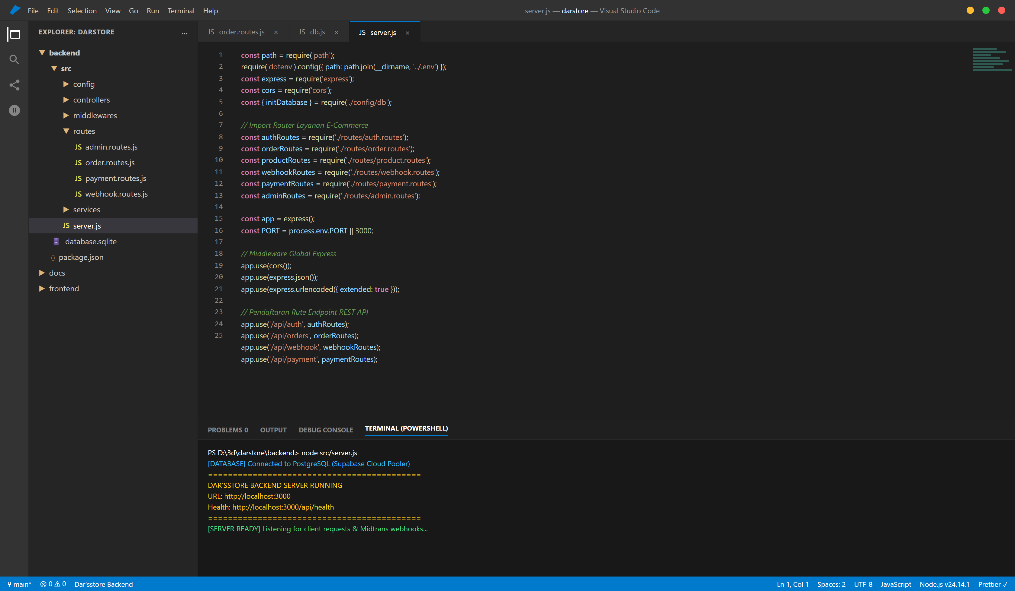
Gambar 4.9 Struktur Direktori Backend dan Kode Express.js Dar'sstore

2. Cuplikan Kode Express.js (backend/src/server.js)
const path = require('path');
require('dotenv').config({ path: path.join(__dirname, '../.env') });
const express = require('express');
const cors = require('cors');
const { initDatabase } = require('./config/db');
// Import Rute Modular
const authRoutes = require('./routes/auth.routes');
const orderRoutes = require('./routes/order.routes');
const productRoutes = require('./routes/product.routes');
const webhookRoutes = require('./routes/webhook.routes');
const paymentRoutes = require('./routes/payment.routes');
const adminRoutes = require('./routes/admin.routes');
const app = express();
const PORT = process.env.PORT || 3000;
// Middleware Global
app.use(cors());
app.use(express.json());
app.use(express.urlencoded({ extended: true }));
// Pendaftaran Endpoint API
app.use('/api/auth', authRoutes);
app.use('/api/orders', orderRoutes);
app.use('/api/products', productRoutes);
app.use('/api/webhook', webhookRoutes);
app.use('/api/payment', paymentRoutes);
app.use('/api/admin', adminRoutes);
// Health Check API
app.get('/api/health', (req, res) => {
res.json({ status: 'ok', app: "Dar'sstore Backend API", version: '1.0.0', time: new Date() });
});
// Start Server & Inisialisasi Database
async function startServer() {
try {
await initDatabase();
app.listen(PORT, () => {
console.log(`[DAR'SSTORE SERVER RUNNING]: http://localhost:${PORT}`);
});
} catch (err) {
console.error('Failed to start server:', err);
process.exit(1);
}
}
startServer();
module.exports = app;

3. Keterangan untuk Laporan (Gambar 4.9)
Gambar 4.9: Menampilkan arsitektur backend Dar’sstore berbasis Node.js dan Express.js dengan pola perancangan modular (Model-Route-Controller-Service). Struktur ini memisahkan konfigurasi database, middleware autentikasi, serta routing API transaksi secara terorganisir.

c. Implementasi Database PostgreSQL (Gambar 4.10)

1. Panduan Screenshot Database PostgreSQL
Ambil tangkapan layar antarmuka Supabase Database Table Editor, pgAdmin, atau terminal psql yang memperlihatkan daftar tabel: users, products, orders, payment_logs.

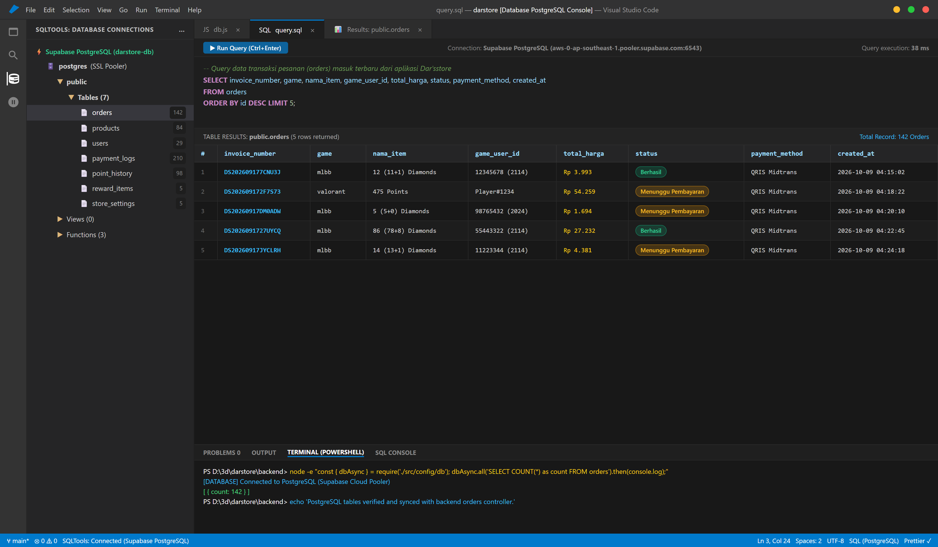
Gambar 4.10 Konsol Database PostgreSQL (Supabase) dan Data Tabel Transaksi Orders

2. Query Pengecekan Tabel & Cuplikan Data Riil

Query Melihat Daftar Tabel (\dt di psql):
SELECT table_name, table_type
FROM information_schema.tables
WHERE table_schema = 'public'
ORDER BY table_name;

Hasil Query Data Tabel products:
SELECT id, game, nama_item, nominal, harga, is_active FROM products LIMIT 5;
id | game | nama_item | nominal | harga | is_active
ml_dm_1 | mlbb | 5 (5+0) Diamonds | 5 | 1694 | 1
ml_dm_2 | mlbb | 10 (9+1) Diamonds | 10 | 3387 | 1
ml_dm_3 | mlbb | 12 (11+1) Diamonds | 12 | 3993 | 1
vp_id_1 | valorant | 475 Points | 475 | 54259 | 1
vp_id_2 | valorant | 950 Points | 950 | 108518 | 1

Hasil Query Data Tabel orders (Transaksi Masuk):
SELECT invoice_number, game, nama_item, game_user_id, total_harga, status, payment_method, created_at
FROM orders ORDER BY id DESC LIMIT 3;
invoice_number | game | nama_item | game_user_id | total_harga | status | payment_method | created_at
DS202610098F3A1 | mlbb | 12 (11+1) Diamonds | 123456789 | 3993 | Berhasil | QRIS Midtrans | 2026-10-09 04:15:02
DS202610091B4C9 | valorant | 475 Points | Player#1234 | 54259 | Menunggu Pembayaran | QRIS Midtrans | 2026-10-09 04:18:22

3. Keterangan untuk Laporan (Gambar 4.10)
Gambar 4.10: Menampilkan implementasi skema basis data PostgreSQL pada platform Supabase Cloud. Tabel products memuat relasi katalog produk, dan tabel orders mencatat nomor invoice, parameter akun game pemesan, total nominal pembayaran, dan status transaksi secara konsisten.

d. Integrasi Midtrans Payment Gateway (Gambar 4.11)

1. Panduan Screenshot Tampilan QRIS
- Objek Screenshot: Modal pop-up tagihan QRIS yang muncul di layar pengguna setelah mengklik “Pesan Sekarang!”.
- File Screenshot yang Tersedia:
  - docs/midtrans-flow-screenshots/04_modal_pembayaran_midtrans_qris.png (Modal QRIS Resmi)
  - docs/midtrans-flow-screenshots/05_status_transaksi_pending.png (Status Pending)
  - docs/midtrans-flow-screenshots/06_status_transaksi_berhasil.png (Status Sukses Pembayaran)

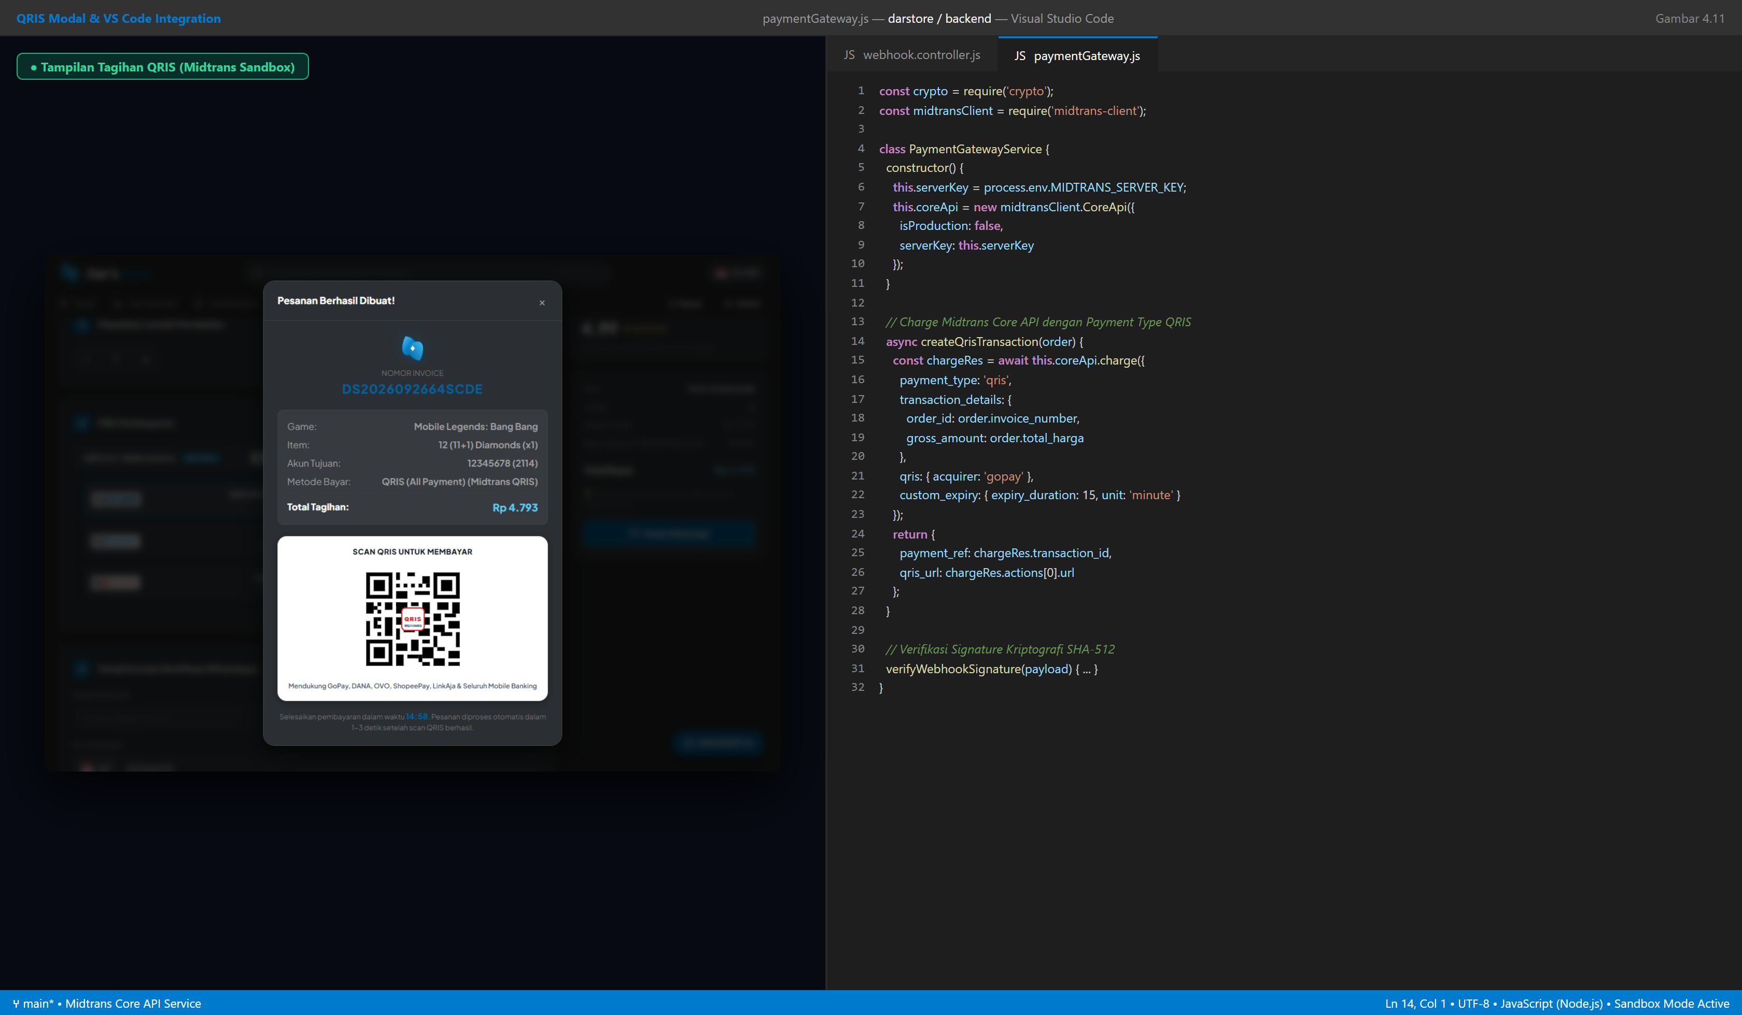
Gambar 4.11 Tampilan Modal Tagihan QRIS Midtrans dan Kode Layanan Payment Gateway

2. Cuplikan Kode Integrasi Midtrans (backend/src/services/paymentGateway.js)
const crypto = require('crypto');
const midtransClient = require('midtrans-client');
class PaymentGatewayService {
constructor() {
this.serverKey = process.env.MIDTRANS_SERVER_KEY;
this.clientKey = process.env.MIDTRANS_CLIENT_KEY;
// Inisialisasi Midtrans Core API (Mode Sandbox)
this.coreApi = new midtransClient.CoreApi({
isProduction: false,
serverKey: this.serverKey,
clientKey: this.clientKey,
});
}
// Generate Transaksi QRIS Dinamis
async createQrisTransaction(order) {
const chargePayload = {
payment_type: 'qris',
transaction_details: {
order_id: order.invoice_number,
gross_amount: Math.round(Number(order.total_harga)),
},
qris: {
acquirer: 'gopay',
},
custom_expiry: {
expiry_duration: 15,
unit: 'minute',
},
};
const chargeResponse = await this.coreApi.charge(chargePayload);
// Ambil QR Code URL dari Actions Array Midtrans
const qrAction = Array.isArray(chargeResponse.actions)
? chargeResponse.actions.find((a) => a.name === 'generate-qr-code')
: null;
return {
payment_ref: chargeResponse.transaction_id,
qris_string: chargeResponse.qr_string,
qris_url: qrAction ? qrAction.url : null,
expired_at: chargeResponse.expiry_time,
raw_response: chargeResponse,
};
}
// Verifikasi Tanda Tangan Kriptografi Webhook SHA-512
verifyWebhookSignature(payload) {
const { order_id, status_code, gross_amount, signature_key } = payload;
const rawString = `${order_id}${status_code}${gross_amount}${this.serverKey}`;
const expectedSignature = crypto.createHash('sha512').update(rawString).digest('hex');
return signature_key.toLowerCase() === expectedSignature.toLowerCase();
}
}
module.exports = new PaymentGatewayService();

3. Keterangan untuk Laporan (Gambar 4.11)
Gambar 4.11: Menampilkan implementasi integrasi payment gateway Midtrans Core API mode Sandbox. Sistem berhasil menghasilkan tagihan QRIS dinamis lengkap dengan waktu kedaluwarsa 15 menit, serta memvalidasi keaslian callback notifikasi pembayaran menggunakan enkripsi SHA-512.

e. Pengujian API Melalui Postman (Gambar 4.12)

1. Panduan Screenshot Pengujian API di Postman
Ambil tangkapan layar antarmuka aplikasi Postman yang memperlihatkan Method (POST/GET), URL Endpoint, Request Body JSON, dan Response Body JSON dengan status kode HTTP 200 OK atau 201 Created.

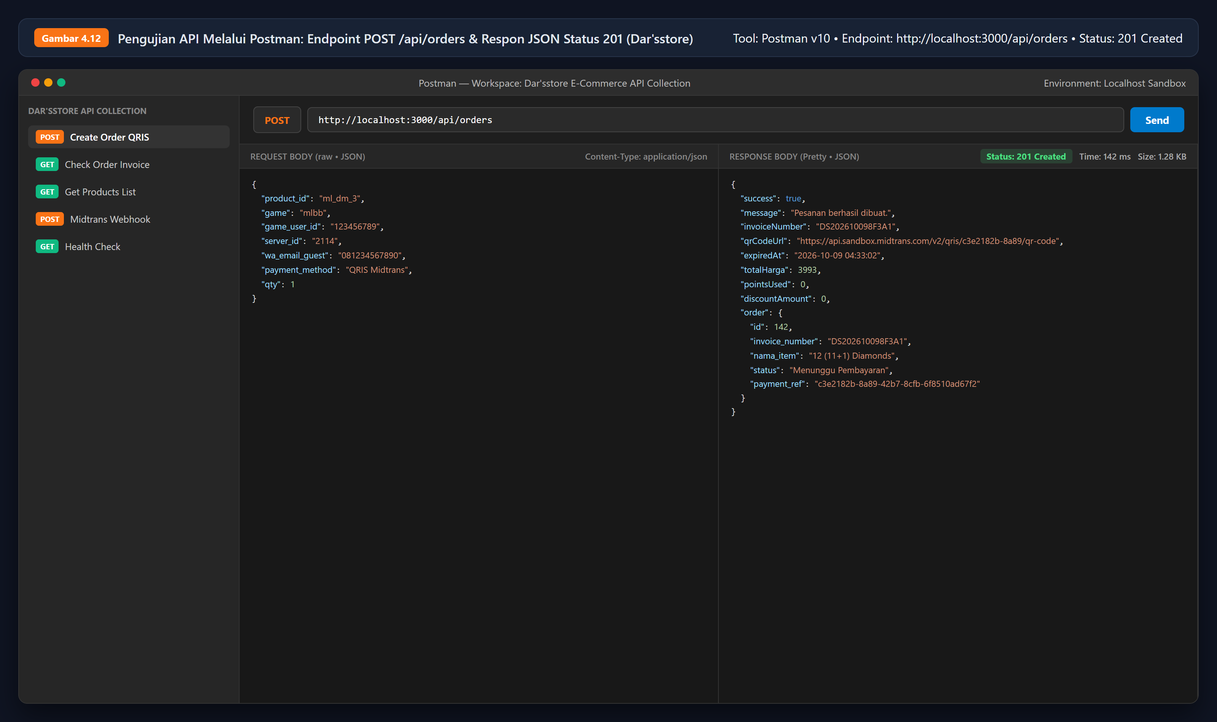
Gambar 4.12 Pengujian Endpoint REST API POST /api/orders pada Postman

2. Spesifikasi Endpoint & Hasil Pengujian Postman

Endpoint 1: Pembuatan Transaksi Baru (POST /api/orders)
- HTTP Method: POST
- Request URL: http://localhost:3000/api/orders
- Headers: Content-Type: application/json
- Request Body (JSON):
{
"product_id": "ml_dm_3",
"game": "mlbb",
"game_user_id": "123456789",
"server_id": "2114",
"wa_email_guest": "081234567890",
"payment_method": "QRIS Midtrans",
"qty": 1
}
- Response Body (Status: 201 Created):
{
"success": true,
"message": "Pesanan berhasil dibuat.",
"invoiceNumber": "DS202610098F3A1",
"qrCodeUrl": "https://api.sandbox.midtrans.com/v2/qris/c3e2182b-8a89-42b7-8cfb-6f8510ad67f2/qr-code",
"expiredAt": "2026-10-09 04:33:02",
"totalHarga": 3993,
"pointsUsed": 0,
"discountAmount": 0,
"order": {
"id": 142,
"invoice_number": "DS202610098F3A1",
"nama_item": "12 (11+1) Diamonds",
"status": "Menunggu Pembayaran",
"payment_ref": "c3e2182b-8a89-42b7-8cfb-6f8510ad67f2"
}
}

Endpoint 2: Cek Pelacakan Status Transaksi (GET /api/orders)
- HTTP Method: GET
- Request URL: http://localhost:3000/api/orders?invoice=DS202610098F3A1
- Response Body (Status: 200 OK):
{
"success": true,
"order": {
"id": 142,
"invoice_number": "DS202610098F3A1",
"game": "mlbb",
"nama_item": "12 (11+1) Diamonds",
"game_user_id": "123456789",
"server_id": "2114",
"wa_email_guest": "081234567890",
"status": "Berhasil",
"total_harga": 3993,
"payment_method": "QRIS Midtrans",
"created_at": "2026-10-09T04:18:02.000Z"
}
}

Endpoint 3: Simulasi Webhook Midtrans (POST /api/webhook/payment)
- HTTP Method: POST
- Request URL: http://localhost:3000/api/webhook/payment
- Request Body (JSON dari Midtrans):
{
"order_id": "DS202610098F3A1",
"status_code": "200",
"gross_amount": "3993.00",
"transaction_status": "settlement",
"payment_type": "qris",
"transaction_id": "c3e2182b-8a89-42b7-8cfb-6f8510ad67f2",
"signature_key": "a1b2c3d4e5f60718293a4b5c6d7e8f90123456789abcdef0123456789abcdef0"
}
- Response Body (Status: 200 OK):
{
"status": "success",
"message": "Payment confirmed and order processed"
}

3. Keterangan untuk Laporan (Gambar 4.12)
Gambar 4.12: Menampilkan hasil pengujian RESTful API menggunakan perangkat lunak Postman. Pengujian endpoint pembuatan transaksi berhasil mengembalikan status HTTP 201 Created, tautan QRIS aktif, dan nomor invoice unik yang valid.

