Reverse

Reverse Engineering

Description

Try reversing this file? Can ya?

I forgot the password to this file. Please find it for me?

Solution:

1) Download the file and open it in a text editor or notepad.

2) Search for the keyword picoCTF and you will find 2 different matches.

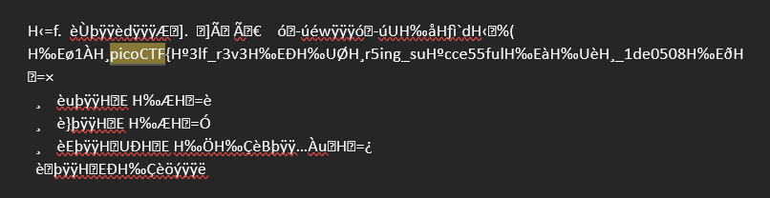

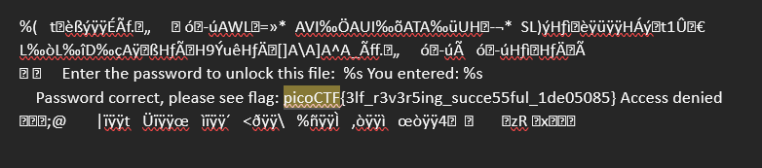

3) The fist one is not the correct flag however the second one is.

Flag: picoCTF{3lf_r3v3r5ing_succe55ful_1de05085}