**Hand Sign Language Recognition**

**Using Machine Learning And**

**Computer Vision**

*Final Year Project Report*

*Submitted in partial fulfillment of the requirements for the degree of*

***Bachelor of Technology***

*in*

***Information Technology Engineering***

|  |  |
| --- | --- |
| **Submited *by*** |  |

**Shreetama Mukherjee - 19101106026**

**Akash Kumar Shaw - 19101106027**

**Abhishek Srivastav - 20101106095**

**Shouvik De - 20101106088**

Supervisor:

**Dr. Subrata Kumar Mandal**



**Department of Information Technology Engineering**

### Jalpaiguri Government Engineering College Jalpaiguri_735102 (India)

10th June 2023

**Certificate**

### Department of Information Technology Engineering Jalpaiguri Government Engineering College, Jalpaiguri

It is certified that the work contained in the project report entitled “**Hand Sign Language Recognition using Machine Learning and Computer Vision”**

by the following students has been carried out under my/our supervision and that this work has not been submitted elsewhere for a degree.

Shreetama Mukherjee - 19101106026

Akash Kumar Shaw - 19101106027

Abhishek Srivastav - 20101106095

Shouvik De - 20101106088

**Dr. Subrata Kumar Mandal**

This project report entitled “**Hand Sign Language Recognition using Machine Learning and Computer Vision**” sub- mitted by the group is approved for the degree of Bachelor of Technology.

|  |
| --- |
|  |
|
| Date: |

The viva-voce examination has been held on .

. .

Examiner(s) Head, Dept. of Information Technology.



# Declaration

JGEC Jalpaiguri

10th June 2023

We declare that this written submission represents our ideas in our own words and where others’ ideas or words have been included, We have adequately cited and referenced the original sources. We declare that We have properly and accurately acknowledged all sources used in the production of this report. We also declare that We have adhered to all principles of academic honesty and integrity and have not misrepresented or fabricated or falsified any idea/data/fact/source in our submission. We understand that any violation of the above will be a cause for disciplinary action by the Institute and can also evoke penal action from the sources which have thus not been properly cited or from whom proper permission has not been taken when needed.

Shreetama Mukherjee - 19101106026

Akash Kumar Shaw - 19101106027

Abhishek Srivastav - 20101106095

Shouvik De - 20101106088

v



# Acknowledgements

JGEC Jalpaiguri

10th June 2023

I would like to extend My sincere and heartfelt thanks towards all those who helped me in making this Project. Without their active guidance, help, cooperation

And encouragement, I would not have been able to present project on time.

I extend my sincere gratitude to my Project Mentor **Dr. Subrata Kumar Mandal**

For his Moral support and guidance during the tenure of my Project.

I also acknowledgement with a deep sense of reverence, my gratitude towards my Group members for sharing their valuable thoughts with me in completing the project.

Shreetama Mukherjee - 19101106026

Akash Kumar Shaw - 19101106027

Abhishek Srivastav - 20101106095

Shouvik De - 20101106088



# Abstract

This report proposes a blockchain-based solution to the challenges faced by traditional e-voting systems, such as security, transparency, and trust. The proposed system allows voters to cast their votes remotely from their computer or mobile device. The voters have no need to visit a polling booth physically for casting their vote. In this project, voter authentication is carried out by UIDAI’s Aadhar authentication, the system ensures that each voter can only cast one vote and that their votes remain anonymous. In the implementation, the smart contract is developed in Solidity and deployed to execute the e-voting system on the Ethereum blockchain. The results of the proposed system are compared to state-of-the-art methods, demonstrating the feasibility and potential of this technology in revolutionizing the voting process. Keywords: E-voting systems,Ethereum blockchain, Voter authentication, Smart contract



# Abstract

This report proposes a Machine learning and Computer Vision based solution to the challenges faced by deaf and hard-of-hearing community due to the lack of understanding of sign language by the general public.

The proposed system allows an essential tool for communication for these individuals, and the inability of others to comprehend it can lead to social exclusion and communication barriers in various aspects of life, such as education, employment, and social interactions.

# Table of Contents

|  |  |
| --- | --- |
| **Acknowledgements** |  |
| **Abstract** |  |
| **List of Figures** |  |
| **List of Tables** |  |
| **1 Introduction** | **1** |
| 1.1 First section of this chapter . . . . . . . . . . . . . . . . . . . . . . . . . | 2 |
| 1.1.1 Equations and Math symbols . . . . . . . . . . . . . . . . . . . . | 2 |
| 1.1.2 Commonly used Symbols . . . . . . . . . . . . . . . . . . . . . | 2 |
| 1.2 Second section of this chapter . . . . . . . . . . . . . . . . . . . . . . . | 2 |
| **2 Literature Review** | **3** |
| **3 Problem Formulation and Proposed Solution** | **5** |
| 3.1 Figures and Tables . . . . . . . . . . . . . . . . . . . . . . . . . . . . . | 5 |
| 3.2 Code . . . . . . . . . . . . . . . . . . . . . . . . . . . . . . . . . . . . . | 7 |
| **4 Results and Discussion** | **9** |
| **5 Conclusion and Future Work** | **11** |
| 5.1 Conclusion . . . . . . . . . . . . . . . . . . . . . . . . . . . . . . . . . | 11 |
| 5.2 Future Work . . . . . . . . . . . . . . . . . . . . . . . . . . . . . . . . . | 11 |
| **A Appendix** | **13** |
| A.1 Appendix 1 . . . . . . . . . . . . . . . . . . . . . . . . . . . . . . . . . | 13 |
| A.2 Appendix 2 . . . . . . . . . . . . . . . . . . . . . . . . . . . . . . . . . | 13 |
| **References** | **15** |
| xi |  |

**List of Figures**

* 1. UML Class diagram 5
  2. Two simple graphs 6

xiii

# List of Tables

* 1. A table shows an example of multirow and multicolumn. 6
  2. Simple table. 7

xv

# Chapter 1 Introduction

This document contains commonly used essential templates to write a LATEX document. This document is to be used along with the files and folders provided. Writing a LATEX document is very simple. Often students need only very simple constructs. This document shows certain essential features that almost all technical report writing requires. Please consult the PDF file for the output of the document, and then look at the corresponding LATEX file to reproduce it. The document illustrates the following constructs

* Unnumbered and numbered Lists
* Equations
* Defining short macros for frequently used symbols
* Bibliography
* Figures
* Tables

The normal procedure for compiling a LATEX document that contains bibliographic entries is to follow the following steps

1. pdflatex mainrep
2. bibtex mainrep
3. pdflatex mainrep

In the above example mainrep is the main LATEX file.

In the preliminary pages, A blank page is inserted.1

1A blank page may be inserted after the cover page when using the twoside (duplex printing) option so that the beginning of the paper does not appear on the back side of the cover page.

1

2 *Introduction*

## First section of this chapter

This is the first chapter, which resides in a directory (folder) intro. Each chapter can contain section, subsection and so on.

### Equations and Math symbols

Equations should be set in a separate mode. For details on getting various types of aligned equations, consult the AMS-LATEX documentation amsldoc.pdf. Simple equa- tions are set as

∫ d*x* cos *x* = sin *x* (1.1)

Equation (1.1) is the integral of the cosine function. Mathematical symbols must al- ways be put inside $$, when they appear outside a math environment (such as equation, align, gather, etc). The symbol “ex” must be written as *x* and not as x.

Another commonly used construct for equations is the align environment to align several equations along a vertical line. It is usually the = sign across which the align- ment is done. The point of alignment for each equation is specified using the ampersand

symbol. One may use the online equation generator to get the latex code of required equations: <https://www.codecogs.com/latex/eqneditor.php>

*a* = *b* (1.2)

*a* + *e* + *f* + g = *m* + *n* + *z* (1.3)

*x* + 2 = *x*3 + 3*x*2 + 2*x* + 5 (1.4)

### Commonly used Symbols

For mathematical symbols it is very convenient to define frequently used symbols as a short macro. For example if you are to be using the symbol ηs frequently it is convenient to define it in as:

\newcommand{\etas}{\ensuremath{\eta_{\mathrm{s}}}}

in the preamble and to simply refer it to in the text as ηs or in a mathematical equation as

ηs = η (1 + ϕ).

* 1. **Second section of this chapter**

# Chapter 2 Literature Review

The bibliographic entries are to be kept in a file named <something>.bib. In this sample report we call it as mylit.bib. This file must be included without the .bib extension in the main file as: \bibliography{mylit}. Open the file mylit.bib to see the format in which the entries are written. This is written in the BibTEXformat. Most of the bibli- ographic web pages (Scopus, ISI Web) and software (EndNote, etc) allow you to export bibliographic entries in the BibTEXformat.

Items with same author is shown in ........

An article [1]

A book [2]

A series [3]

Someone’s thesis [4] Some technical report [5] A collection [6]

Visited website [7] Accepted for publication [8]

Submitted for publication [9] Not published [10]

Conversation [11]

3

# Chapter 3

**Problem Formulation and Proposed Solution**

## Figures and Tables

Figures are conveniently included using postscript format. If you are generating a figure in a software, please check if the software supports writing to a postscript or a PDF format. This format is loss less vector format and with reproduce in any magnification without any pixelation. Make sure to write it to an “Encapsulated Post-script”or .eps format.

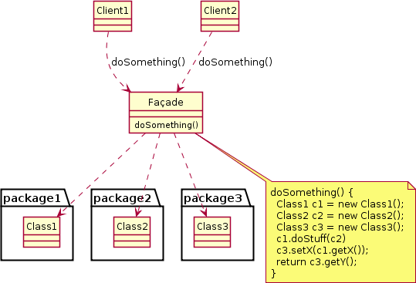

Figure 3.1: UML Class diagram showing an example of the Facade design pattern. The caption of the figure goes here. A shorter caption can be written in square brackets to identify it in the list of figures if required.

Figures should be given a label and which can be used to refer to them in the running text using \ref{} command. Figure 3.1 describes the process flow sheet of the Facade design pattern used in this study. Two simple graphs are shown in Figure 3.2. Multiple

5

6 *Problem Formulation and Proposed Solution*

figures with same caption can be arranged as shown in Figure 3.2 and they are referred in text such as Figure 3.2a and Figure 3.2b. The graphs should be drawn at appropriate places with center alignment and it should be referred in text.

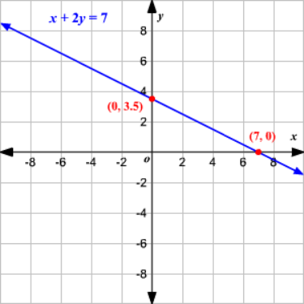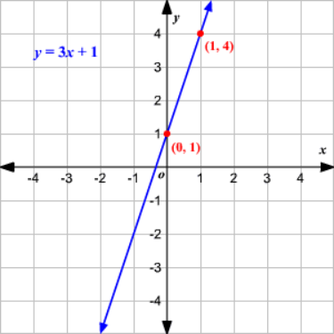

1. Figure2a (b) Figure2b

Figure 3.2: Two simple graphs

The format for tables is given below. The table must referred in the text as Table 3.1. The title of the table with table number should be written at the top of the table with center aligned as shown below in Table 3.1.

Table 3.1: A table shows an example of multirow and multicolumn.

|  |  |  |  |
| --- | --- | --- | --- |
| numeric literals |  | in decimal | 8743 |
| in octal | 0o7464 |
| integers | in hexadecimal | 0x5A0FF |
| 0xE0F2 |
| fractionals | in decimal | 140.58 |
| 8.04e7 |
| 0.347E+12 |
| 47e22 |
| char literals | | | ‘H’ |
| ‘\n’ |
| ‘\x65’ |
| string literals | | | ‘‘bom dia" |
| ‘‘ouro preto\nmg" |

* 1. *Code* 7

A simple table is shown in Table 3.2. One may use the online latex table generator to get the latex code for required table: <https://www.tablesgenerator.com/>

Table 3.2: Simple table.

|  |  |  |
| --- | --- | --- |
| **Value 1**  α | **Value 2**  β | **Value 3**  γ |
| 1 | 1110.1 | a |
| 2 | 10.1 | b |
| 3 | 23.113231 | c |

## 3.2 Code

A simple JAVA code is given below:

/ / *Hello . j ava*

**import** j a v a x . swing . J A p p l e t ;

**import** j a v a . awt . G r a p h i c s ;

**p u b l i c c l a s s** H e l l o **extends** J A p p l e t {

**p u b l i c void** paint Component ( G r a p h i c s g ) {

g . d r a w S t r i n g ( " Hello , ␣ world ! " , 65 , 9 5 ) ;

}

}

# Chapter 4

**Results and Discussion**

In this chapter, ...

9

# Chapter 5

**Conclusion and Future Work**

In this chapter, ...

## Conclusion

In this study, ....

## Future Work

Future direction includes ....

11

# Appendix A Appendix

## Appendix 1

* 1. **Appendix 2**

13

# References

* + 1. A. B. Cummings, D. Eftekhary, and F. G. House, “The accurate determination of college students’ coefficients of friction,” *Journal of Sketchy Physics*, vol. 13, no. 2, pp. 46–129, 2003.
    2. I. J. Kuss, *On the Importance of Kissing Up to Your Boss*, 5th ed. Cambridge MA: Dilbert Books, 1995.
    3. L. M. Napster, *Mathematical Theory of E*fl*cient Piracy*, ser. Lecture Notes in Math- ematics. New York NY: Springer Verlag, 1998, vol. 3204.
    4. O. P. Qwerty, “History of the goofy layout of keyboards,” Ph.D. dissertation, Podunk University Arcana Department, Podunk IN, 1996.
    5. R. Swearingen, “Morpholoty and syntax of british sailors’ english,” Profanity Insti- tute, New York NY, Tech. Rep., 1985.
    6. T. Upsilon, “Obscure greek letters and their meanings in mathematics and the sci- ences,” in *Proceedings of the seventh international trivia conference*, V. W. Xavier, Ed. Philadelphia PA: Last Resort Publishers, 1987, pp. 129–158.
    7. J. Tetazoo, “A brief guide to recreational pyromania,” Accessed on 25 Apr 2020. [Online]. Available: <http://www.blowinglotsofweirdstuffup.com/guide.html>
    8. J. Mentor, “Behavior of small animals on fire,” (in press).
    9. ——, “Behavior of small animals on fire,” 2012, submitted for publication.
    10. ——, “Behavior of small animals on fire,” 2012, unpublished manuscript.
    11. S. Freud, Personal conversation, July 2012.

15