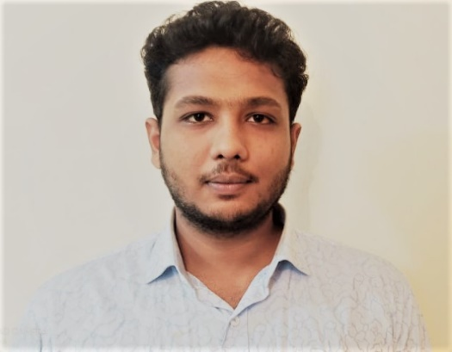­­­­­­­

Project url**: <http://fireskilled.com/> (underconstruction)**

137/6, Wasir Uddin Road,

Middle Paikpara, Mirpur-1, Dhaka-1216

Address

JavaScript

Mysql

WordPress

Language: Python

Published in: IEEE xplore

VERSION CONTROL

CONTAINER

MICROSOFT OFFICE

LINUX

PROBLEM SOLVING

Python

C

Bootstrap

Sass

**Project Type:**  Final Year Project (Academic) with Team

**Identification of Spoken Language using Machine Learning Approach**

**BANGLADESH**

**Publication url:** [**https://ieeexplore.ieee.org/document/9392744**](https://ieeexplore.ieee.org/document/9392744)

**Publication Description:** Identification of spoken language is the way to detect the specific language which is spoken by an anonymous speaker. We will also find out several techniques of machine learning for detecting spoken language. Our major task is to identify parameters and features from spoken language that can be used to separate languages.

**Projects :**

**Project url:** [http://www.outinginfo.com/](http://www.outinginfo.com/%20%20%20)  **(underconstruction)**

**Project Description:** fireskilled.com is a blog based website and outgoinginfo.com is a business website.

Html5, CSS3

**https://github.com/Shovan-Banik**

**https://twitter.com/shovanbanik2**

**https://www.linkedin.com/in/shovan-banik-a3542a177/**

**https://www.facebook.com/shovan.banik.9**

**OTHER PREFFERED SKILLS**

**PROFESSIONAL SKILLS**

**RECENT PUBLICATION AND PROJECTS**

**EDUCATION**

Here, I along with my three friends trying to collect various updated data and create attractive videos using these data. We edit videos using Microsoft Powerpoint 2019 and Camtasia video editor. You’re cordially invited to see our works visiting our Channel.

**EXPERIENCES**

137 / 6, Wasir Uddin Road, Middle Paikpara, Mirpur-1, Dhaka-1216

WORDPRESS

HTML

CSS

Balla coronation school & college

shovan15-7790@diu.edu.bd

This is the work of ICT Ministry. The work is based on Optical Character Recognition. It is a technology that recognizes text within a digital image. It is commonly used to recognize text in scanned documents and images.

**Apurba-DIU R&D Lab – Remote(Contractual)**

**Channel: Data will Alive ( Approximately 25k Subscribers, 3 million views )**

**CONTENT CREATOR OF YOUTUBE**

03 / 2019 - **Present**

06 / 2020 – 08/2020

CONTACT

Relationship

Project Supervisor

Assistant Professor

Designation

Daffodil International University

Institution

abdus.cse@diu.edu.bd

Emailil

Name

Abdus Sattar

REFERENCES

+880-1794792728

Phone

Email

A thoughtful and quick learning individual, looking for an opportunity in your reputed organization which will help me deliver my best and upgrade my skills in engineering and meet the demands of the organization. So, I can completely use my ability of critical thinking, Problem-solving, development and information of Data Science, Machine Learning, Artificial Intelligence to make an important expansion to the association alongside lifting my profession. I prefer to adopt new things in allocated time frame. Always ready to accept new challenges, have ability to think out of the box and love to lead energetic team members who shares their valuable ideas and work hard to make them live.

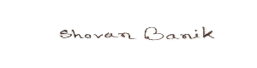

Shovan Banik

**DOCUMENT PROCESSING ENGINEER**

**WEB DEVELOPER & GRADUATE ENGINEER**

**FULL-**

English ( Fluent )

Bangla ( Native )

2010 - **2012**

2012 - **2014**

2016 - **2020**

Department of Science

Department of Science

**SECONDARY SCHOOL CERTIFICATE**

Modhupur shahid smrity college

**HIGHER SECONDARY SCHOOL CERTIFICATE**

Successfully completed with GPA–4.30 out of 5.00

Successfully completed with GPA–5.00 out of 5.00

Succesfully graduated with CGPA-3.37 out of 4.00

Dept. of Computer Science and Engineering

Daffodil International University

**BACHELOR OF SCIENCE**

**Shovan**

**Banik**

Shovan Banik

10th October 1996

Languages

Name

Date of Birth

Relationship

Nationality

Unmarried

Bangladeshi

PROFILE