# **3 Design**

# **Introduction to Design**

One of the important part while developing a project is Design. The second stage of the software development life cycle (SDLC) is design. The system is designed according to the constructed analysis and requirements. Design contains the structure of a system that is to be built which can be represented by various diagrams. Design stage helps a system to be built without having many complication and the errors can be identified easily. The features and function can be described in detail in design specification. Structural models and Behavioral models are mostly covered in design. The design should also include the design of the database system before implementation.

## **3.1 Structural Model**

The whole framework of the system is represented in structural model. It represents all the classes and objects of the system is represented in structural model and also shows their relationship with each other. Class diagram is one of the type of structural model. Different classes, attributes, operations and the relationship between these objects is represented in class diagram.

## **3.1.1 Class Diagram**

Class diagram can be defined as the unified modeling language that shows the structure of the system which includes all the classes and their attributes, operations and relationship between these objects. The static view of the system is represented here which will be used during the development of the project.

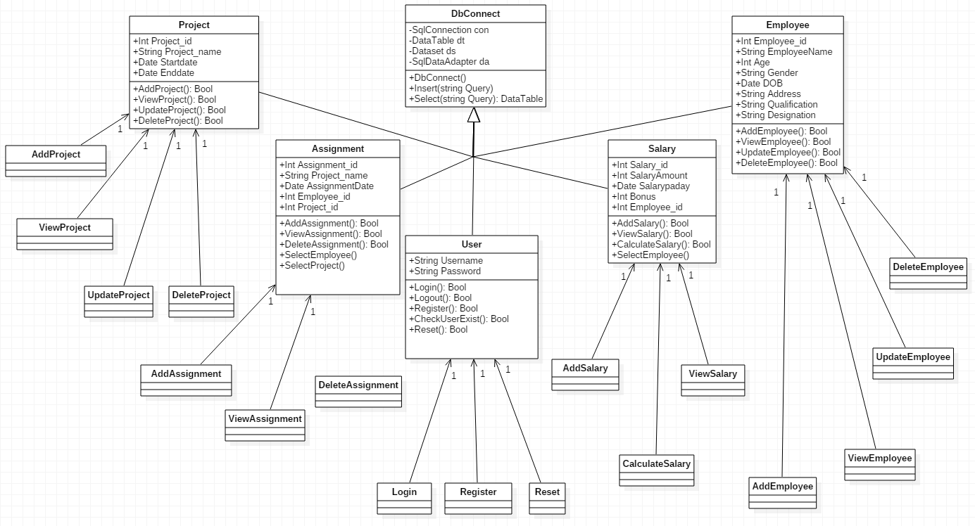

Figure 1 Class Diagram

The above class diagram is for the project (Employee Management System). Model View Controller Pattern is used for this project. The administrator/user will use the four class (Employee, Assignment, Project, and Salary) for their CRUD functions. Login will be used for verifying, authenticating and login of the administrator/user in the system. Register will be used for the registration of the new administrator/user. Add (Employee, Project, Assignment, and Salary) will be used for adding new employee, project, assignment, and salary respectively. View (Employee, Project, Assignment, and Salary) will be used for viewing added and existing employee, project, assignment, and salary respectively. Update (Employee, and Project) will be used for editing and updating employee and project details respectively. Delete (Employee, Project, and Assignment) will be used for deleting their details from the database.

## **3.1.2 Flowchart**

A flow chart can be defined as graphical representation of any activities and action that is involved in a project. The main objective of flow chart is to show the overview of the systems and provides reference point for the people dealing with the project.

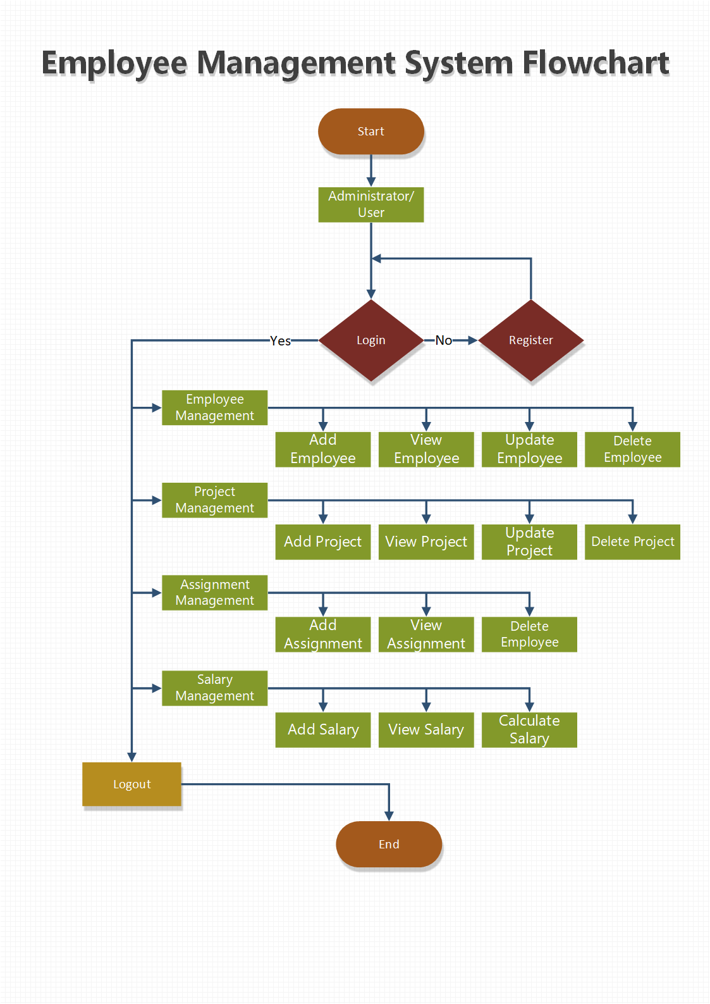

Figure 2 Flow Chart

The flow chart is for the project that is to be developed. Different functions and features like employee management (add, view, update, delete), project management (add, view, update, delete), assignment management (add, view, delete) and salary management (add, view, calculate) can be used by the logged in admin.

## **3.2 Behavioral Model**

Behavioral model can be defined as any graphical representation that shows the internal structure and features of the system. The dynamic sequence of flow of the system is shown. The two types of behavioral model diagram are sequence diagram and activity diagram.

## **3.2.1 Activity Diagram**

An activity diagram can be defined as graphical representation of the system's flow of control and actions/activities. Its main objective is to describe the activities in detail.

**Notations Used**

|  |  |  |
| --- | --- | --- |
| S.N. | Symbol | Name |
| 1 |  | Initial Point |
| 2 |  | Activity |
| 3 |  | Decision Symbol |
| 4 |  | Fork node |
| 5 |  | Join node |
| 6 |  | Activity flow |
| 7 |  | End Point |
| 8 |  | Swinlanes |

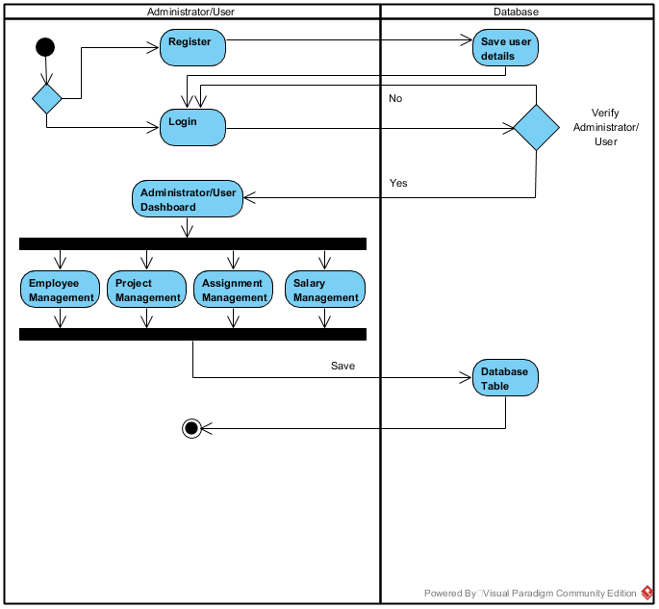

Figure 3 Activity Diagram overview of the system

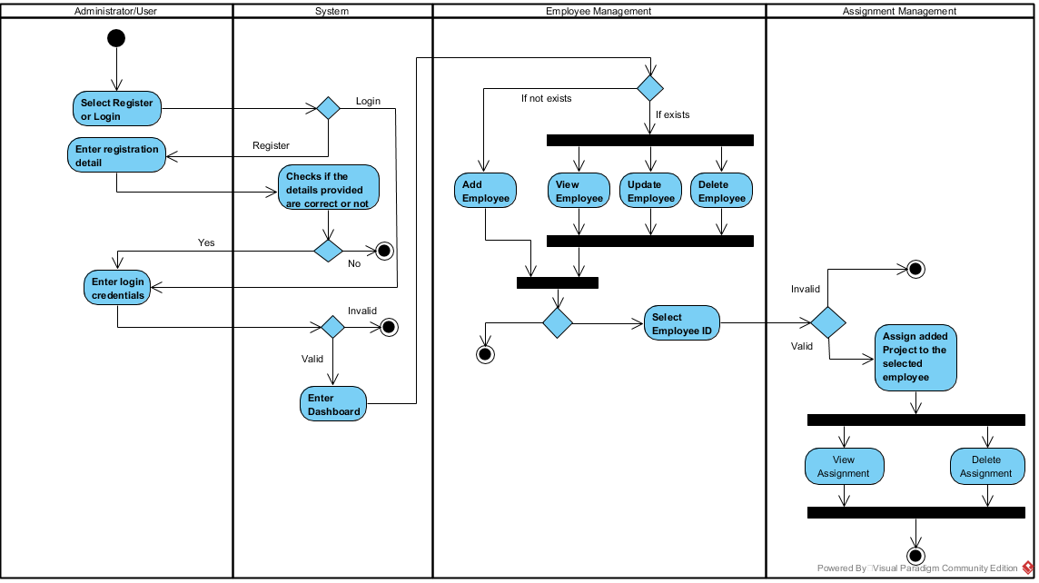

Figure 4 Activity Diagram for Employee Mgmt. and Assignment Mgmt.

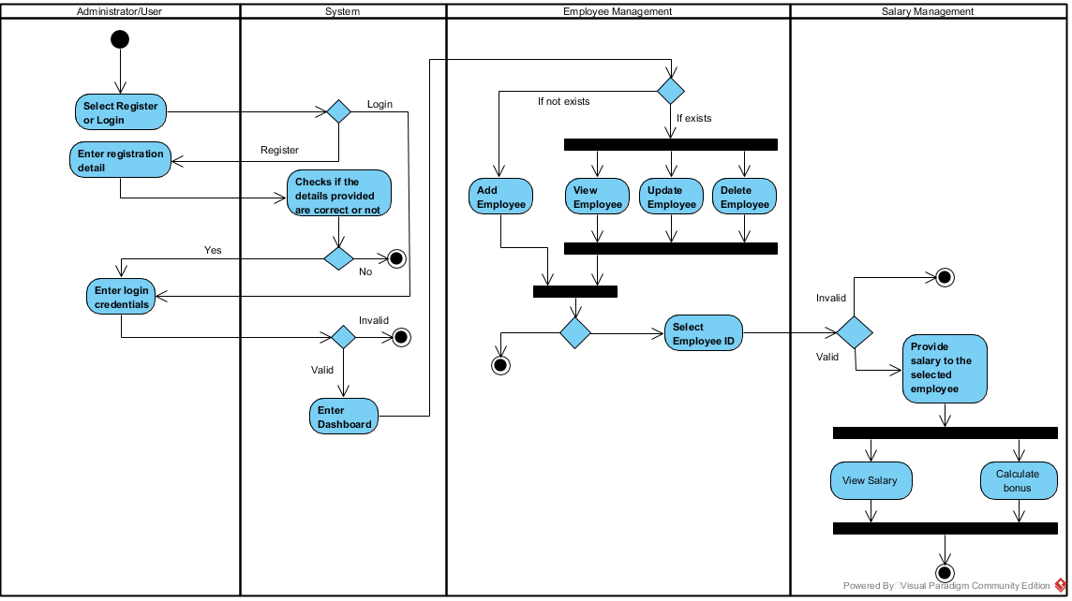

Figure 5 Activity Diagram for Employee Mgmt. and Salary Mgmt.

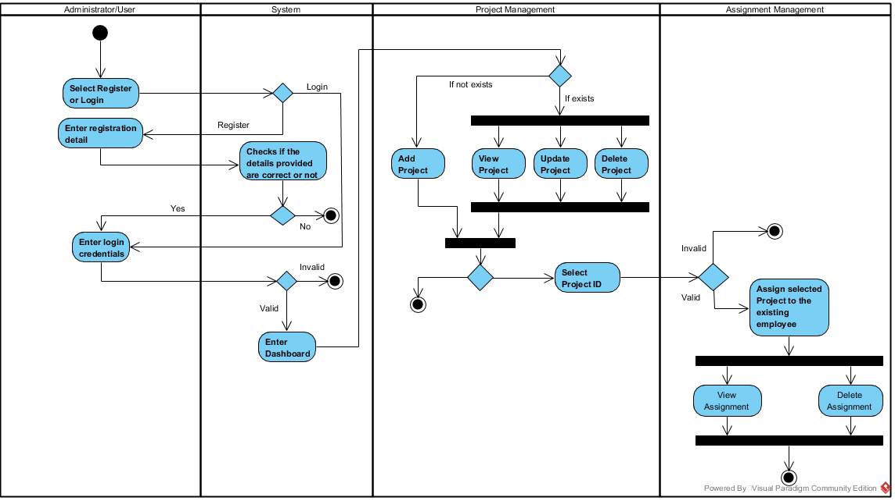

Figure 6 Activity Diagram for Project Mgmt. and Assignment Mgmt.

To begin with, the administrator/user logins to the system. If the administrator/user is not registered than he/she should register in order to login to use the system. When the administrator/user logins, his/her credentials are verified to check if the administrator/user is legit. After the login is successful, he/she is redirected to administrator dashboard where four features are available in the system to be used. The administrator/user can use all the features where he/she will be able to add, view, update and delete employee details in employee management. Administrator/user will be able to add, view, update and delete project details in project management. Administrator/user will be able to assign projects to the employees’ available, view and delete assignment in assignment management. Administrator/user will be able to add, view and calculate salary in salary management. These are all the functions and features that are used by a logged in administrator/user.

## **3.2.2 Sequence Diagram**

Sequence diagram can be defined as operations that are carried out and interactions captured between objects in the content of collaboration. It is one of the most important diagram in design.

**Notations Used**

|  |  |  |
| --- | --- | --- |
| S.N. | Symbol | Name |
| 1 |  | Actor |
| 2 |  | Lifeline |
| 3 |  | Message |
| 4 |  | Self-Message |
| 5 |  | Recursive Message |
| 6 |  | Reply |
| 7 |  | Alt.Combined Fragment |

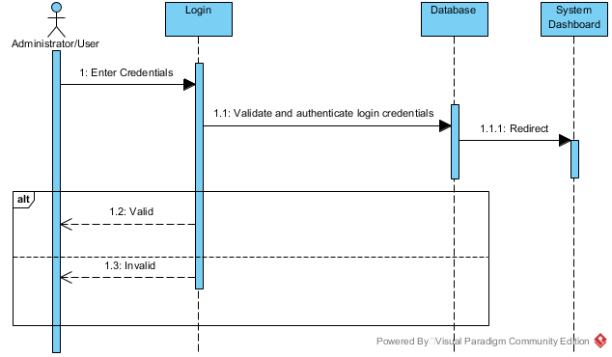

Figure 7 Sequence Diagram for Login

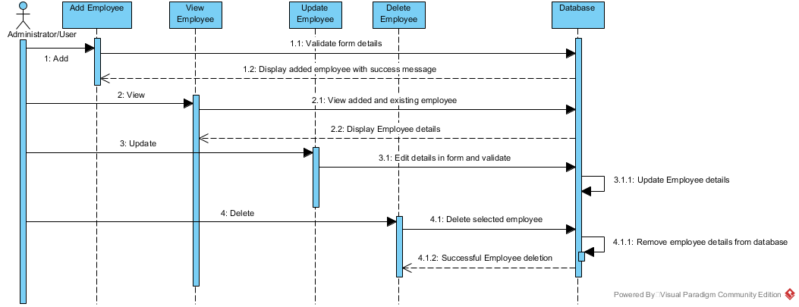

Figure 8 Sequence Diagram for Employee Mgmt.

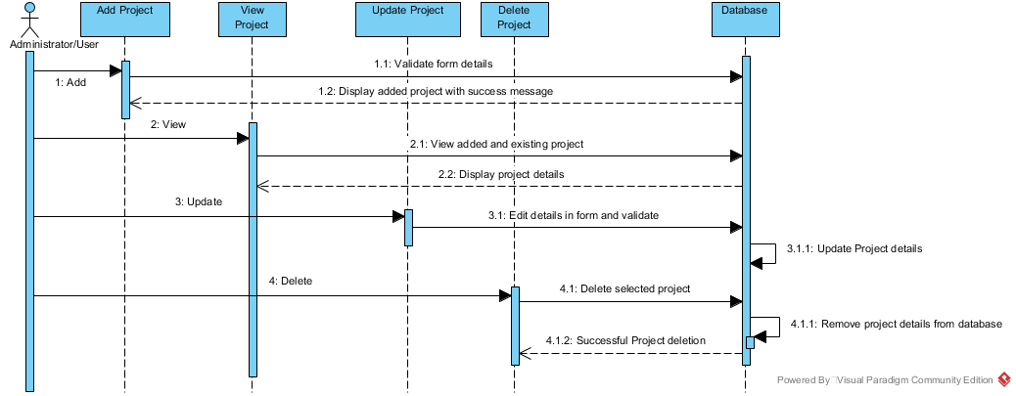

Figure 9 Sequence Diagram for Project Mgmt.

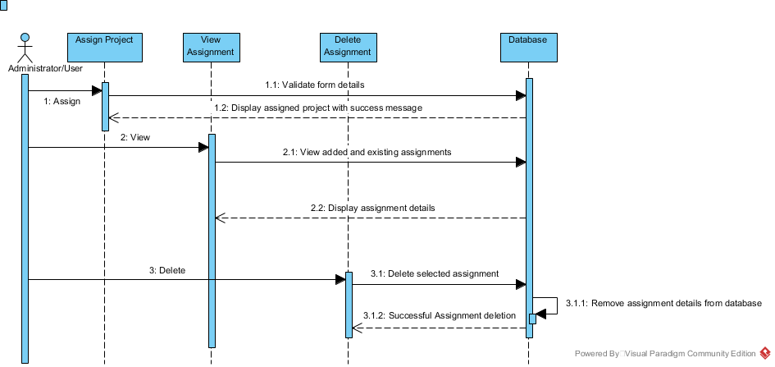

Figure 10 Sequence Diagram for Assignment Mgmt.

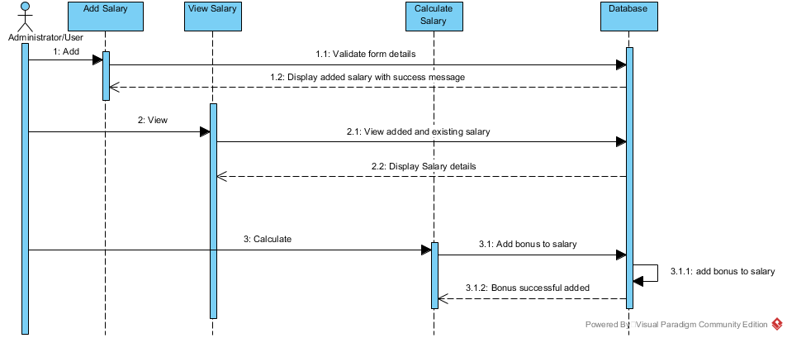

Figure 11 Sequence Diagram for Salary Mgmt.

All the interaction between the administrator/user and the system are represented in the diagrams above. It shows how the features will be used by the administrator/user. The diagram represents the interactions that will happen between the administrator/user and the system. These diagrams shows how the system will react to the user/administrator’s input or action or command to use the functions and features of the system. It shows the sequential process of how the functions are carried out in the system.

## **3.3 Data Modeling**

Database design can be defined as process of collecting the processes that will help the design, implementation and development of a database system.

## **3.3.1 Data Dictionary**

A data dictionary is a set of descriptions about data objects in a data model which are used in a database.

Employee Table

|  |  |  |  |  |
| --- | --- | --- | --- | --- |
| **Attributes** | **Datatype** | **Primary Key** | **Foreign Key** | **Nullable** |
| Employee_id | int(10) | Yes | No | No |
| EmployeeName | varchar(55) | No | No | Yes |
| Age | int(10) | No | No | Yes |
| Gender | varchar(55) | No | No | Yes |
| DateOfBirth | date | No | No | Yes |
| Address | varchar(55) | No | No | Yes |
| Qualification | varchar(55) | No | No | Yes |
| Designation | varchar(55) | No | No | Yes |

Administrator/User Table

|  |  |  |  |  |
| --- | --- | --- | --- | --- |
| **Attributes** | **Datatype** | **Primary Key** | **Foreign Key** | **Nullable** |
| username | varchar(255) | No | No | Yes |
| password | varchar(255) | No | No | Yes |

Project Table

|  |  |  |  |  |
| --- | --- | --- | --- | --- |
| **Attributes** | **Datatype** | **Primary Key** | **Foreign Key** | **Nullable** |
| Project_id | int(10) | Yes | No | No |
| ProjectName | varchar(55) | No | No | Yes |
| ProjectDescription | varchar(155) | No | No | Yes |
| Startdate | date | No | No | Yes |
| Enddate | date | No | No | Yes |

Assignment Table

|  |  |  |  |  |
| --- | --- | --- | --- | --- |
| **Attributes** | **Datatype** | **Primary Key** | **Foreign Key** | **Nullable** |
| Assignment_id | int(10) | Yes | No | No |
| Employee_id | int(10) | No | Yes | No |
| Project_id | int(10) | No | Yes | No |
| ProjectName | varchar(155) | No | No | Yes |
| AssignmentDate | date | No | No | Yes |

Salary Table

|  |  |  |  |  |
| --- | --- | --- | --- | --- |
| **Attributes** | **Datatype** | **Primary Key** | **Foreign Key** | **Nullable** |
| Salary_id | int(10) | Yes | No | No |
| Employee_id | int(10) | No | Yes | No |
| SalaryAmount | int(10) | No | No | Yes |
| SalaryPayday | date | No | No | Yes |
| SalaryBonus | int(10) | No | No | Yes |

## **3.3.2 E.R. Diagram**

An Entity Relationship Diagram can be defined as a visual representation of a database where tables, entities, entities type and relationships between tables.

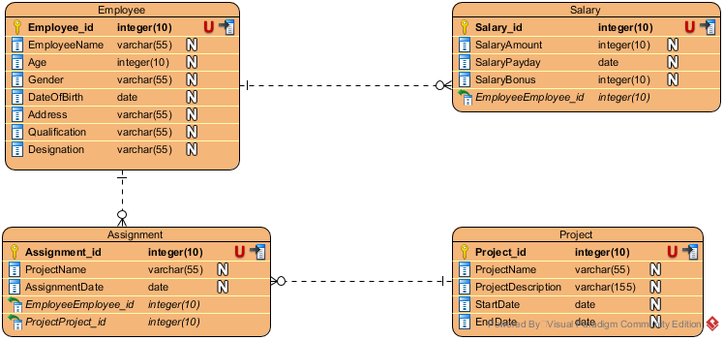

Figure 12 Entity Relationship Diagram

The ER diagram shown above is the ER diagram for the database of the system. There are four main tables in this database system. Employee, project, assignment and salary are the tables’ name. The employee tables shows the detailed information of the employees where employee id is the primary key for this table. The project table shows the detailed information of the projects where project id is the primary key for this table. The assignment table shows the detailed information of the projects assigned to the available employee where assignment id is the primary key and employee id, and Project id are foreign key for this table. The salary table shows the information of the employee's salary where salary id is the primary key and employee id is foreign key for this table.

## **3.4 Prototype Design**

Prototype design can be defined as an interactive development technique where mock-up of the UI in the system is created actively and also allow us to explore solution space for the system.

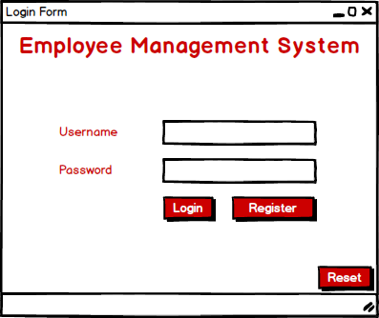

Figure 13 User Form 1

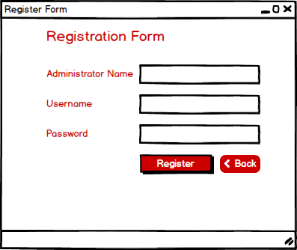

Figure 14 User Form 2

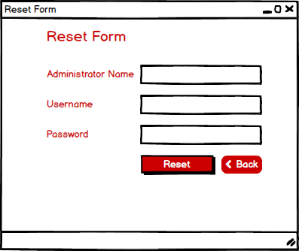

Figure 15 User Form 3

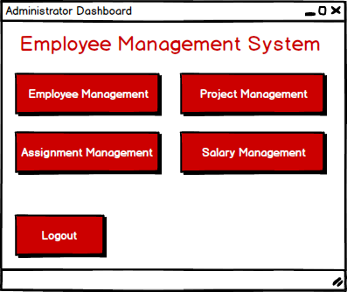

Figure 16 User Form 4

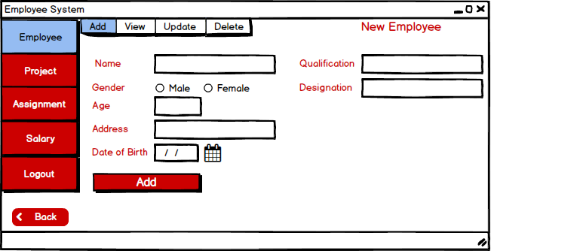

Figure 17 User Form 5

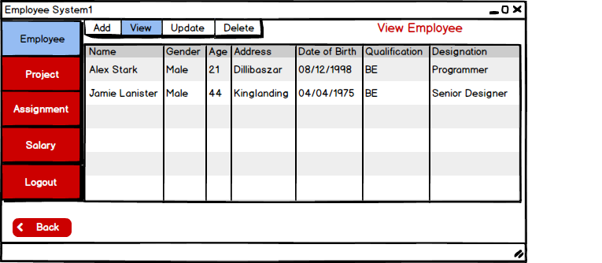

Figure 18 User Form 6

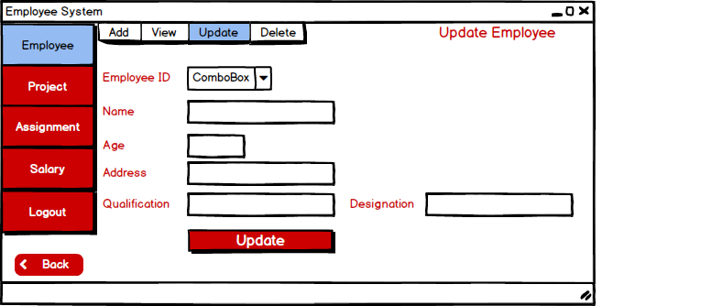

Figure 19 User Form 7

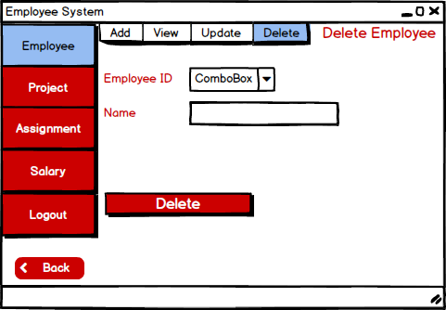

Figure 20 User Form 8

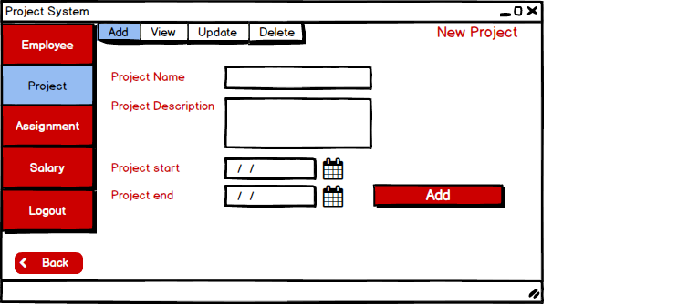

Figure 21 User Form 9

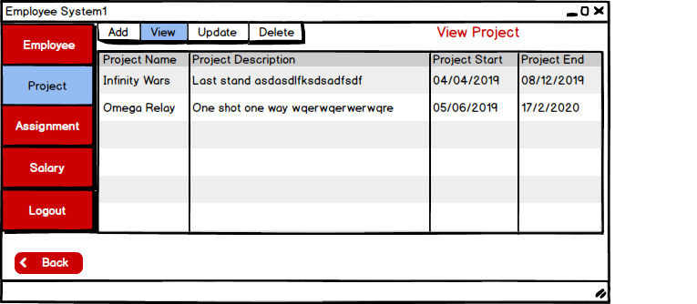

Figure 22 User Form 10

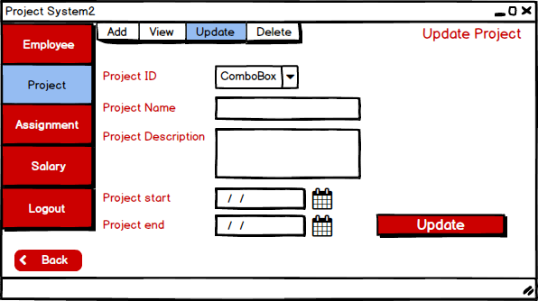

Figure 23 User Form 11

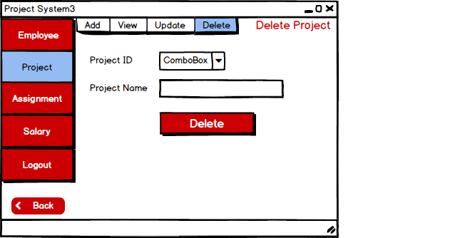

Figure 24 User Form 12

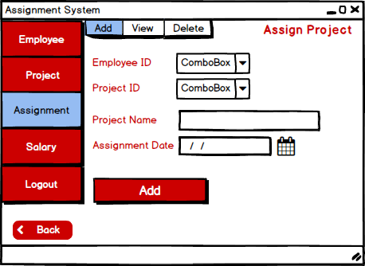

Figure 25 User Form 13

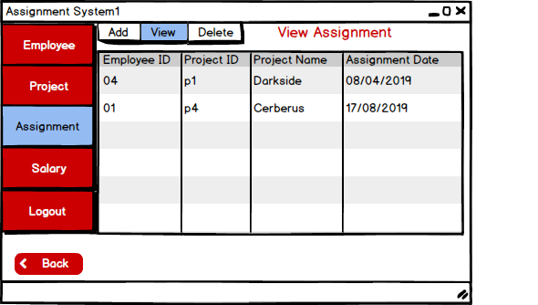

Figure 26 User Form 14

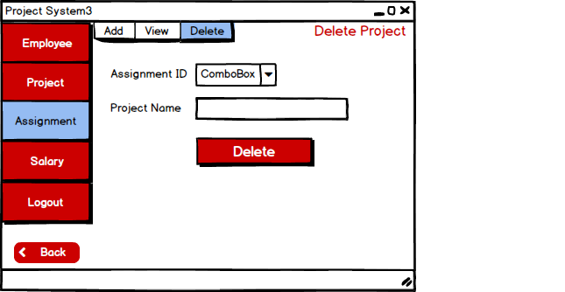

Figure 27 User Form 15

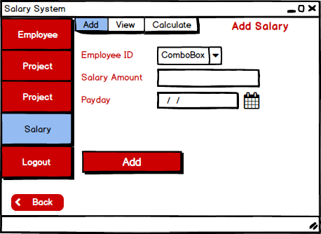

Figure 28 User Form 16

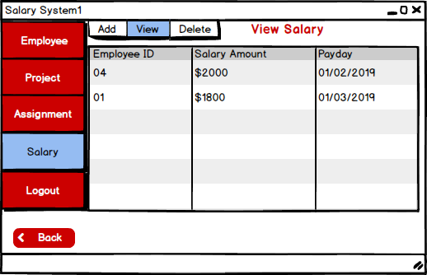

Figure 29 User Form 17

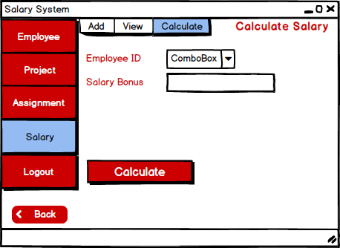

Figure 30 User Form 18

The porotype design for the system is shown above. The software I have used to create these prototype design is Belsamiq Mockup. Every forms that will be in the system is represented and also shows how the system will look and the UI it will have.

# **3.5 Architectural Model**

I have used standalone because the system I am developing is standalone application where the application is installed in a computer and are not dependent in any other servers/computers. The access of this system is limited to a system where the application is installed. Some of the advantages for using standalone application for the system are:-

* There is no need to networking and only requires single system to operate the application.
* Local files can be created and manipulated.
* Does not require internet connection to operate.
* Execution can be done independently and produce output as a UI.
* It can be defined as local service development because it can operate independently.

The system is created for small organizations where small task can be performed to negate simple issue and to make management easier. The system is standalone as it is more focused on providing services for small and compact organization and not for large corporation. The management of the system will be easy and will operate independently. It is easy to deploy and errors can be dealt in short period of time.