# **Chapter 1 Introduction**

## **1.0 Introduction**

The project that is to be developed is Employee Management System (EMS). Employee Management System will be developed for establishing proper management system to store and manage employee information and information relevant and related to employees.

## **1.2 Background of the project**

Commonly in countries like Nepal, information of the employee in an organization or company is not electronically managed or has not adopted employee management system and majority of these organization relies on traditional process of record maintenance of employees (Hand-written). By developing an Employee Management System it will enable for an organization to have more simplified process of recording and managing information of employees. Hence, developing an employee management system will be much better approach for managing employee information and also the information will be securely stored.

## **1.3 Problem Statement**

* The main purpose for developing Employee management system is to manage employee information and data related to it. It is also serves the purpose of assigning specific projects to specific employees.
* Distribution salary and storing employee information is much easier and secured.
* It also track information of the existing projects.
* It solves the problem of entering data and is easy to use. The system is well protected.

## **1.4 Description of the project**

This project is a database management system. Employee Management System will be developed for the sole purpose of simplifying the process of maintaining records and managing information of the employees and provide well designed and established database for securely storing detailed information of the employees.

## **1.4.1 Features of the project**

The Project will consist of these features:-

* Admin Registration and login.
* Admin can add, view, update and delete employee information.
* Admin can view projects and assigned projects.
* Admin can update or assign employee to a project.
* Get detailed information about the employees (Date of joining, Employee ID, Employee Name, Age, Address etc.).
* Admin can manage salary of their employees.

## **1.5 Overview of the project**

# **Chapter 2 Scope of the project**

## **2.1 Scope**

The scope of developing an Employee Management System is to make the whole process of managing and organizing the given information of the employees a lot easier. It will help in proper management of employee information and record maintenance is simpler.

## **2.2 Limitation**

* The system to be developed is not a web-based application.
* The system will not be able to handle huge data in a large organization.
* The system will only authorize admins and managers for its use and will not be accessible by the employees.
* The system will be developed for smaller organization.

## **2.3 Aims**

Project Aim:-

* To develop an Employee Management System to make management of employee information easier and maintainable.
* To store important and critical information of employees to assign them to certain projects and manage their salaries.
* To store detailed information of the employees working in the organization in an well designed database.

## **2.4 Objectives**

Project Objective:-

* To create user friendly system which is easy to use and understand.
* To allow admins to register.
* To make use of login feature for the admins.
* To avoid mixing up information of the employees
* To make the data stored secured.
* To make the data entry easier.
* To make the database maintainable.
* To check the system for defects or errors and correcting or fixing them if required.
* To make the system more adaptive to changes and agile.

## **2.5 Overview of the scope**

# **Chapter 3 Development Methodology**

## **3.1 Description of the chosen methodology**

The development methodology that I have chosen is waterfall development methodology. The reason for choosing this methodology for the development of system is because it will be easier and will be cost and time effective. Due to the step by step process the development of the system will be efficient and will ensure that the system will not face major problems while being developed and will properly work along each step.

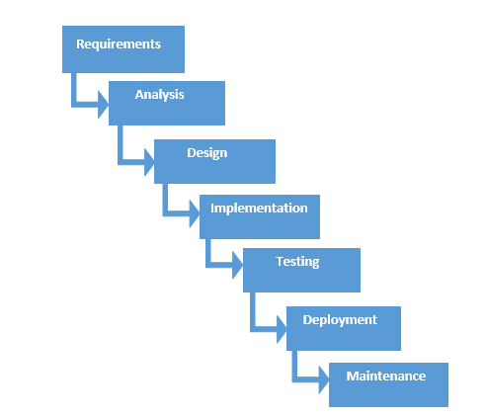

Some of the advantages for using waterfall methodology is because it is easy to use and understand. Each stage has specific task to be performed and will be reviewed. Stages are moved on only after the stage being worked on is completed. This is also very useful for small projects like Employee Management System.

Some of the risk and drawbacks of using this methodology is that using this methodology sometimes can have uncertainty. It is also not a good choice for projects that have their requirements changed constantly. It is not an iterative methodology.

## **3.2 Design Pattern**

The design patter that I will be using for my project is MVC (Model View Controller). The structure of the code can be separated into three different section while using MVC pattern. Modifications will not impact the entire model and also will ensure for fast and efficient development of the system. Change of code will be possible without making major changes to the entire system. Therefore, I am selecting this design pattern for the development of the project.

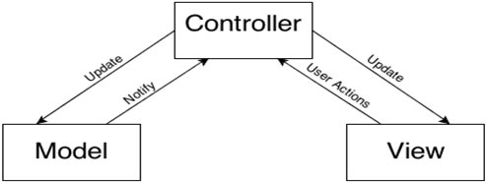

## **3.3 Architecture**

# **Chapter 4 Project Planning**

## **4.1 WBS (Work Breakdown Structure)**

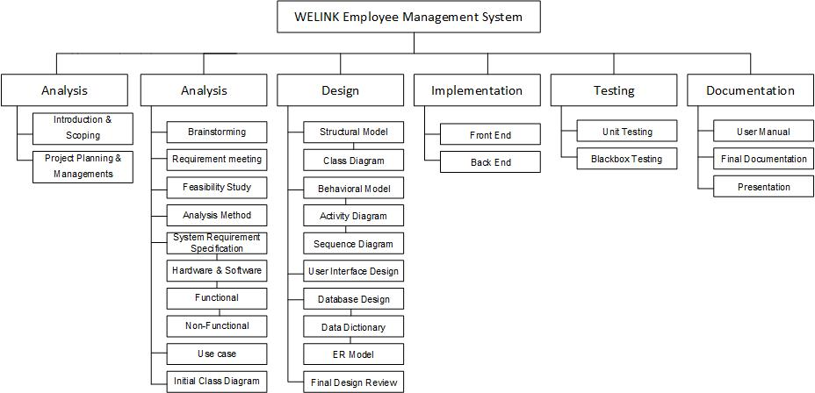

## **4.2 Milestones**

|  |  |  |
| --- | --- | --- |
| **Tasks** | **Deadline** | **Task Estimation(Days)** |
| **Proposal** | 25th March, 2019 --- 9th April, 2019 | 16 |
| Introduction & Scoping | 2nd April, 2019 | 9 |
| Project planning & Managements | 9th April, 2019 | 7 |
|  |  |  |
| **Analysis** | 10th April, 2019 --- 8th May, 2019 | 29 |
| Brainstorming | 13th April, 2019 | 4 |
| Requirement Gathering | 15th April, 2019 | 2 |
| Feasibility Study | 20th April, 2019 | 5 |
| Analysis Methodology | 24th April, 2019 | 4 |
| System Requirement Specification | 30th April, 2019 | 5 |
| Use Case | 4th May, 2019 | 4 |
| Initial Class Diagram | 8th May, 2019 | 3 |
|  |  |  |
| **Design** | 9th May, 2019 --- 3rdJune, 2019 | 26 |
| **Structural Model** |  |  |
| Class Diagram | 15th May, 2019 | 7 |
| **Behavioral Model** |  |  |
| Activity Diagram | 20th May, 2019 | 4 |
| Sequence Diagram | 24th May, 2019 | 5 |
| **User Interface Design** | 28th May, 2019 | 4 |
| **Database Design** |  |  |
| Data Dictionary | 30th May, 2019 | 2 |
| ER Model | 1st June, 2019 | 2 |
| **Review Final Design** | 3rd June, 2019 | 2 |
|  |  |  |
| **Implementation** | 4th June, 2019 --- 24th June, 2019 | 21 |
| Front end | 14th June, 2019 | 11 |
| Back end | 24th June, 2019 | 21 |
|  |  |  |
| **Testing** | 25th June, 2019 --- 1stJuly,2019 | 7 |
| Unit Testing | 30th June, 2019 | 6 |
| Black Box Testing | 1st July, 2019 | 1 |
|  |  |  |
| **Documentation** | 2nd July, 2019 --- 12thJuly, 2019 | 11 |
| User Manual | 4th July, 2019 | 3 |
| Final Documentation | 8th July, 2019 | 4 |
| Presentation | 12th July, 2019 | 4 |

The time is estimated for all the given task. Time estimated for Project proposal is 16 days. The time estimated for analysis is 28 days where analysis was also divided in sub task like Brainstorming (13th April, 2019), Requirement Gathering (15th April, 2019)Feasibility Study (20th April, 2019)

Analysis Methodology 24th April, 2019

System Requirement Specification 30th April, 2019

Use Case 4th May, 2019

Initial Class Diagram 8th May, 2019

## **4.3 Gantt Chart**

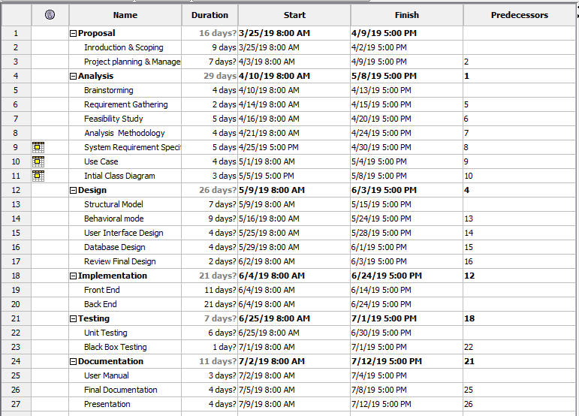

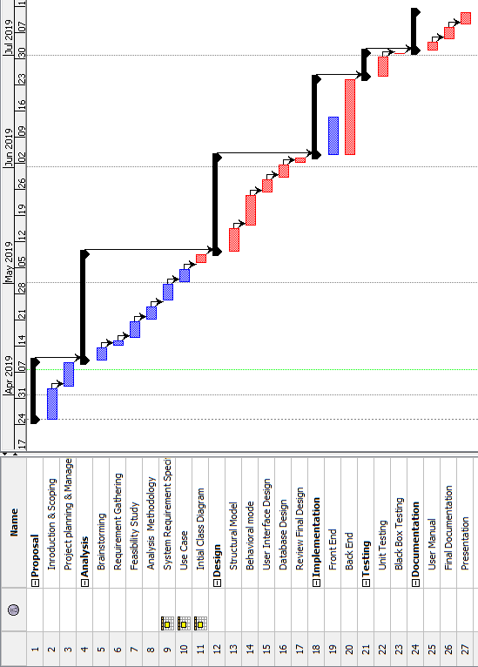

# **Chapter 5 Risk Management**

While developing a project there is always possibility of risks. However, these risk can be dealt with and reduced. Risk management can be defined as the process of identifying the possible threats and controlling risk factors and threats from possible damage and problems to the project being developed. Risk management is important to reduce possible threats and overcome risks from causing damage to the project.

**Value of Likelihood**

|  |  |
| --- | --- |
| **Likelihood** | **Value** |
| Low | 1 |
| Medium | 2 |
| High | 3 |

**Value of Consequences**

|  |  |
| --- | --- |
| **Consequences** | **Value** |
| Very Low | 1 |
| Low | 2 |
| Medium | 3 |
| High | 4 |
| Very High | 5 |

**Impact**

|  |  |  |  |  |  |
| --- | --- | --- | --- | --- | --- |
| **S.N.** | **Risk** | **Likelihood** | **Consequences** | **Impact** | **Action** |
| 1 | Hardware  Crash | 1 | 5 | 5 | Full, incremental and cloud  Backup. |
| 2 | Requirement Changes | 3 | 4 | 12 | Gather necessary requirements. |
| 3 | Security  Breach | 2 | 4 | 8 | Use of proper security tools |
| 4 | Natural  Disasters | 2 | 4 | 8 | Full, incremental and cloud  Backup. |
| 5 | Improper Design | 2 | 5 | 10 | Should be designed according to requirement needs. |

# **Chapter 6 Configuration Management**

My files are broken-down according to Work Breakdown Structure. Files are kept in their respective folders. All the folders and files are also kept in a backup folder. Also, files and folders are constantly update whenever there is change made.

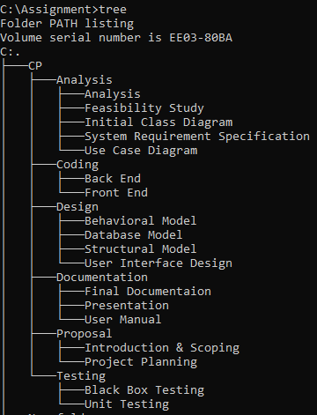

Project configuration management can be defined as managing the configuration of all the project’s key products and assets. (reference). Configuration management is one of the important stage of a software development cycle. It is useful for tracking of folders and files. The management of folders and files is done more efficiently. Hence, configuration management is an important stage for the success of the project.

For the further management of our project's files we will be also using GitHub. GitHub is a service for hosting files in the web and managing them using git. It is also useful to create backup of all of the files and also is useful to revert or go back to older version of the file contents. This way it will help us to develop the system efficiently. Therefore, GitHub will be used for the development of this project.

# **Chapter 7 Conclusion**

Therefore, the following project will provide the managers and admin an efficient way for managing and organizing information about the employees. This project will help in proper management of employee information and record maintenance will be a lot easier. This project will provide services to securely store employee information and information relevant and related to employees. All the necessary information like introduction and background of the project, scope and limitation of the project, analysis, development methodology used, project planning, risk management and configuration management will be presented in the proposal so that the project will not have big issue while being developed and will be more efficient. Thus, this proposal is concluded and i would like to start developing my project on Employee Management System.

# **Chapter 8 Bibliography**