Assignment – 15

1. Implement request validation for a registration form that contains the following fields: name, email, and password. Validate the following rules:

name: required, string, minimum length 2.

email: required, valid email format.

password: required, string, minimum length 8.

First I made a MiddileWare called RegistrationFormValidation.php

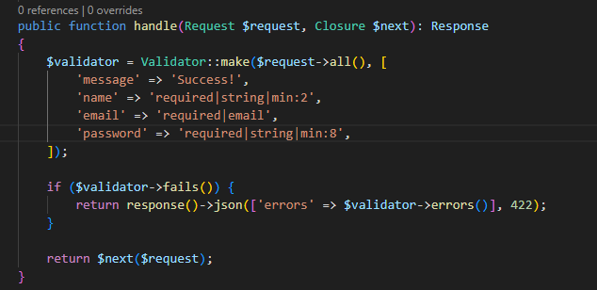

Then I made a controller Called DemoController

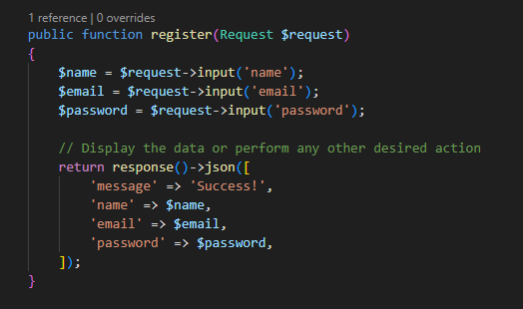

After then I created a Route inside web.php

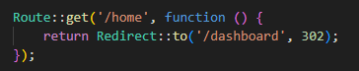

Output By Postman:

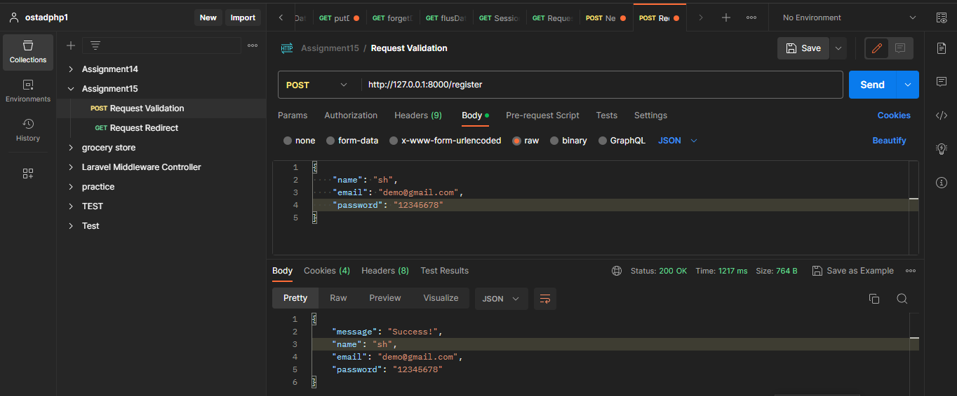

All the Errors when –

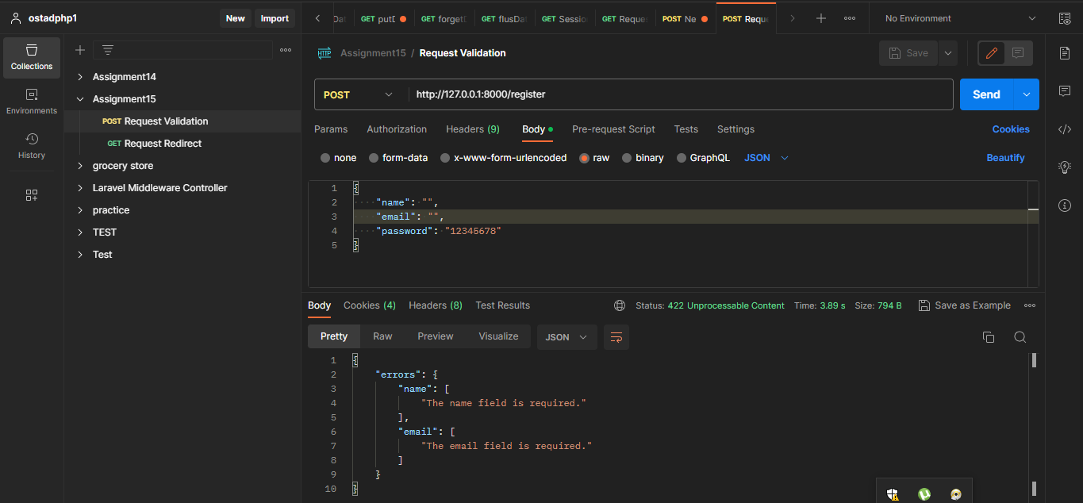

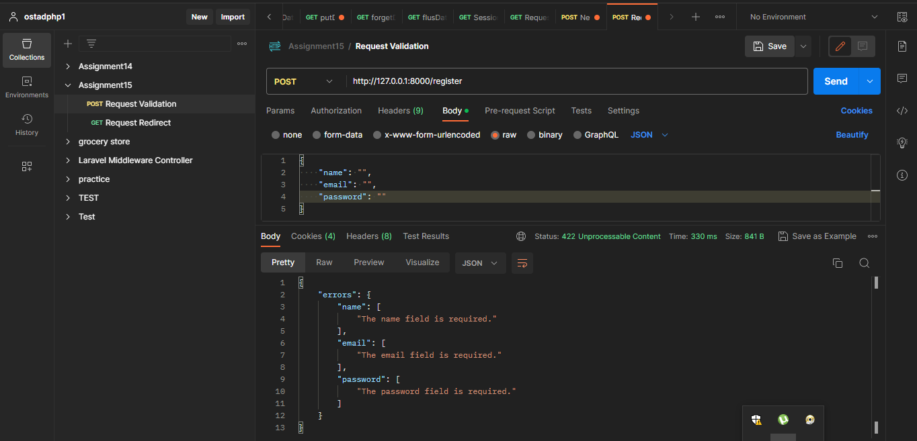

Problem Number 2: Create a route /home that redirects to /dashboard using a 302 redirect.

Firstly I made two routes

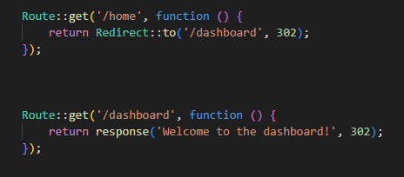

This /home routes redirect to /dashboard with 302 status code

Output By Postman :

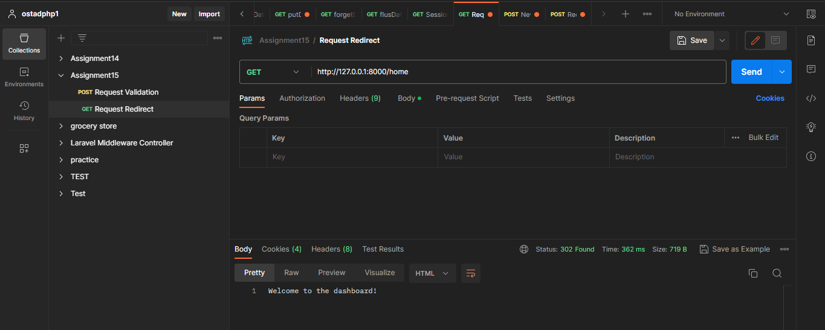

Output By Browser :

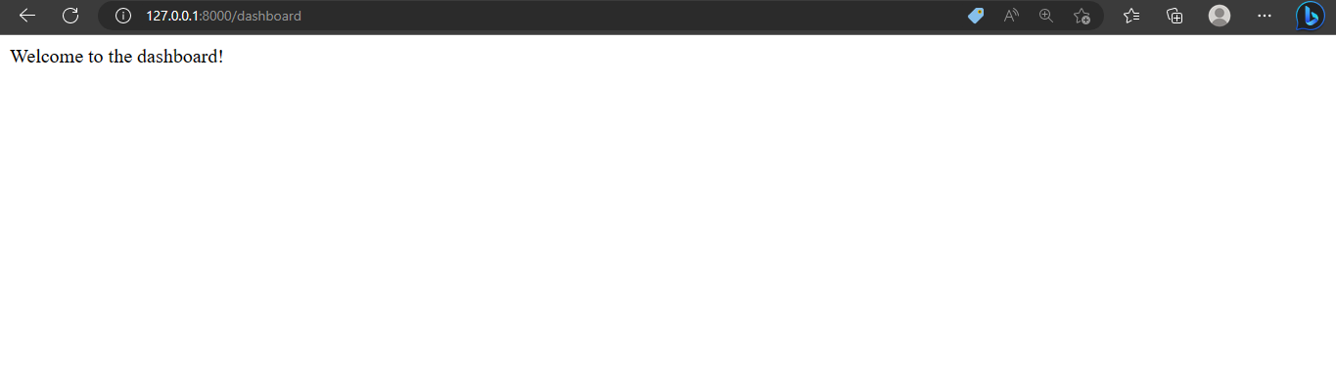

Question No. 3: Create a global middleware that logs the request method and URL for every incoming request. Log the information to the Laravel log file.

First I made a middleware :

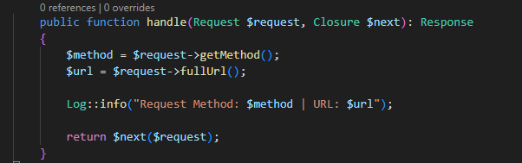

Then I added \App\Http\Middleware\LogRequestMiddleware::class



Then I made a request inside api.php



And this is the Log:

