Assignment-19

Task 1 : Blog Post List By

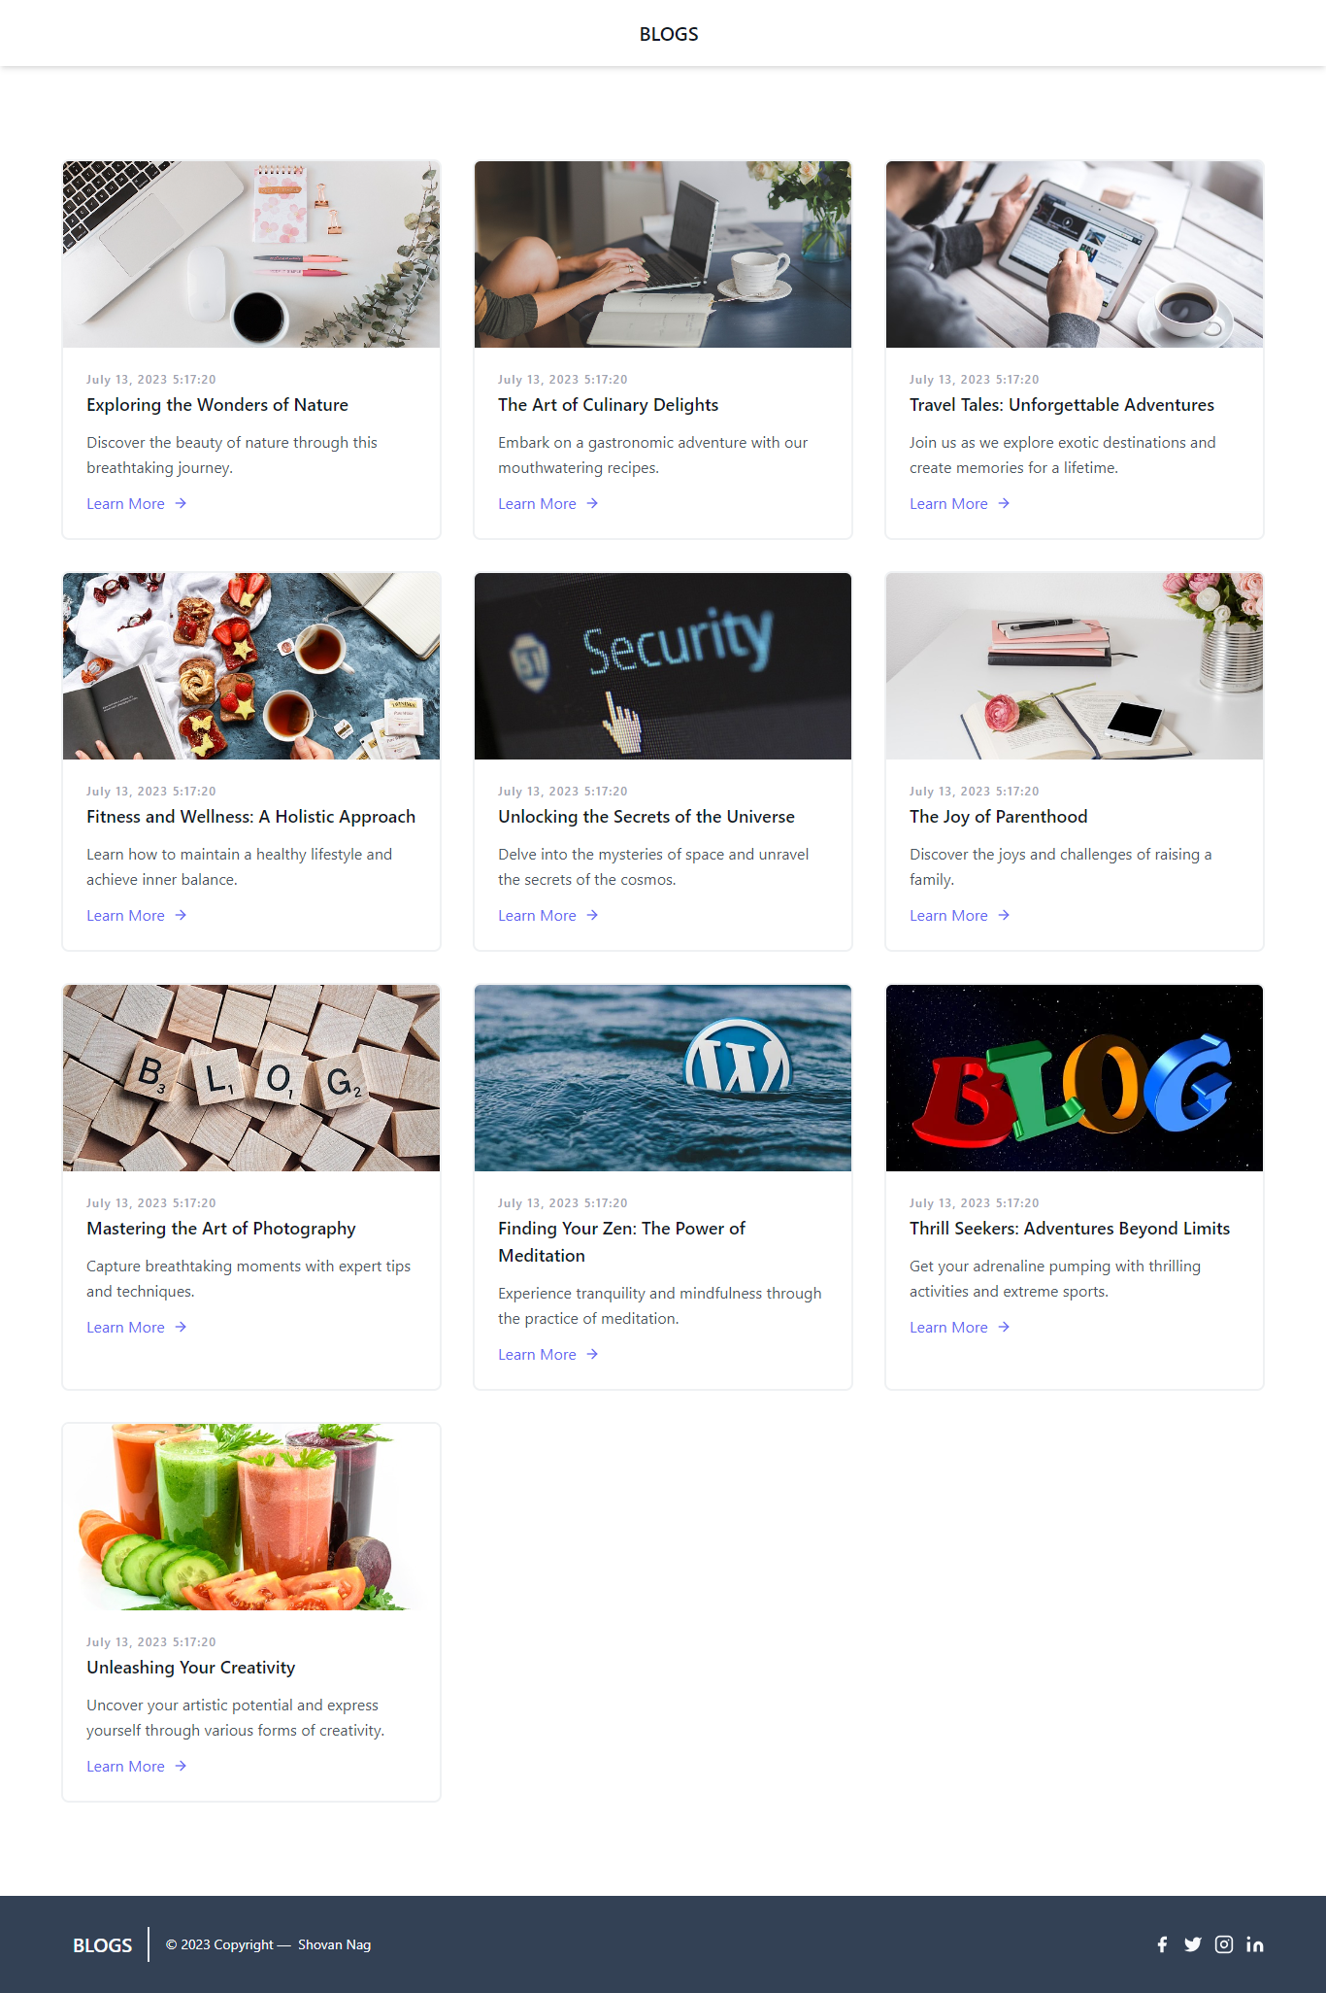

Task 2 : Blog Post Details

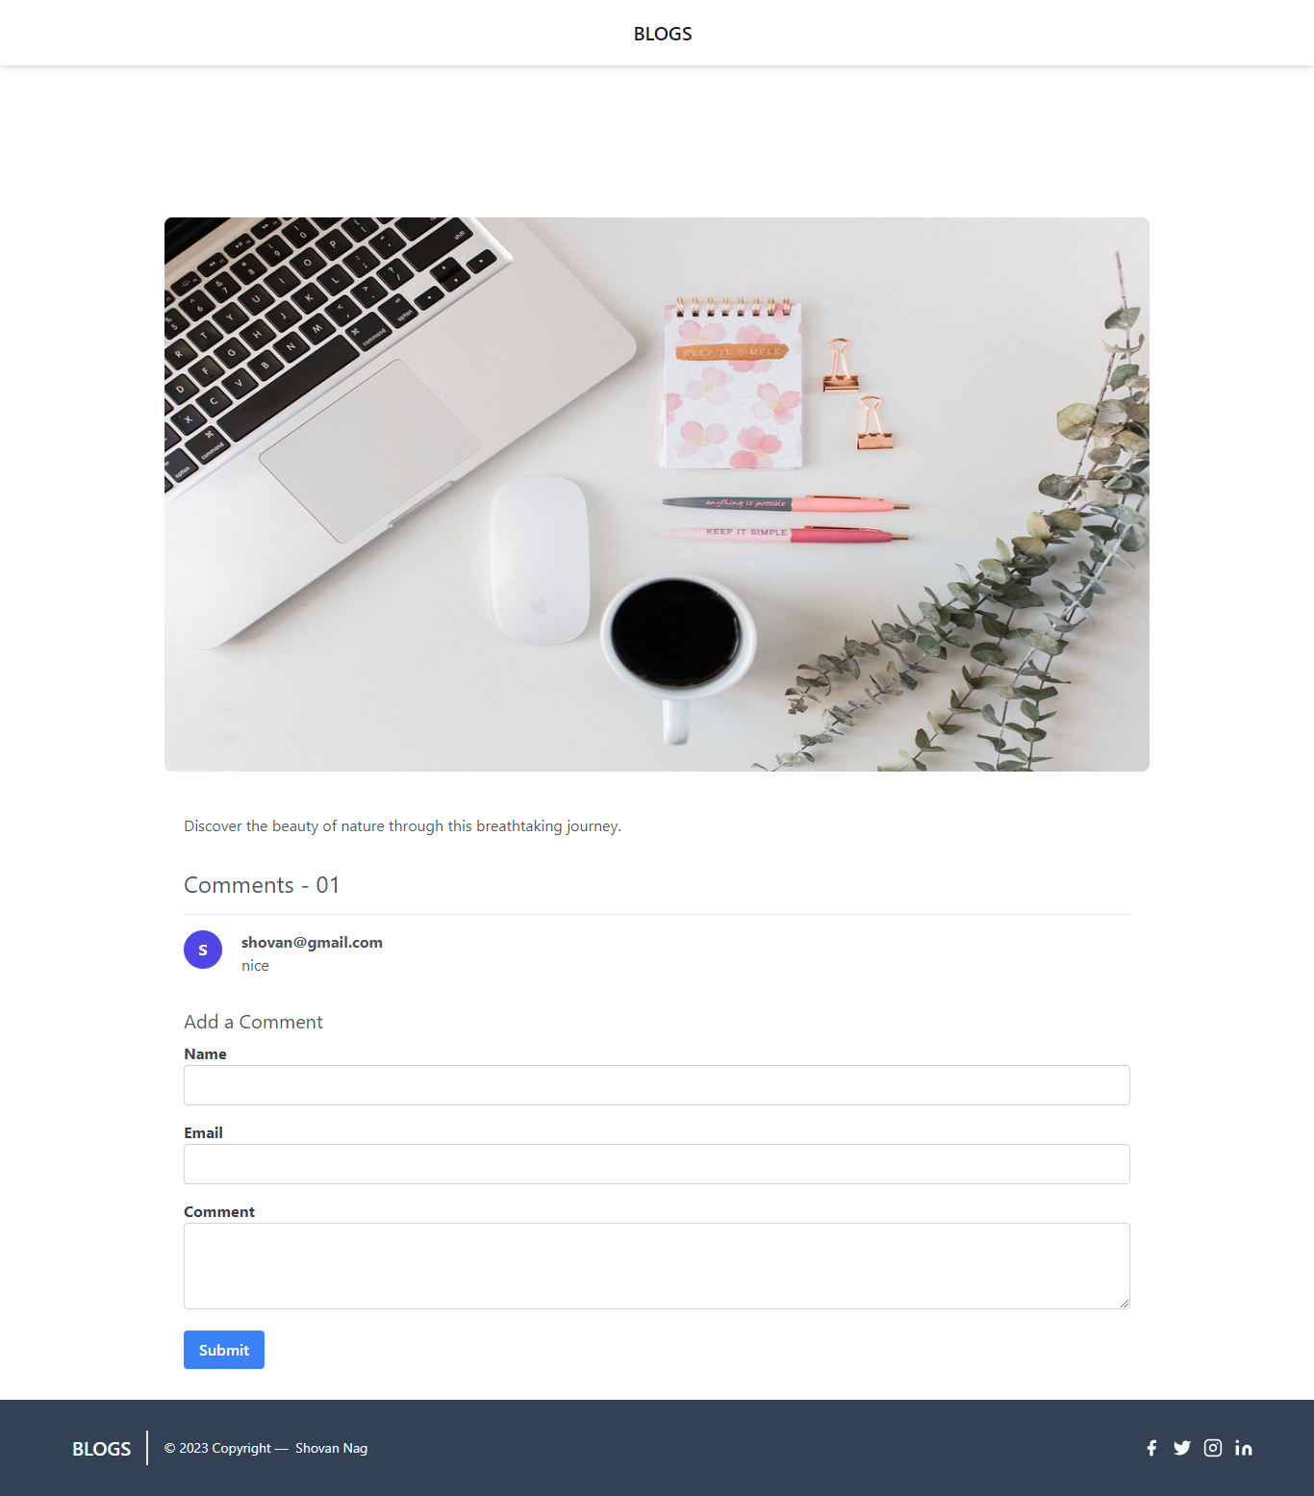

Task 3 : Free comments system

