**Module-16 Assignment**

**Task 1 : Create a new Laravel project named "MigrationAssignment" using the Laravel command-line interface.**

**First I command this “laravel new migrationAssignment”**

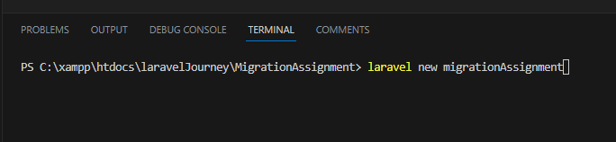

And then a laravel file created by

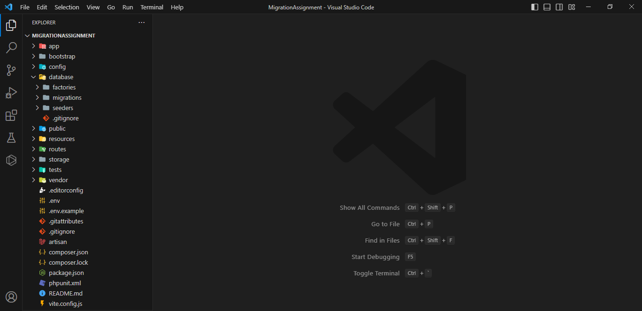

**Task 2: Within the project, create a new migration file named "create_products_table" that will be responsible for creating a table called "products" in the database. The "products" table should have the following columns:**

**id: an auto-incrementing integer and primary key.**

**name: a string column to store the product name.**

**price: a decimal column to store the product price.**

**description: a text column to store the product description.**

**created_at: a timestamp column to store the creation date and time.**

**updated_at: a timestamp column to store the last update date and time.**

First I made database name “products” by .env database name and then a table created by this command "create_products_table" and after I command “php artsan migrate”. Then its create a table call "create_products_table".

This is the .env file where I created a database called products

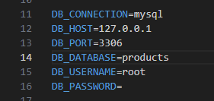

Table that I created



Then a migration file added in migration file

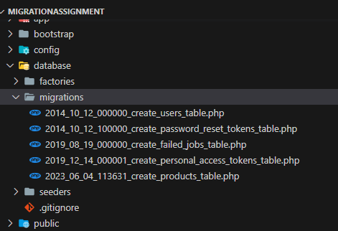

Then I found a schema for creating table where I add require columns

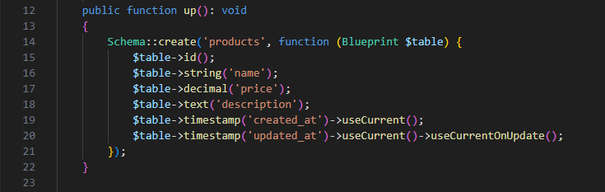

**Task 3 :** **After creating the migration file, run the migration to create the "products" table in the database.**

After that I run migration by the command “php artisan migration” and it migrated with all those column with a table. Here is a screenshot of mysql database called products table bellow.

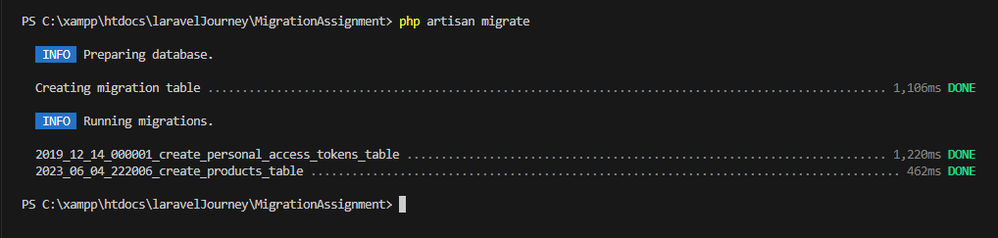

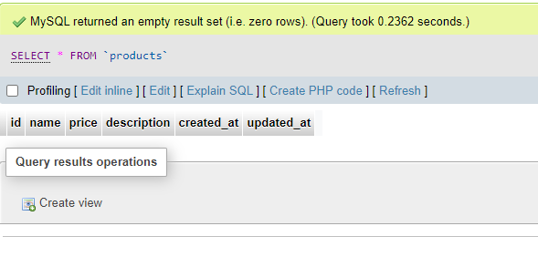

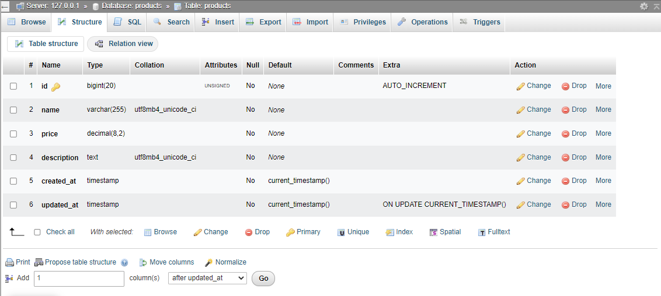

**Task 4. Modify the existing migration file "create_products_table" to add a new column called "quantity" to the "products" table. The "quantity" column should be an integer column and allow null values.**

**For add a column first i add a new column called "quantity" to the "products" table.**

**ScreenShots:**

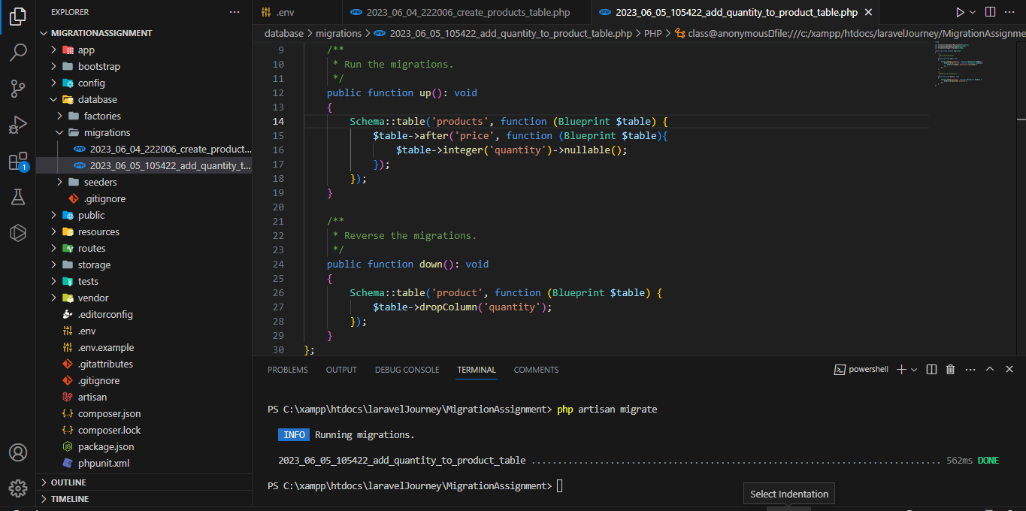

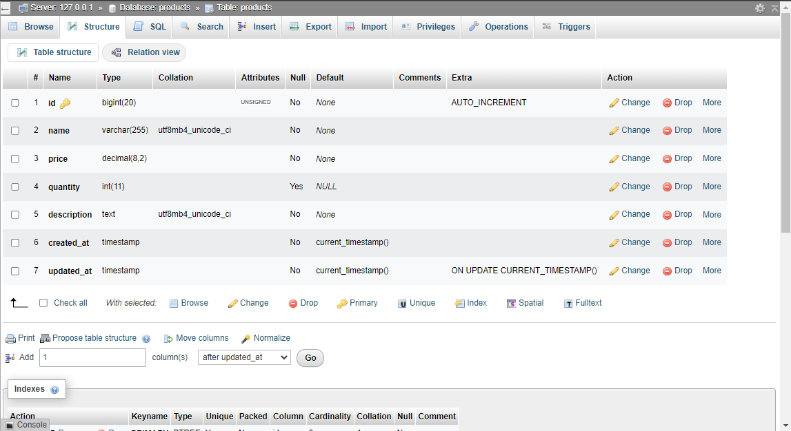

**Task 5. Create a new migration file named "add_category_to_products_table" that will be responsible for adding a new column called "category" to the "products" table. The "category" column should be a string column with a maximum length of 50 characters.**

**First I make a migration file and add a new column called “category” to products table after quantity**

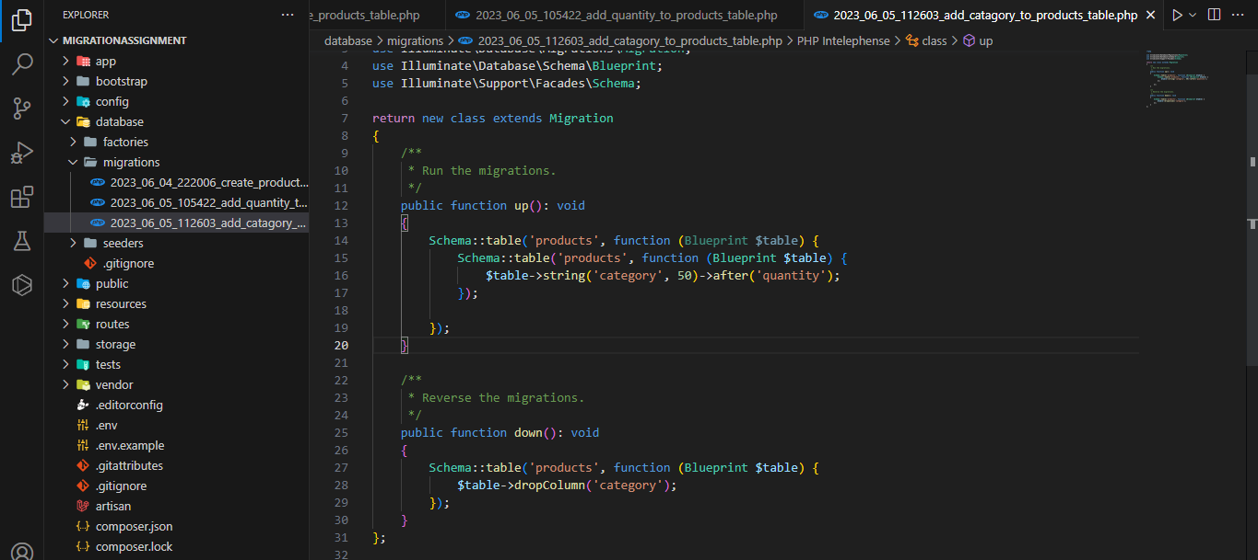

**Task 6. After creating the new migration file, run the migration to add the "category" column to the "products" table.**

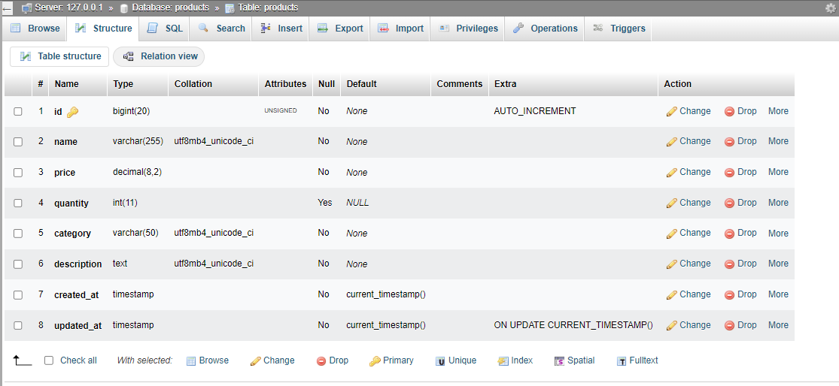

**Task 7:**   
Create a new migration file named "create_orders_table" that will be responsible for creating a table called "orders" in the database. The "orders" table should have the following columns:

* id: an auto-incrementing integer and primary key.
* product_id: an unsigned integer column to establish a foreign key relationship with the "id" column of the "products" table.
* quantity: an integer column to store the quantity of products ordered.
* created_at: a timestamp column to store the creation date and time.
* updated_at: a timestamp column to store the last update date and time.
* Task 8:
* After creating the migration file for the "orders" table, run the migration to create the "orders" table in the database.

Here is the Screenshoot which have orders table and given all the requirements..

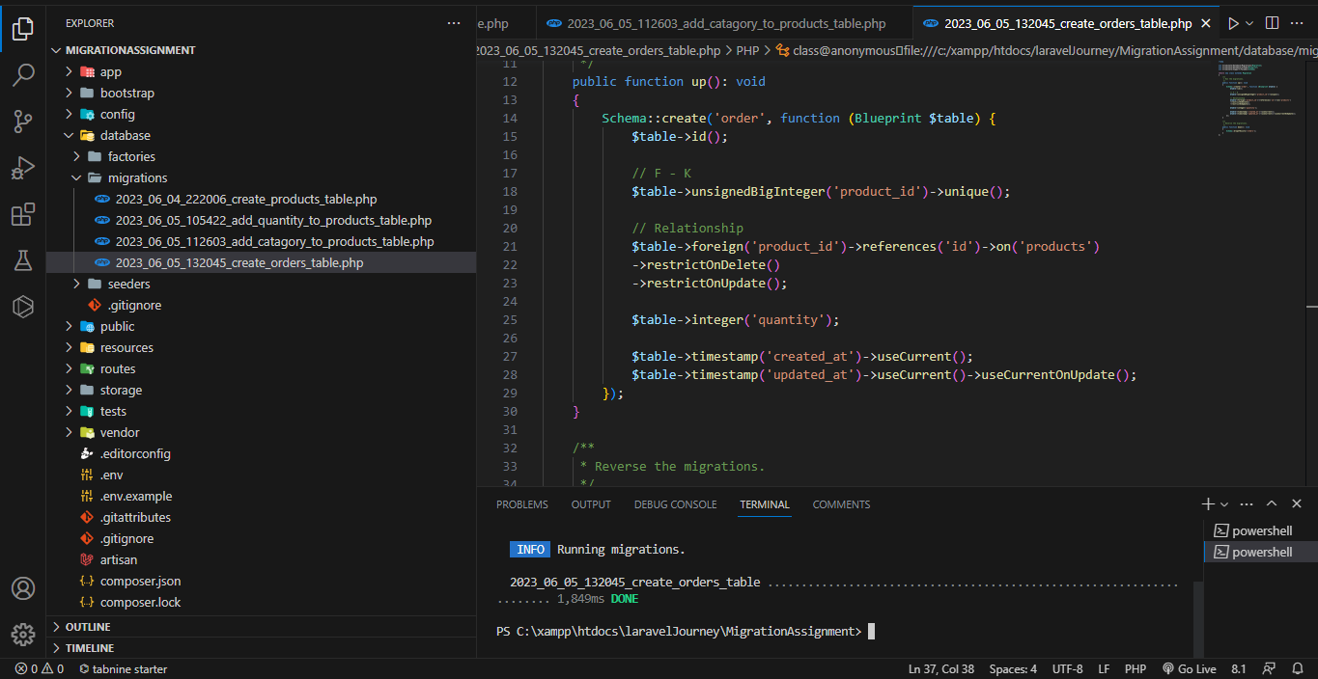

Here is Order table which have an unsigned integer column to establish a foreign key relationship with the "id" column of the "products" table.

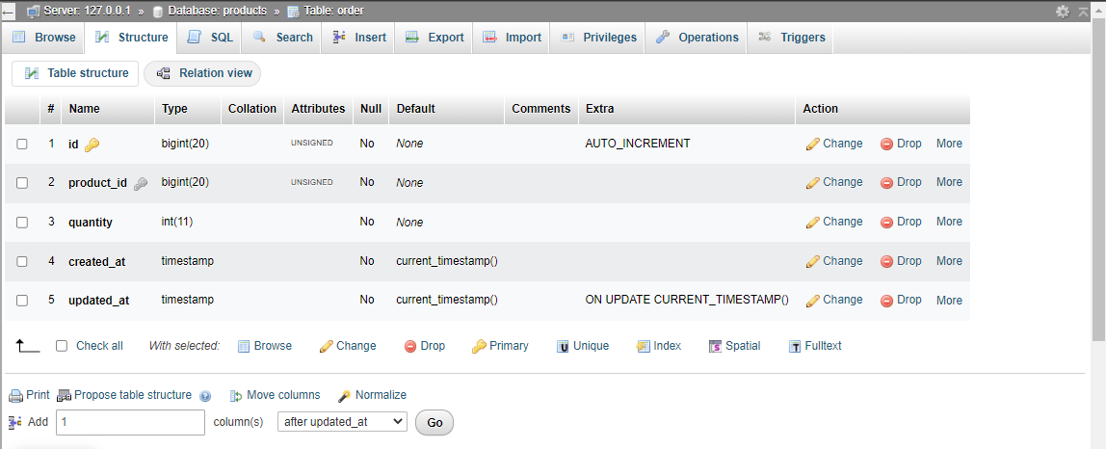

**Task 8 :**

**After creating the migration file for the "orders" table, run the migration to create the "orders" table in the database.**

**Here is the all database:**

**products table:**

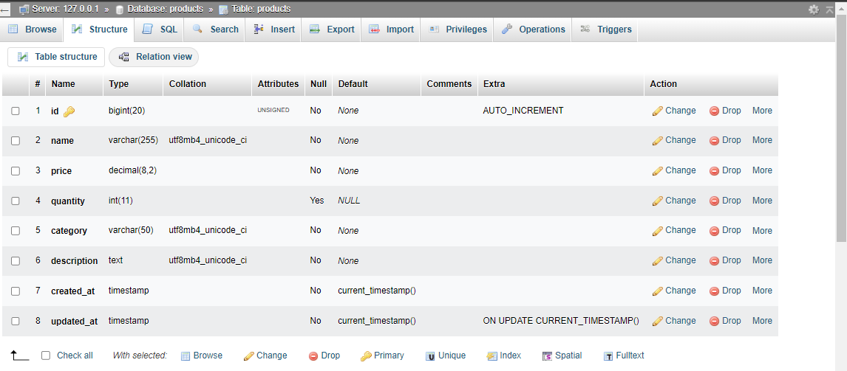

**Order table:**

