# Problem Set 3

Problem Set 3 allows you to start exploring your creating side. You’ll be designing and building your first website (almost) from scratch. You haven’t formally learned any CSS yet, so your website need only incorporate the HTML elements described below.

## Getting Started

To get started, you’ll need to create a [GitHub](https://github.com/) repository to store your Problem Set 3 code. After cloning my skeleton repository, you’ll need to setup a remote to push your code to your repository instead of mine. Steps to accomplish this are outlined below.

### Setup

1. Login to your [GitHub](https://github.com/) account and create a new repository named problem-set-3.
2. In GitBash, navigate to your APCSP folder.
3. Clone my skeleton repository from [GitHub](https://github.com/). This will make a copy of my repository and store it locally.

* git clone git@github.com:rwilson-ucvts/principles-pset3-skeleton.git

1. The cloning process will create a folder named principles-pset3-skeleton. Rename this folder to problem-set-3.

* mv principles-pset3-skeleton problem-set-3

1. Change directories to get into your problem-set-3 folder.

* cd problem-set-3

1. The cloning process will add a remote named origin that points at my skeleton repository. Rename origin to upstream.

* git remote rename origin upstream

1. Add a new remote that points at the problem-set-3 repository you created earlier. Make sure you replace YOUR-USERNAME with your actual [GitHub](https://github.com/) username.

* git remote add origin git@github.com:YOUR-USERNAME/problem-set-3.git

1. Launch [Atom](https://atom.io/), select File and click Add Project Folder....
2. Navigate to the APCSP folder on your Desktop, click the problem-set-3 project folder, and click Open.

* You should now see a folder named problem-set-3 in the Project panel in [Atom](https://atom.io/).

1. Expand the Project folder. You should see a file named index.html, and another named README.md (which is what you’re reading right now!). Open the index.html file.

If you see the following starter code, then you’ve correctly cloned and setup your project.

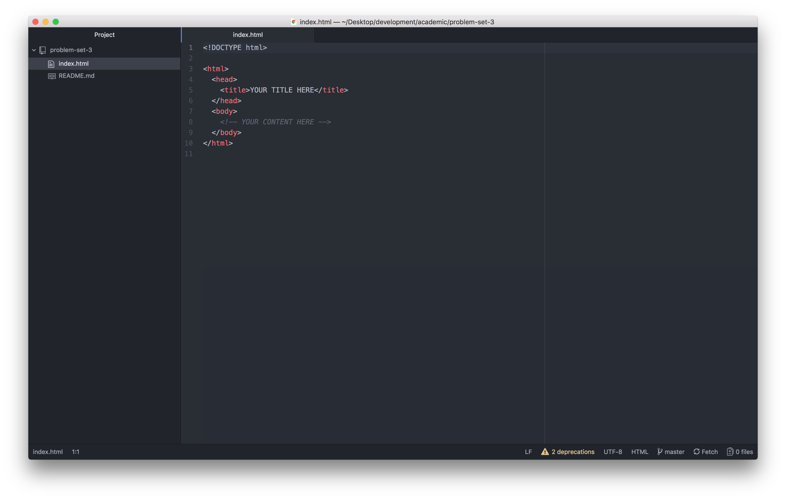

principles problem set 3 skeleton code screenshot

## Requirements

Create a website about a (school-appropriate) topic that interests you. This might be an extracurricular activitiy in which you participate, a sport or instrument you play, or just a hobby of yours. For now, your website should be informative in nature. Later, we’ll add some style and creative expression.

More specifically, your website must include and incorporate the following features and elements.

* 4 distinct pages (i.e., .html files)
  + 1 page that gives a brief overview of your website topic (i.e., a homepage, which should be written in your index.html file)
  + 3 pages that discuss separate subtopics in greater detail
* A navigation bar that allows you to navigate to and from each of the 4 pages
* A unique and descriptive <title> for each of the 4 pages
* At least 3 of the header tags variations: <h1>, <h2>, <h3>, <h4>, <h5>, and <h6>
* At least 7 hyperlinks
  + At least 4 internal links that use a relative URL: <a href="/relative/url.html> or <a href="#id">
  + At least 3 external links that use an absolute URL: <a href="https://absoluteurl.com">
* At least 1 image per page: <img src="/images/picture.png">
  + All images must be stored in a folder named images (the use of subfolders within images is at your discretion)
* At least 2 lists
  + At least 1 ordered list: <ol>
  + At least 1 unordered list: <ul>
* At least 1 horizontal rule: <hr/>
* At least 1 <table>
  + Your <table> must include a header (<thead>), a body (<tbody>), and a footer (<tfoot>)
* A consistent page footer on every page
  + Your footer must include the copyright symbol and year (i.e., © 2018)
  + Your footer must include the school (appropriately hyperlinked), and course (i.e., AIT | APSCS)
  + Your footer must include a contact email (appropriately hyperlinked)
* You must not use an actual email (instead, use info@example.com)

To avoid confusion, your directory structure must match the following. If something is followed with a /, it is a folder; otherwise, it is a file.

problem-set-3/  
 images/  
 myimage1.png  
 subfolder/  
 myimage2.png  
 index.html  
 mysubtopic1.html  
 mysubtopic2.html  
 mysubtopic3.html  
 README.md

Of course, your filenames will be different than mine. They are alphabetized, so they will likely appear in a different order, too. The subfolder inside of the images folder is optional. You might find it useful to further categorize your pictures, but it is not required. The image files inside of the images and subfolder folders are examples. Yours, of course, will be named differently.

## Deadline

Your Canvas submission is due at or before 11:59pm on your section-specific due date.

* October 9, 2018 (A 3/4 & 7/8)
* October 10, 2018 (B 3/4 & 7/8)

### Submission Requirements

All that is required for submission is the top-level URL to your [GitHub](https://github.com/) repository for this problem set.