ShowControl

What is it?
ShowControl is a suite of applications used to control sound, microphones, lighting, and other activities supporting a live theatrical presentation.

How does it work?
ShowControl can be applied to any sort of production, but is typically used for live theater where cues provide a chronological progression of the show from opening to bows.
Cues are defined by the user at various points in the script. Cues may be for sound, lighting, stage direction, or any other activity. For example, a stage direction cue might define when a character is to enter or when they are to be given a particular prop, or a lighting cue may define when a blackout is to occur.
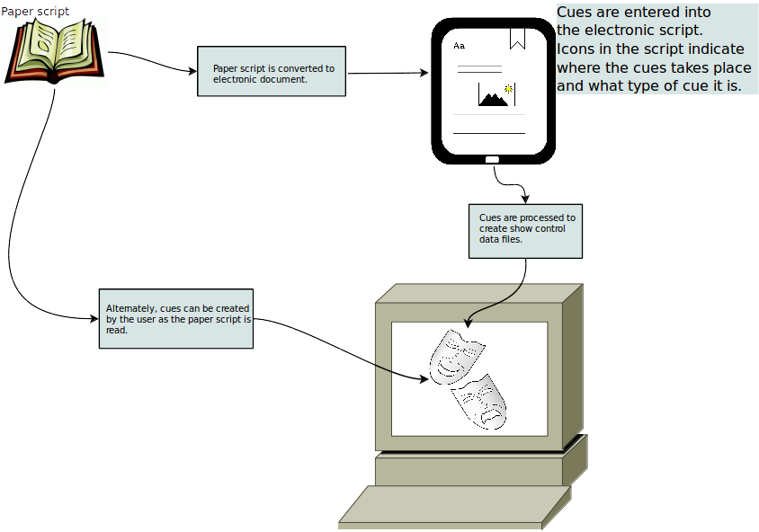
Typically, the user (director, producer, or other designate) goes through the script line by line defining cues. ShowControl provides the user a way to capture the cue definitions (either embedded in a electronic version of the script or manually with the paper script) that creates a database that will subsequently be used to manage the show.
Once the cues are defined they can be used to control the show. ShowControl can be used by one or many operators. For example, for a small community theater group, where the SM may wear the hats of the SM, lighting operator, and sound operator, ShowControl allows a single person to perform all of these functions. For a production that has an SM, lighting, and sound operator each can perform only their assigned functions. This is possible because cues have types.
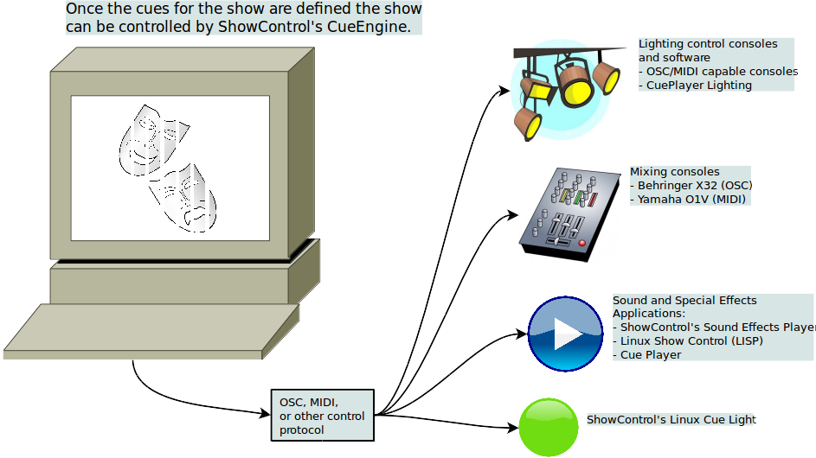
Cue types can be stage direction, sound, special effects, lighting, mixer, to name a few. Each cue can have one or many types. The type determines who or what might receive the output of the cue.

Implementation Overview
In general, venue specific and production specific details must be addressed to implement ShowControl for any production. The following we discuss the work flow involved for each area.

Venue Specific
The venue specific implementation consists of determining what is to be controlled. For example, the venue may have a digital mixer and digital lighting control software running on a PC. These will be referred to as control targets.
For each control target, the protocol and protocol transport method needs to be known. For example, the digital mixer may be connected to the venue network and can be controlled by OSC commands. Or, the lighting software may be controlled by MIDI. Also, for each control target, the command structure used with the chosen protocol must be known. The command structure is usually detailed in the operating or programming manual for the given device or software.
Currently, the minimum command set for some devices are available:
Command Target | Protocol | Protocol Transport
Behringer X32 Digital Mixer | OSC | UDP
Yamaha O1V | MIDI | MIDI connector

Other software, for example Linux Show Player or CuePlayer, can be controlled by MIDI as well. The commands for these can be defined as needed for a given project.
For complete details on how to create the control target specific protocol definitions files, see the ShowControl device specification manual.

Project Specific
Project specific information defines the details of the production. This includes, but is not limited to, characters, actors, understudies, dates, times, and cues. Some things are required, many are optional. For example, a rock concert would not typically have understudies.
For a theatrical production, cues define when a character in on stage and whether their microphone is muted or not. The cues might also define when a particular light cue is to be activated.
The basic work flow for defining a show is shown below:
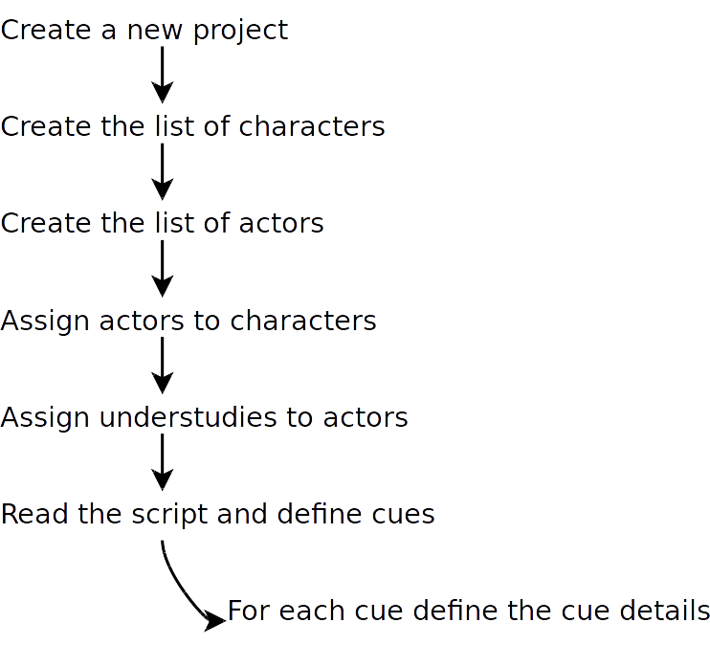
Let’s look at each of these steps in detail.

