Developer Workstation Performance Troubleshooting
VS Code, Code Helper, GitHub repositories, OneDrive, file watching and macOS background services
Executive Summary
A 16 GB MacBook Air used for SAP BAIP/BTP and CAP development experienced significant performance degradation.
The investigation initially identified multiple VS Code Code Helper (Plugin) processes consuming approximately 97% CPU each.
VS Code was then moved from Downloads to /Applications, removing the AppTranslocation path. After restart, Code Helper dropped to approximately 0.3% CPU and the VS Code Extension Host was around 0–3% CPU.
Later measurements showed substantial CPU activity from OneDrive, OneDrive File Provider, fileproviderd and macOS suggestd.
The key lesson is that developer-workstation performance should be diagnosed at the process, IDE, filesystem, synchronization and workspace levels before concluding that hardware alone is the problem.

1. Background and Context
Modern software-development workstations are increasingly resource-intensive. A typical environment can simultaneously run VS Code, AI coding assistants, Git, language servers, Node.js, Java tooling, CAP tooling, build processes, browsers, cloud synchronization clients and corporate security agents.
In this case, the development machine was a 16 GB MacBook Air. Performance issues made day-to-day development more difficult, and a higher-configuration replacement was recommended. A higher-memory machine can certainly provide additional headroom, but the immediate troubleshooting question was: what is actually consuming CPU, memory and filesystem resources?

2. Initial Problem Statement
The laptop was showing high CPU usage and elevated memory consumption while development tools were running. The initial assumption was that VS Code and its extensions could be contributing to the issue, particularly because multiple Code Helper (Plugin) processes were visible in Activity Monitor.
Rather than immediately removing extensions or replacing the laptop, the investigation used Activity Monitor, VS Code Process Explorer and Terminal process inspection to identify the active resource consumers.

3. Initial Activity Monitor Findings
The initial Activity Monitor view showed several Code Helper (Plugin) processes at approximately 97% CPU each. Other background processes were also consuming CPU.
This made VS Code a reasonable suspect, but a high CPU value for Code Helper does not by itself identify the specific extension or root cause.
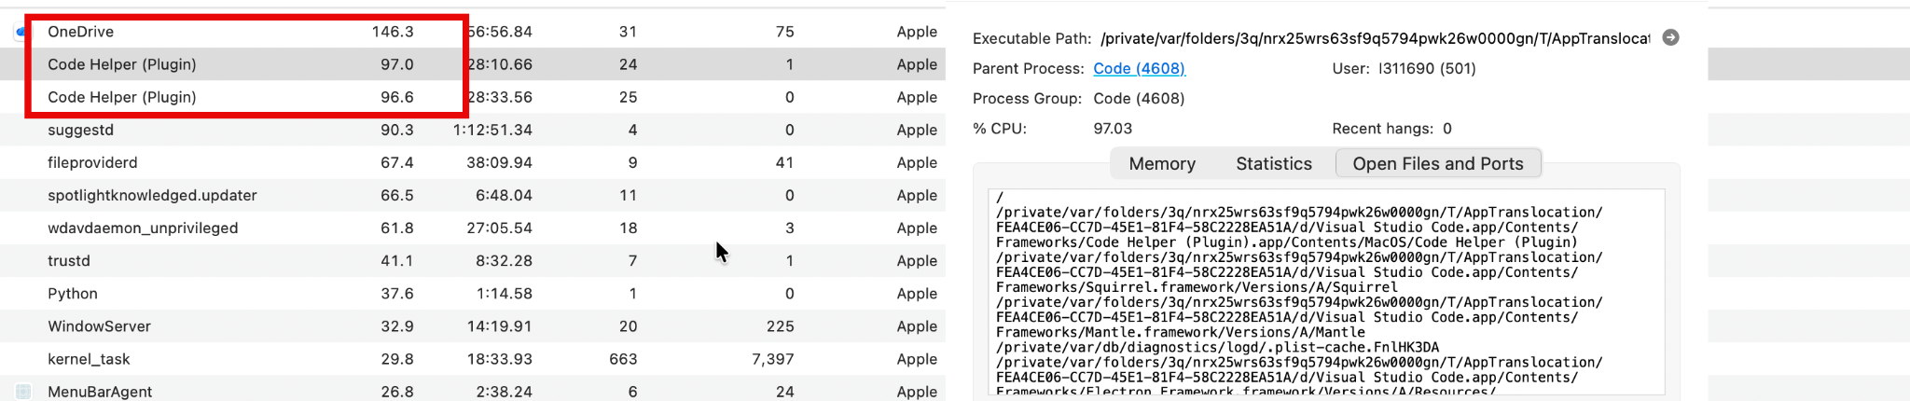
Earlier Activity Monitor view showing high Code Helper and other processes

4. Investigating Code Helper (Plugin)
The following command was used to inspect the active VS Code Code Helper processes:
ps aux | grep "Code Helper (Plugin)" | grep -v grep
The initial output showed multiple Code Helper processes. Some child processes referenced:
• VS Code Markdown language features
• dbaeumer.vscode-eslint version 3.0.34
The ESLint server processes themselves were not shown consuming significant CPU in that output, so it would not have been justified to conclude that ESLint was the culprit solely from that evidence.

5. AppTranslocation Investigation
An important finding was the executable path. VS Code was running from a macOS AppTranslocation directory under /private/var/folders/... rather than directly from /Applications.
The standard Applications location was checked:
ls -ld "/Applications/Visual Studio Code.app"
Initially, the application was not present in /Applications. A search showed the application under Downloads:
/Users/ABC/Downloads/Visual Studio Code.app
The application was then moved to the standard Applications directory:
mv "/Users/ABC/Downloads/Visual Studio Code.app" "/Applications/"
The application was explicitly launched from /Applications:
open "/Applications/Visual Studio Code.app"
After relaunching, the VS Code processes were observed running from:
/Applications/Visual Studio Code.app/...
rather than the previous AppTranslocation path.

Why this matters
macOS Gatekeeper can use App Translocation for recently downloaded applications, including applications launched from the Downloads directory. Apple describes this as a security mechanism that can run an application from a randomized, read-only location.
Apple's developer documentation specifically recommends moving the application to its intended installation location, usually /Applications, before launching when dealing with this translocation condition.
Therefore, for applications downloaded from the web, a practical installation pattern is:
Download → Verify trusted source → Install/Move to /Applications → Launch
Apple also explains that applications downloaded from the web are subject to Gatekeeper checks, including Developer ID signing and notarization where applicable.

Verification
The application's extended attributes were checked:
xattr "/Applications/Visual Studio Code.app"
The observed attributes were:
com.apple.macl
com.apple.provenance
No com.apple.quarantine attribute was present at the time of the check.

Best Practice: When installing a Mac application downloaded from the web, use the developer's installation instructions and, where appropriate, move the .app bundle to /Applications before launching it as your regular installation. This also helps avoid Gatekeeper App Translocation scenarios associated with launching recently downloaded applications from locations such as Downloads.
https://developer.apple.com/documentation/fileprovider/nsfileprovidererror/code/providertranslocated?language=objc

6. Verifying the New VS Code Installation
VS Code was closed and checked before restarting:
osascript -e 'quit app "Visual Studio Code"'
pgrep -fl "Visual Studio Code"
It was then launched explicitly from /Applications:
open "/Applications/Visual Studio Code.app"
The Code Helper path was checked again:
ps aux | grep "Code Helper (Plugin)" | grep -v grep
The active process path now started with:
/Applications/Visual Studio Code.app/
instead of:
/private/var/folders/.../AppTranslocation/
This confirmed that the active VS Code copy was running from the standard Applications location.

7. CPU Behaviour After Restart
Immediately after startup, Code Helper briefly reached approximately 154.8% CPU. This was a transient observation rather than the final steady state.
After the application settled, Code Helper dropped to approximately 0.3% CPU. A separate macOS ditto process had also been observed during startup/update activity and later disappeared.
ps aux | grep "ditto" | grep -v grep
The absence of output from the ditto check indicated that the observed extraction/update process had completed.

8. VS Code Process Explorer
VS Code's built-in Process Explorer was used to separate the main application, extension host and supporting processes.
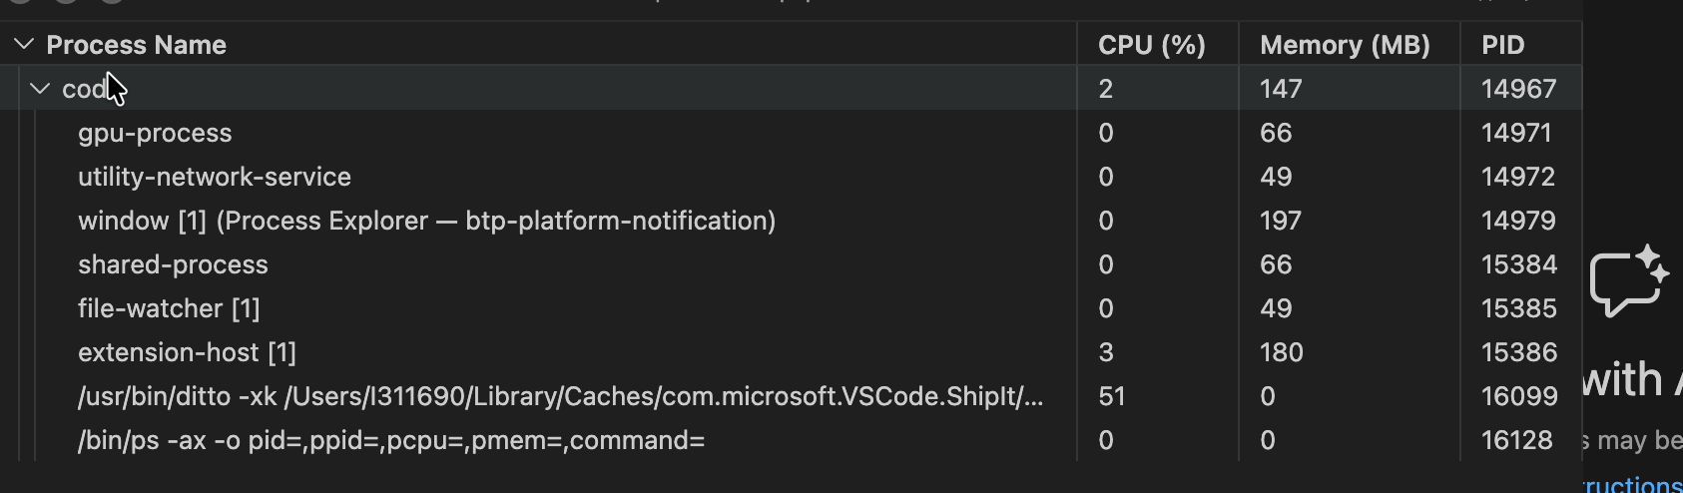
VS Code Process Explorer showing low extension-host CPU
The Process Explorer screenshot showed the Extension Host at approximately 3% CPU and the main Code process around 2%. This was evidence that VS Code's extension host was not continuously consuming high CPU at that point.
Therefore, the investigation did not justify disabling or uninstalling extensions simply because Code Helper had previously been high.

9. VS Code Workspace Optimization for BAIP/BTP CAP Projects
For SAP BAIP/BTP and CAP Node.js projects, large dependency and generated directories can create unnecessary filesystem activity. Common examples include node_modules, gen and dist. Git's internal object directory can also be large.
A practical VS Code optimization is to exclude appropriate directories from Explorer visibility and file watching.
{
"files.exclude": {
"**/.git": true,
"**/.svn": true,
"**/.hg": true,
"**/CVS": true,
"**/.DS_Store": true,
"**/tmp": true,
"**/node_modules": true,
"**/bower_components": true,
"**/dist": true,
"**/gen": true
},
"files.watcherExclude": {
"**/.git/objects/**": true,
"**/.git/subtree-cache/**": true,
"**/node_modules/**": true,
"**/tmp/**": true,
"**/bower_components/**": true,
"**/dist/**": true,
"**/gen/**": true
}
}
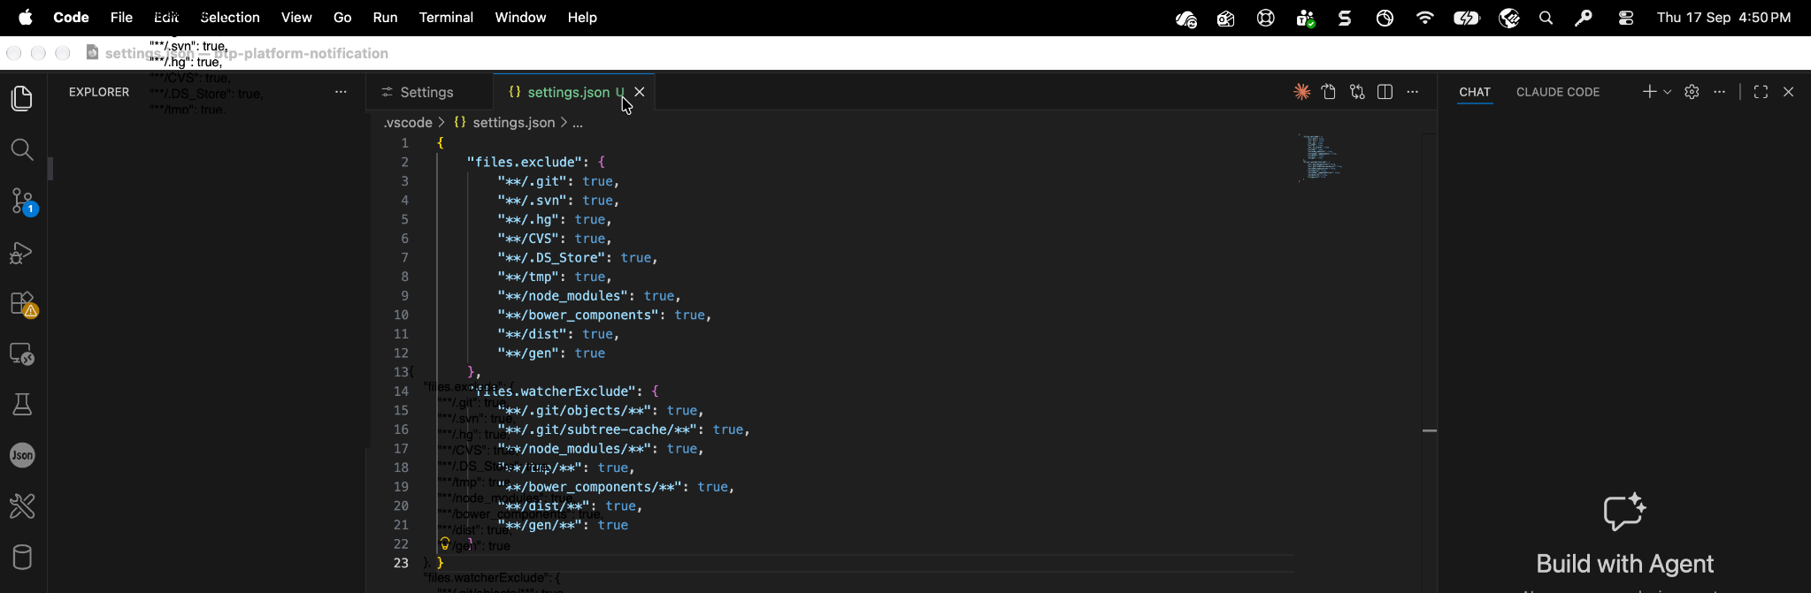
VS Code settings.json with file and watcher exclusions

9.1 What These settings do
files.exclude hides matching folders from VS Code's file views. files.watcherExclude prevents VS Code from continuously watching matching paths for filesystem changes.
These settings do not delete files. They change how VS Code interacts with those paths.
For active source code, avoid unnecessary exclusions. Typical CAP source folders such as app, db, srv and test should normally remain visible and available to language services and development tooling.
Important
The configuration is a performance optimization, not a replacement for understanding the project. Apply exclusions selectively and validate that the development experience—navigation, IntelliSense, debugging and build workflows—continues to work as expected.

10. GitHub Repositories and OneDrive
A key workstation practice is to keep active Git working copies outside OneDrive unless there is a specific organizational requirement to synchronize them.
If a GitHub repository is cloned inside a OneDrive-managed folder, several systems can react to the same filesystem changes:
• Git tracks repository changes.
• VS Code watches workspace files.
• npm/CAP/build tools create and modify dependencies and generated files.
• OneDrive monitors and synchronizes changes.
• macOS File Provider services process filesystem activity.
• Security software may scan changed files.
This can create unnecessary background activity, especially for large projects.

10.1 Recommended Development Directory
~/Development/
btp-platform-notification/
harmony-quote/
pricing-summary/
quote-pricing-service/
A cleaner separation is:
Git/GitHub → source-code versioning and collaboration
Local Development folder → active Git working copies
OneDrive → documents and files that actually need cloud synchronization
For example, keep architecture documents, presentations and reports in OneDrive, while active Git repositories remain under a local development directory.

10.2 Why Pausing OneDrive Is Not the Primary Solution
OneDrive can be paused temporarily as a diagnostic or when synchronization is actively interfering with development. However, repeatedly pausing synchronization is not the preferred long-term solution if the repository does not need to be synchronized in the first place.
Keeping the active Git clone outside OneDrive removes the need to make OneDrive a participant in the normal source-code development workflow.

11. OneDrive and macOS Background Activity
After VS Code had settled, Activity Monitor showed significant CPU consumption from OneDrive and macOS File Provider components. The observed processes included OneDrive, OneDrive File Provider, fileproviderd and suggestd.
Activity Monitor showing high OneDrive/File Provider activity
Process-level inspection was performed with:
ps -p 802 -o pid,ppid,%cpu,%mem,etime,command
ps -p 1285,1150,805 -o pid,ppid,%cpu,%mem,etime,command
The captured point-in-time values were approximately:
• suggestd — 74.5% CPU
• fileproviderd — 50.0% CPU
• OneDrive File Provider — 73.2% CPU
• OneDrive — 70.8% CPU
These measurements show significant background activity at that moment, but they do not by themselves prove a permanent root cause.

12. Understanding suggestd
suggestd is a legitimate macOS CoreSuggestions system process. It supports Apple's suggestion and related system intelligence functions.
It should not be deleted. If it remains at very high CPU for an extended period, investigate what other filesystem or indexing activity is occurring rather than treating suggestd itself as an application to remove.

13. Safe OneDrive Diagnostic
A controlled test is to temporarily pause OneDrive synchronization and observe whether OneDrive, OneDrive File Provider and fileproviderd CPU usage decreases.
This establishes correlation without immediately unlinking the account or resetting OneDrive.
If OneDrive-related CPU falls significantly after pausing, synchronization/file-system activity is a strong candidate contributor. If suggested remains high independently, investigate that separately.

14. Other Best Practices for a 16 GB Developer Mac
Practice | Why it helps
Open only the workspace you need | Avoid opening a huge parent directory containing many unrelated repositories. Open the current project or a deliberately selected multi-root workspace.
Limit simultaneous watchers | Avoid leaving multiple cds watch, npm run watch, Java services, React dev servers or local containers running when they are not needed.
Keep generated folders out of source control | Use the project's appropriate .gitignore so dependency and generated output is not accidentally committed.
Use npm ci where appropriate | For reproducible Node.js dependency installation, npm ci can recreate node_modules from package-lock.json without storing dependencies in cloud sync.
Review VS Code extensions | Keep extensions that provide value, but periodically review unused or overlapping AI/code-assistance extensions and language servers.
Use Process Explorer before disabling extensions | If Code Helper is high, identify the responsible process/extension before removing or disabling anything.
Monitor Memory Pressure | macOS Activity Monitor's Memory Pressure is more useful than simply looking at free RAM. Also observe swap usage when performance is poor.
Control browser load | Large numbers of browser tabs and development tools can consume substantial memory alongside VS Code.
Keep cloud-sync folders separate | Avoid placing active Git repositories, node_modules and build output inside OneDrive/iCloud/other synchronization folders.
Measure after every change | Change one thing, restart if required, measure again and record the result.

15. BAIP/BTP CAP Node.js Workspace Recommendations
For BAIP/BTP CAP development, a practical local workspace can look like:
~/Development/
├── btp-platform-notification/
├── harmony-quote/
├── pricing-summary/
└── quote-pricing-service/
Typical project folders:
├── app/ # application/source
├── db/ # CAP data model
├── srv/ # CAP services
├── test/ # tests
├── package.json
├── package-lock.json
├── mta.yaml
├── xs-security.json
├── node_modules/ # dependencies; keep local, don't watch unnecessarily
├── gen/ # generated CAP/build output
└── dist/ # build/distribution output
The important distinction is that app, db, srv and test are source-oriented folders, while node_modules, gen and dist are dependency/generated areas. The latter are good candidates for reduced watching, subject to the specific project workflow.

16. Useful Terminal Commands
Check Code Helper processes
ps aux | grep "Code Helper (Plugin)" | grep -v grep
Check VS Code installation
ls -ld "/Applications/Visual Studio Code.app"
Find VS Code installations
mdfind "kMDItemCFBundleIdentifier == 'com.microsoft.VSCode'"
Check VS Code extended attributes
xattr "/Applications/Visual Studio Code.app"
Quit VS Code
osascript -e 'quit app "Visual Studio Code"'
Check whether VS Code remains running
pgrep -fl "Visual Studio Code"
Launch the Applications copy
open "/Applications/Visual Studio Code.app"
Check VS Code update/extraction activity
ps aux | grep "ditto" | grep -v grep
Inspect a specific process
ps -p <PID> -o pid,ppid,%cpu,%mem,etime,command
Inspect multiple processes
ps -p <PID1>,<PID2>,<PID3> -o pid,ppid,%cpu,%mem,etime,command
Inspect recent suggestd activity
log show --last 10m --predicate 'process == "suggestd"' --style compact | tail -100

17. Recommended Troubleshooting Flow
- Open Activity Monitor and identify the top CPU, memory and disk consumers.
- Use VS Code Process Explorer to determine whether the main Code process, Extension Host or another VS Code process is responsible.
- If Code Helper is high, inspect the process and determine whether the spike is transient or persistent.
- Confirm VS Code is running from /Applications and not an AppTranslocation path.
- Restart VS Code and measure again.
- Review workspace size and exclude large dependency/generated directories from unnecessary file watching.
- Do not uninstall extensions without evidence that a specific extension is responsible.
- If VS Code is normal but the Mac remains slow, investigate OneDrive, File Provider, security agents, indexing and other background services.
- Use a controlled OneDrive pause to test whether synchronization correlates with CPU load.
- Only after the workload is understood should you decide whether software/configuration changes, workspace restructuring or additional hardware is required.

18. What the Investigation Demonstrated
The measurements changed over time:
Initial state:
• Three Code Helper (Plugin) processes were around 97% CPU each.
After moving VS Code and restarting:
• Code Helper later settled around 0.3% CPU.
• VS Code Extension Host was around 0–3% CPU.
Later Activity Monitor:
• OneDrive, OneDrive File Provider and fileproviderd were all using substantial CPU.
• suggestd was also using substantial CPU.
This demonstrates why a single screenshot or a single process name should not be treated as the complete diagnosis.

19. Key Lessons Learned
Lesson | Practical takeaway
Diagnose before upgrading | A higher-spec machine can help, but identifying the real resource consumers is the first step.
AI-era developer environments are complex | IDE extensions, AI assistants, language servers, build tools, cloud sync and security agents can all run simultaneously.
Git and OneDrive have different purposes | Git is designed for source-code versioning; OneDrive is designed for synchronized file storage. Separating the active working copy from cloud synchronization can reduce unnecessary activity.
File watching matters | Large node_modules, gen, dist and Git internals can create unnecessary filesystem work if watched indiscriminately.
CPU and RAM need separate investigation | A process can be CPU-heavy without being memory-heavy, and vice versa.
Measure after each change | A controlled troubleshooting cycle produces better evidence than making many changes at once.

20. Final Conclusion
The investigation did not establish that a 16 GB MacBook Air is universally sufficient or universally insufficient for modern development. Instead, it showed that workstation performance depends on the combined workload and configuration.
VS Code was a significant suspect during the initial CPU spike, but after correcting the installation location and restarting, its Code Helper and Extension Host CPU usage became low. Subsequent measurements identified substantial OneDrive/File Provider and macOS background activity.
For BAIP/BTP/CAP development, a strong workstation practice is therefore to keep active Git repositories in a local development directory, keep OneDrive for documents that need synchronization, exclude large dependency/generated folders from unnecessary VS Code file watching, keep the number of simultaneously running development services under control, and use Activity Monitor plus VS Code Process Explorer to diagnose resource consumption before deciding that a hardware replacement is the only solution.
Bottom Line
Higher-spec hardware provides more headroom, but good developer-environment hygiene and observability matter too. The practical objective is not simply to have more CPU or RAM—it is to ensure that the CPU, memory and filesystem are being used for work that actually supports the development task.

21. Screenshot Appendix
VS Code settings.json with file and watcher exclusions
VS Code Process Explorer showing low extension-host CPU
Activity Monitor showing high OneDrive/File Provider activity
Earlier Activity Monitor view showing high Code Helper and other processes

