Embedded Systems Design
Lab2 Report

Name：岳雪颖 XueyingYue
Num:192050217
Date: 2020-6-18

- Lab Process:
Step1:first we create a project which type is STM32,and then search STM32F429ZI,choose the package LQFP144.
Step2:Set the PB7 and PB14 as the GPIO_OUTPUT and save it.
Step3:Click the middle ware,choose the FREERTOS,select the CMSIS_V2,click task to add a second task,there is a default task and the new task.
Step4:Click build all,and in the generate main.c we should add code.
Step5:write code
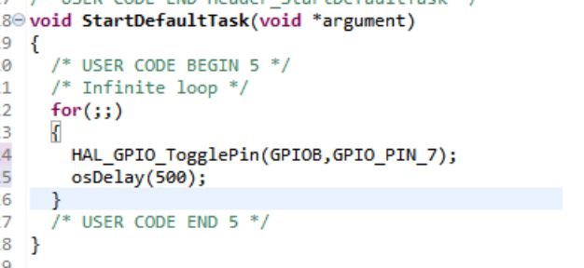
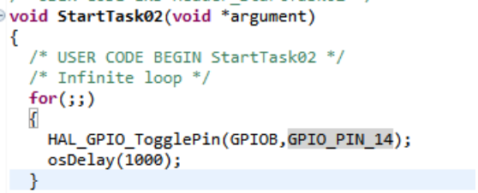
2.Answer Questions
1.What features of FreeRTOS do you remember?
FreeRTOS has the following standard features:
• Pre-emptive or co-operative operation
• Very flexible task priority assignment
• Flexible, fast and light weight task notification mechanism
• Queues
• Binary semaphores
• Counting semaphores
• Mutexes
• Recursive Mutexes
• Software timers
• Event groups
• Tick hook functions
• Idle hook functions
• Stack overflow checking
• Trace recording
• Task run-time statistics gathering
• Optional commercial licensing and support
• Full interrupt nesting model (for some architectures)
• A tick-less capability for extreme low power applications
•

2.What are the differences between FreeRTOS, OpenRTOS and SafeRTOS?
The FreeRTOS open source license is designed to ensure:
1. FreeRTOS can be used in commercial applications.
2. FreeRTOS itself remains freely available to everybody.
3. FreeRTOS users retain ownership of their intellectual property.

OpenRTOS is a commercially licensed version of FreeRTOS provided under license from Real Time Engineers Ltd. by a third party.

SafeRTOS shares the same usage model as FreeRTOS, but has been developed in
accordance with the practices, procedures, and processes necessary to claim compliance with
various internationally recognized safety related standards.

3.Why do we need the vTaskStartScheduler() function?
Starts the FreeRTOS scheduler running.
Typically, before the scheduler has been started, main() (or a function called by main()) will be executing. After the scheduler has been started, only tasks and interrupts will ever execute.
The Idle task is created automatically when the scheduler is started. vTaskStartScheduler() will only return if there is not enough FreeRTOS heap memory available for the Idle task to be created.
It control which task was executed and when according to the priority.If we used VtaskStartScheduler(),the highest priority task that was created while the scheduler was in the Initialization state to enter the Running state.

4. Why do we need the xTaskCreate() function?
xTaskCreate() function is used to create a FreeRTOS function.And add it to task stack.Create a task and initialize it.Set the priority ,if the priority of task which is running is smaller than the created one, then task switch.If a task is created and added into ready queue successfully,it will return ‘pdPASS’,else it will return error code.Newly created tasks are initially placed in the Ready state, but will immediately become the running state task if there are no higher priority tasks that are able to run.

