**Human detection and classroom door lock automation system.**

**Abstract:**

In technological advancements, people are skyrocketing now. The development of technology has enabled device control of household appliances. An automated system is more versatile and effective, and it may be used to open doors. It might be difficult to get up from your seat and make it to the door to unlock someone you already know and have an appointment with if you have a busy family or life. Through our initiative, SMART DOORS, we are making a little contribution to the enormous efforts being made to improve and simplify our lives. A basic concept called "AUTOMATIC DOOR" let users who enter the room, take control of their access to doors. To display the object there, we utilize the Processing IDE software as a communication tool. When there is presence of object or human within its Ultrasonic radar, The door will automatically open with the help of servo motor. Otherwise, the door will be automatically be closed. This door lock automation system can allow all type of unauthorized personnel. Basically, with the help of this automated door system it can be controlled shopping mall door, toll plazas etc. The main benefit of our suggested system that it can be easily installed when and where necessary without requirement of any infrastructures and proper planning.

**Introduction:**

The Internet of Things (IOT) is a technology framework for communicating with electrical items in the modern computer age. Due to its flexibility and ease of use, wirelessly operated gadgets have been gaining market domination in a number of sectors, including consumer electronics and home security. This kind of technology is referred to as the "internet of things." With the use of this technology, new automation systems for homes, businesses, and other settings are being created.

Modern homes are quickly transitioning away from traditional switches in favour of a centralized control system with remote control switches. The most significant advantage of our proposed system is to build smart door lock which can be access via sensing module, to increase security of the house and to design and implement a cheap and open source home automation. This project will make human lives more versatile with enhanced security, ease, and the ability to live an upper-class lifestyle, resulting in our lives becoming much simpler, finer, accessible, and stable.

This project monitors the door open/ close and informs about the object via radarsarvo. The system makes use of Arduino Uno board, Sensing module to sense the entity present in front of the door, Servomotor as a door movement device.

The major goal of smart door lock technology is to improve living conditions by introducing networking tools and equipment within the classroom. A smart door lock allows for complete automation, resulting in comfortable living conditions and additional advantages for those with disabilities. Every door locking system now in use requires a traditional key or some other electrical pass to access the system. By creating an automated door, users can access the premises without any hassle.

Suppose someone is knocking at your door but you are preoccupied to unlock the door, ultrasonic sensor senses the person, operates the system and opens the motorized door.

**Methodology:**

The IoT project is based on detection of human and opening or closing the door in an automated process which incorporate sensing, controlling and communication layer of IoT architecture. The equipment’s used in this work is Ultrasonic sensor, Servo motor, Arduino uno board and connecting cables (male to male and male to female) and bread board. The software used for communication purpose is ‘Processing IDE 4’ where 4 depicts the version. All the instructions to functioning the project is uploaded in Arduino uno board which is a microcontroller used for the purpose of controlling the whole process through cable connections and necessary coding. Figure 1 visualizes the entire project with labeling of various parts.

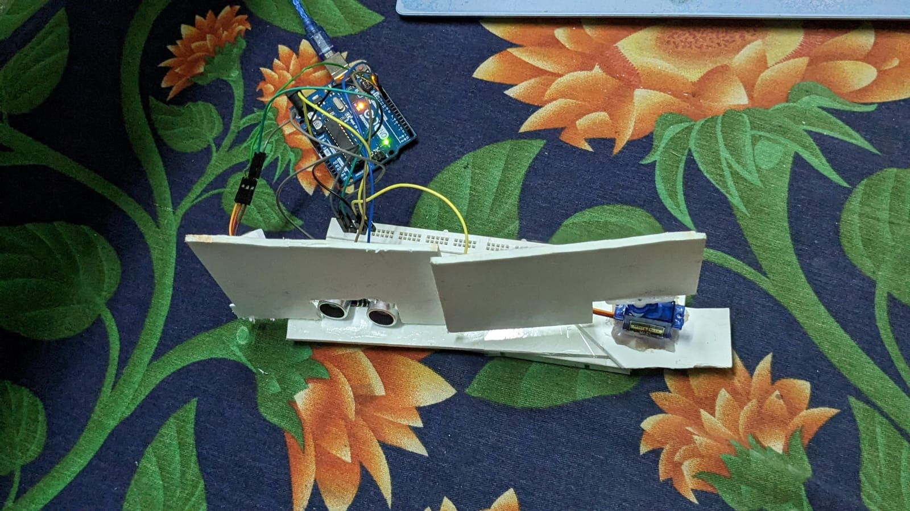

*Ultrasonic Sensor*

*Servomotor*

*Arduino uno board*

Figure 1: Visualization of the entire project implementation with labeling of various parts.

1. **Sensing:**

For the purpose of sensing the human arriving at the door of a classroom, ultrasonic sensor is used in this project as labeled in Figure 1. It works by measuring the distance to an object using sound waves. A transducer is used to send and receive ultrasonic pulses which provide information about object’s proximity. The sensor is triggered by high frequency sound wave. The DC power supply of 5V is used to work with this sensor. After giving the power supply, a sound wave is generated which travels to hit the object. The echo signal is reflected from the boundary of the object which is human in this case. By calculating the travel time of triggered and echo signal reception and the speed of sound, the distance of the human can be calculated which is depicted in equation (1).

(1)

Where S is the distance to the human from the sensor, V is the speed of sound (343 m/s) and T is the time for the sound wave to hit the object and return back. The division by 2 allows to calculate actual distance because of the double time taken by the sound wave to be triggered and reflected back.

There are four pins in the ultrasonic sensor. Among them, two power pin e.g. Vcc pin and Gnd pin is connected to 5V pin and GND pin of Arduino uno board. The sensor is powered up by the voltage supply of the Arduino uno board. The Trig pin and Echo pin is connected to pin 13 and pin 10 in the board.

1. **Controlling:**

For the purpose of controlling the door lock with respect to arrival and departure of human, rotary servomotor is incorporated in this work as referred to Figure 1. As it is a DC servo motor, it is powered by DC power supply of 5V from Arduino uno board. Servomotor is a closed loop system that rotate with a great precision based on feedback about current position of the motor shaft. The human detection information coming from the sensor is compared with the reference command signal of servomotor. The difference between these two signals is the control signal for servomotor. When there is no object knocking at the door, the servomotor will not rotate due to absence of control signal as shown in door lock situation in Figure 2(a). The entrance of human within the range of ultrasonic sensor provides an echo signal. There must be a difference between this signal with reference signal which causes the rotation of motor shaft by 900. It is visualized as door open situation as in Figure 2(b).

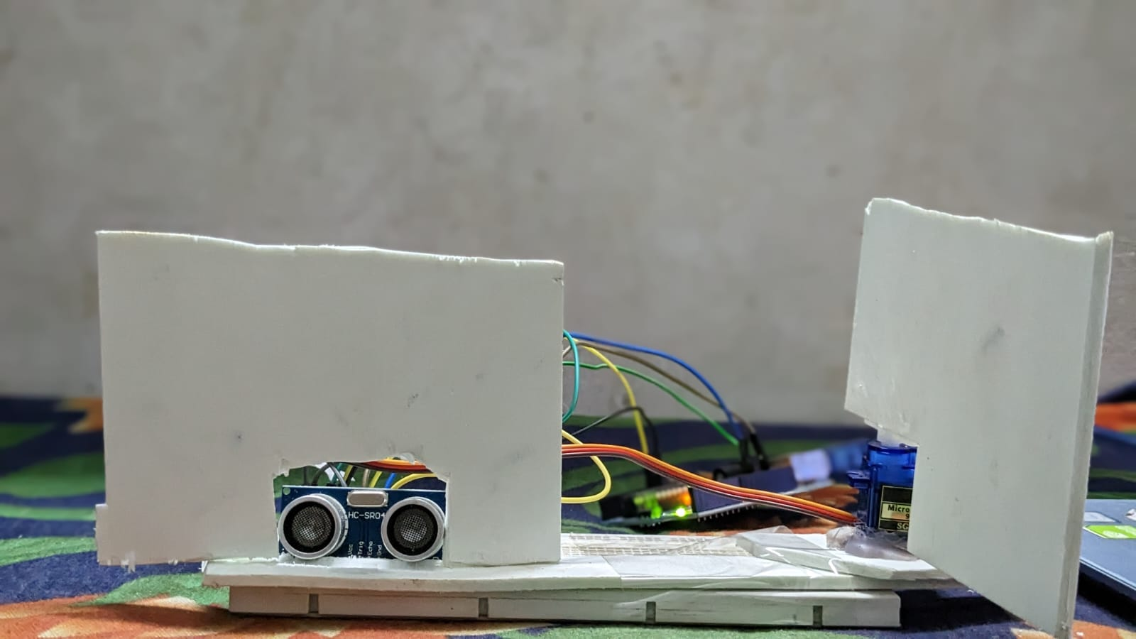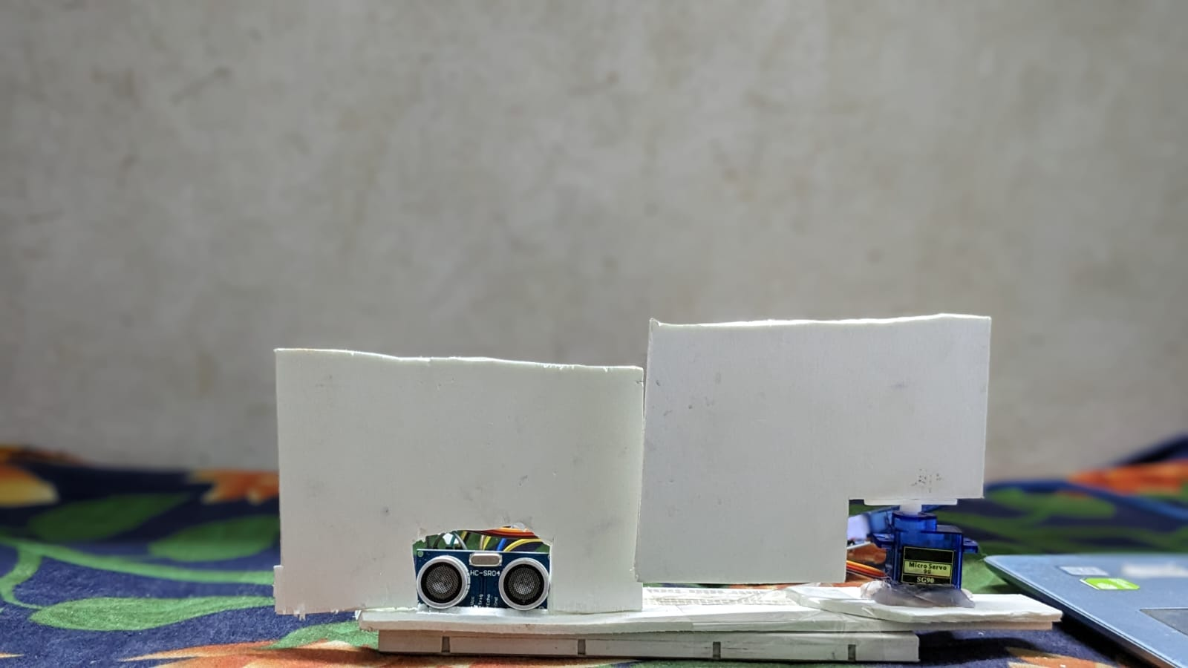

1. (b)

Figure 2: Visualization of (a) Door lock and (b) Door open with the 900 rotation of servo motor.

1. **Communication:**

To enable communication between users of this work, a software named ‘Processing IDE’ is utilized. A build in source code written in Arduino programming language with an extension ‘. pde’ allow users to get notified when arrival of a person is happened. There is a constant 1800 rotation clockwise and anticlockwise one after another with the green vertical lines even when there is no object as shown in Figure 3(a). When any object arrives within the range of ultrasonic sensor, green vertical lines become red which is an indication about person’s arrival as referred to the Figure 3(b). After the departure of a person, red vertical lines will become green as before.

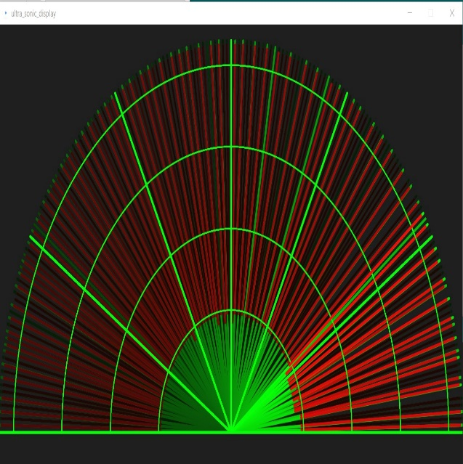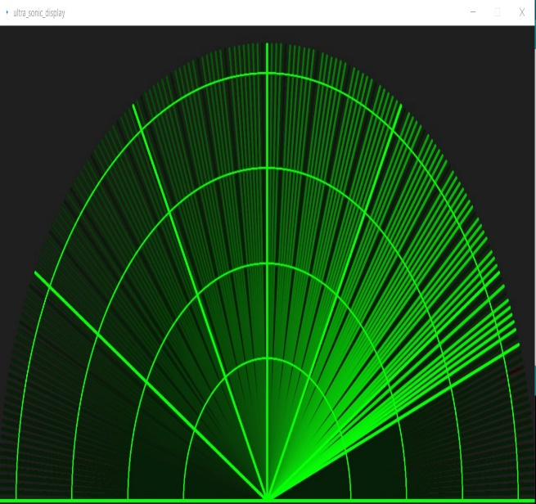

1. (b)

Figure 3: Visualization of (a) Green vertical lines, and (b) Red vertical lines in ‘Processing IDE’ software.

1. **Simulation:**

In the simulation part of the project, only sensing and controlling layer of IoT is utilized. Referring to Figure 4, ultrasonic sensor and servomotor is used to sense the object and control the door lock respectively as mentioned earlier. A potentiometer is used as reference for human object. To visualize the working, a virtual terminal is used which indicate the distance. For necessary cabling and instructions uploading, Arduino uno board is used.

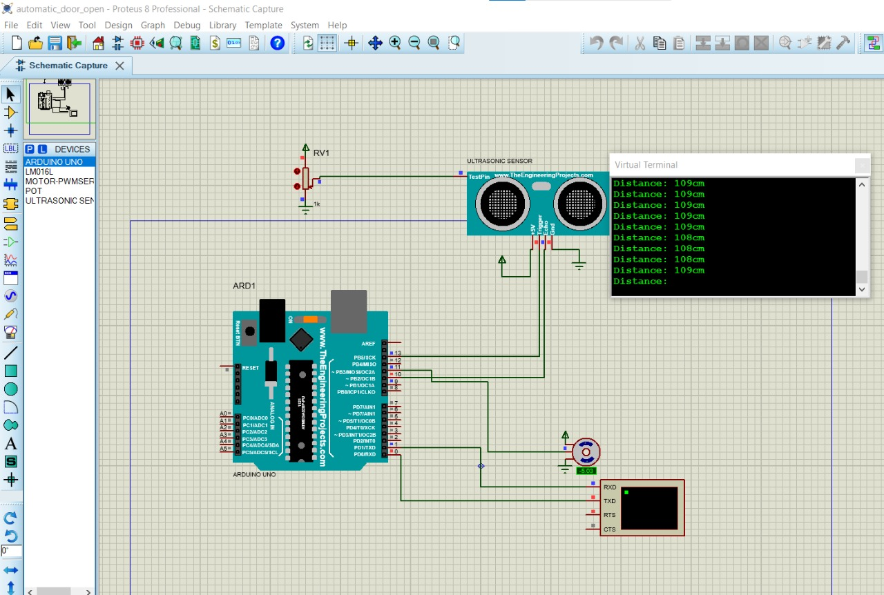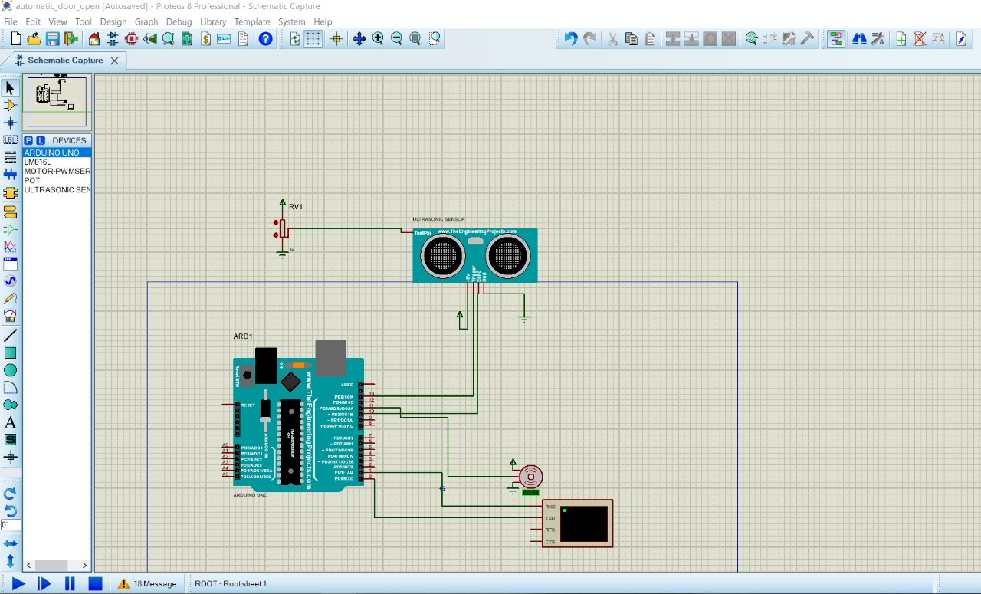

1. (b)

Figure 4: Visulization of simulation part of the project incorporating sensing and controlling (a) Before simulation, and (b) After simulation.

1. **Project Code:**

The project code referred to Figure 5 is started with inclusion of servo library into the project sketch. Trig and Echo pin of ultrasonic sensor is connected to pin 13 and 10 of Arduino uno board. From the servo library, two objects named as ‘radarServo’, and ‘myservo’ is called. ‘radarServo’ is used in ‘Processing IDE’ software for communication purpose. ‘myservo’ is used to rotate the servomotor for controlling purpose. Setup is mandatory void function in Arduino programming language. The code inside this function is executed only once at the beginning of the program. As the echo signal from ultrasonic sensor is a measure of distance, it is configured as an input pin. The control pin of ‘radarServo’ and ‘myservo’ is connected to 9 and 11 pin of Arduino uno board. Loop is another void function where the lines inside it executed again and again. At first, Trig pin is made low for a resetting purpose. After a 2 sec delay, Trig pin is made high to enable the ultrasonic sensor and wait 10 sec for the echo signal. Then Trig pin is set to low again. The duration when the Echo pin is high is used to calculate the distance of the object referring to Eq. (1). The Arduino code to work with ‘Processing IDE’ software is composed of two for loop. One is for 00 to 1800 rotation and another one is for 1800 to 00 rotation. Inside of both loop, ultrasonic sensor is triggered and after a delay echo signal is received and distance to object is measured. This is to notify a user by the red vertical line that a human is arrived. When the distance to a human arriving at a door is less than or equal 40cm, servomotor for the controlling purpose named as ‘myservo’ rotates 900.

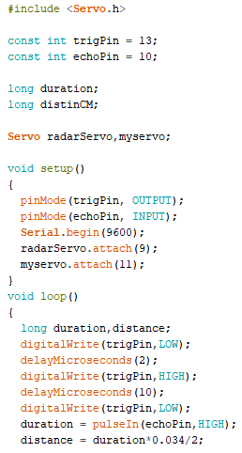

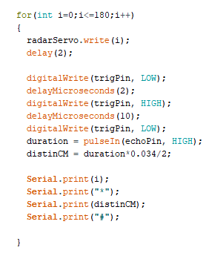

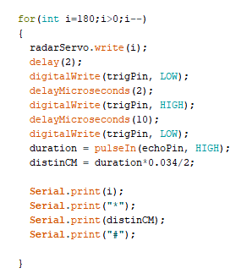

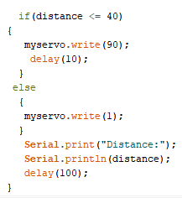

Figure 5: Illustration of project code of final implementation.

**Result:**

The following table represents the observation of the proposed mechanical system. Delay time according to distance has been showed here.

Table 01: Door opening and closing time delay

|  |  |  |  |
| --- | --- | --- | --- |
| Observation No | Distance(cm) | Door open time delay(s) | Door close time delay(s) |
| 1 | 10 | 3 | 7 |
| 2 | 15 | 3.5 | 7 |
| 3 | 20 | 4 | 7 |
| 4 | 30 | 5.5 | 7 |

From the table, it has been observed that when distance between object and door increases, door opening time delay also increases. For example, when object is 10 cm away from the door, the open time delay is around 3 seconds. When the distance is 15 cm, the opening time delay is around 3.5 seconds. Similarly, when the distance is 20cm and 30 cm, the opening time delay is around 4 & 5 seconds respectively. But in case of closing time delay, it remains constant whether distance increases or not.

But these opening and closing time delay can vary when Arduino, servomotor, ultrasonic sensor, jumper wire etc. are used again and again and the connection becomes loose.

The below graph represents the relationship between door opening time delay and distance. The graph shows that when the distance increases, the door opening time delay also increases.

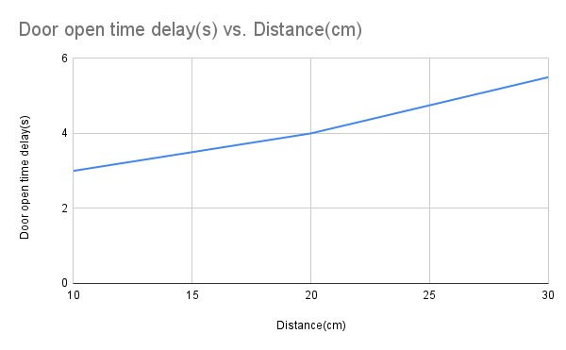

Figure: Door opening time delay(s) vs distance(cm) graph

CONCLUSION

This project introduces a mechanical arrangement to motorize a door lock, that will enable humans to have an enhanced security and improved lifestyle. Manual door key or pass can be replaced with a smart computerized lock to make life easier and efficient. Limitation of the traditional smart lock system is mainly the installment and maintain cost, exclusivity. The expense of the proposed procedure is kept at an affordable range to be able to use in regular home security. In comparison to the current available technologies, the proposed prototype of IOT based door lock is easier to implement and maintain. Here used apparatus are: Arduino uno for operation, ultrasonic sensoring module for entity detection, radar servo for monitoring the presence of the entity.

The represented structure can be broadened to introduce other characteristics of modernization and reliability of home lock system. Moreover, the project can often be supplemented to reinforce other OS platforms distant from Android. The shortcomings of conventional systems can be improved by implementing various innovative ideas proposed.

Various limitations are faced on the proposed arrangement. There are some time delay variations in opening and closing introduced. The entity detected cannot be specified. Door lock operates for all random entity present. Visual observation of entity is not possible. Backbone system is not introduced to detect each person or object separately analyzing their specifications.

Future improvements can be introduced to optimize the operation of the system. Biometric detection, fingerprint, voice control lock can be used to specify each person individually. CCTV can be used for visual sensing and observation of entities remotely. Motion detection can be used if someone is present near the door and to record any suspicious activity and send to smartphone. Alarming device can be used in case of any intrusion and any emergency situation. Extension applications can be used to operate the system and control remotely using wireless smart devices. Passcode, electrical lock can be used for further security upgrade.