NORMALIZATION

Player attribute and Game attribute

Plays:Player id,pname,nationality,jersey number,gamedate ,players,result

1NF:players is multivalued attribute

2NF:player id,pname,nationality,jersey number,gamedate,players,result

3NF:pid,pname,jersey number

Nid,nationality

Game date,players,result

Player attribute and team attribute

Plays in:player id,pname,jersey number,nationality,team id ,tname,country,city

1NF:no multivalued attribute

2NF:player id,pname,jersey number,natinality,team id,tname,country,city

3NF:player id,pname,jersey number

Nid,nationality

Team id,tname

Cid,country,city

Game attribute and coach attribute

Participate:game date,players,result,coach id,cname,nationality

1 NF:players multivalued attribute

2 NF:game date,players,result

Coach id,cname,nationality

3 NF:game date,players,result

Cid,cname

Nid,nationality

Final table for plays

Player id,pname,jersey number,nid,game date

Nid

game date,result

game date,players

Final table for plays in

Player id,pname,jersey number,nid,team id,cid,player id

Nid

team id,tname

cid

Player id,city

Final table for participate

game date,result,cid,nid

Cid,cname

Nid

game date,players

Final table

1.player id,pname,jersey number,nid,gamedate

2.Nid

3.game date,result

4.gamedate,players

5.Player id ,pname,jersey number,nid,team id,cid,player id

6.Nid

7.Team id,tname

8.Cid

9.Player id ,city

10.Game date,result,cid,nid

11.Cid,cname

12.Nid

13.Game date,players

Main Final table

1.player id,pname,jersey number,nid,gamedate

2.nid

3.game date,players

4.player id,pname,jersey number,nid,team id,cid,player id

5.team id,tname

6.player id,city

7.gamedate,result,cid,nid

8.cid,cname

**Table Creation:**

**Table 1:**

create table Player_info

(

Name varchar(30),

Player_ID int primary key,

Jersey_Number int,

Nationality varchar(30)

);

**Table 2:**

create table Team_info

(

Team_ID int primary key,

City varchar(30),

Name varchar(30)

);

**Table 3:**

create table Coach_info

(

Name varchar(30),

Coach_ID int primary key,

Nationality varchar(30)

);

**Table 4 :**

create table Game_info

(

Results int,

Players varchar(30) ,

Match_date DATE primary key

);

**Table 1 Screenshot:**

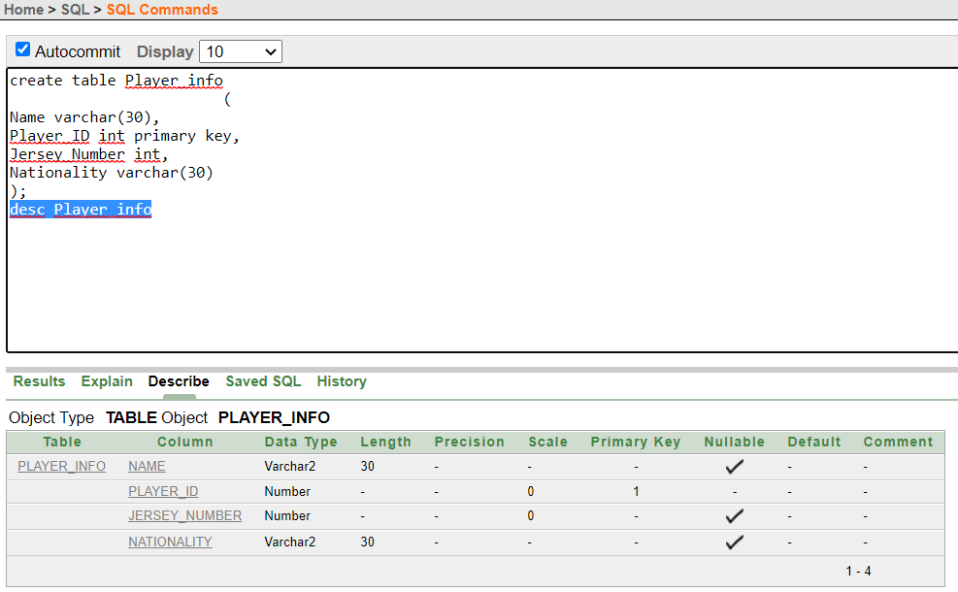

**Table 2 Screenshot:**

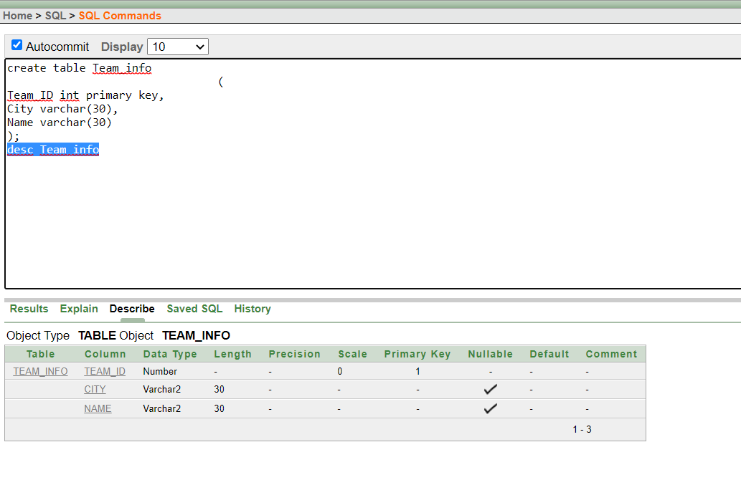

**Table 3 Screenshot:**

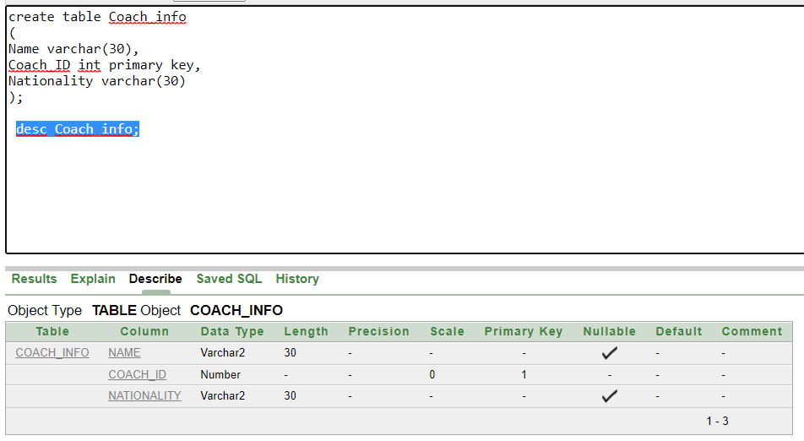

**Table 4 Screenshot:**

