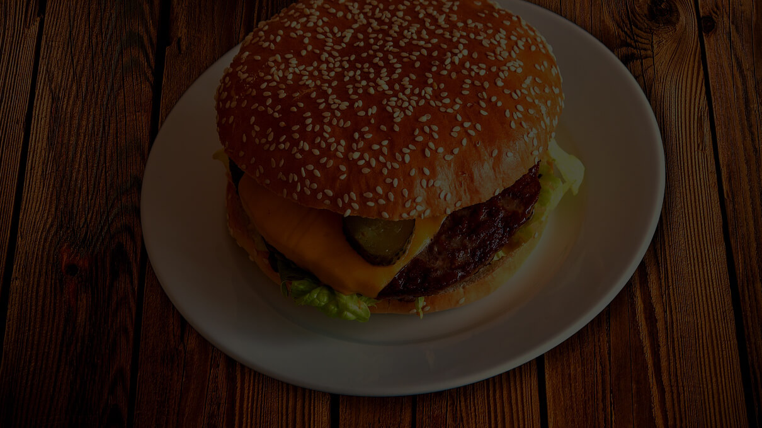

Documentation

On Foodstack (a Food Blog)

Showrin Barua | Internet Programming Lab. | 2018

# Setting Google Icon Font for offline

>> Download and copy the iconfont folder, containing the material design icons files, into your local project -- <https://github.com/google/material-design-icons/tree/master/iconfont>

>> Replace the source in the url attribute of @font-face with your local project folder path (where the font files are located) eg. **url( "iconfont/MaterialIcons-Regular.ttf").**

>> Add the styles given below to your main css file.

@font-face {

font-family: 'Material Icons';

font-style: normal;

font-weight: 400;

src: url(iconfont/MaterialIcons-Regular.eot); /* For IE6-8 */

src: local('Material Icons'),

local('MaterialIcons-Regular'),

url(iconfont/MaterialIcons-Regular.woff2) format('woff2'),

url(iconfont/MaterialIcons-Regular.woff) format('woff'),

url(iconfont/MaterialIcons-Regular.ttf) format('truetype');

}

.material-icons {

font-family: 'Material Icons';

font-weight: normal;

font-style: normal;

font-size: 24px; /* Preferred icon size */

display: inline-block;

line-height: 1;

text-transform: none;

letter-spacing: normal;

word-wrap: normal;

white-space: nowrap;

direction: ltr;

/* Support for all WebKit browsers. */

-webkit-font-smoothing: antialiased;

/* Support for Safari and Chrome. */

text-rendering: optimizeLegibility;

/* Support for Firefox. */

-moz-osx-font-smoothing: grayscale;

/* Support for IE. */

font-feature-settings: 'liga';

}

>> Then use it in normal way. Eg: <i class="material-icons">face</i>

## Heading 2

You might like the photo on the cover page as much as we do, but if it’s not ideal for your report, it’s easy to replace it with your own.

Just delete the placeholder picture. Then, on the Insert tab, click Picture to select one from your files.