COS20007: Object Oriented Programming

Pass Task 3.1: Clock Class with your own hour format

Show Wai Yan/105293041

# Clock.cs

namespace ClockProgram

{

public class Clock

{

// Fields

private Counter _hour;

private Counter _minute;

private Counter _second;

// Constructor

public Clock()

{

_hour = new Counter("Hour");

_minute = new Counter("Minute");

_second = new Counter("Second");

}

// Methods

public void Tick()

{

this.IncrementSecond();

}

public void Reset()

{

_second.Reset();

_minute.Reset();

_hour.Reset();

}

private void IncrementSecond()

{

_second.Increment();

if (_second.Ticks == 60)

{

_second.Reset();

this.IncrementMinute();

}

}

private void IncrementMinute()

{

_minute.Increment();

if (_minute.Ticks == 60)

{

_minute.Reset();

this.IncrementHour();

}

}

private void IncrementHour()

{

_hour.Increment();

if (_hour.Ticks == 13)

{

_hour.Reset();

_hour.Increment();

}

}

public string GetTime()

{

return $"{this.Hour}:{this.Minute}:{this.Second}";

}

// Properties

public string Hour

{

get { return _hour.Ticks.ToString("D2"); }

}

public string Minute

{

get { return _minute.Ticks.ToString("D2"); }

}

public string Second

{

get { return _second.Ticks.ToString("D2"); }

}

}

}

# Program.cs

namespace ClockProgram

{

public class Program

{

public static void Main(string[] args)

{

int secondsInADay = 86400;

Clock myClock = new Clock();

for (int i = 0; i < secondsInADay; i++)

{

myClock.Tick();

Console.WriteLine(myClock.GetTime());

}

}

}

}

# TestCounter.cs

using NUnit.Framework;

using NUnit.Framework.Legacy;

using ClockProgram;

namespace CounterTest

{

[TestFixture]

public class CounterTest

{

private Counter _counter;

[SetUp]

public void Setup()

{

_counter = new Counter("Test");

}

[Test]

public void TestInitialize()

{

// ClassicAssert.AreEqual(0, _counter.Ticks);

Assert.That(_counter.Ticks, Is.EqualTo(0));

}

[Test]

public void TestOneIncrement()

{

_counter.Increment();

// ClassicAssert.AreEqual(1, _counter.Ticks);

Assert.That(_counter.Ticks, Is.EqualTo(1));

}

[Test]

public void TestNIncrement()

{

_counter = new Counter("Test"); // create a new obj for testing

int nIncrement = 10;

for (int i = 0; i < nIncrement; i++)

{

_counter.Increment();

}

// ClassicAssert.AreEqual(nIncrement, _counter.Ticks);

Assert.That(_counter.Ticks, Is.EqualTo(nIncrement));

}

public void TestReset()

{

_counter.Reset();

Assert.That(_counter.Ticks, Is.EqualTo(0));

}

}

}

# TestClock.cs

using NUnit.Framework;

using ClockProgram;

namespace ClockTest

{

[TestFixture]

public class Tests

{

private Clock clock;

[SetUp]

public void Setup()

{

clock = new Clock();

}

[Test]

public void TestOneSecond()

{

clock.Reset();

clock.Tick();

Assert.That(clock.GetTime(), Is.EqualTo("00:00:01"));

}

[Test]

public void TestNSecond()

{

clock.Reset();

int second = 49;

for (int i = 0; i < second; i++) clock.Tick();

Assert.That(clock.GetTime(), Is.EqualTo($"00:00:{second.ToString("D2")}"));

}

[Test]

public void TestOneMinute()

{

clock.Reset();

int second = 60;

for (int i = 0; i < second; i++) clock.Tick();

Assert.That(clock.GetTime(), Is.EqualTo("00:01:00"));

}

[Test]

public void TestNMinute()

{

clock.Reset();

int minute = 3;

int second = 60 * minute;

for (int i = 0; i < second; i++) clock.Tick();

Assert.That(clock.GetTime(), Is.EqualTo($"00:{minute.ToString("D2")}:00"));

}

[Test]

public void TestSecondMinute()

{

clock.Reset();

int second = 190;

int minute = second / 60;

for (int i = 0; i < second; i++) clock.Tick();

Assert.That(clock.GetTime(), Is.EqualTo($"00:{minute.ToString("D2")}:{(second % 60).ToString("D2")}"));

}

[Test]

public void TestOneHour()

{

clock.Reset();

int second = 3600;

for (int i = 0; i < second; i++) clock.Tick();

Assert.That(clock.GetTime(), Is.EqualTo("01:00:00"));

}

[Test]

public void TestNHour()

{

clock.Reset();

int hour = 5;

int second = 3600 * hour;

for (int i = 0; i < second; i++) clock.Tick();

Assert.That(clock.GetTime(), Is.EqualTo($"{hour.ToString("D2")}:00:00"));

}

[Test]

public void TestHourMinuteSecond()

{

clock.Reset();

int second = 5500;

int minute = (second % 3600) / 60;

int hour = second / 3600;

for (int i = 0; i < second; i++) clock.Tick();

Assert.That(clock.GetTime(), Is.EqualTo($"{hour.ToString("D2")}:{minute.ToString("D2")}:{(second % 60).ToString("D2")}"));

}

}

}

# UML Class diagram

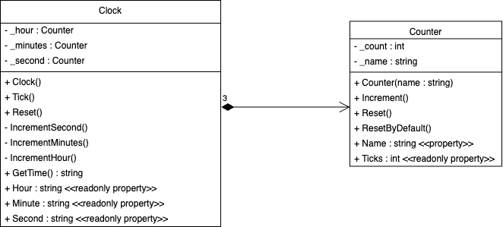

# Screenshot of the console output

# Screenshot of the Test Explorer showing your unit tests running

## For TestCounter.cs For TestClock.cs