Freight Rate Prediction: Validation Report
Muhammad Shozab Imdad | Machine Learning Engineer assessment

1. Summary
My final model is LightGBM trained on the log of the posted rate after I remove a log-linear time trend. In my out-of-time backtest over August to October 2025 it reaches a mean absolute error of $50.82 and a MAPE of 2.18% on valid labels, compared with 8.13% for a rate-per-mile baseline.

2. Train/validation split
The labeled data covers 1 January to 31 October 2025, and the 12,000 loads I had to predict cover November and December 2025. Since the task is forecasting forward in time, I did not use a random split: it would leak future market conditions into training and overstate accuracy. Instead I evaluated every model with an expanding-window backtest that mirrors the real setting:
- Fold 1: train January-July, test August
- Fold 2: train January-August, test September
- Fold 3: train January-September, test October
I re-run the label screening (section 3) inside every training window, so no information from a test month reaches the model evaluated on it. After selecting the model, I refit it on all of January to October to produce the final predictions.

3. Data findings and quality fixes
- Corrupted labels: I found 677 loads (1.4%) whose posted rates are roughly 3-6x above or below comparable loads. I score each label with a Huber-loss model trained on the other folds and exclude rows with an absolute log residual above 0.3 from training. Valid residuals sit within about +/-0.12, so the cut-off is not sensitive.
- Negative weights: 292 training loads (0.6%). With the sign removed they fall in the normal 5,000-47,500 lb range and their rates show no bias, so I treat them as sign errors.
- Missing values: I fill missing weight (300 rows) with the median for the same equipment type, and missing market_index (374 rows) with the mean for the same date, since the date alone explains about 98% of its variance.
- Time trend: I found that at a fixed market_index, rates rise about 8% per year. A tree model cannot extrapolate this, and my first LightGBM under-predicted September and October by a steady 3.7%. I now estimate the trend with the log-linear model, remove it before fitting LightGBM and add it back at prediction time.
- Distance floor: short lanes are floored at 70 miles. This is consistent across files, so I kept it as is.
- Unseen cities: eight cities (e.g. Chicago, Charlotte, San Diego) occur only in the prediction set, so I use coordinates rather than city identities as features.

4. Model comparison
Mean over the three backtest folds. 'Valid labels' excludes the rows I screened as corrupted; 'All labels' includes them.
Model | MAE valid ($) | MAPE valid (%) | MAE all ($) | MAPE all (%)
Rate-per-mile baseline | 181.41 | 8.13 | 233.26 | 10.49
Log-linear with trend | 64.11 | 2.94 | 117.84 | 5.42
LightGBM without trend | 82.27 | 3.67 | 135.64 | 6.05
LightGBM with trend (final) | 50.82 | 2.18 | 104.64 | 4.66

Per-fold MAPE of my final model on valid labels: 2025-08: 3.21%, 2025-09: 1.75%, 2025-10: 1.57%. The error falls as more history becomes available to estimate the trend, and my final model uses all ten months.

5. Final model
I use these features: distance, log distance, equipment, weight, market_index, quote_signal, pickup and delivery coordinates, and day of week. I deliberately left out month and day-of-year, because the training data never covers November or December. The target is the log posted_rate minus the linear time trend. I trained LightGBM with 1,500 trees, learning rate 0.03, 31 leaves, row and column subsampling of 0.8, and a fixed seed.

6. December prediction chart
The chart uses a fixed lane: Lexington to Fort Wayne, 360 miles, Dry Van, 32,000 lb. The chart inputs omit coordinates and market signals, so I look up coordinates per city, set market_index to the mean of all prediction-set loads on the same date, and set quote_signal to the December Dry Van median. My predictions range from $832 to $857, in line with the $758-$934 range of Dry Van loads on this lane in January to October.
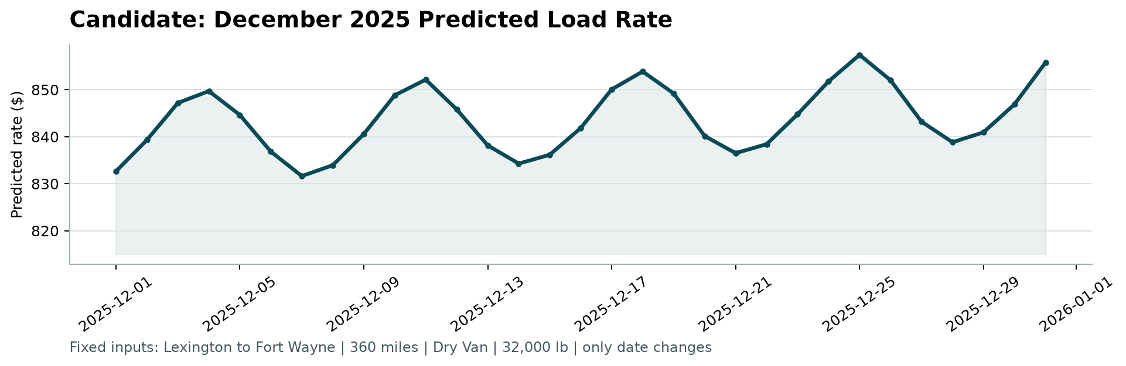

7. Limitations
- I extrapolate the time trend one to two months beyond the training data, so a change in trend would not be captured.
- If the hidden labels contain the same ~1.4% of corrupted rates, those rows will dominate the error on all loads, as the 'All labels' columns show.

