**GreenPower Motor Company Inc.**

**(NASDAQ: GP ; TSX: GPV.VN)**

GreenPower Motor Company Inc. develops, manufactures, and distributes electric vehicles for commercial markets in the United States and Canada. It offers all-electric transit, school, and charter buses. The company is based in Vancouver, Canada.

GreenPower Motor Company was founded in 2010 with one vision: advancing the adoption of EVs by making battery-electric buses and trucks affordable, durable, and easy for customers to deploy. Our approach is to use a ‘clean sheet’ design to achieve this goal. GreenPower now offers commercial vehicles for delivery, public transit, schools, vanpooling, micro-transit, shuttles, and the capability of autonomous operation. GreenPower’s corporate headquarters is located in Vancouver, Canada. We have a sales and administration office in Rancho Cucamonga, CA; US assembly takes place in Porterville, CA (San Joaquin Valley).

GreenPower’s electric buses are purpose-built, designed from the ground-up to be all-electric from day one, and built with exacting standards. This clean-sheet design approach allows us to put the battery and the propulsion system in optimized locations that give us weight and a structural advantage over our competitors. GreenPower vehicles have an industry-best driving range for each of the models it produces. The GreenPower chassis has been engineered to be the strongest, safest, and most durable product on the market.

GreenPower designs, builds, markets, and supports electric vehicles that not only meet the operational demands of transporting goods and passengers; GreenPower vehicles do so with unmatched safety and efficiency. GreenPower vehicles use SAE J1772, standard charging with industry-best charging rates for both level 2 and the DC fast charging and we also offer wireless charging on the EV Star family of vehicles for operator-free driving overcharging.

#### THE FUTURE OF GREENPOWER

With a total of 62 EV deliveries in the last two quarters mid-way through 2020, GreenPower is proving to have the strongest team in the industry. These deliveries encompass GreenPower’s full suite of electric vehicles and include 57 EV Stars, 4 electric school buses, and 1 EV350. Significant order growth is expected as GreenPower implements its national strategy through its partnership with Creative Bus Sales, the Nation’s largest bus dealer. With 18 physical locations across the United States, over 100 experienced sales personnel, and exceptional parts and service support, the Creative Bus Sales partnership paves the way for a greater reach of GreenPower EVs.

### Electrameccanica Vehicles Corp.

### (NASDAQ: SOLO)

Electrameccanica Vehicles Corp., a development-stage company, develops, manufactures, and sells electric vehicles in Canada. The company operates in two segments, Electric Vehicles and Custom Build Vehicles. Its flagship product is the SOLO, a single seat vehicle. The company sells its vehicles online through electrameccanica.com Website, as well as through corporate owned stores. Electrameccanica Vehicles Corp. was founded in 2015 and is headquartered in Vancouver, Canada.

Every day, 119 million North Americans commute using personal vehicles— and 105 million of them commute alone. Step into the future of driving. Reduce your gas bill to zero. Eliminate your environmental impact. Turn your commute into the highlight of your day.

**The Solo Car**

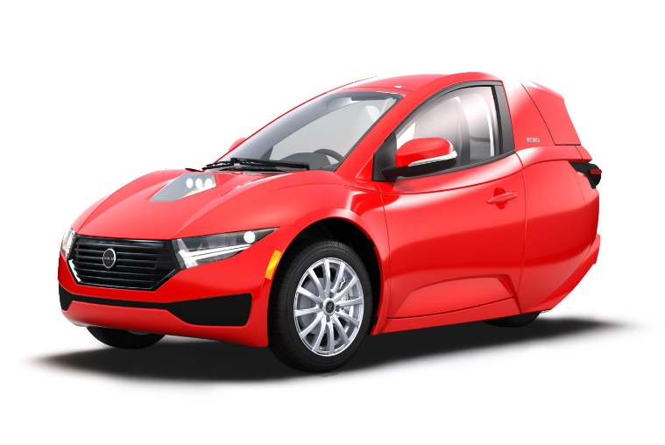

Technically, the Solo is a motorcycle, though it’s fully enclosed and drives like a car with a steering wheel and foot pedals. It has only one seat, but it’s accessible with doors on both sides. It also has a trunk, and amenities common to a full-size passenger vehicle, including Bluetooth stereo, air conditioning and a backup camera.

Having three wheels, it is not subject to the sorts of crash-testing the National Highway Traffic Safety Administration requires for street-legal, four-wheeled vehicles, but it does have a seatbelt and an integrated roll bar.

Dynamic Performance

You don’t have to give up performance when you give up gas. Zero to 60 in 10 seconds. Top speed of 80 MPH. Your Solo accelerates your commute while reducing your environmental footprint. Sustainability has never looked—or felt—better.

#### Quick Charge, Prime Parking

Three hours to a full charge. All the best parking spots. Your Solo is powered by a 17.3 kWh NCA Battery liquid cooled and compatible with universal charging stations everywhere.

#### The Definition of Low Maintenance

Your Solo has 99% fewer parts than a combustion engine—meaning significantly fewer opportunities for things to go wrong. Spend more time getting where you want to be, and less time dealing with unexpected maintenance.

#### Safer than a motorcycle, cooler than a car

Your SOLO is rigorously tested and tested again. It is engineered to meet the highest standards for today and the future.

#### The details you expect, and some you won’t

Heated seat. Vegan-friendly vehicle. Bluetooth stereo. Rear-view camera. Keep all the perks of your full-sized car, but none of the upkeep and a fraction of the costs.

#### Charge Everywhere

What if you charged your car the way you charge your phone? When it’s not in use, it’s charging. Free public charging is now a mainstay in malls, parking lots and city-built stations, and it’s easy to install a low-cost charge station at home.

Annual Fuel Cost

Your Vehicle $891

Your Solo $70

Annual Savings $821

After launching in Los Angeles later this year, ElectraMeccanica will expand sales to San Francisco, Seattle and Portland — early-adopter cities in states that also have generous incentives for electric vehicles. California provides a $750 rebate for the Solo; Oregon, $2,500. Mr. Rivera said the Solo would expand to the rest of the country over the next 18 months to two years, then globally.

Taking a page from Tesla, which sells its cars through retail stores rather than dealerships, ElectraMeccanica is offering the Solo through shopping mall kiosks, starting with two in the Los Angeles area — Westfield Fashion Square in the San Fernando Valley and Westfield Century City. Together, the malls have 24 million visitors a year, according to a Westfield official.

The coronavirus is changing the transportation landscape in ways that seemed unthinkable. Public transportation ridership is plummeting throughout the country. Cars are suddenly unaffordable to millions who have lost jobs. And the threat of climate change remains very real.

So maybe — just maybe — the Solo has a chance. Arriving on the market when travelers are hesitant to touch what others have touched, it provides for social distancing. Priced at $18,500, it also costs about half as much as the current average sales price for a new passenger vehicle ($35,667 as of March 2020). And it has zero emissions, allowing for up to 100 miles of travel per charge at a top speed of 80 miles an hour. It recharges with Level 1 or 2 chargers.

“Conceptually, it makes sense,” said Juan Matute, deputy director of the Institute of Transportation Studies at the University of California, Los Angeles. “But what’s socially desirable and environmentally beneficial isn’t necessarily personally optimal.”